UNITED STATES

SECURITIES AND EXCHANGE COMMISSION

Washington, D.C. 20549

SCHEDULE 14A

PROXY STATEMENT PURSUANT TO SECTION 14(a) OF

THE SECURITIES EXCHANGE ACT OF 1934

Filed by the Registrant ☐

Filed by a Party other than the Registrant ☒

Check the appropriate box:

- Preliminary Proxy Statement

- Confidential, for Use of the Commission Only (as permitted by Rule 14a-6(e)(2))

- Definitive Proxy Statement

- Definitive Additional Materials

- Soliciting Material Pursuant to §240.14a-12

GOLD KIST, INC.

(Name of Registrant as Specified In Its Charter)

PILGRIM’S PRIDE CORPORATION

PROTEIN ACQUISITION CORPORATION

(Name of Person(s) Filing Proxy Statement, if other than the Registrant)

Payment of Filing Fee (Check the appropriate box):

- No fee required.

- Fee computed on table below per Exchange Act Rules 14a-6(i)(1) and 0-11.

  - Title of each class of securities to which transaction applies:

  - Aggregate number of securities to which transaction applies:

  - Per unit price or other underlying value of transaction computed pursuant to Exchange Act Rule 0-11 (set forth the amount on which the filing fee is calculated and state how it was determined):

  - Proposed maximum aggregate value of transaction:

  - Total fee paid:

- Fee paid previously with preliminary materials.

- Check box if any part of the fee is offset as provided by Exchange Act Rule 0-11(a)(2) and identify the filing for which the offsetting fee was paid previously. Identify the previous filing by registration statement number, or the Form or Schedule and the date of its filing.

  - Amount Previously Paid:

  - Form, Schedule or Registration Statement No.:

  - Filing Party:

  - Date Filed:



The following presentation was posted on Pilgrim’s Pride’s Corporation’s external web site:

Pilgrim's Pride Corporation's Acquisition of Gold Kist Inc.

Creating the World’s Leading Chicken Producer

December 12, 2006

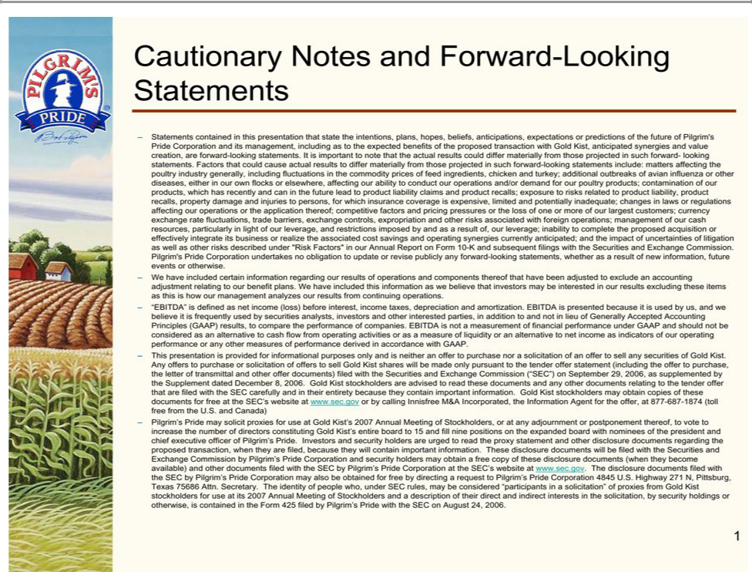


Proposed Transaction

– Pilgrim’s Pride (NYSE:PPC) publicly announced on December 4, 2006 that it had entered into a definitive merger agreement to acquire Gold Kist Inc. (NasdaqGS:GKIS) for $21 per share

  - Represents a 62% premium to the August 18, 2006 closing price of $12.93

  - Initially approached Gold Kist in 2004 prior to its IPO

  - Recent offer proposals began in February 2006

– We maintain our strong desire to close this transaction with Gold Kist to create the world’s largest chicken company

  - Powerful strategic and financial rationale

– Anticipated close: early CY2007

2


Attractive Proposal…

– Value creation expected for all shareholders

Offer Summary

(amounts in millions except per share amounts)

Price Per Share (8/18/06) | $12.93
Offer Price Per Share | $21.00
Fully-Diluted Share Count (1)(2) | 51.4
Purchase Price of Gold Kist equity | $1,079
Assumed Gold Kist Debt⁽³⁾ | $144
Cash on Gold Kist Balance Sheet(3)(4) | 93
Total Enterprise Value of Offer (5) | $1,130
Offer Price as a Percent of Gold Kist's:
Close Price (8/18/06) | 162%
Prior 90-Day Average (8/18/06) | 154%
52-Week High (8/18/06) | 100%

- Reflects repurchase of shares from option proceeds.

- As of 12/2/06.

- As of 9/30/06.

- Includes $15.9 million in Investments.

- Does not include fees and deal-related expenses.

3

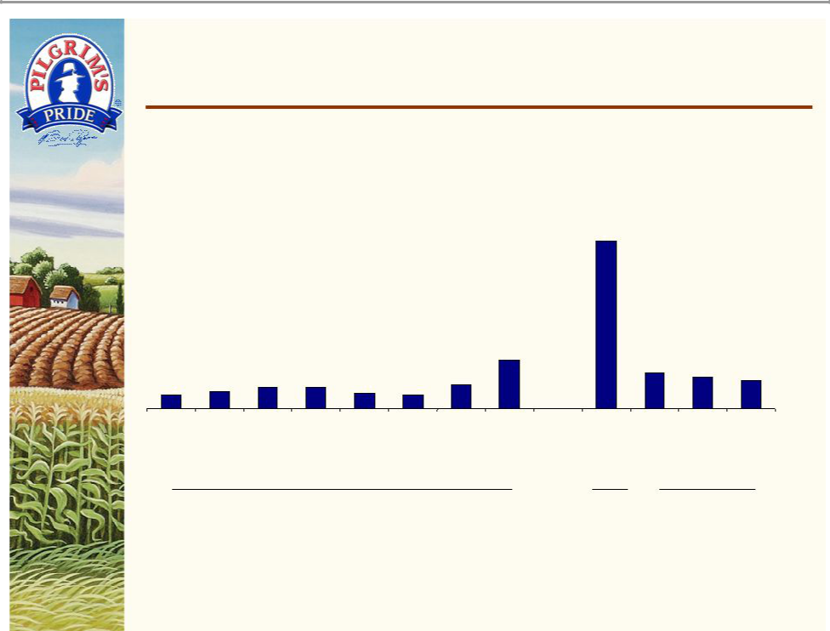
…Relative to Historical Multiples

– Our proposal represents full value for Gold Kist

Gold Kist Enterprise Value/EBITDA Multiples

34.1x

 |  |  |  |  |  |  | 9.8x
 |  |  |  |  |  |  |  |  | 7.2x |  | 6.3x | 5.7x
 |  |  | 4.3x | 4.3x |  |  | 4.8x |  |  |  | 6.3x | 5.7x
2.8x |  | 3.3x | 4.3x | 4.3x | 3.0x | 2.7x | 4.8x
12/31/04 |  | 3/31/05 | 6/30/05 | 9/30/05 12/31/05 |  | 3/31/06 | 6/30/06 Multiple as | (1%) LTM | 5% |  | 6% | 7%
 |  |  |  |  |  |  | of 8/18/06 | Operating
 |  |  |  |  |  |  | based on | Margin⁽⁴⁾
 |  |  |  |  |  |  | LTM
 |  |  |  |  |  |  | Adjusted
 |  |  |  |  |  |  | EBITDA⁽³⁾
 |  |  | Historical Trailing EBITDAMultiples (1)(2) |  |  |  |  | $21.00 Offer as a |  |  | $21.00 Offer as
 |  |  |  |  |  |  |  | Multiple of LTM |  |  | Multiples of EBITDA
 |  |  |  |  |  |  |  | Adjusted EBITDA(3) |  | Assuming Normalized
 |  |  |  |  |  |  |  |  |  |  | Operating Margins(5)
(1) | Historical trailing multiples calculated as follows: The numerator is the enterprise value derived from the prior quarter’s balance sheet and
 | the final close price at the end of the current quarter. The denominator is the LTM EBITDA as of the prior quarter.
(2) | Data per Capital IQ.
(3) | Please see Appendix A for calculation.
(4) | Per Gold Kist’s public filings. |  |  |  |  |  |  |  |  |  |  | 4
(5) | Please see Appendix B for calculation. |  |  |  |  |  |  |  |  |  |  | 4

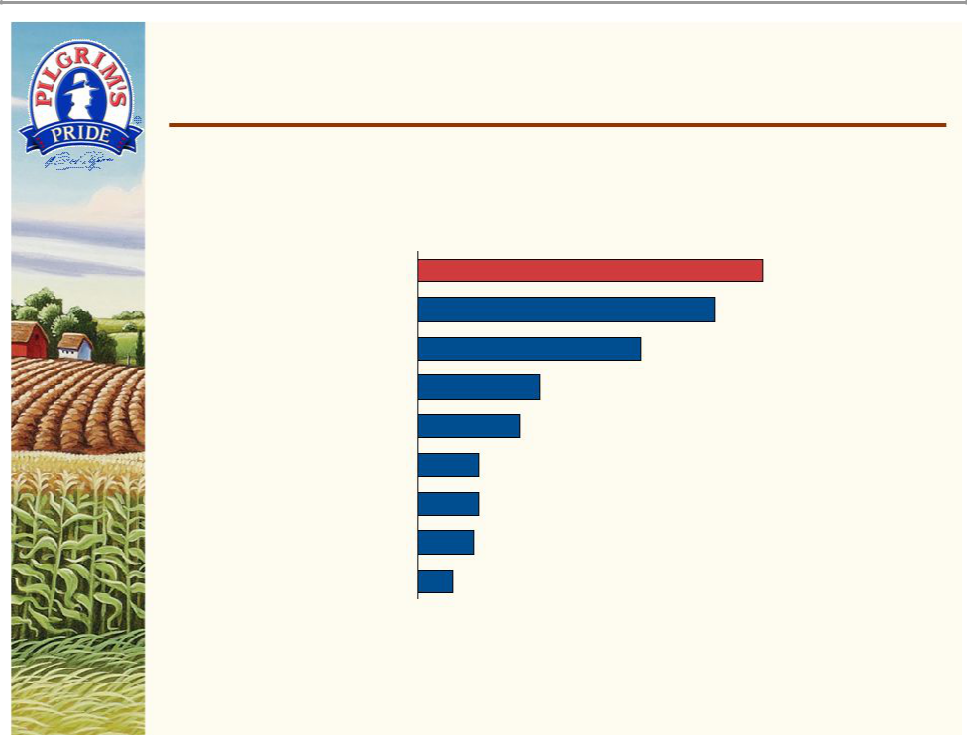
Creates the Number One Chicken Company in North America

U.S. Chicken Industry Leaders Market Share by Production(1)

Pilgrim's Pride & Gold Kist | PF 24.8% ⁽²⁾
Tyson Foods | 21.4%
Pilgrim's Pride | 16.0%
Gold Kist | 8.8%
Perdue Farms | 7.3%
Sanderson Farms | 4.3%
Wayne Farms | 4.3%
Mountaire Farms | 4.0%
Foster Farms | 2.5%

Source: WATT Poultry USA, January 2006.
- Ready-To-Cook million pounds per week.
- As used in this presentation, PF = Pro Forma.

5

Formidable Protein Industry Player

– Combined company would be the #3 U.S. protein company by revenue

– Largest pure-play dedicated to chicken

LTM Revenues

($ in millions)

Tyson Foods

Smithfield⁽¹⁾

Foods

Pilgrim's Pride &

Gold Kist

Hormel Foods

Pilgrim's Pride

Gold Kist

Sanderson

Farms

$11,183

PF $7,363

$5,746

$5,236

$2,127

$1,048

Chicken Beef Pork

$25,559 Tyson Foods

Smithfield

Foods

Pilgrim’s Pride &

Gold Kist

Hormel Foods

Pilgrim’s Pride

Gold Kist

Sanderson

Farms

Note: LTM results through the most recent twelve-month reporting period for each public entity. | 6
(1) Does not include pro forma results from pending acquisition of PremiumStandard Farms.


Powerful Combination

– Delivers compelling economics to shareholders of both companies

  - Balanced portfolio of fresh chicken and value-added products

  - Further economies of scale

  - Estimated synergies of $50 million

– Production

– Purchasing

– Distribution

– Logistics

– Selling, General & Administrative

– No anticipated plant closings or production headcount reductions

– Better serve existing customers and expand customer base

– Consolidation of a still fragmented industry

7


Consistent With Pilgrim’s Pride Long-Standing Business Strategy

Capitalize on significant scale with leading industry position and brand recognition

Capitalize on attractive U.S. prepared foods market

Enhance U.S. fresh chicken profitability through value-added, branded products

Improve operating efficiencies and increase capacity on a cost-effective basis

Continue to seek strategic acquisitions Capitalize on export opportunities

8

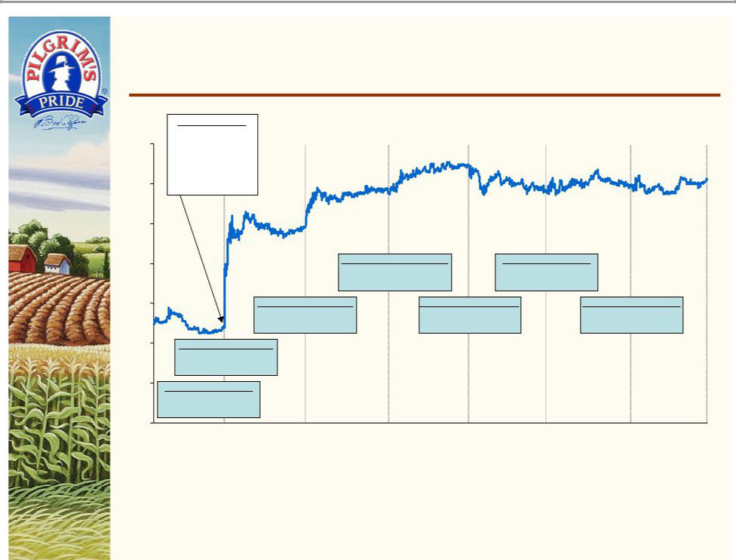
Pilgrim’s Pride Stock Since Deal Announcement

 | December 4, 2006
$30.00 | Announcement of
$30.00 | merger agreement
 | between Pilgrim’s Pride
 | and Gold Kist prior to
$29.00 | market open
$28.00
$27.00 |  |  |  |  |  | Wednesday, December 6, 2006 |  |  | Friday, December 8, 2006
$27.00 |  |  |  |  |  | Close: | $29.44 |  | Close: | $28.98
 |  |  |  |  |  | Change: | 0.69 (2.4%) |  | Change: | 0.19 (0.7%)
$26.00 |  |  | Tuesday, December 5, 2006 |  |  |  | Thursday, December 7, 2006 |  |  |  | Monday, December 11, 2006
 |  |  | Close: |  | $28.75 |  | Close: | $28.79 |  |  | Close: | $29.09
 |  |  | Change: |  | 0.85 (3.0%) |  | Change: -0.65 (-2.2%) |  |  |  | Change: | 0.11 (0.4%)
$25.00 | Monday, December 4, 2006
 | Close: |  | $27.90
 | Change: |  | 2.52 (9.9%)
$24.00 | Friday, December 1, 2006
 | Close: | $25.38
 | Change: -0.14 (-0.5%)
$23.00
12/1/06 |  | 12/4/06 |  | 12/5/06 |  | 12/6/06 |  | 12/7/06 | 12/8/06 |  | 12/11/06 |  | 12/11/06
 |  |  |  |  |  |  |  |  |  |  |  |  | close

– Pilgrim’s Pride’s stock price has risen 15% since announcement

9

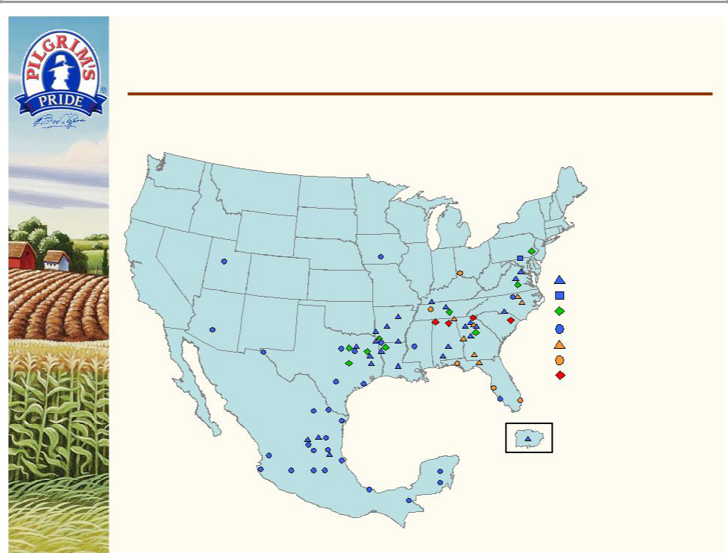
Expanded Geographic Footprint…

– Gold Kist acquisition expands Southeast presence

Pilgrim's Pride’s Chicken Processing

Pilgrim's Pride's Turkey Processing

Pilgrim's Pride's Prepared Foods

Pilgrim's Pride's Distribution Centers

Gold Kist Chicken Processing

Gold Kist Distribution Centers

Gold Kist Prepared Food Plant

10

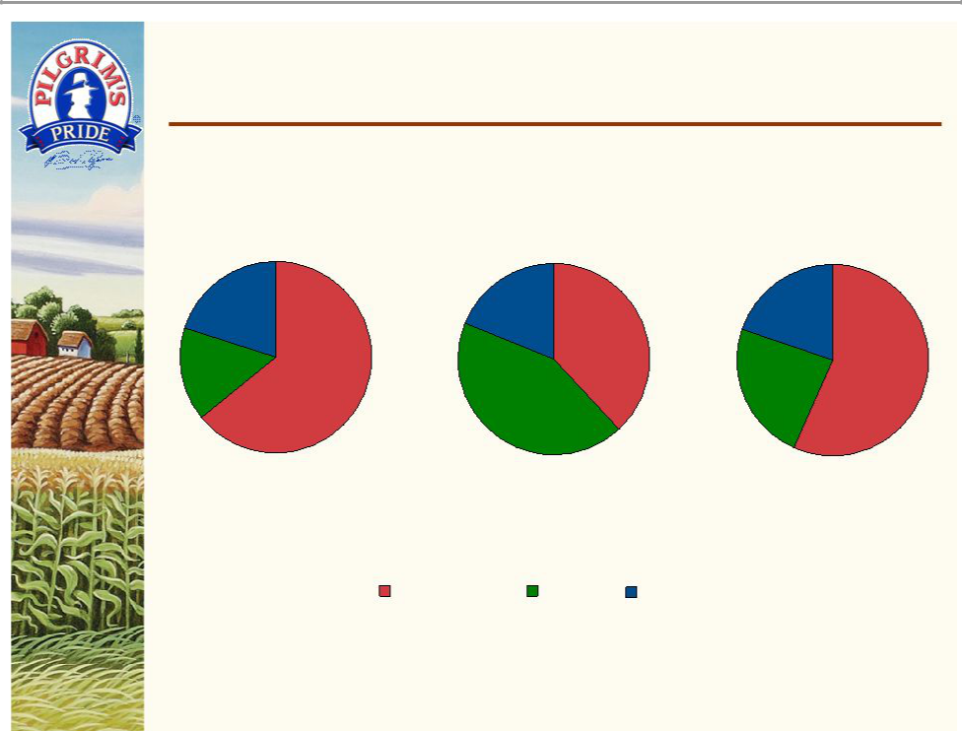
…With More Diversified End Markets

– Enhances retail prepared foods opportunities

Pilgrim’s Pride Gold Kist Combined

^{20%} 19% 38% 20% 57%

64%

16%
24%

43%

FY 2005 Net Sales: $5.7 BN FY 2005 Net Sales: $2.3 BN FY 2005 Net Sales: $8.0 BN

Foodservice Retail Export/Other

Source: WATT Poultry USA, January 2006.

11

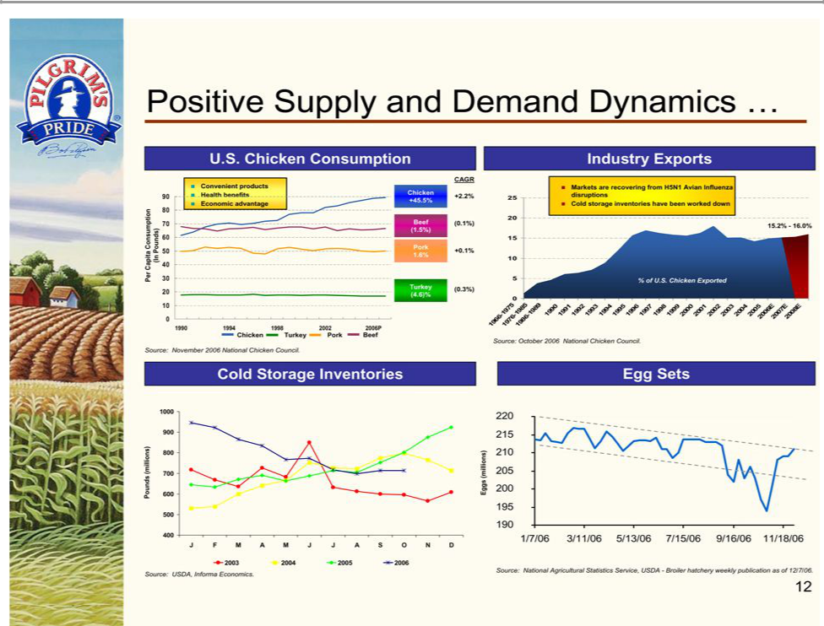

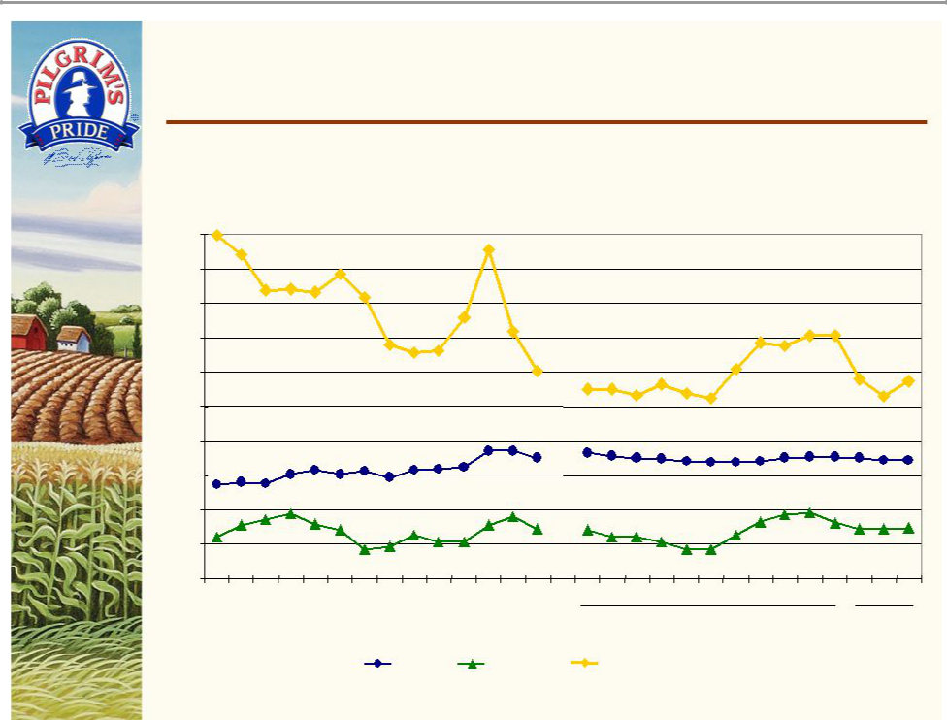
…Leading to Stabilized Pricing Outlook

Average Prices Over Periods Represented

$2.00

$1.80

$1.60

$1.40

$1.20

$1.00

$0.80

$0.60

$0.40

$0.20

$0.00

'93 '94 '95 '96 '97 '98 '99 '00 '01 '02 '03 '04 '05 '06

Fiscal Years

GA Dock Leg Quarters

Source: UrnerBarry Publications, Inc.

(1) Month to date through December 8, 2006.

N D J F M A M J J | A S O N D ⁽¹⁾
FY 2006 | FY 2007

Boneless Skinless Breast

13


Combined Company

($ in millions)
 | FYE
 | 9/30/06
Net Sales
Pilgrim's Pride | $5,236
Gold Kist | 2,127
Combined Net Sales | $7,363
EBITDA⁽¹⁾
Pilgrim's Pride - Adjusted EBITDA | $143
Gold Kist - Adjusted EBITDA | 33
Combined Adjusted EBITDA | $176
Capital Expenditures(2)
Pilgrim's Pride | $144
Gold Kist | 90
Combined Capital Expenditures | $234

- See Appendix A for reconciliation.

- CapEx data per FY2006 Q4 earnings release conference calls for Pilgrim's Pride and Gold Kist.

14


Liquidity and Financial Capacity

As of September 30, 2006

($ in millions)

 | Facility | Amount | Net
Source of Liquidity | Amount | Outstanding | Available
Cash and cash equivalents | $ – | $ – | $156
Investments in available for sale securities | – | – | 137
Debt Facilities:
Revolving credit facilities | $225 | $75 | $127 ⁽¹⁾
Revolving/term facility | 795 | – | 795 | (2)
Term Loans | 430 | 91 | 339 | (2)
Bridge Loan | 450 | – | 450 | (3)
Receivables purchase agreement | $125 | $ – | $125
Total Available From Debt Facilities | $2,025 | $166 | $1,836

- At September 30, 2006, the Company had $23.4 million in letters of credit outstanding relating to normal business transactions.
- The amount available at September 30, 2006 under these facilities was $535.3 million. If the transaction is successful, the amount of borrowings available will increase by up to $486 million and, with the pledgingof additional identified collateral to secure this facility; the full amountof the commitment under this facility will be available. The amounts reflected above contemplate that both of these events will occur.
- Reflects a bridge loan agreement obtained by the Company from certain investment banks, pursuant to which, subject to specified conditions, the investment banks have agreed to make available to the Company a $450 million senior unsecured bridge loan for the purchase of shares of common stock of Gold Kist.

15



Appendix


Appendix A: EBITDA Reconciliation

($ in millions)
 | As of 8/18/06 | Present
 | LTM | LTM
 | 6/30/06 | 9/30/06
Adjusted EBITDA Reconciliation
Net Income
Pilgrim's Pride | $48 | ($34)
Gold Kist | $4 | ($18)
Combined Net Income | $52 | ($52)
Adjustments:
Pilgrim's Pride - Add:
Income Tax Expense | $13 | ($2)
Net Interest Expense | 40 | 41
Depreciation & Amortization (1) | 138 | 133
Pilgrim's Pride - Adjustments:
Accounting Adjustment - Benefit Plans | $0 | 6
Gold Kist - Add:
Income Tax Expense (Benefit) | ($3) | ($15)
Net Interest Expense | 11 | 10
Depreciation & Amortization (1) | 50 | 51
Gold Kist - Adjustments:
Benefit Plan and Pension Settlement Loss | 1 | -
Loss on Investment | 3 | -
Debt Prepayment Penalties | 6 | -
Antitrust Settlement (Benefit) | - | (1)
Unsolicited Offer Expenses | - | 6
Adjusted EBITDA
Pilgrim's Pride | $239 | $143
Gold Kist | 72 | 33
Combined Adjusted EBITDA | $311 | $176

(1) Excludes amortization of capitalized finance costs and includes amortization of share-based compensation.

17


Appendix B: Implied Normalized Gold Kist Operating Margins

Implied Normalized Financial Information – Gold Kist

($ in millions)

Fiscal Year Ending September 30,
FY2006 Sales | $2,127 | $2,127 | $2,127
Assumed Normalized EBIT Margin | 5% | 6% | 7%
Implied Normalized EBIT | $106 | $128 | $149
Plus: Depreciation & Amortization⁽¹⁾ | 51 | 51 | 51
Implied Normalized EBITDA | $157 | $178 | $200
Actual FY2006 Adjusted EBITDA | $33 | $33 | $33
Enterprise Value at $21 per share | $1,130 | $1,130 | $1,130
EV/Sales | 0.53x | 0.53x | 0.53x
EV/Normalized EBITDA | 7.2x | 6.3x | 5.7x

(1) Depreciation assumed to be equivalent to LTM as of 9/30/06.

18

