UNITED STATES
SECURITIES AND EXCHANGE COMMISSION
WASHINGTON, D.C. 20549
FORM |  |  | 8-K
CURRENT REPORT
Pursuant to Section 13 or 15(d) of the Securities Exchange Act of 1934
Date of report (Date of earliest event reported): October 9, 2026
PILGRIM'S PRIDE CORPORATION
(Exact Name of registrant as specified in its charter)
Delaware |  |  |  |  |  | 1-9273 |  |  |  |  |  | 75-1285071
(State or other jurisdiction of  incorporation or organization) |  |  |  |  |  | (Commission File Number) |  |  |  |  |  | (IRS Employer Identification No.)
1770 Promontory Circle |  |  |  |  |  |  |  |  | 80634-9038
Greeley |  |  | CO |  |  |  |  |  | (Zip Code)
(Address of principal executive offices)
Registrant's telephone number, including area code: (970) 506-8000
Not Applicable
(Former name or former address, if changed since last report.)
Check the appropriate box below if the Form 8-K filing is intended to simultaneously satisfy the filing obligation of the registrant under any of the following provisions:
☐ Written communications pursuant to Rule 425 under the Securities Act (17 CFR 230.425)
☐ Soliciting material pursuant to Rule 14a-12 under the Exchange Act (17 CFR 240.14a-12)
☐ Pre-commencement communications pursuant to Rule 14d-2(b) under the Exchange Act (17 CFR 240.14d-2(b))
☐ Pre-commencement communications pursuant to Rule 13e-4(c) under the Exchange Act (17 CFR 240.13e-4(c))
Securities registered pursuant to Section 12(b) of the Act:
Title of each class |  |  |  |  |  | Trading Symbol |  |  |  |  |  | Name of Exchange on Which Registered
Common Stock, Par Value $0.01 |  |  |  |  |  | PPC |  |  |  |  |  | The Nasdaq Stock Market LLC
Indicate by check mark whether the registrant is an emerging growth company as defined in Rule 405 of the Securities Act of 1933 (§230.405 of this chapter) or Rule 12b-2 of the Securities Exchange Act of 1934 (§240.12b-2 of this chapter).
Emerging growth company |  |  | ☐
If an emerging growth company, indicate by check mark if the registrant has elected not to use the extended transition period for complying with any new or revised financial accounting standards provided pursuant to Section 13(a) of the Exchange Act. ☐

Item 8.01 Other Events.
On October 9, 2026, Pilgrim’s Pride Corporation (the “Company”) issued a press release announcing the formation of a special committee of independent and disinterested directors (the “Special Committee”) to review and evaluate the previously announced unsolicited proposal received on August 18, 2026 from JBS N.V. to acquire all of the outstanding shares of common stock of the Company that JBS does not currently own. A copy of the press release is filed as Exhibit 99.1 hereto.

Item 9.01 Financial Statements and Exhibits.
(d) Exhibits
Exhibit No. |  |  |  |  |  | Description
99.1 |  |  |  |  |  | Press Release issued by the Company dated October 9, 2026.
104 |  |  |  |  |  | Cover Page Interactive Data File (formatted as Inline XBRL and contained in Exhibit 101)

SIGNATURES
Pursuant to the requirements of the Securities Exchange Act of 1934, the registrant has duly caused this report to be signed on its behalf by the undersigned hereunto duly authorized.
 |  |  |  |  |  |  |  |  | PILGRIM’S PRIDE CORPORATION
Date: |  |  | October 9, 2026 |  |  |  |  |  | /s/ Matthew Galvanoni
 |  |  |  |  |  |  |  |  | Matthew Galvanoni
 |  |  |  |  |  |  |  |  | Chief Financial Officer and Chief Accounting Officer
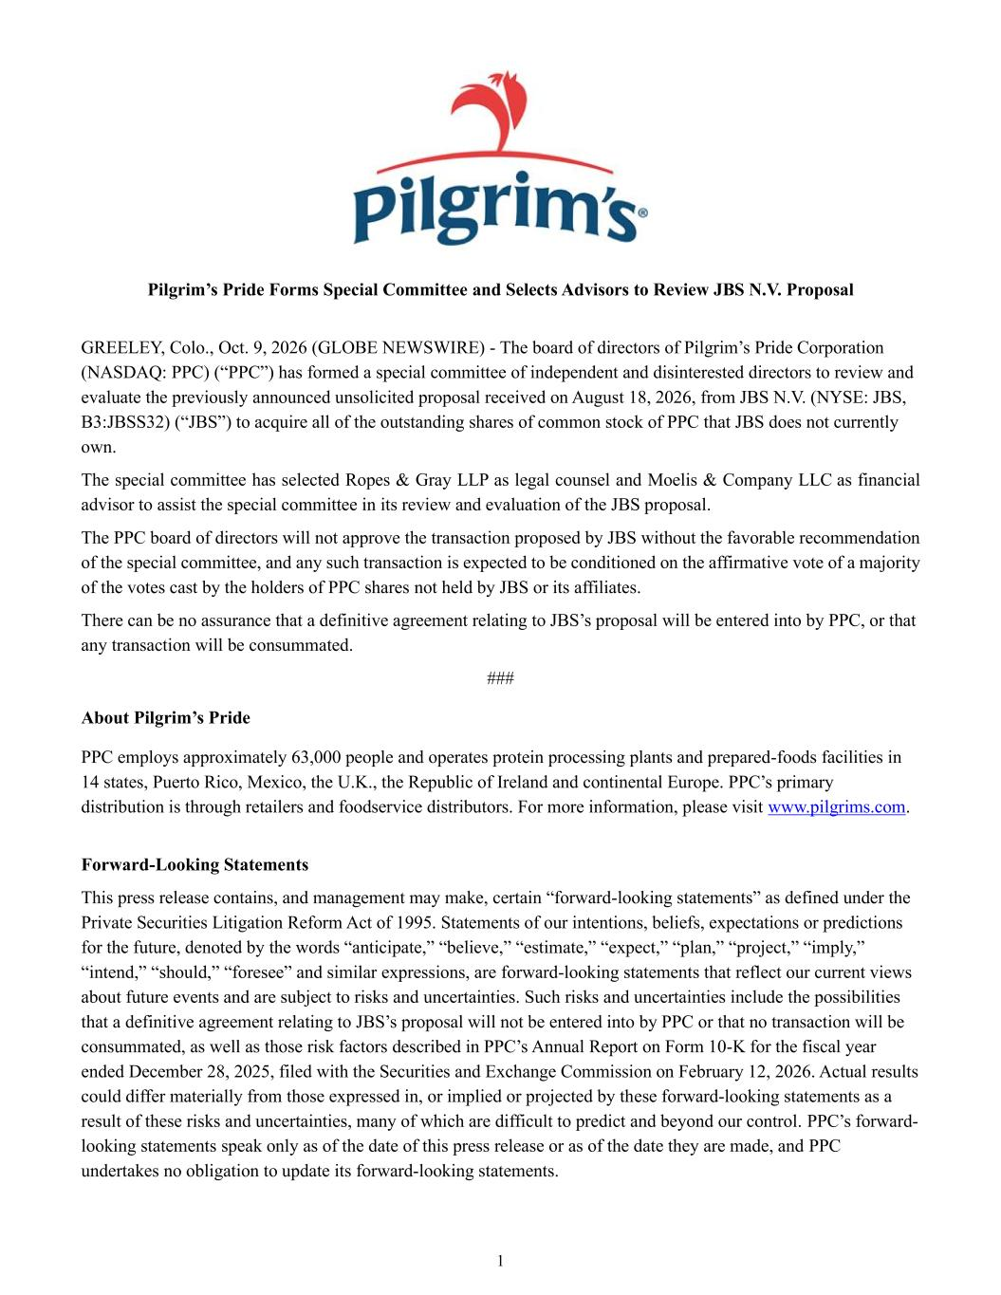

1 Pilgrim’s Pride Forms Special Committee and Selects Advisors to Review JBS N.V. Proposal GREELEY, Colo., Oct. 9, 2026 (GLOBE NEWSWIRE) - The board of directors of Pilgrim’s Pride Corporation (NASDAQ: PPC) (“PPC”) has formed a special committee of independent and disinterested directors to review and evaluate the previously announced unsolicited proposal received on August 18, 2026, from JBS N.V. (NYSE: JBS, B3:JBSS32) (“JBS”) to acquire all of the outstanding shares of common stock of PPC that JBS does not currently own. The special committee has selected Ropes & Gray LLP as legal counsel and Moelis & Company LLC as financial advisor to assist the special committee in its review and evaluation of the JBS proposal. The PPC board of directors will not approve the transaction proposed by JBS without the favorable recommendation of the special committee, and any such transaction is expected to be conditioned on the affirmative vote of a majority of the votes cast by the holders of PPC shares not held by JBS or its affiliates. There can be no assurance that a definitive agreement relating to JBS’s proposal will be entered into by PPC, or that any transaction will be consummated. ### About Pilgrim’s Pride PPC employs approximately 63,000 people and operates protein processing plants and prepared-foods facilities in 14 states, Puerto Rico, Mexico, the U.K., the Republic of Ireland and continental Europe. PPC’s primary distribution is through retailers and foodservice distributors. For more information, please visit www.pilgrims.com. Forward-Looking Statements This press release contains, and management may make, certain “forward-looking statements” as defined under the Private Securities Litigation Reform Act of 1995. Statements of our intentions, beliefs, expectations or predictions for the future, denoted by the words “anticipate,” “believe,” “estimate,” “expect,” “plan,” “project,” “imply,” “intend,” “should,” “foresee” and similar expressions, are forward-looking statements that reflect our current views about future events and are subject to risks and uncertainties. Such risks and uncertainties include the possibilities that a definitive agreement relating to JBS’s proposal will not be entered into by PPC or that no transaction will be consummated, as well as those risk factors described in PPC’s Annual Report on Form 10-K for the fiscal year ended December 28, 2025, filed with the Securities and Exchange Commission on February 12, 2026. Actual results could differ materially from those expressed in, or implied or projected by these forward-looking statements as a result of these risks and uncertainties, many of which are difficult to predict and beyond our control. PPC’s forward- looking statements speak only as of the date of this press release or as of the date they are made, and PPC undertakes no obligation to update its forward-looking statements.


2 Contact: Andrew Rojeski Head of Strategy, Investor Relations, & Sustainability IRPPC@pilgrims.com www.pilgrims.com

