Table of Contents

UNITED STATES

SECURITIES AND EXCHANGE COMMISSION

Washington, D.C. 20549

FORM 10-K

- ANNUAL REPORT PURSUANT TO SECTION 13 OR 15(d) OF THE SECURITIES EXCHANGE ACT OF 1934

For the fiscal year ended December 29, 2024

OR

- TRANSITION REPORT PURSUANT TO SECTION 13 OR 15(d) OF THE SECURITIES EXCHANGE ACT OF 1934

 |  |  |  |  |  |  |  |  |  |  | For the transition period from |  |  |  | to
 |  |  |  |  |  |  |  |  |  |  | Commission File number 1-9273
 |  |  |  |  |  |  |  |  |  |  | PILGRIM’S PRIDE CORPORATION
 |  |  |  |  |  |  |  |  |  |  | (Exact name of registrant as specified in its charter)
 |  |  |  |  | Delaware |  |  |  |  |  |  |  |  | 75-1285071
 | (State or other jurisdiction of incorporation or organization) |  |  |  |  |  |  |  |  |  |  |  |  |  |  |  |  |  | (I.R.S. Employer Identification No.)
 |  |  | 1770 Promontory Circle |  |  |  |  |  |  |  |  |  |  | 80634-9038
 |  |  |  | Greeley CO
 | (Address of principal executive offices) |  |  |  |  |  |  |  |  |  |  |  |  |  |  |  |  |  |  | (Zip code)
 |  |  |  |  |  |  |  |  |  |  | Registrant’s telephone number, including area code: (970) 506-8000
 |  |  |  |  |  |  |  |  |  |  | Securities registered pursuant to Section 12(b) of the Act:
 | Title of each class |  |  |  |  |  |  |  |  |  | Trading Symbol |  |  |  |  |  |  |  |  | Name of each exchange on which registered
Common Stock, par value $0.01 per share |  |  |  |  |  |  |  |  |  |  |  |  |  |  |  |  |  |  |  | The Nasdaq Stock Market LLC
 |  |  |  |  |  |  |  |  |  |  | PPC
 |  |  |  |  |  |  |  |  |  |  | Securities registered pursuant to Section 12(g) of the Act: None
Indicate by check mark if the registrant is a well-known seasoned issuer, as defined in Rule 405 of the Securities Act. Yes |  |  |  |  |  |  |  |  |  |  |  |  |  | x No o


Indicate by check mark if the registrant is not required to file reports pursuant to Section 13 or Section 15(d) of the Exchange Act. Yes o No x

Indicate by check mark whether the registrant (1) has filed all reports required to be filed by Section 13 or 15(d) of the Securities Exchange Act of 1934 during the preceding 12 months (or for such shorter period that the registrant was required to file such reports), and (2) has been subject to such filing requirements for the past 90 days. Yes x No o

Indicate by check mark whether the registrant has submitted electronically every Interactive Data File required to be submitted pursuant to Rule 405 of Regulation S-T (§232.405 of this chapter) during the preceding 12 months (or for such shorter period that the registrant was required to submit such files). Yes x No o

Indicate by check mark whether the registrant is a large accelerated filer, an accelerated filer, a non-accelerated filer, a smaller reporting company, or an emerging growth company. See the definitions of “large accelerated filer,” “accelerated filer,” “smaller reporting company,” and “emerging growth company” in Rule 12b-2 of the Exchange Act.

Large Accelerated Filer | x | Accelerated Filer | o
Non-accelerated Filer | o | Smaller reporting company | ☐
 |  | Emerging growth company | ☐

If an emerging growth company, indicate by check mark if the registrant has elected not to use the extended transition period for complying with any new or revised financial accounting standards provided pursuant to Section 13(a) of the Exchange Act.o

Indicate by check mark whether the registrant has filed a report on and attestation to its management’s assessment of the effectiveness of its internal control over financial reporting under Section 404(b) of the Sarbanes-Oxley Act (15 U.S.C. 7262(b)) by the registered public accounting firm that prepared or issued its audit report.☒
If securities are registered pursuant to Section 12(b) of the Act, indicate by check mark whether the financial statements of the registrant included in the filing reflect the correction of an error to previously issued financial statements.o
Indicate by check mark whether any of those error corrections are restatements that required a recovery analysis of incentive-based compensation received by any of the registrant’s executive officers during the relevant recovery period pursuant to §240.10D-1(b). o
Indicate by check mark whether the registrant is a shell company (as defined in Rule 12b-2 of the Exchange Act). Yes ☐ No x

The aggregate market value of the registrant’s Common Stock, $0.01 par value, held by non-affiliates of the registrant as of June 30, 2024 was $1,584,521,371. The number of shares of the registrant’s Common Stock outstanding as of February 12, 2025 was 237,122,205.

DOCUMENTS INCORPORATED BY REFERENCE

Table of Contents

Portions of the Company’s Proxy Statement for the 2025 Annual Meeting of Stockholders are incorporated by reference into Part III of this annual report.

Table of Contents
 |  |  |  |  |  |  |  |  |  |  |  |  |  |  |  | PILGRIM’S PRIDE CORPORATION
 |  |  |  |  |  |  |  |  |  |  |  |  |  |  |  |  |  |  | FORM 10-K
 |  |  |  |  |  |  |  |  |  |  |  |  |  |  |  |  |  | TABLE OF CONTENTS
 |  |  |  |  |  |  |  |  |  |  |  |  |  |  |  |  |  |  |  | PART I |  |  |  |  | Page
 | Item 1. |  |  | Business |  |  |  |  |  |  |  |  |  |  |  |  |  |  |  |  |  |  |  |  |  | 1
 | Item 1A. |  |  | Risk Factors |  |  |  |  |  |  |  |  |  |  |  |  |  |  |  |  |  |  |  |  |  | 6
 | Item 1B. |  |  | Unresolved Staff Comments |  |  |  |  |  |  |  |  |  |  |  |  |  |  |  |  |  |  |  |  | 17
 | Item 1C. |  |  | Cybersecurity |  |  |  |  |  |  |  |  |  |  |  |  |  |  |  |  |  |  |  |  | 17
 | Item 2. |  |  | Properties |  |  |  |  |  |  |  |  |  |  |  |  |  |  |  |  |  |  |  |  | 19
 | Item 3. |  |  | Legal Proceedings |  |  |  |  |  |  |  |  |  |  |  |  |  |  |  |  |  |  |  |  | 20
 | Item 4. |  |  | Mine Safety Disclosures |  |  |  |  |  |  |  |  |  |  |  |  |  |  |  |  |  |  |  |  | 20
 |  |  |  |  |  |  |  |  |  |  |  |  |  |  |  |  |  |  |  | PART II
 | Item 5. |  |  | Market for Registrant’s Common Equity, Related Stockholder Matters and Issuer Purchases of Equity Securities |  |  |  |  |  |  |  |  |  |  |  |  |  |  |  |  |  |  |  |  | 21
 | Item 6. |  |  | Reserved |  |  |  |  |  |  |  |  |  |  |  |  |  |  |  |  |  |  |  |  | 22
 | Item 7. |  |  | Management’s Discussion and Analysis of Financial Condition and Results of Operations |  |  |  |  |  |  |  |  |  |  |  |  |  |  |  |  |  |  |  |  | 23
 | Item 7A. |  |  | Quantitative and Qualitative Disclosures about Market Risk |  |  |  |  |  |  |  |  |  |  |  |  |  |  |  |  |  |  |  |  | 37
 | Item 8. |  |  | Financial Statements and Supplementary Data |  |  |  |  |  |  |  |  |  |  |  |  |  |  |  |  |  |  |  |  | 40
 | Item 9. |  |  | Changes in and Disagreements with Accountants on Accounting and Financial Disclosure |  |  |  |  |  |  |  |  |  |  |  |  |  |  |  |  |  |  |  |  | 91
 | Item 9A. |  |  | Controls and Procedures |  |  |  |  |  |  |  |  |  |  |  |  |  |  |  |  |  |  |  |  | 91
 | Item 9B. |  |  | Other Information |  |  |  |  |  |  |  |  |  |  |  |  |  |  |  |  |  |  |  |  | 93
 | Item 9C. |  |  | Disclosure Regarding Foreign Jurisdictions that Prevent Inspections |  |  |  |  |  |  |  |  |  |  |  |  |  |  |  |  |  |  |  |  | 93
 |  |  |  |  |  |  |  |  |  |  |  |  |  |  |  |  |  |  |  | PART III
 | Item 10. |  |  | Directors, Executive Officers and Corporate Governance |  |  |  |  |  |  |  |  |  |  |  |  |  |  |  |  |  |  |  |  | 93
 | Item 11. |  |  | Executive Compensation |  |  |  |  |  |  |  |  |  |  |  |  |  |  |  |  |  |  |  |  | 93
 | Item 12. |  |  | Security Ownership of Certain Beneficial Owners and Management and Related Stockholder Matters |  |  |  |  |  |  |  |  |  |  |  |  |  |  |  |  |  |  |  |  | 93
 | Item 13. |  |  | Certain Relationships and Related Transactions, and Director Independence |  |  |  |  |  |  |  |  |  |  |  |  |  |  |  |  |  |  |  |  | 94
 | Item 14. |  |  | Principal Accountant Fees and Services |  |  |  |  |  |  |  |  |  |  |  |  |  |  |  |  |  |  |  |  | 94
 |  |  |  |  |  |  |  |  |  |  |  |  |  |  |  |  |  |  |  | PART IV
 | Item 15. |  |  | Exhibits and Financial Statement Schedules |  |  |  |  |  |  |  |  |  |  |  |  |  |  |  |  |  |  |  |  | 95
 | Item 16. |  |  | Form 10-K Summary |  |  |  |  |  |  |  |  |  |  |  |  |  |  |  |  |  |  |  |  | 98
 | Signatures |  |  |  |  |  |  |  |  |  |  |  |  |  |  |  |  |  |  |  |  |  |  |  | 98

i

Table of Contents

PART I

Forward Looking Statements and Explanatory Note

This annual report contains, and management may make, certain “forward-looking statements” as defined under the Private Securities Litigation Reform Act of 1995. Statements of our intentions, beliefs, expectations or predictions for the future, denoted by the words “anticipate,” “believe,” “estimate,” “expect,” “plan,” “project,” “imply,” “intend,” “should,” “foresee” and similar expressions, are forward-looking statements that reflect our current views about future events and are subject to risks and uncertainties. Such risks and uncertainties include those described under “Risk Factors” below and elsewhere in this annual report. Actual results could differ materially from those expressed in, or implied or projected by these forward-looking statements as a result of these risks and uncertainties, many of which are difficult to predict and beyond our control. The Company’s forward-looking statements speak only as of the date of this report or as of the date they are made, and the Company undertakes no obligation to update its forward-looking statements. The risks described in this annual report are not the only risks we face, and additional risks and uncertainties may impair our business operations. The occurrence of any one or more of the factors described herein or other currently unknown factors could materially adversely affect our business and operating results.

Item 1. Business

Company Overview

Pilgrim’s Pride Corporation (referred to herein as “Pilgrim’s,” “PPC,” “the Company,” “we,” “us,” “our,” or similar terms) is primarily engaged in the production, processing, marketing and distribution of fresh, frozen and value-added chicken and pork products to retailers, distributors and foodservice operators. JBS S.A., through its indirect wholly-owned subsidiaries (together, “JBS”), beneficially owns 82.42% of our outstanding common stock.

We market our balanced portfolio of fresh, prepared and value-added meat products to a diverse set of customers across the U.S., the U.K. and Europe, Mexico and in over 120 other countries. Our sales efforts are largely targeted towards the foodservice industry, principally chain restaurants and food processors, such as Chick-fil-A® and retail customers, including grocery store chains and wholesale clubs, such as Kroger®, Costco®, Publix® and H-E-B® in the U.S., chain restaurants such as McDonald’s® and grocery store chains such as Sainsbury’s®, Tesco® and Waitrose® in the U.K. and Europe, and grocery store chains such as Wal-Mart® in Mexico.

As a vertically integrated company, we are able to control nearly every phase of the production process, which helps us manage food safety and quality, control margins and improve customer service. Our plants are strategically located to ensure that customers timely receive fresh products. With our global network of approximately 4,500 growers, 35 feed mills, 49 hatcheries, 39 processing plants, 30 prepared foods cook plants, 29 distribution centers, 12 protein conversion facilities and five pet food plants, we believe we are well-positioned to supply the growing demand for our products.

We operate on the basis of a 52/53-week fiscal year ending on the Sunday falling on or before December 31. Any reference we make to a particular year (for example 2024) in the notes to these Consolidated Financial Statements applies to our fiscal year and not the calendar year. Fiscal year 2024 was a 52-week fiscal year and fiscal year 2023 was a 53-week fiscal year.

Reportable Segments

We operate in three reportable segments: U.S., Europe, and Mexico. We produce or purchase for resale chicken products through our operations in the U.S., the U.K. and continental Europe, and Mexico and pork products through our operations in the U.K. We conduct separate operations in the U.S., the U.K., the Republic of Ireland, continental Europe, Puerto Rico and Mexico; however, for geographic reporting purposes, we include Puerto Rico with our U.S. operations. See “Note 20. Reportable Segments” of our Consolidated Financial Statements included in this annual report for additional information.

Products and Markets

Fresh Products Overview. Our fresh products consist of refrigerated whole or cut-up chicken, frozen whole chickens, breast fillets, mini breast fillets and prepackaged case-ready chicken, and in the U.K., primary pork cuts, added value pork, pork ribs and lamb products. Our case-ready chicken includes various combinations of freshly refrigerated, whole chickens, chicken parts in trays, bags or other consumer packs labeled and priced ready for the retail grocer’s fresh meat counter. Additionally, we are an important player in the live chicken market in Mexico. In 2024, our fresh product sales accounted for 82.1%, 22.9%, and 84.2% of our total U.S., Europe, and Mexico product sales, respectively.

Prepared Products Overview. Our prepared products include portion-controlled breast fillets, tenderloins and strips, delicatessen products, salads, formed nuggets and patties and bone-in chicken parts. These products are sold either refrigerated

1

Table of Contents

or frozen and may be fully cooked, partially cooked or raw. In addition, these products may be breaded and/or marinated. Our prepared products include processed sausages, bacon, slow cooked, smoked meat, gammon joints, ready-to-cook variety of meat products, pre-packed meats, sandwich and deli counter meats, pulled pork balls, meatballs and coated foods. In 2024, our prepared foods products sales accounted for 10.3%, 65.8%, and 10.4% of our total U.S., Europe, and Mexico chicken and pork sales, respectively.

Exported Products Overview. Exported products primarily consist of whole chickens and chicken parts sold either refrigerated for distributors in the U.S. or frozen for distribution to export markets and in the U.K., primary pork cuts, hog heads and trotters frozen for distribution to export markets. In 2024, our export product sales accounted for 4.4% and 9.3% of our total U.S. and Europe product sales, respectively.

Market Overview. Our foodservice market principally consists of chain restaurants, food processors, broad-line distributors and certain other institutions. Our retail market consists primarily of grocery store chains, wholesale clubs and other retail distributors. Our export market consists primarily of customers who purchase for distribution in the U.S., U.K. and continental Europe, or for export to Mexico, the Middle East, Asia, and other international markets.

Net Sales for Primary Product Lines and Markets

The following table sets forth, for the periods beginning with 2022, net sales attributable to each of our primary product lines and markets served with those products. We based the table on our internal sales reports and their classification of product types.

 |  |  |  |  | Years Ended
 |  | December 29, 2024 |  |  | December 31, 2023 |  |  | December 25, 2022
 |  |  |  |  | (In thousands)
U.S. reportable segment:
Fresh products | $ | 8,731,905 |  | $ | 8,105,269 |  | $ | 8,624,421
Prepared foods |  | 1,094,818 |  |  | 978,423 |  |  | 1,107,734
Export |  | 468,553 |  |  | 533,205 |  |  | 552,823
Other products |  | 334,653 |  |  | 410,846 |  |  | 463,372
Total U.S. reportable segment |  | 10,629,929 |  |  | 10,027,743 |  |  | 10,748,350
Europe reportable segment:
Fresh products |  | 1,178,459 |  |  | 1,074,900 |  |  | 908,882
Prepared foods |  | 3,381,178 |  |  | 3,525,359 |  |  | 3,104,347
Export |  | 477,486 |  |  | 472,656 |  |  | 712,685
Other products |  | 99,624 |  |  | 130,406 |  |  | 148,824
Europe reportable segment |  | 5,136,747 |  |  | 5,203,321 |  |  | 4,874,738
Mexico reportable segment:
Fresh products |  | 1,777,815 |  |  | 1,796,670 |  |  | 1,587,809
Prepared foods |  | 220,270 |  |  | 212,651 |  |  | 167,589
Other products |  | 113,530 |  |  | 121,832 |  |  | 89,891
Total Mexico reportable segment |  | 2,111,615 |  |  | 2,131,153 |  |  | 1,845,289
Total net sales | $ | 17,878,291 |  | $ | 17,362,217 |  | $ | 17,468,377

Raw Materials

Grains. The Company utilizes various raw materials in its operations, including corn, soybean meal and wheat, along with various other ingredients from which the Company produces its own formulated feeds. In 2024, corn, soybean meal and wheat accounted for approximately 42.2%, 38.0% and 5.0% of our feed costs, respectively. The production of feed ingredients is positively or negatively affected primarily by the global level of supply, demand for feed ingredients, the agricultural policies of the U.S. and foreign governments and weather patterns throughout the world. We attempt to mitigate the impact of price volatility on our profitability by decreasing the amount of our products that are sold under longer term fixed-price contracts, broadening our product portfolio and expanding the variety of contracts within our book of business. To also manage this risk, we purchase derivative financial instruments. The Company has long-standing relationships with its sources of grain and other feed ingredients and expects to have an adequate supply for its present needs.

2

Table of Contents

Live chicks. The Company’s chicken operations purchase one-day old chicks from a few major breeders. These chicks, when mature, serve as the grandparent and parent stock of the broilers that these operations process for consumption. Should breeder stock from its present suppliers not be available for any reason, the Company believes that it could obtain adequate breeder stock from other suppliers in the regions in which it operates.

Live pigs. The Company’s pork operations in the U.K. maintain a pig production base that makes up approximately 31.6% of the total number of pigs processed by the Company each year. Additionally, the Company’s pork operations procure live pigs for slaughter within a few days of purchase from numerous independent farmers throughout the U.K. Live pigs sourced from independent farmers make up approximately 68.4% of the total number of pigs processed by the Company each year. Although we generally expect adequate supply of live pigs in the U.K., there may be periods of imbalance in supply and demand.

Trademarks

We own registered trademarks which are used in connection with our business. The trademarks are important to the overall marketing and branding of our products. A significant portion of our trademarks in our business are registered. In part, our success is partially dependent on the existence and continued protection of these trademarks. As long as the Company continues to use its trademarks, they may be renewed indefinitely. Some of the more significant owned or licensed trademarks used by the Company or its affiliates include Pilgrim’s®, Just Bare®, Gold’n Plump®, Gold Kist®, Country Pride®, Pierce Chicken®, Pilgrim’s® Mexico, Savoro, To-Ricos®, Del Dia®, Moy Park, O’Kane, Richmond, Fridge Raiders and Denny.

Seasonality

The demand for our chicken products generally is greatest during the spring and summer months and lowest during the winter months. The demand for our pork products generally is higher during the summer and peaks during the winter primarily due to the holiday season.

Key Customers

Our two largest customers, which operate in the U.S., together accounted for approximately 16.6% and 13.2% of our consolidated net sales in 2024 and 2023, respectively. No single customer accounted for ten percent or more of our consolidated net sales in either 2024 or 2023.

Competition

The chicken and pork industries in the U.S., the U.K., continental Europe and Mexico are highly competitive. The competitive factors in our business include price, product quality, product development, brand identification, breadth of product line and customer service. We believe that being a vertically integrated chicken company and having a fully integrated supply chain in the pork business may provide long-term cost and quality advantages over non-vertically integrated and other processors. We utilize various advertising and marketing techniques to develop and strengthen trade and consumer awareness and enhance brand loyalty for consumer products. We believe our efforts to achieve and maintain brand awareness and loyalty could support achievement of greater price premiums than would otherwise be the case in certain markets and support and expand our product distribution. We actively seek to identify and address consumer preferences by using qualitative and quantitative consumer research techniques in key geographic markets to discover and validate new product ideas, packaging designs and methods. Although poultry and pork are often relatively inexpensive in comparison with other meats, we also compete indirectly with the producers of other meats and fish, since changes in the relative prices of these foods can alter consumer buying patterns.

Regulation and Environmental Matters

The chicken, pork and prepared foods industries are subject to government regulation, particularly in the health, workplace safety and environmental areas, including provisions relating to the discharge of materials into the environment, treatment and disposal of agricultural and food processing wastes, the use and maintenance of refrigeration systems, ammonia-based chillers, noise, odor and dust management, the operation of mechanized processing equipment and other operations, storm water, air emissions, treatment, storage and disposal of wastes, handling of hazardous substances and remediation of contaminated soil, surface water and groundwater, by the Centers for Disease Control, the United States Department of Agriculture (“USDA”), the Food and Drug Administration (“FDA”), the Environmental Protection Agency (“EPA”), the Occupational Safety and Health Administration and state and local regulatory authorities in the U.S. and by similar governmental agencies in the U.K., the Republic of Ireland, continental Europe and Mexico. Our chicken processing facilities in the U.S. are subject to on-site examination, inspection and regulation by the USDA. The FDA inspects the production of our feed mills in the U.S. Our food processing facilities and feed mills in the U.K., continental Europe and Mexico are subject to

3

Table of Contents

on-site examination, inspection and regulation by government agencies that perform functions similar to those performed by the USDA and FDA.

The EPA, environmental authorities in the U.K., the Republic of Ireland, continental Europe and Mexico, and/or other U.S. or Mexican state and local authorities may, from time to time, adopt revisions to environmental rules and regulations, and/or changes in the terms and conditions of our environmental permits, with which we must comply. Compliance with existing or new environmental requirements, including more stringent limitations imposed or expected in recently-renewed or soon-to be renewed environmental permits or raw material sourcing, may require additional capital expenditures and operating expenses which may be significant. Moreover, customers in select regions may require additional or more immediate adoption of various regulations, further increasing overall investments and costs.

In the U.K., all poultry farms which exceed a threshold size of 40,000 birds placed are required to carry out activities in compliance with their environmental permits and they must use Best Available Techniques in order to achieve a high level of environmental protection. Our pork sites are independently audited and certified by the British Retail Consortium standard. Many of our pork sites are additionally certified by farm-to-fork traceability schemes including Royal Society for the Prevention of Cruelty to Animals Assured, Soil Association, Organic Farmers and Growers and Assured Food Standards.

Human Capital Resources

As of December 29, 2024, we employed over 61,600 persons. Our success is largely dependent on the skills, experience and efforts of our employees. We rely on an adequate number of skilled employees to serve in critical production roles, such as processing workers and operations supervisors. In managing our business, we focus on a number of human capital measures or objectives, which are rooted in our core values and include the following items:

Health and Safety. A core tenet of our Company is the promotion of a safe and healthy working environment. Key examples of our focus and commitment include:

- We engage with our team members through the use of safety committees and other safety initiatives to improve the overall safety of the workplace and advance a safety first culture.

- We train team members on how to identify physical hazards, conduct focused daily, monthly and annual physical hazard assessments at all facilities, ensure that identified physical hazards are logged and ensure timely remediation.

- Leveraging third-party experts, we conduct regular ergonomic assessments, ensure that identified ergonomic issues are logged and ensure timely remediation.

- We conduct safety audits of all facilities on an annual basis. These audits include auditing the physical state of the plant, policies, safety culture and our occupational health clinics.

- Our efforts in 2024 have resulted in year-over-year reductions in severe injuries of 37%.

Anti-discrimination. We value diversity in the workplace, and do not discriminate on the basis of age, color, disability, family or marital status, gender, national origin, or any other characteristic protected by applicable law, regulation, or ordinance. We prohibit discrimination in all recruiting, hiring, promotion, training, compensation, termination, and other employment decisions.

Retention and Career Development. We are committed to retaining talented employees at both production and management levels by offering competitive compensation and benefits, as well as leadership training and development opportunities.

- We strive to provide competitive pay to our team members and reward top performers. Our benefits offerings include a minimum paid time off and paid sick leave for salaried employees, life and disability insurance and Company-matching retirement plans.

- We have extensive leadership training programs, such as our Supervisor Development Program, created to help identify and develop production workers into frontline supervisors, the aforementioned People First Program, designed to equip frontline supervisors with the behavioral and technical skills needed to effectively lead their production teams and our Summit Program, designed to improve the skill set of our senior leadership team. We have found that recognizing our employees’ efforts through training for continued advancement strengthens their performance and helps with our goals to achieve business results. Our employees completed over 1,394,426 training hours during 2024 and over 332,000 training hours during 2023.

4

Table of Contents

Community Support. We are focused on supporting the communities in which we operate and serve.

- Hometown Strong Initiative. Hometown Strong, which we launched in 2020, is an initiative to help the communities in which we operate respond to the unexpected challenges on society. We believe the Hometown Strong initiative has provided consequential investment projects and helped communities prepare for unanticipated challenges and build for the future. Since inception, we have committed to Hometown Strong donations of $20 million.

- Tomorrow Fund. The Tomorrow Fund, which we launched in 2019, is a scholarship program designed to support the collegiate scholastic pursuits of our employees and their direct dependents. The Tomorrow Fund awards certain employees scholarships to an eligible university of their choice.

- Better Futures. Better Futures, which we launched in 2021, is the largest privately funded free community college program in rural America, offering free community college to our team members and their dependents. So far, over 2,126 team members or dependents have signed up and 705 have started their selected academic pathway.

Employee Relations. We respect our team members’ rights of association, including by joining labor unions and collective bargaining. Approximately 35.4% of our workforce are covered by a collective bargaining agreement. For additional information, see “Item 1A. Risk Factors - Our performance depends on favorable labor relations with our employees and our compliance with labor laws. Any deterioration of those relations or increase in labor costs due to our compliance with labor laws could adversely affect our business.”

Available Information

The Company’s website is www.pilgrims.com. The Company makes available, free of charge, through its website, the Company’s annual reports on Form 10-K, quarterly reports on Form 10-Q, current reports on Form 8-K, directors and officers Forms 3, 4 and 5, and amendments to those reports, as soon as reasonably practicable after electronically filing such materials with, or furnishing them to, the SEC. The Company may use its website as a distribution channel of material company information. Financial and other important information regarding the Company is routinely posted on and accessible through the Company’s website at http://ir.pilgrims.com. Information contained on the Company’s website is not included as part of, or incorporated by reference into, this annual report.

Information about our Executive Officers

Name | Age | Background and Experience | Dates
Fabio Sandri | 53 | President and Chief Executive Officer | September 2020 to Present
Matthew Galvanoni | 52 | Chief Financial Officer | March 2021 to Present

Fabio Sandri was named the Chief Executive Officer in September 2020 and previously served as our Chief Financial Officer from June 2011 to March 2021. From April 2010 to June 2011, Mr. Sandri served as the Chief Financial Officer of Estacio Participações, the private post-secondary educational institution in Brazil. From November 2008 until April 2010, he was the Chief Financial Officer of Imbra SA, a provider of dental services based in Sao Paolo, Brazil. Commencing in 2005 through October 2008, he was employed by Braskem S.A., a New York Stock Exchange-listed petrochemical company headquartered in Camaçari, Brazil, first from 2005 to 2007 as its strategy director, then from 2007 until his departure as its corporate controller. He earned his Master’s of Business Administration degree in 2001 from the Wharton School at the University of Pennsylvania and a degree in electrical engineering in 1993 from Escola Politécnica da Universidade de São Paulo.

Matthew Galvanoni was named the Chief Financial Officer in February 2021, effective March 2021. Prior to his appointment to the Company, Mr. Galvanoni served as Vice President, Finance, of Ingredion Incorporated, a leading global ingredients solution company, since 2016. Mr. Galvanoni joined Ingredion in 2012, serving in the role of Global Corporate Controller and Chief Accounting Officer, where he managed the company’s accounting-related and external financial reporting responsibilities. Mr. Galvanoni started his career at PricewaterhouseCoopers LLP in 1994 and subsequently held several financial leadership positions at Exelon Corporation, where he most recently served as Assistant Corporate Controller. Mr. Galvanoni graduated from the University of Illinois with a Bachelor’s of Accounting degree and later received a Master’s of Business Administration degree from the Kellogg School of Management at Northwestern University.

5

Table of Contents

Item 1A. Risk Factors

The following risk factors should be read carefully in connection with evaluating our business and the forward-looking information contained in this annual report on Form 10-K. Any of the following risks could materially adversely affect our business, operations, industry or financial position or our future financial performance. While we believe we have identified and discussed below all risk factors affecting our business that we believe are material, there may be additional risks and uncertainties that are not presently known or that are not currently believed to be significant that may adversely affect our business, operations, industry, financial position and financial performance in the future.

Business and Operational Risk Factors

Industry cyclicality can affect our earnings, especially due to fluctuations in commodity prices of feed ingredients, chicken and pork.

Profitability in the chicken and pork industries is materially affected by the commodity prices of feed ingredients and the market prices of chicken and pork, which are determined by supply and demand factors. As a result, the chicken and pork industries are subject to cyclical earnings fluctuations.

The price of feed ingredients is positively or negatively affected primarily by the global level of supply and demand for feed ingredients, the agricultural policies of the U.S. and foreign governments and weather patterns throughout the world. In particular, weather patterns often change agricultural conditions in an unpredictable manner. A significant change in weather patterns could affect supplies of feed ingredients, as well as our ability to obtain feed ingredients, grow chickens and pigs or deliver products. Consequently, there can be no assurance that the price of grains will not rise as a result of, among other things, increasing demand for these products around the world and alternative uses of these products, such as ethanol and biodiesel production.

Volatility in feed ingredient prices has had, and may continue to have, a materially adverse effect on our operating results, which has resulted in, and may continue to result in, additional noncash expenses due to impairment of the carrying amounts of certain of our assets. We periodically seek, to the extent available, to enter into advance purchase commitments or financial derivative contracts for the purchase of feed ingredients in an effort to manage our feed ingredient costs. The use of these instruments may not be successful. In addition, we have not designated the derivative financial instruments that we have purchased to mitigate commodity purchase exposures as cash flow hedges. Therefore, we recognize changes in the fair value of these derivative financial instruments immediately in earnings. Unexpected changes in the fair value of these instruments could adversely affect the results of our operations. Although we attempt to mitigate the impact of feed price volatility on our profitability by decreasing the amount of our products that are sold under longer term fixed-price contracts, these changes will not eliminate the impact of changes in feed ingredient prices on our profitability and would prevent us from profiting on such contracts during times of declining market prices for chicken and/or pork.

Outbreaks of livestock diseases in general, and poultry and pig diseases in particular, including avian influenza and African swine fever, can significantly and adversely affect our ability to conduct our operations and the demand for our products.

We take precautions intended to ensure that our flocks and herds are healthy and that our processing plants and other facilities operate in a sanitary and environmentally-sound manner. However, events beyond our control, such as outbreaks of disease, either in our own flocks and herds or elsewhere, could significantly affect the demand for our products or our ability to conduct our operations. Furthermore, an outbreak of disease could result in governmental restrictions on the import and export of our fresh chicken, fresh pork or other products involving our suppliers, facilities or customers, or require us to euthanize one or more of our flocks or herds in order to comply with disease control legislative requirements. This could result in customer order cancellations or create adverse publicity that may have a material adverse effect on our ability to market our products successfully and on our business, reputation and prospects.

There have been recent outbreaks of both high- and low-pathogenic strains of avian influenza (“HPAI” and “LPAI”, respectively) in Europe, the U.S., the U.K., and in Mexico. Outbreaks of both HPAI and LPAI are increasingly common. For example, HPAI H5 has been detected in a number of states in the U.S. predominantly in poultry flocks but also more recently in dairy cattle, wild birds and mammals, as well as in farm workers directly exposed to infected animals. Even if no additional highly pathogenic or highly contagious strains of avian influenza are confirmed in Europe, the U.S., the U.K. or Mexico, there can be no assurance that outbreaks elsewhere will not materially adversely affect international demand for poultry produced in our operating countries. Additionally, should any of these strains spread to or within Europe, the U.S., the U.K. or Mexico, there can be no assurance that it would not significantly affect our ability to conduct our operations and/or demand for our products, in each case in a manner having a material adverse effect on our business, reputation and/or prospects.

6

Table of Contents

While our pork products are produced through our U.K. operations, previous outbreaks of African swine fever in China and its subsequent spread across the world had a significant effect on both the global supply of pork and on pork prices. As an island, the U.K. has an element of built-in biosecurity, but there are risks, mainly as a result of human movement of infected meat from the European Union (the “E.U.”). In the event of an outbreak of African Swine Fever in the U.K., we believe the Company’s risks are somewhat mitigated. However, we cannot provide assurance that it would not significantly affect our ability to conduct our operations and/or demand for our products, in each case in a manner having a material adverse effect on our business, reputation, or prospects.

If our products become contaminated, we may be subject to product liability claims and product recalls. Such product liability claims or product recalls could adversely affect our business reputation, expose us to increased scrutiny by federal and state regulators and may not be fully covered by insurance.

Poultry and pork products are susceptible to contamination by harmful organisms, or pathogens, such as Listeria monocytogenes, Salmonella, generic E.coli, Yersinia enterocolitica and Staphylococcus aureus. These pathogens are generally found in the environment or naturally exist in the animal’s gut. These pathogens may also be introduced due to improper handling at the further processing, foodservice, or consumer level. These risks can be managed—but not eliminated—through good manufacturing practices and finished product testing. We have little, if any, control over proper handling once the product leaves our facilities. Illness and death may result if the pathogens are not eliminated at the further processing, foodservice or consumer level. An inadvertent shipment of contaminated products which contravenes relevant legislative requirements may lead to increased risk of exposure to product liability claims, product recalls and increased scrutiny by federal and state regulatory agencies and may have a material adverse effect on our business, reputation and/or prospects. The packaging, marketing and distribution of food products entail an inherent risk of product liability and product recall and the resultant adverse publicity. We may be subject to significant liability if the consumption of any of our products causes injury, illness or death.

We could be required to recall certain products in the event of contamination or damage to the products. In addition to the risks of product liability or product recall due to deficiencies caused by our production or processing operations, we may encounter the same risks if any third-party tampers with our products. We cannot provide assurance that we will not be required to perform product recalls, or that product liability claims will not be asserted against us in the future. Any claims that may be made may create adverse publicity that could have a material adverse effect on our ability to market our products successfully or on our business, reputation, prospects, financial condition and results of operations. If our products become contaminated, spoiled, are tampered with or are mislabeled, we may be subject to product liability claims and product recalls. A widespread product recall could result in significant losses due to recall-related costs, the destruction of product inventory, and lost sales from product unavailability for a period of time. Such a product recall also could result in adverse publicity, damage to our reputation and a loss of consumer confidence in our products, which could have a material adverse effect on our business results.

We currently maintain insurance coverage for certain risks, including product liability, business interruption, and general liability insurance. However, insurance can be expensive and difficult to obtain. There is no assurance that we can maintain adequate coverage in the future or that such insurance would be sufficient to cover all potential losses. Moreover, even though our insurance coverage may be designed to protect us from losses attributable to certain events, it may not adequately protect us from liability and expenses we incur in connection with such events.

Our foreign operations and commerce in international markets pose special risks to our business and operations and subject us to additional regulatory frameworks and compliance costs.

We have significant operations and assets located in Mexico, the U.K., the Republic of Ireland, and continental Europe and may participate in or acquire operations and assets in other foreign countries in the future. Foreign operations may be exposed to a number of special risks such as currency exchange rate fluctuations, trade barriers, exchange controls, expropriation and changes in laws and policies, including tax laws and laws governing foreign-owned operations. Currency exchange rate fluctuations have had adverse effects on us in the past. Exchange rate fluctuations or one or more other risks may have a material adverse effect on our business or operations in the future. Our operations in Mexico, the U.K., the Republic of Ireland, and continental Europe are conducted through subsidiaries organized under non-U.S. laws. Claims of creditors of our subsidiaries, including trade creditors, will generally have priority as to the assets of our subsidiaries over our claims. Additionally, the ability of these subsidiaries to make payments and distributions to us can be limited by terms of subsidiary financing arrangements and will be subject to, among other things, the laws applicable to these subsidiaries. To date, these laws have not had a material adverse effect on the ability of these subsidiaries to make these payments and distributions. However, laws such as these may have a material adverse effect on the ability of these subsidiaries to make these payments and distributions in the future.

7

Table of Contents

Our operations in foreign jurisdictions also subject us to additional regulatory frameworks, which can increase costs of compliance and subject us to possible fines and penalties, some of which could be significant. In some cases, foreign regulatory frameworks may be considered more stringent or complex than similar regimes in the United States. For example, the European Union’s Deforestation Regulation (the “EUDR”), which generally becomes effective on December 30, 2025, will require companies trading in cattle, cocoa, coffee, oil palm, rubber, soya, and wood, as well as products derived from these commodities, to conduct extensive diligence on the value chain to ensure the goods do not result from recent deforestation, forest degradation, or breaches of local laws in order to sell such products in the European Union market. The EUDR, and other current or proposed regulations in the European Union and elsewhere, are expected to increase our compliance costs, may affect sales in such markets, and may result in fines and penalties or reputational harm if we do not fully comply.

Additionally, to conduct our operations, we regularly move data across national borders (including data related to business, financial, marketing and regulatory matters) and must comply with increasingly complex and rigorous regulatory standards enacted to protect business and personal data in the U.S. and elsewhere. For example, in 2018, the European Union (the “E.U.”) recently commenced enforcement of the General Data Protection Regulation (the “GDPR”). The GDPR imposes significant additional compliance obligations on companies regarding the handling of personal data and provides certain individual privacy rights to persons whose data is stored. The GDPR grants enforcement powers to certain E.U. regulators including extra-territorial powers in some cases. These enforcement powers allow regulators to conduct investigations and dawn raids, to issue penalties up to the greater of €20 million or 4% of worldwide turnover for the most serious violations, and to require changes to the way that organizations (including the Company) use personal data. Due to the geographic scope of our operations, the GDPR may increase our responsibility and liability in relation to personal data that we process, and we may be required to put in place additional mechanisms to minimize the risk of non-compliance with applicable privacy laws and regulations. Privacy laws such as the GDPR and similar laws and regulations are increasing in complexity and number, change frequently and sometimes conflict. In particular, as the E.U. states reframe their national legislation to harmonize with the GDPR, we will need to monitor compliance with all relevant E.U. member states’ laws and regulations, including where permitted derivations from the GDPR are introduced. Additional laws may be enacted in U.S. states or at the U.S. federal level. Compliance with such existing, proposed, and recently enacted laws and regulations can be costly and may necessitate the review and implementation of policies and processes relating to our collection, security, and use of data. Any failure to comply with these regulatory standards could subject us to legal and reputational risks including proceedings against the Company by governmental entities or others, fines and penalties, or damage to our reputation and credibility and could have a negative impact on our business and results of operations.

Historically, we have targeted international markets to generate additional demand for our products. In particular, given the general preference for white chicken meat by U.S. and U.K. consumers, we have targeted international markets for the sale of certain dark chicken meat and parts, such as chicken paws. We have also targeted international markets for excess primary pork cuts and parts, such as hog heads and trotters. As part of this initiative, we have created a significant international distribution network into several markets in Mexico, the Middle East, and Asia. Our success in these markets may be impacted, and in recent periods, has been influenced by disruptions in export markets. A significant risk is disruption due to import restrictions and tariffs, other trade protection measures, and import or export licensing requirements regarding food products imposed by foreign countries. Significant political or regulatory developments in the jurisdictions in which we sell our products, such as those stemming from the presidential administration in the U.S., are difficult to predict, may create uncertainty, and could impact our business. For example, the implementation of new tariff schemes by various governments, such as those implemented by the U.S. and China in recent years, could increase the costs of our operations and ultimately increase the cost of products sold from one country into another country. In addition, disruptions may be caused by outbreaks of diseases—either in our flocks and herds or elsewhere in the world—and resulting changes in consumer preferences. One or more of these or other disruptions in the international markets and distribution channels could adversely affect our business.

Competition in the chicken and pork industries with other vertically integrated chicken or pork companies may make us unable to compete successfully in this industry, which could adversely affect our business.

Both the chicken and pork industries are highly competitive. In the U.S., Mexico, the U.K., the Republic of Ireland, and continental Europe, we primarily compete with other vertically integrated chicken and pork companies. In general, the competitive factors in these industries include price, product quality, product development, brand identification, breadth of product line and customer service. Competitive factors vary by major market. In the foodservice market, competition is based on consistent quality, product development, service and price. In the U.S. retail market, competition is based on product quality, brand awareness, customer service and price. Further, there is some competition with non-vertically integrated further processors in the prepared chicken business. In the Mexico retail and foodservice markets, where product differentiation has traditionally been limited, product quality and price have been the most critical competitive factors. In the U.K., the Republic of Ireland, and continental Europe retail and food service markets, key competitive factors include price, delivering consistent levels of the highest quality, service level, and delivering strong innovation. The fresh U.K. and continental Europe market primarily consists of retailer private label products. The U.K. fresh market is primarily sourced from within the U.K., making

8

Table of Contents

vertical integration a prerequisite for operating in that market. The U.K. prepared foods market is less exclusively sourced from within the U.K. so vertical integration is less of a consideration, and competition is opened up to other processors; some of whom produce or source from abroad. Our success depends in part on our ability to manage costs and be efficient in the highly competitive poultry and pork industries, and our failure to do so may materially and adversely affect our business, financial condition, and results of operations.

Media campaigns related to food production; regulatory and customer focus on environmental, social and governance responsibility; and recent increased focus and attention by the U.S.

government on market dynamics in the meat processing industry could expose us to additional costs or risks.

Individuals or organizations can use social media platforms to publicize inappropriate or inaccurate stories or perceptions about the food production industry or our company. Such practices could cause damage to the reputations of our company and/or the food production industry in general. This damage could adversely affect our financial results. In addition, regulators, stockholders, customers and other interested parties have focused increasingly on the environmental, social and governance practices of companies. This has led to an increase in regulations and may continue to cause us to be subject to additional regulations in the future. Our customers or other interested parties may also require us to implement certain environmental, social or governance procedures or standards before doing or continuing to do business with us. Also, the U.S. government has increased its focus on market dynamics within the meat industry. The U.S. government has conducted inquiries related to the meat processing industry on matters such as market pricing and processor relationships with the farming community. This increased attention on environmental, social, and governance practices could cause us to incur additional compliance costs, divert management attention from operating our business, impair our access to capital among certain investors, and subject us to litigation risk for disclosures we make and practices we adopt regarding these issues. This in turn could have a material adverse effect on our business, financial condition, and the results of operations.

We are increasingly dependent on information technology, and our business and reputation could suffer if we are unable to protect our information technology systems against, or effectively respond to, cyber-attacks or other cyber security incidents or breaches, or if our information technology systems are otherwise disrupted.

The proper functioning of our information systems is critical to the successful operation of our business. We rely on information technology networks and systems, including the Internet, to process, transmit, and store electronic and financial information, to manage a variety of business processes and activities, and to comply with regulatory, legal, and tax requirements. We also depend on our information technology infrastructure for digital marketing activities and for electronic communications among our locations, personnel, customers, and suppliers. Although our information systems are protected with robust backup systems, including physical and software safeguards and remote processing capabilities, information systems by their nature are still vulnerable to cyber-attacks, natural disasters, power losses, unauthorized access, telecommunication failures, and other problems. In addition, certain software we use is licensed from, and certain services related to our information systems are provided by, third parties who could choose to discontinue their relationship with us or who could encounter system disruptions or attacks of their own. If critical information systems fail or these systems or related software or services are otherwise unavailable, our ability to process orders, maintain proper levels of inventory, collect accounts receivable, pay expenses, and maintain the security of Company and customer data could be adversely affected. Cyber-attacks and other cyber incidents have been increasing in frequently and continue to evolve in nature and sophistication. We have experienced actual or attempted cyber-attacks and anticipate facing ongoing cybersecurity threats of our information technology systems or networks. To date, none of these actual or attempted cyber-attacks has had a material adverse effect on our operations or financial condition. For example, as disclosed in prior filings, we were the target of an organized cybersecurity attack in 2021 that affected some of the servers supporting our global IT systems. Our encrypted backup servers allowed for a return to full operation within two days and the loss of food produced was limited to less than one day of production. In total, we incurred a loss of approximately $10.0 million related to the cyberattack during the second quarter of 2021, which included an allocation of $2.4 million of the total $11.0 million ransom paid by our parent company. However, there can be no assurances that future attacks would not have an adverse effect on our operations of financial condition.

Our failure to maintain our cyber-security measures and keep abreast of new and evolving threats may make our systems vulnerable. The rapid evolution and increased adoption of new technologies, such as artificial intelligence, may intensify our cybersecurity risks. The potential consequences of a material cyber-security incident include reputational damage, litigation with third parties, regulatory actions, disruption of plant operations, and increased cyber-security protection and remediation costs. We cannot assure that we will be able to prevent all of the rapidly evolving forms of increasingly sophisticated and frequent cyber-attacks. Moreover, our efforts to address network security vulnerabilities may not be successful, resulting potentially in the theft, loss, destruction, or corruption of information we store electronically, as well as unexpected interruptions, delays, or cessation of service, any of which could cause harm to our business operations. The vulnerability of our systems and our failure to identify or respond timely to cyber incidents could have an adverse effect on our operations and reputation and expose us to liability or regulatory enforcement actions.

9

Table of Contents

Our operations are subject to general risks of litigation.

We are involved, on an ongoing basis, in litigation relating to alleged antitrust violations or arising in the ordinary course of business or otherwise. Trends in litigation may include class actions involving consumers, shareholders, employees, or injured persons, and claims relating to commercial, labor, employment, antitrust, securities, or environmental matters. Litigation trends and the outcome of litigation cannot be predicted with certainty, and adverse litigation trends and outcomes could result in material damages, which could adversely affect our financial condition and results of operations.

For example, between September 2, 2016 and October 13, 2016, a series of purported class action lawsuits were brought against the Company and other defendants by and on behalf of direct and indirect purchasers of broiler chickens alleging violations of antitrust and unfair competition laws. The complaints seek, among other relief, treble damages for an alleged conspiracy among defendants to reduce output and increase prices of broiler chickens from the period of January 2008 to 2019. For additional information on this and other litigation matters, see Part II, Item 8, Notes to Consolidated Financial Statements, “Note 21. Commitments and Contingencies” in this annual report. The outcome of the litigation matters involving the Company remains uncertain. Adverse actions, judgments, or settlements have previously and could result in materially adverse monetary damages, fines, penalties, or injunctive relief against the Company. Any claims or litigation, even if fully indemnified or insured, could damage the Company’s reputation and make it more difficult to compete effectively or to obtain adequate insurance in the future.

We may not be able to successfully integrate the operations of companies we acquire or benefit from growth opportunities.

We continue to pursue selective acquisitions of complementary businesses, such as Pilgrim’s Food Masters, which we acquired in 2021. Inherent in any future acquisitions are certain risks such as increasing leverage and debt service requirements and combining company cultures and facilities, which could have a material adverse effect on our operating results, particularly during the period immediately following such acquisitions. Additional debt or equity capital may be required to complete future acquisitions, and there can be no assurance that we will be able to raise the required capital. These opportunities may expose us to successor liability relating to actions involving any acquired entities, their respective management or contingent liabilities incurred prior to our involvement and may expose us to liabilities associated with ongoing operations, in particular to the extent we are unable to adequately and safely manage such acquired operations. A material liability associated with these types of opportunities or our failure to successfully integrate any acquired entities into our business could have a material adverse effect on us.

We may not be able to successfully integrate any growth opportunities we may undertake in the future or successfully implement appropriate operational, financial and administrative systems and controls to achieve the benefits that we expect to result therefrom. These risks include: (1) failure of the acquired entities to achieve expected results; (2) possible inability to retain or hire key personnel of the acquired entities; and (3) possible inability to achieve expected synergies and/or economies of scale. In addition, the process of integrating businesses could cause interruption of, or loss of momentum in, the activities of our existing business. The diversion of our management’s attention, the lack of experience in operating in the geographical market of the acquired business and any delays or difficulties encountered in connection with the integration of these businesses could adversely affect our business, results of operations and prospects.

The consolidation of customers and/or the loss of one or more of our largest customers could adversely affect our business.

Our customers, such as supermarkets, warehouse clubs and food distributors, have consolidated in recent years, and consolidation is expected to continue throughout the U.S. and in other major markets. These consolidations have produced large, sophisticated customers with increased buying power who are more capable of operating with reduced inventories, opposing price increases, and demanding lower pricing, increased promotional programs and specifically tailored products. These customers also may use shelf space currently used for our products for their own private label products. Because of these trends, our volume growth could slow or we may need to lower prices or increase promotional spending for our products, any of which could adversely affect our financial results.

Our two largest customers together accounted for approximately 16.6% of our consolidated net sales in 2024. Our business could suffer significant setbacks in revenues and operating income if we lost one or more of our largest customers, or if our customers’ plans and/or markets should change significantly.

10

Table of Contents

We depend on contract growers and independent producers to supply us with livestock.

We contract primarily with independent contract growers to raise the live chickens and pigs processed in our operations. If we do not attract and maintain contracts with growers or maintain marketing and purchasing relationships with independent producers, our production operations could be negatively affected.

Changes in consumer preference could negatively impact our business.

The food industry in general is subject to changing consumer trends, demands and preferences. Trends within the food industry can shift frequently, and failure to identify and respond to these trends could lead to, among other things, reduced demand and price reductions for our products, and could have an adverse effect on our financial results. For example, consumer concerns related to human health, climate change, resource conservation and animal welfare of animal-based protein sources have contributed to consumer interest in plant-based protein sources. Because we primarily produce chicken and pork products, we may be limited in our ability to respond to changes in consumer preferences towards other animal-based proteins or away from animal-based proteins entirely.

We strive to respond to consumer preferences and expectations, but there is no assurance that our efforts will be successful. We could be adversely affected if consumers lose confidence in the quality of certain food products or ingredients. Prolonged negative perceptions of certain food products or ingredients could influence consumer preferences and acceptance of some of our products and marketing programs. Prolonged negative perceptions of specific food products or ingredients could materially and adversely affect our product sales, financial condition and results of operations. Our Pilgrim’s Food Masters business has a number of well-recognized brands with significant market presence. While we have recently made efforts to increase the market share of our Just Bare® and Pilgrim’s® brands in the U.S. market, maintaining and enhancing the value of these brands is a priority for our business. Brand value is based in large part on consumer perceptions. Success in promoting and enhancing brand value depends in large part on our ability to provide high-quality products. Brand value may be impacted by a number of factors, including consumer perception that we have acted in an irresponsible manner, adverse publicity about our products (whether or not valid), our failure to maintain the quality of our products, the failure of our products to deliver consistently positive consumer experiences or the products becoming unavailable to consumers.

Climate change and related regulations may have a long-term adverse impact on our business and results of operations.

Generally, global average temperatures are gradually increasing, which is likely due to increased concentration of carbon dioxide and other greenhouse gases in the atmosphere, which may contribute to significant changes in weather patterns around the globe and an increase in the frequency and severity of natural disasters. Decreased agricultural productivity in certain regions of the world as a result of changing weather patterns may limit the availability or increase the cost of key agricultural commodities and natural resources, as well as raw materials such as corn, soybean meal and other feed ingredients, which are important sources of ingredients for our products, and could impact the food security of communities around the world. Increased frequency or duration of extreme weather conditions could also impair production capabilities, disrupt our supply chain or impact demand for our products. Increasing concern over climate change also may adversely impact demand for our products due to changes in consumer preferences and result in additional legal or regulatory requirements designed to reduce or mitigate the effects of carbon dioxide and other greenhouse gas emissions on the environment. In addition, climate change could affect our ability to procure needed commodities at reasonable costs and in quantities we currently experience and may require us to make additional unplanned capital expenditures. Increased energy or compliance costs and expenses due to increased legal or regulatory requirements could be prohibitively costly and may cause disruptions in, or an increase in, the costs associated with, the running of our production facilities. Furthermore, compliance with any such legal or regulatory requirements could necessitate significant changes to our business operations and strategy, which may require substantial time, attention and resources. There is no assurance that we will not be subject to significant fines if such laws and regulations are interpreted and applied in a manner inconsistent with our practices. The effects of climate change and legal or regulatory initiatives to address climate change could have a long-term adverse impact on our business and results of operations. We currently have outstanding Senior Notes that are linked to our achievement of targeted reductions in Scope 1 and 2 greenhouse gas emissions intensity by 2025. If we fail to meet these targeted reductions in 2025, the interest rate applied to these Senior Notes will increase. Finally, from time to time we establish and publicly announce goals and targets to reduce our carbon footprint. If we fail to achieve, adequately specify or accurately report on our progress toward achieving our carbon emissions reduction goals and targets, we could be subject to lawsuits, investigations, government actions, or other claims made by public or private entities, each of which could have a material impact on our business, financial condition, results of operations and prospects. In addition, the resulting negative publicity from any such allegations could adversely affect consumer preference for our products.

11

Table of Contents

Legal and Regulatory Risk Factors

Regulations, present and future, are constant factors affecting our business.

Our operations are and are expected to remain affected by federal, state and local governmental legislation and regulation, including in the health, safety and environmental areas. Changes in laws or regulations or the application thereof regarding areas such as wage and hour and environmental compliance may lead to government enforcement actions and potential litigation by private litigants. In addition, new laws and regulations, unforeseen developments, or stricter interpretations of existing laws or regulations may also materially affect our business or operations in the future. For example, the USDA amended the Packers and Stockyards Act to require new disclosures that live poultry dealers must provide to contract growers.

Immigration

Immigration reform continues to attract significant attention in the public arena and the U.S. Congress. Despite our past and continuing efforts to hire only U.S. citizens and/or persons legally authorized to work in the U.S., we cannot guarantee that all of our employees and contractors are persons legally authorized to work in the U.S. There is no certainty that enforcement efforts by governmental authorities will not disrupt a portion of our workforce or operations at one or more facilities, which could negatively impact our business. Also, no assurance can be given that further enforcement efforts by governmental authorities will not result in the assessment of fines that could adversely affect our financial position, operating results or cash flows.

Environmental, Health and Safety

Our operations are subject to extensive federal, state, local and foreign laws and regulations pertaining to the protection of the environment, including those relating to the discharge of materials into the environment, the handling, treatment and disposal of wastes, and the remediation of soil and groundwater contamination. Certain regulations have become increasingly stringent over time. Failure to comply with these requirements may result in criminal as well as civil and administrative penalties, claims for property damage, personal injury and damage to natural resources. Additionally, adverse publicity could arise from regulatory actions. Compliance with existing or changing environmental requirements, including potentially more stringent limitations imposed or expected to be imposed in recently-renewed or soon to be renewed environmental permits, may require capital expenditures for installation of new or upgraded pollution control equipment at some of our facilities.

Operations at many of our facilities involve the treatment and disposal of wastewater, stormwater and agricultural and food processing wastes, the use and maintenance of refrigeration systems, including ammonia-based chillers, noise, odor and dust management, the operation of mechanized processing equipment, and other operations that potentially could affect the environment, health and safety. Some of our facilities have been operating for many years were built before current environmental standards were imposed, and/or are in areas that have recently experienced increased residential and commercial development pressures. Failure to comply with current and future applicable environmental, health and safety standards could result in fines and penalties, and we have previously been subject to such sanctions. We are upgrading wastewater treatment facilities at a number of these locations, either pursuant to consent agreements with regulatory authorities or on a voluntary basis in anticipation of future permit requirements. For example, the EPA has proposed Meat and Poultry Products Effluent Guidelines and Standards, which may increase requirements and necessitate further upgrades to existing facilities.

In the past, we have acquired businesses with operations such as pesticide and fertilizer production that involved greater use of hazardous materials and generation of more hazardous wastes than our current operations. While many of those operations have been sold or closed, some environmental laws impose strict and, in certain circumstances, joint and several liability for costs of investigation and remediation of contaminated sites on current and former owners and operators of the sites, and on persons who arranged for disposal of wastes at such sites. In addition, current owners or operators of such contaminated sites may seek to recover cleanup costs from us based on past operations or contractual indemnifications.

Additionally, we have from time to time had incidents at our plants involving worker health and safety. These have included ammonia releases due to mechanical failures in chiller systems and worker injuries and fatalities involving processing equipment and vehicle accidents. We have taken preventive measures in response; however, we can make no assurance that similar incidents will not arise in the future. New environmental, health and safety requirements, stricter interpretations of existing requirements, or obligations related to the investigation or clean-up of contaminated sites, may materially affect our business or operations in the future.

12

Table of Contents

Anti-Corruption

We are subject to a number of anti-corruption laws, including the U.S. Foreign Corrupt Practices Act (“FCPA”) and the U.K. Bribery Act (“UKBA”). The FCPA and similar anti-bribery laws generally prohibit companies and their intermediaries from making improper payments or improperly providing anything of value to foreign officials, directly or indirectly, for the purpose of obtaining or keeping business and/or other benefits. Some of these laws have legal effect outside the jurisdictions in which they are adopted under certain circumstances. The FCPA also requires maintenance of adequate record-keeping and internal accounting practices to accurately reflect transactions. Under the FCPA, companies operating in the U.S. may be held liable for actions taken by their strategic or local partners or representatives.

The UKBA is broader in scope than the FCPA in that it directly prohibits commercial bribery (i.e. bribing individuals or organizations other than government officials) in addition to bribery of government officials and it does not recognize certain exceptions, notably for facilitation payments, that are permitted by the FCPA. The UKBA also has wide jurisdiction. It covers any offense committed in the U.K., but proceedings can also be brought if a person who has a close connection with the U.K. commits the relevant acts or omissions outside the U.K. It defines a person with a close connection to include British citizens, individuals ordinarily resident in the U.K. and bodies incorporated in the U.K. The UKBA also provides that any organization that conducts part of its business in the U.K., even if it is not incorporated in the U.K., can be prosecuted for the corporate offense of failing to prevent bribery by an associated person, even if the bribery took place entirely outside the U.K. and the associated person had no connection with the U.K.

Other jurisdictions in which we operate have adopted similar anti-corruption, anti-bribery and anti-kickback laws to which we are subject. Civil and criminal penalties may be imposed for violations of these laws.

Despite our ongoing efforts to ensure compliance with the FCPA, the UKBA and similar laws, there can be no assurance that our directors, officers, employees, agents, third-party intermediaries and the companies to which we outsource certain of our business operations, have previously complied or will comply with those laws and our anti-corruption policies or that our compliance program will be sufficient to prevent or detect bribery, and we may be ultimately held responsible for any such non-compliance. If we or our directors or officers violate anti-corruption laws or other laws governing the conduct of business with government entities (including local laws), we or our directors or officers may be subject to criminal and civil penalties or other remedial measures, which could harm our reputation and have a material adverse impact on our business, financial condition, results of operations and prospects. Any actual or alleged violations of such laws could also harm our reputation or have an adverse impact on our business, financial condition, results of operations and prospects.

Labor and Employment Risk Factors

Our performance depends on favorable labor relations with our employees and our compliance with labor laws. Any deterioration of those relations or increase in labor costs due to our compliance with labor laws could adversely affect our business.

As of December 29, 2024, we employed approximately 61,600 persons. Approximately 35.4% of our workforce are covered by a collective bargaining agreement. Substantially all employees covered under collective bargaining agreements are covered under agreements that expire in 2025 or later. We have not experienced any labor-related work stoppage at any location in over ten years. We believe our relationship with our employees and union leadership is satisfactory. At any given time, we will likely be in some stage of contract negotiations with various collective bargaining units. In the absence of an agreement, we may become subject to labor disruption at one or more of these locations, which could have an adverse effect on our financial results.

Loss of essential employees or material increase in employee turnover could have a significant negative impact on our business.

Our success is largely dependent on the skills, experience, and efforts of our management and other employees. The loss of the services of one or more members of our senior management or of numerous employees with essential skills could have a negative effect on our business, financial condition and results of operations. If we are not able to retain or attract talented, committed individuals to fill vacant positions when needs arise, it may adversely affect our ability to achieve our business objectives.

We also rely on an adequate supply of skilled employees at our processing and food facilities. Trained and experienced personnel in our industry are in high demand, and we have experienced high turnover and difficulty retaining employees with appropriate training and skills. We cannot predict whether we will be able to attract, motivate and maintain an adequate skilled workforce necessary to operate our existing and future facilities efficiently, or that labor expenses will not increase as a result of a shortage in the supply of skilled personnel, thereby adversely impacting our financial performance. While our industry

13

Table of Contents

generally operates with high employee turnover, any material increases in employee turnover rates or any widespread employee dissatisfaction could also have a material adverse effect on our business, financial condition and results of operations.

Labor shortages and increased turnover or increases in employee and employee-related costs could have adverse effects on our profitability.

We and our third-party vendors have experienced increased labor shortages at some of our production facilities and other locations. Several factors have had and may continue to have adverse effects on the labor force available to us and our third-party vendors, including government regulations, which include laws and regulations related to workers’ health and safety, wage and hour practices and work authorization. Labor shortages and increased turnover rates within the Company and our third-party vendors have led to and could in the future lead to increased costs, such as increased overtime to meet demand and increased wage rates to attract and retain employees and could negatively affect our ability to efficiently operate our production facilities or otherwise operate at full capacity and could result in downtime of our production facilities. An overall or prolonged labor shortage, lack of skilled labor, increased turnover or labor inflation for any of the foregoing reasons could have a material adverse impact on our operations, results of operations, reputation, liquidity or cash flows.

If we are unable to attract, hire or retain key team members or a highly skilled and diverse global workforce, it could have a negative impact on our business, financial condition or results of operations.

Our continued growth requires us to attract, hire, retain and develop key team members, including our executive officers and senior management team, and maintain a highly skilled and diverse global workforce. We compete to attract and hire highly skilled team members and our own team members are highly sought after by our competitors and other companies. Competition could cause us to lose talented team members, and unplanned turnover could deplete our institutional knowledge and result in increased costs due to increased competition for team members. In addition, our compensation arrangements may not always be successful in attracting new employees or retaining our existing team members.

Stock Ownership and Financial Risk Factors

JBS USA beneficially owns a majority of our common stock and has the ability to control the vote on most matters brought before the holders of our common stock.

JBS USA Food Company Holdings, Inc. (“JBS USA Holdings”) beneficially and indirectly owns a majority of the shares and voting power of our common stock and is entitled to appoint a majority of the members of our Board of Directors. As a result, subject to restrictions on voting power and actions in the Stockholders Agreement with JBS USA Holding Lux S.a.r.l. and our organization documents, JBS USA Holdings has the ability to control our management, policies and financing decisions, elect a majority of the members of our Board of Directors at the annual meeting and control the vote on most matters coming before the holders of our common stock. Under the Stockholders Agreement, and through its parent entity, JBS USA Holding Lux S.a.r.l., JBS USA Holdings has the ability to elect up to eight members of our Board of Directors and the other holders of our common stock have the ability to elect up to two members of our Board of Directors. Moreover, our ultimate controlling shareholders may serve as members of our Board of Directors or as members of the board of directors or other senior management positions at any JBS companies.

JBS USA Holdings may have interests that are different from other shareholders and may vote in a way that may be adverse to our other shareholders’ interests. JBS USA Holding’s concentration of ownership could also have the effect of delaying or preventing a change in control or otherwise discouraging a potential acquirer from attempting to obtain control of us, which could cause the market price of our common stock to decline or prevent our shareholders from realizing a premium over the market price for their common stock.

We are subject to reputational risk in connection with U.S. and Brazilian civil and criminal actions and investigations involving our ultimate controlling shareholders, and these actions may materially adversely impact our business and prospects and damage our reputation and image.

As previously disclosed in our Proxy Statement filed in April 2024, in 2017, our ultimate controlling shareholders (Wesley Mendonça Batista and Joesley Mendonça Batista), among others, entered into collaboration agreements with the Brazilian Attorney General’s Office (Procuradoria-Geral da República) (the “Collaboration Agreements”), and J&F Investimentos S.A., a corporation (sociedade por ações) incorporated under the laws of Brazil controlled by our ultimate controlling shareholders (“J&F”), on behalf of itself and its subsidiaries, entered into a leniency agreement with the Brazilian Federal Prosecution Office (Ministério Público Federal) (the “Leniency Agreement”) following disclosures of illicit payments made to Brazilian politicians from 2009 to 2015. Pursuant to the Leniency Agreement, J&F agreed to pay a fine of R$8.0 billion and contribute an additional R$2.3 billion to social projects in Brazil, each adjusted for inflation, over a 25-year period. The total fine was subsequently reduced to R$3.5 billion (equivalent to approximately US$630 million, converted using the

14

Table of Contents

foreign exchange rate as of June 30, 2024). In December 2023, the Brazilian Supreme Court (Supremo Tribunal Federal) justice overseeing the case suspended J&F’s obligation to make additional installment payments under the Leniency Agreement following a petition from J&F that cited potential misconduct by enforcement authorities in connection with entering into the Leniency Agreement. Notwithstanding the suspension of the fine, the Leniency Agreement otherwise remains in effect.

In 2020, J&F, JBS S.A., and our ultimate controlling shareholders (collectively, the “Respondents”) also entered into a settlement with the U.S. Securities and Exchange Commission (the “SEC”) relating to the circumstances and payments that were the subject of the Collaboration Agreements and Leniency Agreement. Pursuant to the SEC settlement and related order, the Respondents undertook, among other things, to improve anti-bribery and anti-corruption compliance programs, make progress reports to the SEC, and pay disgorgement and civil penalties. JBS S.A. was ordered to pay disgorgement to the SEC in the amount of US$26.9 million, and each of our ultimate controlling shareholders was ordered to pay a civil penalty of US$550,000, each of which payment has been made in full.

Also in 2020, J&F reached a plea agreement with the Department of Justice (“DOJ”) in which J&F pled guilty to one count of conspiracy to violate the FCPA in relation to the circumstances and payments that were the subject of the Collaboration Agreements and Leniency Agreement and agreed to pay a criminal penalty of US$256.5 million, payable in two installments of approximately US$128.2 million each. J&F paid US$128.2 million to the U.S. government, and the balance was considered to have been offset by payments made by J&F to Brazilian authorities under the Leniency Agreement. The DOJ plea agreement also required J&F to implement a compliance program and improve its internal policies and to make progress and other reports to the DOJ. Since 2017, JBS S.A. and J&F have implemented numerous and material changes to their anti-corruption compliance policies intended to detect and prevent illicit payments and conduct throughout their operations, including the introduction of new policies and practices and the hiring of experienced professionals who have a track record of building effective compliance programs. In addition, the terms of the above-referenced agreements with Brazilian authorities, the SEC and the DOJ provide strong disincentives to any violation of their terms. Our management and leadership teams are strongly committed to operating our business in compliance with anti-corruption principles and law. However, no assurance can be given that new and improved policies, practices and personnel will be effective to detect or prevent illicit activities in all cases.

As a result of the above-mentioned matters, the reputation of JBS USA Holdings, our ultimate controlling shareholders and JBS S.A. has suffered and may continue to suffer. Although we and, to our knowledge, our ultimate controlling shareholders and their affiliates are currently in compliance with our and their respective obligations under the Brazilian Collaboration Agreements and Leniency Agreement, the SEC order and the DOJ plea agreement, and while we understand that these agreements resolved the Brazilian and U.S. criminal legal exposure of JBS S.A, J&F and our ultimate controlling shareholders related to the illicit conduct that was the subject of these agreements, any breach of any of the obligations under these agreements could result in negative publicity that could have a material adverse effect on our reputation and the reputation of our ultimate controlling shareholders. In addition, to the extent any negative reputational impact of these events continues into the future, if pending investigations and proceedings are not resolved favorably to JBS S.A. and our ultimate controlling shareholders, or if future events or actions give rise to new investigations, allegations or proceedings involving us, our ultimate controlling shareholders or affiliates, our reputation and our ability to execute our business strategies, enter into beneficial transactions, partnerships or acquisitions, may be materially adversely affected.

Our future financial and operating flexibility may be adversely affected by significant leverage.

On a consolidated basis, as of December 29, 2024, we had approximately $3.2 billion of unsecured indebtedness and had the ability to borrow approximately $1.1 billion under our credit agreements. Significant amounts of cash flow would be necessary to make payments of interest and repay the principal amount of such indebtedness. The degree to which we are leveraged could have important consequences because (1) it could affect our ability to satisfy our obligations under our credit agreements, (2) a substantial portion of our cash flow from operations is required to be dedicated to interest and principal payments and may not be available for operations, working capital, capital expenditures, expansion, acquisitions or general corporate or other purposes, (3) our ability to obtain additional financing and to fund working capital, capital expenditures and other general corporate requirements in the future may be impaired; (4) we may be more highly leveraged than some of our competitors, which may place us at a competitive disadvantage, (5) our flexibility in planning for, or reacting to, changes in our business may be limited, (6) it may limit our ability to pursue acquisitions and sell assets and (7) it may make us more vulnerable in the event of a continued or new downturn in our business or the economy in general.

Our ability to make payments on and to refinance our debt, including our credit facilities, would depend on our ability to generate cash in the future. This, to a certain extent, is subject to various business factors (including, among others, the commodity prices of feed ingredients, chicken and pork) and general economic, financial, competitive, legislative, regulatory, and other factors that are beyond our control.

15

Table of Contents

There can be no assurance that we will be able to generate sufficient cash flow from operations or that future borrowings will be available under our credit facilities in an amount sufficient to enable us to pay our debt obligations, including obligations under our credit facilities, or to fund our other liquidity needs. We may need to refinance all or a portion of their debt on or before maturity. There can be no assurance that we will be able to refinance any of their debt on commercially reasonable terms or at all.

Impairment in the carrying value of goodwill or other identifiable intangible assets could negatively affect our operating results.

We have a significant amount of goodwill and identifiable intangible assets on our Consolidated Balance Sheets. Under the accounting principles generally accepted in the U.S. (“U.S. GAAP”), goodwill and other identifiable intangible assets with indefinite lives must be evaluated for impairment annually or more frequently if events indicate it is warranted. If the carrying value of our reporting units exceeds their current fair value as determined based on the discounted future cash flows of the related business, the goodwill is considered impaired and is reduced to fair value by a non-cash charge to earnings. For indefinite-lived intangible assets, an impairment loss is recognized if the carrying amount of an indefinite-lived intangible asset exceeds the estimated fair value of that intangible asset. Identified intangible assets with definite lives are tested for recoverability whenever events or changes in circumstances indicate that their carrying amount may not be recoverable. Events and conditions that could result in impairment in the value of our goodwill and other identifiable intangible assets include changes in the industry in which we operate, particularly the impact of a downturn in the global economy or the economies of geographic regions or countries in which we operate, as well as competition, adverse changes in the regulatory environment, or other factors leading to reduction in expected long-term sales or profitability.

General Risk Factors

Weak or unstable national or global economic conditions, including inflation, could negatively impact our business.

Our business may be adversely affected by:

- weak or volatile national or global economic conditions, including inflation;

- unfavorable currency exchange rates and interest rates;

- the lack of availability of credit on reasonable terms;

- restricted access to capital markets;

- changes in consumer spending rates and habits;

- unemployment and underemployment; and

- a tight energy supply and high energy costs.

Our business could be negatively affected if efforts and initiatives of the governments of the United States and other countries to manage and stimulate the economy fail or result in worsening economic conditions. Deteriorating economic conditions could negatively affect consumer demand for protein generally or our products specifically, consumers’ ability to afford our products, consumer habits with respect to how they spend their food dollars, and the cost and availability of raw materials we need.

Disruptions in credit and other financial markets caused by deteriorating or weak national and international economic conditions could, among other things:

- make it more difficult for us, our customers or our growers or prospective growers to obtain financing and credit on reasonable terms;

- cause lenders to change their practice with respect to the industry generally or our company specifically in terms of granting credit extensions and terms;

- impair the financial condition of our customers, suppliers or growers making it difficult for them to meet their obligations and supply raw material; or

- impair the financial condition of our insurers, making it difficult or impossible for them to meet their obligations to us.

16

Table of Contents

Our business may be negatively impacted by economic or other consequences from Russia’s war against Ukraine and the sanctions imposed as a response to that action.

We face risks related to the ongoing Russia-Ukraine war that began in February 2022. The impact of the ongoing war and sanctions will likely not be limited to businesses that operate in Russia and Ukraine and may negatively impact other global economic markets including where we operate. The impacts have included and may continue to include, but are not limited to, higher prices for commodities, such as food products, ingredients and energy products, increasing inflation in some countries, and disrupted trade and supply chains. The conflict has disrupted shipments of grains, vegetable oils, fertilizer and energy products.

The impact on the agriculture markets falls into two main categories: (1) the effect on Ukrainian crop production, as the region is key in global grain production; and (2) the duration of the disruption in trade flows. Safety and financing concerns in the region are restricting export execution, which is in turn forcing grain and oil demand to find alternative supply. The duration of the war and related volatility makes global markets extremely sensitive to growing-season weather in other global grain producing regions and has led to a large risk premium in futures prices. Moreover, Russia’s suspension of the Black Sea Grain Initiative in June 2023 may further pressure on trade flows in the region. The continued volatility in the global markets, in part as a result of the war, has adversely impacted our costs by driving up prices, raising inflation and increasing pressure on the supply of feed ingredients and energy products throughout the global markets.

In addition, the U.S. government and other governments in jurisdictions in which we operate have imposed sanctions and export controls against Russia, Belarus and interests therein and threatened additional sanctions and controls. The impact of these measures, now and in the future, could adversely affect our business, supply chain or customers.

Finally, there may be increased risk of cyberattack as a result of the ongoing conflict. We have not seen any new or heightened risk of potential cyberattacks since the outbreak of the Russia-Ukraine war.

Extreme weather, natural disasters or other events beyond our control as well as interruption by man-made problems such as power disruptions could negatively impact our business.

Bioterrorism, fire, pandemic, extreme weather or natural disasters, including droughts, floods, excessive cold or heat, hurricanes or other storms, could impair the health or growth of our flocks, production or availability of feed ingredients, or interfere with our operations due to power outages, fuel shortages, damage to our production and processing facilities or disruption of transportation channels, among other things. Any of these factors could have an adverse effect on our operations or financial results. Moreover, climate change, including the impact of global warming, may contribute to risks including extreme weather events and adverse impacts on agricultural production, as well as potential regulatory compliance risks, all of which could have a material adverse effect on our results of operations, financial condition and liquidity.

A significant power outage could have a material adverse impact on our business, results of operations, and financial condition. Although we maintain incident management and disaster response plans, in the event of a major disruption caused by a man-made problem such as a power disruption, we may be unable to continue our operations and may endure system interruptions, reputational harm, delays in our development activities, lengthy interruptions in service, breaches of data security and loss of critical data, and our insurance may not cover such events or may be insufficient to compensate us for the potentially significant losses we may incur.

Item 1B. Unresolved Staff Comments

None.

Item 1C. Cybersecurity

Cybersecurity Risk, Strategy and Governance

The Company maintains a robust cybersecurity infrastructure to safeguard our operations, networks and data through comprehensive security measures including our technology tools, internal management and external service providers.

The Company’s Chief Information Officer (“CIO”) is responsible for assessing, identifying, and managing the risks from cybersecurity threats. Our CIO has significant experience in information technology and many of our information technology team members hold qualifications in technology security positions. We maintain a cross-functional Cybersecurity Committee, as well as a Global Security Committee consisting of the information technology professionals and security managers from each country in which we have operations.

17

Table of Contents

We have both policies and procedures that align with the National Institute of Standards and Technology Cybersecurity Framework. Our information security program includes, among other aspects, vulnerability management, antivirus and malware protection, encryption and access control, and employee training. Our CIO, together with our Global Security Committee, reviews emerging threats, controls, and procedures as part of assessing, identifying, and managing risks. Risks identified by our cybersecurity program are analyzed to determine the potential impact on us and the likelihood of occurrence. Such risks are continuously monitored to ensure that the circumstances and severity of such risks have not changed.

We also endeavor to apprise employees of emerging risks and require them to undergo regular security awareness trainings and supplemental trainings as needed. Additionally, we conduct periodic internal exercises to gauge the effectiveness of the trainings and assess the need for additional training.

In addition, we engage independent third-party cybersecurity providers for testing and vulnerability detection. We regularly engage with third-party vendors to perform external penetration testing, which identifies potential threats and reduces the impact and/or likelihood of these threats. Our employees perform similar intrusion tests and internal and external scans to help improve and harden the company’s security posture. We also conduct security assessments of our IT vendors and certain business partners and maintain cyber incident response plans that are periodically reviewed and updated by our IT Security and Cyber Defense Teams and leveraged table top exercised performed by our IT teams. The incident response plan ties into our Cybersecurity Committee processes for review to ensure the required reporting of material incidents to the Board of Directors, as applicable.

Our Board of Directors, primarily through the Audit Committee, oversees management’s approach to managing cybersecurity risks as part of its risk management oversight. The Audit Committee holds periodic discussions with management regarding the Company’s guidelines and policies with respect to cybersecurity risks and receives regular reports from the CIO regarding such risks and the steps management has taken to monitor and control any exposure resulting from such risks.

As of the date of this report, we are not aware of any risks from cybersecurity threats that have materially affected or are reasonably likely to materially affect our business strategy, results of operations, or financial condition.

18

Table of Contents

Item 2. Properties

Operating Facilities

Our main operating facilities are as follows:

 |  |  | Number of Facilities
 | Owned |  |  | Leased |  |  | Total |  |  | Capacity^{(a)} |  | Unit of Measure | Average Capacity
 | Owned |  |  | Leased |  |  | Total |  |  |  |  | Unit of Measure | Utilization
Chicken Operations:
Fresh processing facilities |  | 35 |  |  | 1 |  |  | 36 |  | 8.3 million |  | Birds per day | 93.4 %
Prepared foods facilities |  | 12 |  |  | 2 |  |  | 14 |  | 535,368 |  | Tons per year | 81.7 %
Hatcheries |  | 47 |  |  | 2 |  |  | 49 |  | 3.2 billion |  | Eggs per year | 91.3 %
Other operation facilities^{(b)} |  | 51 |  |  | 1 |  |  | 52 |  | 16.1 million |  | Tons per year | 73.9 %
Grain elevator |  | 1 |  |  | — |  |  | 1 |  | 8.6 million |  | Bushels per year | 13.6 %
Pork Operations:
Fresh processing facilities |  | 2 |  |  | — |  |  | 2 |  | 8,550 |  | Pigs per day | 94.3 %
Prepared foods facilities |  | 7 |  |  | — |  |  | 7 |  | 232,401 |  | Tons per year | 66.1 %
Other operation facilities^{(c)} |  | 1 |  |  | — |  |  | 1 |  | 3,750 |  | Pigs per year | 88.9 %
Lamb Operations^{(d)}:
Fresh processing facilities |  | 1 |  |  | — |  |  | 1 |  | 3,333 |  | Lambs per day | 89.7 %
Prepared foods facilities |  | 1 |  |  | — |  |  | 1 |  | 13,614 |  | Tons per year | 69.9 %
Prepared Meals Operations:
Prepared meals facilities |  | 5 |  |  | 3 |  |  | 8 |  | 294,666 |  | Tons per year | 64.5 %
Distribution Centers and Other |  | 11 |  |  | 18 |  |  | 29 |  | N/A |  |  | N/A

- Capacity and utilization numbers do not include idled facilities.

- Other facilities in the chicken operations include feed mills, protein conversion and rendering facilities, and pet food facilities in the U.S.

- Other facilities in the pork operations include company-owned pig farms in the U.K.

- Facilities in lamb operations are from the acquisition of Randall Parker Foods and are in the U.K.

19

Table of Contents

Item 3. Legal Proceedings

The information required with respect to this item can be found in Part II, Item 8, Notes to Consolidated Financial Statements, “Note 21. Commitments and Contingencies” in this annual report and is incorporated by reference into this Item 3.

Item 4. Mine Safety Disclosures

None.

20

Table of Contents

PART II

Item 5. Market for the Registrant’s Common Equity, Related Stockholder Matters and Issuer Purchases of Equity Securities

Market Information

Our common stock is listed on the Nasdaq Global Select Market (“Nasdaq”) under the symbol “PPC.”

Holders

As of February 7, 2025, the Company estimates that there were approximately 85,000 holders (including individual participants in security position listings) of the Company’s common

stock.

Dividends

The Company does not have a policy of paying dividends to its stockholders. Any change in dividend policy will depend upon future conditions, including earnings and financial condition, general business conditions, any applicable contractual limitations and other factors deemed relevant by our Board of Directors in its discretion.

Both the U.S. Credit Facility and the indentures governing the Company’s senior notes restrict, but do not prohibit, the Company from declaring dividends. In addition, the terms of the Europe Revolver Facility Agreement restrict the Europe’s ability and the ability of certain of Europe’s subsidiaries to, among other things, make payments and distributions to us, which could in turn impair our ability to pay dividends to our stockholders. See “Note 13. Debt” of our Consolidated Financial Statements included in this annual report for additional information.

Performance Graph

The graph below shows a comparison from December 29, 2019 through December 29, 2024 of the cumulative 5-year total stockholder return of holders of the Company’s common stock with the cumulative total returns of the Russell 2000 index and a customized peer group of two companies: Tyson Foods Inc and Hormel Foods Corp. The graph assumes that the value of the investment in our common stock, in each index, and in the peer group (including reinvestment of dividends) was $100 on December 29, 2019 and tracks it through December 29, 2024.

The graph covers the period from December 29, 2019 to December 29, 2024, and reflects the performance of the Company’s single class of common stock. The stock price performance represented by this graph is not necessarily indicative

21

Table of Contents
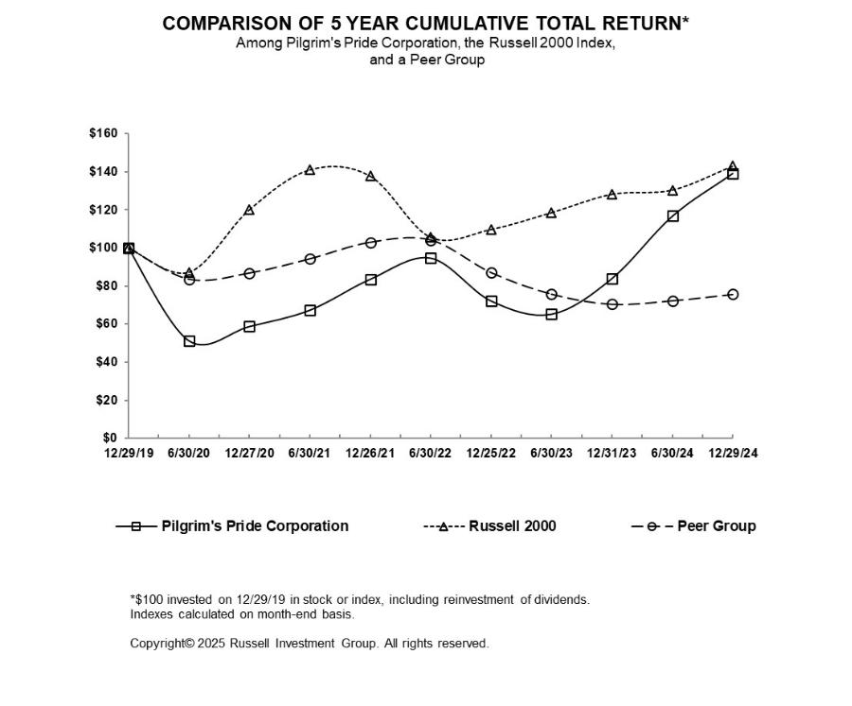

of future stock performance.

 |  | 12/29/19 |  |  | 06/30/20 |  |  | 12/27/20 |  |  | 06/30/21 |  |  | 12/26/21 |  |  | 06/30/22 |  |  | 12/25/22 |  |  | 06/30/23 |  |  | 12/31/23 |  |  | 06/30/24 |  |  | 12/29/24
PPC | $ | 100.00 |  | $ | 51.23 |  | $ | 58.69 |  | $ | 67.27 |  | $ | 83.56 |  | $ | 94.72 |  | $ | 72.19 |  | $ | 65.18 |  | $ | 83.89 |  | $ | 116.74 |  | $ | 139.28
Russell 2000 |  | 100.00 |  |  | 87.02 |  |  | 119.96 |  |  | 141.00 |  |  | 137.74 |  |  | 105.47 |  |  | 109.59 |  |  | 118.45 |  |  | 128.14 |  |  | 130.36 |  |  | 142.93
Peer Group |  | 100.00 |  |  | 83.63 |  |  | 86.82 |  |  | 94.23 |  |  | 102.85 |  |  | 104.05 |  |  | 87.07 |  |  | 75.85 |  |  | 70.52 |  |  | 72.38 |  |  | 75.67

Item 6. [Reserved]

22

Table of Contents

Item 7. Management’s Discussion and Analysis of Financial Condition and Results of Operations

Executive Summary

Overview

We are one of the largest protein companies in the world, and as a vertically integrated company, we are able to control nearly every phase of the production process, which helps us manage food safety and quality, control margins and improve customer service. This gives us the opportunity to continue to create growth and development opportunities, further increasing our position as a leading domestic and global protein company.

We reported net income attributable to Pilgrim’s Pride Corporation of $1.1 billion, or $4.57 per diluted common share, and profit before tax totaling $1.4 billion, for 2024. These operating results included gross profit of $2.3 billion and generated $2.0 billion of cash from operations. We generated consolidated operating margins of 8.4% with operating margins of 10.5%, 3.3%, and 10.6% in our U.S., Europe, and Mexico reportable segments, respectively. During 2024, we generated EBITDA and Adjusted EBITDA of $1.9 billion and $2.2 billion, respectively. A reconciliation of net income to EBITDA and Adjusted EBITDA is included later in “Item 7. Management’s Discussion and Analysis of Financial Condition and Results of Operations” in this annual report.

We operate on the basis of a 52/53-week fiscal year that ends on the Sunday falling on or before December 31. Any reference we make to a particular year applies to our fiscal year and not the calendar year. Fiscal year 2024 was a 52-week fiscal year and fiscal year 2023 was a 53-week fiscal year.

Global Economic Conditions

During 2024, global inflation levels declined, but remained above historical averages. The U.K. and E.U. region saw a continued decrease in inflation rate and flat demand, leading to cost recovery for our business and stabilizing prices for customers, though labor costs continue to be a challenge for our Europe operations. We have and will continue to invest in our people and implement supply chain solutions to mitigate global economic impacts in our Europe operations. The Russia-Ukraine war's impact on the global feed ingredient and energy markets is currently less pronounced though there remain many risks and uncertainties that may impact global markets. In Mexico, inflation remains high and the peso weakened further against the U.S. dollar in the fourth quarter of 2024. Mexico remains a relatively volatile market given overall business seasonality.

We have responded to these challenges by continuing negotiations with customers to mitigate the impact of extraordinary costs we have experienced. We also continue to focus on operational initiatives that aim to deliver labor efficiencies, better agricultural performance and improved yields.

Raw Materials and Input Costs

Our U.S. and Mexico segments use corn and soybean meal as the main ingredients for feed production, while our Europe segment uses wheat, soybean meal and barley as the main ingredients for feed production.

During 2024, the global price of corn, measured at U.S. dollars per metric ton, maintained lower prices at an average of about 30% below prior year prices, per the International Monetary Fund as reported by the St. Louis Fed research center. Towards the end of 2024, corn prices ticked upwards and ended the year about 4% lower than the prior year. Global wheat prices at the end of 2024 were about 14% lower than the prior year ending prices. Good growing conditions and lower demand led to the decrease in corn prices, while wheat prices fluctuated more throughout 2024. Soybean prices were lower than 2023 due to better growing conditions and lower demand.

23

Table of Contents

 | Corn^{(a)} |  |  | Soybean Meal^{(a)} |  |  | Wheat^{(a)}
 | Highest Price | Lowest Price |  | Highest Price | Lowest Price |  | Highest Price | Lowest Price
 |  | (In whole dollars) |  |  |  |  | (In whole pounds sterling)
2024
Fourth Quarter | 4.54 | 4.01 |  | 350.0 | 279.5 |  | 190.5 | 174.0
Third Quarter | 4.18 | 3.62 |  | 387.0 | 303.4 |  | 196.9 | 168.7
Second Quarter | 4.65 | 3.97 |  | 386.5 | 328.3 |  | 202.8 | 165.1
First Quarter | 4.67 | 4.00 |  | 381.2 | 327.8 |  | 184.5 | 153.7
2023
Fourth Quarter | 5.05 | 4.50 |  | 473.6 | 363.2 |  | 193.9 | 182.0
Third Quarter | 6.37 | 4.61 |  | 464.7 | 388.2 |  | 216.0 | 170.8
Second Quarter | 6.78 | 5.55 |  | 465.7 | 389.7 |  | 204.8 | 165.5
First Quarter | 6.85 | 6.19 |  | 513.0 | 438.3 |  | 239.0 | 191.0

- We obtain corn and soybean meal prices from the Chicago Board of Trade, and we obtain wheat prices from the London International Financial Futures and Options Exchange.

During 2024, U.S. commodity market prices for chicken products trended in line with historical averages to begin the year, but saw stronger seasonal increases in mid-first quarter as industry production declined relative to the prior year levels and domestic demand growth absorbed produced volumes and eroded cold storage inventories. Supply rebounded with growth in the second quarter, however, hatchability and broiler mortality headwinds inhibited more substantial production increases. Although broiler production grew, robust retail and foodservice demand growth absorbed production at a rate sufficient to maintain market prices above the five-year historical average throughout the remainder of 2024.

U.S. commodity market prices throughout 2025 will be impacted by the evolution of foodservice, retail, and export meat demand, influenced by factors such as government regulation, spread of Avian influenza cases both domestically and abroad, evolution of the general economy, and overall protein supply.

During 2024, the U.K. chicken market saw an increase in labor costs due to the national living wages change in April 2024. Through customer contracts and additional negotiations, we have offset the majority of these cost increases. Due to increased competition with the U.K. egg market, there has been an increase in costs to retain growers, while feed costs have decreased throughout the year. We continue to focus on managing costs, including labor and yield efficiencies, agricultural performance and increasing operational efficiencies through investments in capital projects.

Commodity prices for chicken in Mexico ended 2024 above prior-year prices despite incremental decreases throughout the second half of the year. Mexico grain prices decreased from prior year levels.

U.K. market prices for pork products have followed an upward trend from 2022, albeit at a slower rate throughout 2024. During the year, the U.K. market price for a pig has fallen slowly in line with a general reduction in input prices as well as market pressure from Europe. U.K. pig farming became profitable in the second quarter of 2023 and has remained profitable since.

U.K. prices for prepared foods have increased from inflationary pressures. We continue to focus on partnering with our Key Customers and increasing operational efficiency. Sustainability

We believe sustainability involves continuously improving social responsibility, economic viability and environmental stewardship. We are committed to helping society meet the global challenge of feeding a growing population in a responsible matter.

Environmental Stewardship. We are focused on improving the efficiency of our operations and supporting producers to reduce our environmental footprint. In support of this initiative in April 2021, we issued $1.0 billion of sustainability-linked bonds, which require us to reduce our Scope 1 and 2 global greenhouse gas emissions intensity of 17.7% by 2025 and by 30.0% by 2030 from our 2019 baseline.

Social Responsibility. Safety of our team members is a condition at Pilgrim’s. The physical health and mental well-being of our workforce continues to be a top priority for our business. As such, we implemented hundreds of safety measures within our facilities and constantly evolve our operations as needed. To support the communities where our team members live and work, we have committed $20 million in funding for local projects focused on alleviating food insecurity and strengthening

24

Table of Contents

long-term community infrastructure through our Hometown Strong initiative. To date, we have approved over $15 million for these areas. We also continue to build on Hometown Strong through our

Better Futures program, which provides team member and their dependents in tuition free, higher education program, to improve their skills and career opportunities. The program has been exceptionally well received as we have over 2,100 participants since inception. Finally, ensuring the well-being of animals under our care is an uncompromising commitment at Pilgrim’s. We continually strive to improve our welfare efforts through the use of new technologies and the implementation of standards that meet and exceed regulatory requirements and industry guidelines.

Governance. To cultivate discipline and drive accountability for Sustainability-related matters, we use our annual budgeting process to establish strategies, plans, and risk mitigation tactics. This process is further reinforced by a series of key performance indicators to evaluate and monitor progress. These performance indicators are linked with compensation for both senior executive and plant level personnel. As part of our business management processes, progress against these metrics is reviewed at least monthly and evaluated by external agencies to assess progress against industry peers. In addition, the Board of Directors formed a Sustainability Committee to provide oversight and counsel on strategies, policies, and investments to reduce the impact of climate change. The Sustainability Committee meets on a quarterly basis to monitor progress, provide feedback, and evaluate impact of trends.

Reportable Segments

We operate in three reportable segments: the U.S., Europe, and Mexico. We measure segment profit as operating income. Certain corporate expenses are allocated to the Mexico and Europe reportable segments based upon various apportionment methods for specific expenditures incurred related thereto with the remaining amounts allocated to the U.S. For additional information, see “Note 20. Reportable Segments” of our Consolidated Financial Statements included in this annual report.

Results of Operations

2024 Compared to 2023

A significant factor in each of the year-over-year comparisons below in is that our fiscal year 2023 was 53-weeks whereas our fiscal year 2024 was 52-weeks.

Net sales. Net sales for 2024 increased $516.1 million, or 3.0%, from $17.4 billion generated in 2023 to $17.9 billion generated in 2024. The following table provides additional information regarding net sales:

 |  |  |  |  |  | Change from 2023 |  |  |  |  | Impact on Change from 2023
Sources of net sales |  |  | 2024 |  | Amount |  | Percent |  |  | Sales Volume | Sales Prices | Foreign Currency Translation
 |  |  | 2024 |  | Amount |  | Percent |  |  | Sales Volume | Sales Prices | Impact
 |  |  |  | (In thousands, except percent data)
U.S. |  | $ | 10,629,929 | $ |  | 602,187 |  | 6.0 % |  | (1.4)% | 7.4 % | — %
Europe |  |  | 5,136,747 |  |  | (66,575) |  | (1.3)% |  | (0.9)% | (3.1)% | 2.7 %
Mexico |  |  | 2,111,615 |  |  | (19,538) |  | (0.9)% |  | 0.1 % | 1.8 % | (2.8)%
Total net sales |  | $ | 17,878,291 |  | $ | 516,074 |  | 3.0 %

U.S. Reportable Segment. U.S. net sales generated in 2024 increased $602.2 million, or 6.0%, from U.S. net sales generated in 2023 primarily because of an increase in net sales per pound, contributing $739.0 million, or 7.4 percentage points, to the increase in net sales. This increase in net sales per pound was partially offset by a decrease in sales volume of $136.8 million, or 1.4 percentage points, due to one less week in 2024. The increase in net sales per pound was primarily driven by higher commodity market pricing for fresh chicken products as compared to prior year across all major cuts.

Europe Reportable Segment. Europe sales generated in 2024 decreased $66.6 million, or 1.3%, from sales generated in 2023 primarily from a decrease in net sales per pound due to the pass-through of lower input costs and a decrease in sales volume of $163.0 million, or 3.1 percentage points, and $48.4 million, or 0.9 percentage points, respectively. These decreases were partially offset by the favorable impact of foreign currency translation of $144.8 million, or 2.7 percentage points.

Mexico Reportable Segment. Mexico sales generated in 2024 decreased $19.5 million, or 0.9%, from sales generated in 2023 primarily because of the unfavorable impact of foreign currency translation of $62.0 million, or 2.8 percentage points, partially offset by an increase in net sales per pound and an increase in sales volume of $39.3 million, or 1.8 percentage points, and $3.2 million, or 0.1 percentage points, respectively. The unfavorable impact of foreign currency translation was due to a weakening of the Mexican peso against the U.S. dollar. The increases in net sales per pound and sales volume were driven by

25

Table of Contents

improved product mix and increased commodity chicken prices. Sales volumes increased across all sales channel, except live chicken which slightly decreased.

Gross profit. Gross profit increased by $1.2 billion, or 106.8%, from $1.1 billion generated in 2023 to $2.3 billion generated in 2024. The following tables provide gross profit information:

 |  |  |  |  |  |  | Change from 2023 |  |  |  |  |  |  |  |  |  |  |  |  | Percent of Net Sales
Components of gross profit |  |  |  | 2024 |  |  | Amount |  |  |  |  |  | Percent |  |  |  |  |  |  | 2024 |  |  | 2023
 |  |  |  |  |  |  |  | (In thousands, except percent data)
Net sales |  |  | $ | 17,878,291 |  | $ | 516,074 |  |  |  |  |  | 3.0 % |  |  |  |  |  |  | 100.0 % |  |  | 100.0 %
Cost of sales |  |  |  | 15,565,524 |  |  | (678,292) |  |  |  |  |  | (4.2)% |  |  |  |  |  |  | 87.1 % |  |  | 93.6 %
 | Gross profit |  | $ | 2,312,767 |  | $ | 1,194,366 |  |  |  |  |  | 106.8 % |  |  |  |  |  |  | 12.9 % |  |  | 6.4 %
 |  |  |  |  |  |  |  |  |  |  |  |  |  |  |  |  |  |  |  | Change from 2023
 | Sources of gross profit |  |  |  |  |  |  |  |  |  |  |  | 2024 |  |  |  |  |  |  | Amount |  |  | Percent
 |  |  |  |  |  |  |  |  |  |  |  |  |  | (In |  |  |  |  | thousands, except percent data)
 | U.S. |  |  |  |  |  | $ |  |  |  |  |  | 1,564,092 | $ |  |  |  |  |  | 1,041,608 |  |  | 199.4 %
 | Europe |  |  |  |  |  |  |  |  |  |  |  | 461,667 |  |  |  |  |  |  | 86,968 |  |  | 23.2 %
 | Mexico |  |  |  |  |  |  |  |  |  |  |  | 287,008 |  |  |  |  |  |  | 65,576 |  |  | 29.6 %
 | Elimination^{(a)} |  |  |  |  |  |  |  |  |  |  |  | — |  |  |  |  |  |  | 214 |  |  | (100.0)%
 | Total gross profit |  |  |  |  |  |  |  |  |  |  | $ | 2,312,767 |  |  |  |  |  | $ | 1,194,366 |  |  | 106.8 %
 |  |  |  |  |  |  |  |  |  |  |  |  |  |  |  |  |  |  |  | Change from 2023
 | Sources of cost of sales |  |  |  |  |  |  |  |  |  |  |  | 2024 |  |  |  |  |  |  | Amount |  |  | Percent
 |  |  |  |  |  |  |  |  |  |  |  |  |  | (In thousands, except percent data)
 | U.S. |  |  |  |  |  | $ |  |  |  |  |  | 9,065,837 | $ |  |  |  |  |  | (439,421) |  |  | (4.6)%
 | Europe |  |  |  |  |  |  |  |  |  |  |  | 4,675,080 |  |  |  |  |  |  | (153,543) |  |  | (3.2)%
 | Mexico |  |  |  |  |  |  |  |  |  |  |  | 1,824,607 |  |  |  |  |  |  | (85,114) |  |  | (4.5)%
 | Elimination^{(a)} |  |  |  |  |  |  |  |  |  |  |  | — |  |  |  |  |  |  | (214) |  |  | (100.0)%
 | Total cost of sales |  |  |  |  |  |  |  |  |  | $ |  | 15,565,524 |  |  |  |  | $ |  | (678,292) |  |  | (4.2)%

- Our Consolidated Financial Statements include the accounts of our company and our majority owned subsidiaries. We eliminate all significant affiliate accounts and transactions upon consolidation.

U.S. Reportable Segment. Cost of sales incurred by our U.S. operations in 2024 decreased $439.4 million, or 4.6%, from cost of sales incurred by our U.S. operations in 2023. Cost of sales decreased primarily due to decreased cost per pound sold and sales volume of $309.8 million, or 3.3 percentage points, and $129.6 million, or 1.3 percentage points, respectively. The decrease in cost per pound sold was driven by a reduction in feed ingredients, such as corn and soy, costs in our live operations. The reduction in live operations costs was partially offset by an increase in labor, incentive compensation, and insurance costs.

Europe Reportable Segment. Cost of sales incurred by the Europe operations during 2024 decreased $153.5 million, or 3.2%, from cost of sales incurred by the Europe operations during 2023 primarily due to decreases in cost per pound sold and sales volume of $248.7 million, or 5.2 percentage points, and $44.9 million, or 0.9 percentage points, respectively. These decreases were partially offset by the unfavorable impact of foreign currency translation of $140.1 million, or 2.9 percentage points. The decrease in cost per pound was driven by decreased feed ingredients, labor, utilities and other operating costs and from production efficiencies as a result of our restructuring initiatives.

Mexico Reportable Segment. Cost of sales incurred by the Mexico operations during 2024 decreased $85.1 million, or 4.5%, from cost of sales incurred by the Mexico operations during 2023 primarily because of the favorable impact of foreign currency remeasurement and a decrease in cost per pound sold of $53.6 million, or 2.8 percentage points, and $34.3 million, or 1.8 percentage points, respectively. These decreases in cost of sales were partially offset by an increase in sales volume of $2.8 million, or 0.1 percentage points. The favorable impact of foreign currency remeasurement was due to a weakening of the Mexican peso against the U.S. dollar. The decrease in cost per pound sold was driven by a reduction in commodity ingredients costs, partially offset by an increase in employee profit sharing costs due to higher profitability in 2024.

Operating income. Operating income increased $983.8 million, or 188.4%, from $522.3 million generated for 2023 to $1,506.1 million generated for 2024. The following tables provide operating income information:

26

Table of Contents

 |  |  |  |  |  | Change from 2023 |  |  |  | Percent of Net Sales
Components of operating income |  |  | 2024 |  |  | Amount | Percent |  |  | 2024 | 2023
 |  |  |  |  |  |  | (In thousands, except percent data)
Gross profit |  | $ | 2,312,767 |  | $ | 1,194,366 | 106.8 % |  |  | 12.9 % | 6.4 %
SG&A expenses |  |  | 713,310 |  |  | 161,540 | 29.3 % |  |  | 4.0 % | 3.2 %
Restructuring activities |  |  | 93,388 |  |  | 49,043 | 110.6 % |  |  | 0.5 % | 0.3 %
Operating income |  | $ | 1,506,069 |  | $ | 983,783 | 188.4 % |  |  | 8.4 % | 3.0 %

 |  |  |  |  |  |  |  |  | Change from 2023
Sources of operating income |  |  |  |  | 2024 |  |  |  | Amount |  | Percent
 |  |  |  |  |  | (In thousands, except percent data)
U.S. |  |  | $ |  | 1,113,001 | $ |  |  | 874,107 |  | 365.9 %
Europe |  |  |  |  | 169,693 |  |  |  | 41,542 |  | 32.4 %
Mexico |  |  |  |  | 223,375 |  |  |  | 67,920 |  | 43.7 %
Eliminations^{(a)} |  |  |  |  | — |  |  |  | 214 |  | (100.0)%
Total operating income |  |  | $ |  | 1,506,069 |  |  | $ | 983,783 |  | 188.4 %
 |  |  |  |  |  |  |  |  | Change from 2023
Sources of SG&A expenses (defined below) |  |  |  |  | 2024 |  |  |  | Amount |  | Percent
 |  |  |  |  |  | (In thousands, except percent data)
U.S. |  |  | $ |  | 451,091 | $ |  |  | 167,501 |  | 59.1 %
Europe |  |  |  |  | 198,586 |  |  |  | (3,617) |  | (1.8)%
Mexico |  |  |  |  | 63,633 |  |  |  | (2,344) |  | (3.6)%
Total SG&A expense |  |  |  | $ | 713,310 |  |  | $ | 161,540 |  | 29.3 %
 |  |  |  |  |  |  |  |  | Change from 2022
Sources of restructuring activities charges |  |  |  |  | 2023 |  |  |  | Amount |  | Percent
 |  |  |  |  |  | (In thousands, except percent data)
Europe |  |  | $ |  | 93,388 | $ |  |  | 49,043 |  | 110.6 %

- Our Consolidated Financial Statements include the accounts of our company and our majority owned subsidiaries. We eliminate all significant affiliate accounts and transactions upon consolidation.

U.S. Reportable Segment. Selling, general and administrative (“SG&A”) expense incurred by the U.S. operations during 2024 increased $167.5 million, or 59.1%, from SG&A expense incurred by the U.S. operations during 2023 primarily from increases in litigation settlement costs and incentive compensation costs.

Europe Reportable Segment. SG&A expense incurred by the Europe operations during 2024 decreased $3.6 million, or 1.8%, from SG&A expense incurred by the Europe operations during 2023 primarily due to decreased labor and employee-related costs.

Mexico Reportable Segment. SG&A expense incurred by the Mexico operations during 2024 decreased $2.3 million, or 3.6%, from SG&A expense incurred by the Mexico operations during 2023. SG&A expense decreased primarily from the favorable impact of foreign currency translation due to the weakening of the Mexican peso against the U.S. dollar, partially offset by increased wages and employee profit share costs.

Net interest expense. Consolidated interest expense decreased 46.9% to $88.5 million in 2024 from $166.6 million in 2023. The decrease in net interest expense resulted primarily from an increase in interest income earned on higher cash balances, a decrease from early extinguishment of debt, and a decrease in interest expense on outstanding borrowings due to decreased borrowings. The decrease in net interest expense from early extinguishment of debt is due to gross realized gains of $13.8 million recognized on the repurchases of $164.3 million of outstanding principal senior notes during 2024 compared to a loss on early extinguishment of debt of $20.7 million recognized on the repayment of senior notes during 2023. As a percent of net sales, net interest expense in 2024 and 2023 was 0.5% and 1.0%, respectively.

Income taxes. Our consolidated income tax expense in 2024 was $325.0 million, compared to income tax expense of $42.9 million in 2023. The increase in income tax expense in 2024 resulted primarily from an increase in pre-tax income during 2024.

27

Table of Contents

2023 Compared to 2022

For discussion of 2023 results of operations in comparison to 2022 results of operations, see Item 7. Management’s Discussion and Analysis of Financial Condition and Results of Operations in Part II of the 2023 Annual Report on Form 10-K filed on February 27, 2024.

Liquidity and Capital Resources

Our principal sources of liquidity are cash generated from operations, funds from borrowings, and existing cash on hand. The following table presents our available sources of liquidity as of

December 29, 2024:

Sources of Liquidity |  | Facility | Amount |  | Available
 |  | Amount | Outstanding |  | Available
 |  |  | (In millions)
Cash and cash equivalents |  | $ | — $ | — $ | 2,043.2
Borrowing arrangements:
U.S. Credit Facility^{(a)} |  |  | 850.0 | — | 825.8
Mexico Credit Facility^{(b)} |  |  | 54.6 | — | 54.6
Europe Credit Facility^{(c)} |  |  | 188.6 | — | 188.6

- Availability under the U.S. Credit Facility is also reduced by our outstanding standby letters of credit. Standby letters of credit outstanding at December 29, 2024 totaled $24.2 million.

- As of December 29, 2024, the U.S. dollar-equivalent of the amount available under the Mexico Credit Facility was $54.6 million ($1.1 billion Mexican pesos).

- As of December 29, 2024, the U.S. dollar-equivalent of the amount available under the Europe Credit Facility was $188.6 million (£150.0 million).

On May 1, 2024, the Pilgrim’s Board of Directors approved a bond repurchase program which authorizes the Company to repurchase up to $200.0 million to buy back our outstanding senior notes. Under the program, we have repurchased $144.3 million of outstanding principal of the Senior Notes Due 2031 and $20.0 million of the outstanding principal of the Senior Notes due 2033 for an aggregate of $164.3 million.

We expect cash flows from operations, combined with availability under our credit facilities, to provide sufficient liquidity to fund current obligations, projected working capital requirements, maturities of long-term debt and capital spending for at least the next twelve months.

Historical Flow of Funds

 |  |  | Year Ended
Cash Flows from Operating Activities |  |  | December 29, 2024 |  |  | December 31, 2023
 |  |  | (In millions)
Net income |  | $ | 1,087.2 |  | $ | 322.3
Net noncash expenses |  |  | 480.0 |  |  | 462.5
Changes in operating assets and liabilities:
Trade accounts and other receivables |  |  | 88.3 |  |  | (19.0)
Inventories |  |  | 134.5 |  |  | 12.6
Prepaid expenses and other current assets |  |  | (33.3) |  |  | 17.8
Accounts payable and accrued expenses |  |  | 126.7 |  |  | (68.7)
Income taxes |  |  | 109.4 |  |  | (8.9)
Long-term pension and other postretirement obligations |  |  | 26.1 |  |  | (10.0)
Other operating assets and liabilities |  |  | (28.8) |  |  | (30.7)
Cash provided by operating activities |  | $ | 1,990.1 |  | $ | 677.9

Net Noncash Expenses

Items necessary to reconcile from net income to cash flow provided by operating activities included net noncash expenses of $480.0 million for the year ended December 29, 2024. Net noncash expense items included $433.6 million of depreciation and amortization, deferred income tax expense of $4.8 million, asset impairment of $28.6 million, stock-based compensation expense of $14.9 million, gain on early extinguishment of debt recognized as a component of interest expense of

28

Table of Contents

$11.2 million, loan cost amortization of $5.0 million, accretion of bond discount of $2.5 million, and a $1.8 million gain on property disposals.

Items necessary to reconcile from net income to cash flow provided by operating activities included net noncash expenses of $462.4 million for the year ended December 31, 2023. Net noncash expense items included $419.9 million of depreciation and amortization, loss on early extinguishment of debt recognized as a component of interest expense of $20.7 million, loan cost amortization of $7.4 million, stock-based compensation expense of $7.2 million, deferred income tax expense of $6.7 million, asset impairment of $4.0 million, and accretion of bond discount of $2.3 million. Partially offsetting the net noncash expenses was an $6.1 million gain on property disposals. Other items affecting net noncash expenses were individually immaterial.

Changes in Operating Assets and Liabilities

The change in trade accounts and other receivables, including accounts receivable from related parties, represented a $88.3 million source of cash in 2024. The change in cash was primarily due to the timing of customer payments and collections of insurance proceeds. The change in trade accounts and other receivables, including accounts receivable from related parties, represented a $19.0 million use of cash in 2023. The change in cash was primarily due to the timing of customer payments.

The change in inventories represented a $134.5 million source of cash in 2024. The change in cash resulted from a decrease in our finished goods inventories and lower input costs included in inventory values. The change in inventories represented a $12.6 million source of cash in 2023. The change in cash resulted from an decrease in our raw materials and work-in-process inventory values.

The change in prepaid expenses and other current assets represented a $33.3 million use of cash in 2024. This change resulted primarily from a net increase in the commodity derivatives assets from favorable fair value positions, an increase from short-term available-for-sale investments, and the impact of foreign currency translation. The change in prepaid expenses and other current assets represented a $17.8 million source of cash in 2023. This change resulted primarily from a net decrease in the commodity derivatives assets.

Accounts payable and accrued expenses, including accounts payable to related parties, represented a $126.7 million source of cash in 2024. This change resulted primarily from increases in litigation settlement and incentive compensation accruals. Accounts payable and accrued expenses, including accounts payable to related parties, represented a $68.7 million use of cash in 2023. This change resulted primarily from the timing of payments.

The change in income taxes, which includes income taxes receivable, income taxes payable, deferred tax assets, deferred tax liabilities, reserves for uncertain tax positions and the tax components within accumulated other comprehensive loss, represented a $109.4 million source of cash in 2024. This change resulted primarily from the timing of estimated tax payments and higher profitability in 2024 which increased our income tax payables and reduced income tax receivable. The change in income taxes, which includes income taxes receivables, income taxes payable, deferred tax assets, deferred tax liabilities, reserves for uncertain tax positions and the tax components within accumulated other comprehensive loss, represented a $8.9 million use of cash in 2023. This change resulted primarily from the timing of estimated tax payments and lower profitability in 2023.

 |  |  | Year Ended
Cash Flows from Investing Activities |  |  | December 29, 2024 |  |  | December 31, 2023
 |  |  | (In millions)
Acquisitions of property, plant and equipment |  | $ | (476.2) |  | $ | (543.8)
Proceeds from insurance recoveries |  |  | — |  |  | 20.7
Proceeds from property disposals |  |  | 15.4 |  |  | 19.8
Cash used in investing activities |  | $ | (460.8) |  | $ | (503.4)

Capital expenditures during the two years were incurred for growth projects, such as the Athens, GA expansion and the South Georgia protein conversion plant, and to improve operational efficiencies, information technology system enhancement projects, and to reduce costs for the years ended December 29, 2024 and December 31, 2023. Proceeds from property disposals were primarily for the sale of a farm in Mexico and other miscellaneous equipment.

29

Table of Contents

 |  |  | Year Ended
Cash Flows from Financing Activities |  |  | December 29, 2024 |  |  | December 31, 2023
 |  |  | (In millions)
Proceeds from revolving line of credit and long-term borrowings |  | $ | — |  | $ | 1,768.2
Payments on revolving line of credit, long-term borrowings, and finance lease obligations |  |  | (152.1) |  |  | (1,616.3)
Payment of capitalized loan costs |  |  | — |  |  | (19.8)
Payment on early extinguishment of debt |  |  | (0.2) |  |  | (13.8)
Proceeds from contribution (payment of distribution) of capital under Tax Sharing Agreement with JBS USA Holdings |  |  | 1.4 |  |  | (1.6)
Cash provided by (used in) financing activities |  | $ | (150.9) |  | $ | 116.7

Payments on revolving line of credit, long-term borrowings and finance lease obligations during 2024 are primarily related to open market repurchases of outstanding senior notes. The proceeds from contribution of capital under the Tax Sharing Agreement with JBS USA Holdings during 2024 were an allocation made during tax year 2023 for payment of historical tax adjustments. Payments on early extinguishment of debt during 2024 are transaction fees related to the bond repurchases.

Proceeds from revolving line of credit, long-term borrowings and finance lease obligations during 2023 are primarily from the offerings of our 2033 and 2034 Senior Notes as well as borrowings on our U.S. and Europe Credit Facilities. Payments on revolving line of credit, long-term borrowings, and finance lease obligations during 2023 are primarily due to the paydown of our term loans and revolving notes on our 2021 U.S. Credit Facility, the completed tender offer of our 2027 Senior Notes, and repayment of borrowings on our Europe Credit Facility. The payment of capitalized loan costs during 2023 relates to the offerings of our 2033 and 2034 Senior Notes and the execution of our 2023 U.S. Credit Facility. The payment on early extinguishment of debt during 2023 primarily relates to the tender-offer payment of our 2027 Senior Notes. The distribution of equity under the Tax Sharing Agreement during 2023 is the 2022 distribution of equity that was paid in the first quarter of 2023.

Long-Term Debt and Other Borrowing Arrangements

Our long-term debt and other borrowing arrangements consist of senior notes, revolving credit facilities and other term loan agreements. For a description, refer to Part II, Item 8, Notes to Consolidated Financial Statements, “Note 13. Debt.”

Capital Expenditures

We anticipate spending between $450 million and $500 million on the acquisition of property, plant and equipment in 2025. Capital expenditures will primarily be incurred to grow our operations, improve efficiencies, to reduce costs, and for information technology system enhancement projects. We expect to fund these capital expenditures with cash flow from operations and cash on hand.

Contractual Obligations

In addition to our debt commitments at December 29, 2024, we had other commitments and contractual obligations that require us to make specified payments in the future. The following table summarizes the total amounts due as of December 29, 2024 under all debt agreements, commitments and other contractual obligations. The table indicates the years in which payments are due under the contractual obligations.

Contractual Obligations

Long-term debt^{(a)}

Interest^{(b)}

Finance leases

Operating leases

Derivative liabilities

Purchase obligations^{(c)}

Total

Payments Due By Period

 | Total |  |  | Less than |  |  | One to |  |  | Three to |  |  | Greater than
 |  |  |  | One Year |  |  | Three Years |  |  | Five Years |  |  | Five Years
 |  |  |  |  |  |  | (In thousands)
$ | 3,256,324 |  | $ | 322 |  | $ | 696 |  | $ | 769 |  | $ | 3,254,537
 | 1,339,347 |  |  | 164,554 |  |  | 329,058 |  |  | 328,984 |  |  | 516,751
 | 1,875 |  |  | 577 |  |  | 1,079 |  |  | 219 |  |  | —
 | 294,184 |  |  | 73,332 |  |  | 104,223 |  |  | 53,474 |  |  | 63,155
 | 4,669 |  |  | 4,669 |  |  | — |  |  | — |  |  | —
 | 438,087 |  |  | 400,703 |  |  | 24,877 |  |  | 3,495 |  |  | 9,012
$ | 5,334,486 |  | $ | 644,157 |  | $ | 459,933 |  | $ | 386,941 |  | $ | 3,843,455

30

Table of Contents

- Long-term debt is presented at face value and excludes $24.2 million in letters of credit outstanding related to normal business transactions. Long-term debt includes the Live Oak CHP Project PACE Loan. For a description, refer to Part II, Item 8, Notes to Consolidated Financial Statements, “Note 13. Debt.”
- Interest expense in the table above assumes the continuation of interest rates and outstanding borrowings as of December 29, 2024.

- Includes agreements to purchase goods or services that are enforceable and legally binding on us and that specify all significant terms, including fixed or minimum quantities to be purchased; fixed, minimum, or variable price provisions; and the approximate timing of the transaction.

We expect cash flows from operations, combined with availability under the U.S., Mexico, and Europe Credit Facilities to provide sufficient liquidity to fund current obligations, projected working capital requirements, maturities of long-term debt and capital spending for at least the next twelve months.

Pillar II Tax Initiative

Global Minimum Tax

The Organization for Economic Co-operation and Development (“OECD”) is an international organization composed of 38 member countries that work together to establish international standards and develop solutions for various social, economic, and environmental challenges. These solutions range from improving economic performance and job creation to promoting quality education and combating international tax evasion.

Regarding the fight against tax evasion, the Base Erosion and Profit Shifting (“BEPS”) project was launched in 2013 as a collaboration between the G20 (a group of the world's 20 largest economies) and the OECD. The project aims to implement 15 measures to combat tax avoidance, enhance the consistency of international tax rules, and ensure a more transparent global tax environment. It seeks to prevent the misuse of tax regulations that result in the erosion of the tax base, particularly through profit shifting to jurisdictions with more favorable or no taxation.

Pillar II is part of one of the OECD’s most recent initiatives, known as BEPS 2.0, which aims to address tax challenges arising from evolving business models in a globalized economy. The goal of Pillar II is to establish a global minimum tax system for multinational enterprises (“MNEs”) with annual consolidated revenue exceeding €750 million. This additional taxation seeks to balance the global allocation of corporate income taxes and ensure that multinational groups pay a minimum effective tax rate of 15% per jurisdiction where they operate.

Starting in the 2024 calendar year, the Pillar II rules came into effect in several jurisdictions, impacting multinational companies operating in these markets. However, during the first three years of implementation, transitional rules (Safe Harbor) have been introduced to simplify the calculation of the effective tax rate per jurisdiction, facilitating the adaptation of multinational groups to the new requirements.

As the Group operates in multiple countries that have adopted the global minimum tax as of 2024—including France, Ireland, Luxembourg, Malta, the Netherlands, and the U.K.—the Company has been closely monitoring the potential impacts of these new regulations and, to date, does not anticipate significant material exposure to this tax.

Recent Accounting Pronouncements

Refer to Part II, Item 8, Notes to Consolidated Financial Statements, “Note 1. Business and Summary of Significant Accounting Policies.”

Critical Accounting Policies and Estimates

General. Our discussion and analysis of our financial condition and results of operations are based upon our financial statements, which have been prepared in accordance with U.S. GAAP. The preparation of these financial statements requires us to make estimates and judgments that affect the reported amounts of assets, liabilities, revenues and expenses. On an ongoing basis, we evaluate our estimates, including those related to revenue recognition, inventory, goodwill and other intangible assets, litigation and income taxes. We base our estimates on historical experience and on various other assumptions that are believed to be reasonable under the circumstances, the results of which form the basis for making judgments about the carrying values of assets and liabilities that are not readily apparent from other sources. Actual results may differ from these estimates under different assumptions or conditions.

We believe the following critical accounting policies affect our more significant judgments and estimates used in the preparation of our financial statements.

Revenue Recognition. The vast majority of our revenue is derived from contracts which are based upon a customer ordering our products. While there may be master agreements, the contract is only established when the customer’s order is accepted by us. We account for a contract, which may be verbal or written, when it is approved and committed by both parties,

31

Table of Contents

the rights of the parties are identified along with payment terms, the contract has commercial substance and collectability is probable.

We evaluate the transaction for distinct performance obligations, which are the sale of our products to customers. Since our products are commodity market-priced, the sales price is representative of the observable, standalone selling price. Each performance obligation is recognized based upon a pattern of recognition that reflects the transfer of control to the customer at a point in time, which is upon destination (customer location or port of destination) and depicts the transfer of control and recognition of revenue. There are instances of customer pick-up at our facilities, in which case control transfers to the customer at that point and we recognize revenue. Our performance obligations are typically fulfilled within days to weeks of the acceptance of the order.

We make judgments regarding the nature, amount, timing and uncertainty of revenue and cash flows arising from revenue and cash flows with customers. Determination of a contract requires evaluation and judgment along with the estimation of the total contract value and if any of the contract value is constrained. Due to the nature of our business, there is minimal variable consideration, as the contract is established at the acceptance of the order from the customer. When applicable, variable consideration is estimated at contract inception and updated on a regular basis until the contract is completed. Allocating the transaction price to a specific performance obligation based upon the relative standalone selling prices includes estimating the standalone selling prices including discounts and variable consideration.

Inventories. Live chicken and pig inventories are stated at the lower of cost or net realizable value and breeder hen, breeder sow and boar inventories at the lower of cost, less accumulated amortization, or net realizable value. The costs associated with breeder hen inventories are accumulated up to the production stage and amortized over their productive lives using the unit-of-production method. The costs associated with breeder sow inventories are accumulated up to the production stage and amortized on a straight-line basis over their productive lives to the estimated residual cull value. The costs associated with finished poultry products, finished pork products, feed, eggs and other inventories are stated at the lower of cost (average) or net realizable value. Inventory typically transfers from one stage of production to another at a standard cost, where it accumulates additional cost directly incurred with the production of inventory, including overhead. The standard cost at which each type of inventory transfers is set by management to reflect the actual costs incurred in the prior steps. We monitor and adjust standard costs throughout the year to ensure that standard costs reasonably reflect the actual average cost of the inventory produced.

We allocate meat costs between our various finished chicken products based on a by-product costing technique that reduces the cost of the whole bird by estimated yields and amounts to be recovered for certain by-product parts. This primarily includes leg quarters, wings, tenders and offal, which are carried in inventory at the estimated recovery amounts, with the remaining amount being reflected as our breast meat cost. We allocate meat costs between our various finished pork products based on a by-product costing technique that allocates the cost of the whole pig into the primal cuts by estimated yields and amounts to be recovered for certain by-product parts. This primarily includes legs, shoulders, bellies, offal and fifth quarter parts, which are carried in inventory at the estimated recoverable amounts, with the remaining amount being reflected as our loin meat cost.

For our prepared foods inventories, raw materials and packaging materials are valued at the lower of weighted average cost and net realizable value, work in progress is valued at the latest production cost (raw materials, packaging), finished goods are valued at the lower of the latest actual monthly production cost (raw materials, packaging and direct labor) and attributable overheads and net realizable value, and engineering spares and consumables are valued at cost with an appropriate provision for obsolete engineering spares consistent with historical practice.

Generally, we perform an evaluation of whether any lower of cost or net realizable value adjustments are required at the country level based on a number of factors, including: (1) pools of related inventory, (2) product continuation or discontinuation, (3) estimated market selling prices and (4) expected distribution channels. If actual market conditions or other factors are less favorable than those projected by management, additional inventory adjustments may be required. We also record valuation adjustments, when necessary, for estimated obsolescence at or equal to the difference between the cost of inventory and the estimated market value based upon known conditions affecting inventory obsolescence, including significantly aged products, discontinued product lines, or damaged or obsolete products.

Goodwill and Other Intangibles, net. Goodwill represents the excess of the aggregate purchase price over the fair value of the net identifiable assets acquired in a business combination. Identified intangible assets represent trade names and customer relationships arising from acquisitions that are recorded at fair value as of the date acquired less accumulated amortization, if any. We use various market valuation techniques to determine the fair value of our identified intangible assets.

Goodwill is not amortized but is tested for impairment on an annual basis in the fourth quarter of each fiscal year or more frequently if impairment indicators arise. For goodwill, an impairment loss is recognized for any excess of the carrying

32

Table of Contents

amount of a reporting unit’s goodwill over the implied fair value of that goodwill. Management first reviews relevant qualitative factors to determine whether it is more likely than not (that is, a likelihood of more than 50 percent), that the fair value of a reporting unit is less than the unit’s carrying amount (including goodwill). If management determines it is more likely than not that the carrying amount of a reporting unit goodwill might be impaired, a quantitative impairment test is performed. Management has the option to bypass the qualitative assessment for any reporting unit in any period and proceed directly to performing the quantitative impairment test. Management would be able to resume performing the qualitative assessment in any subsequent period. When performing quantitative impairment tests, we estimate the fair value of our reporting units with material goodwill carrying amounts using an income approach (discounted cash flow method). We develop projections for cash flows over a 5-year period based on assumptions about revenue growth and margin changes using internally-developed economic projections and industry data obtained from government authorities such as the U.S. Department of Agriculture and other sources. We also make terminal value assumptions about revenue growth and margin changes for periods beyond the projection period. We utilize margin assumptions based on operating performance expectations, margins historically realized in the reporting units’ industries, and general macroeconomic trends. We utilize the weighted average cost of capital as a proxy for the discount rate. We consider reporting units that have 20% or less excess fair value over carrying amount to have a heightened risk of future goodwill impairment.

In 2022, we reviewed relevant qualitative factors and determined that no indicators of goodwill impairment existed for our Moy Park, Pilgrim’s Food Masters, Pilgrim’s Mexico, and Pilgrim’s U.S. reporting units. Our Pilgrim’s U.K. reporting unit reported goodwill of $2.1 million at December 25, 2022. These amounts were considered immaterial to warrant quantitative goodwill impairment testing.

In 2023, we experienced (1) an increase in long-term treasury rates that management determined could negatively affect discount rates and (2) continued inflationary pressures impacting primarily our Moy Park and Pilgrim’s Food Masters reporting units that management determined could negatively affect our margins. Both discount rates and margins are used in estimating the fair value of the reporting units. Therefore, management elected to bypass qualitative assessments and performed quantitative goodwill impairment tests for the Moy Park, Pilgrim’s Food Masters, Pilgrim’s Mexico, and Pilgrim’s U.S. reporting units as of December 31, 2023. Our Pilgrim’s U.K. reporting unit reported goodwill of $2.3 million at December 31, 2023. This amount was considered immaterial to warrant quantitative goodwill impairment testing. Based on the outcome of the quantitative tests, management determined that no goodwill impairment existed in the Moy Park, Pilgrim’s Food Masters, Pilgrim’s Mexico, or Pilgrim’s U.S. reporting units as of December 31, 2023.

On July 1, 2024, the Company effectively completed a reorganization within its Europe reportable segment. The previous reporting units were Moy Park, Pilgrim's UK, and Pilgrim's Food Masters. The new reporting units are Fresh Pork/Lamb, Fresh Poultry, Food Service, Meals, and Brands & Snacking. As a result of this reorganization, the Company reassigned assets and liabilities to the applicable reporting units and allocated goodwill using the relative net assets approach. The Company then performed an interim impairment test on the reporting units on both a pre- and post-reorganization basis. There was no impairment recognized as a result of these tests.

As of December 29, 2024, the Company assessed qualitative factors to determine if it was necessary to perform quantitative impairment tests related to the carrying amounts of its goodwill.

Based on these assessments, the Company determined that it was not necessary to perform quantitative impairment tests related to the carrying amount of its goodwill at that date.

Other intangible assets with indefinite lives are not amortized but are tested for impairment on an annual basis in the fourth quarter of each fiscal year or more frequently if impairment indicators arise. An impairment loss is recognized if the carrying amount of an indefinite-life intangible asset exceeds the estimated fair value of that intangible asset. Management first reviews relevant qualitative factors to determine whether it is more likely than not (that is, a likelihood of more than 50%) that an intangible asset is impaired. If management determines there is an indication that the carrying amount of the intangible asset might be impaired, a quantitative impairment test is performed. Management has the option to bypass the qualitative assessment for any indefinite-life intangible asset in any period and proceed directly to performing the quantitative impairment test.

The fair value of our indefinite-life intangible assets is calculated principally using a relief-from-royalty valuation approach, which uses significant unobservable inputs as defined by the fair value hierarchy, and is believed to reflect market participant views which would exist in an exit transaction. Under this valuation approach, we make estimates and assumptions about brand sales growth, royalty rates and discount rates based on specific brand sales projections, general economic projections, anticipated future cash flows and marketplace data. We consider indefinite-life intangible assets that have 20% or less excess fair value over carrying amount to have a heightened risk of future impairment. Our 2022 indefinite-life intangible assets impairment analyses did not result in an impairment charge.

33

Table of Contents

In 2023, we experienced an increase in long-term treasury rates that management determined could negatively affect discount rates, which are used in estimating the fair value of the reporting units. Therefore, management elected to bypass qualitative assessments for all indefinite-life intangible assets and performed quantitative impairment tests. Based on the outcome of the quantitative tests, management determined that no material impairment existed as of December 29, 2024.

The Company additionally assessed if the Pilgrim’s Europe reorganization indicated that any carrying amounts of its non-goodwill intangible assets might not be recoverable. The reorganization did not result in any change in business use for any of the intangible assets and therefore, the Company determined no indicators were present that required us to test the recoverability of the asset group-level carrying amounts of its Europe intangible assets at that date.

As of December 29, 2024, the Company assessed qualitative factors to determine if it was necessary to perform quantitative impairment tests related to the carrying amounts of its intangible assets not subject to amortization. Based on these assessments, the Company determined that it was not necessary to perform quantitative impairment tests related to the carrying amount of its intangible assets not subject to amortization at that date.

Identifiable intangible assets with definite lives, such as customer relationships and trade names that we expect to use for a limited amount of time, are amortized over their estimated useful lives on a straight-line basis. The useful lives range from 15 to 20 years for trade names and three to 18 years for customer relationships. Identified intangible assets with definite lives are tested for recoverability whenever events or changes in circumstances indicate that their carrying amount may not be recoverable. Management assessed if events or changes in circumstances indicated that the aggregate carrying amount of its identified intangible assets with definite lives might not be recoverable and determined that there were no impairment indicators during the years ended December 29, 2024 and December 31, 2023.

Litigation and Contingent Liabilities. We are subject to lawsuits, investigations and other claims related to employment, environmental, product, and other matters. We are required to assess the likelihood of any adverse judgments or outcomes, as well as potential ranges of probable losses, to these matters. We estimate the amount of reserves required for these contingencies when losses are determined to be probable and after considerable analysis of each individual issue. We expense legal costs related to such loss contingencies as they are incurred. With respect to our environmental remediation obligations, the accrual for environmental remediation liabilities is measured on an undiscounted basis. These reserves may change in the future due to changes in our assumptions, the effectiveness of strategies, or other factors beyond our control.

Income Taxes. We follow provisions under the Financial Accounting Standards Board (“FASB”) Accounting Standards Codification (“ASC”) Topic 740, Income Taxes, with regard to members of a group that file a consolidated tax return but issue separate financial statements. We file certain state unitary returns with JBS USA Food Company Holdings. Our income tax expense is computed using the separate return method. The provision for income taxes has been determined using the asset and liability approach of accounting for income taxes. For the unitary states, we have an obligation to make tax payments to JBS USA Food Company Holdings for our share of the unitary taxable income, which is included in taxes payable in our Consolidated Balance Sheets. Under this approach, deferred income taxes reflect the net tax effect of temporary differences between the book and tax bases of recorded assets and liabilities, net operating losses and tax credit carry forwards. The amount of deferred tax on these temporary differences is determined using the tax rates expected to apply to the period when the asset is realized or the liability is settled, as applicable, based on the tax rates and laws in the respective tax jurisdiction enacted as of the balance sheet date. We recognize potential interest and penalties related to income tax positions as a part of the income tax provision.

Defined Benefit Pension and Other Postretirement Plans. We sponsor four qualified defined benefit pension plans, two nonqualified defined benefit retirement plans, and one defined benefit postretirement life insurance plan. Some of these plans are administered by a board of trustees made up of management within the participating companies and representatives from associated labor groups while others are administered by an investment committee made up of management from the participating company. We use independent third-party actuaries to assist in determining our pension obligations and net periodic benefit cost. We, along with the actuaries, review assumptions including estimates of the present value of projected future pension payments to participants. We accumulate and amortize the impact of actuarial gains and losses over future periods.

Our defined benefit pension and other postretirement plans contains uncertainties because it requires management to make assumptions and apply judgments. The key assumptions made in developing key estimates include discount rates, expected returns on plan assets, retirement rates, and mortality. These assumptions can have a material impact on the funded status and the net periodic benefit cost. The discount rates reflect yields on high-quality corporate bonds as of the measurement date and were compared to the effective discount rate determined by discounting plan cash flows using the 12/27/2024 Empower Above Mean Curve. All other assumptions reflect estimates of future experience and considering relevant historical information, such as credible plan experience, from representative populations and relevant plan characteristics. The mortality

34

Table of Contents

assumption reflects experience from representative populations, based on the Pri-2012 Private Retirement Plans Mortality Table Report issued by the Society of Actuaries (“SOA”) in October 2019 and the Mortality Improvement Scale MP-2021 Report issued by the SOA in October 2021. It is reasonable to expect that changes in external factors will result in changes to the assumptions noted above that are used to measure pension obligations and net periodic benefit cost in future periods.

During 2024, we terminated our Pilgrim’s Pride Pension Plan for Legacy Gold Kist (“LGK Plan”) and our Pilgrim’s Pride Retirement Plan for Union Employees (“Union Plan”). The termination included settling all outstanding obligations through a combination of lump-sum payouts to participants who elected to receive one and through a purchase of annuities for the participants who did not elect a lump-sum payout. In order to fund the lump-sum payments and purchases of nonparticipating annuity contracts, all invested assets within each of the two plans was liquidated. The remaining assets within the two plans at the end of the year represents an excess of the liquidated assets over the amount of outstanding obligations at time of termination. These assets will be split between an amount transferred to our qualifying 401(k) retirement plan and an amount reverted to the Company less applicable excise taxes in Q1 2025.

We evaluated the termination of our LGK and Union Plans to confirm if this transaction met the definition of a settlement as defined under ASC Topic 715 Compensation—Retirement Benefits, which defines a settlement as “a transaction that is an irrevocable action, relieves the employer (or the plan) of primary responsibility for a pension or postretirement obligation, and eliminates significant risks related to the obligation and the assets used to effect the settlement.” The termination of our LGK and Union Plans was an irrevocable action that relieved us from the pension obligations through the payment of lump-sum payouts and nonparticipating annuity purchases using the liquidated assets of the plans. Additionally, through the termination and settlement of all obligations, we eliminated the significant risks associated with maintaining the obligations and assets. Through this analysis, it was determined we met the criteria of a full settlement of the pension obligations, we applied settlement accounting which required us to recognize the net loss remaining in accumulated other comprehensive loss at the time of settlement as a net loss in Miscellaneous, net on the Statement of Income for the year ended December 29, 2024.

Business Combination Accounting. We allocate the consideration of an acquired business to its identifiable assets and liabilities based on estimated fair values. The excess of the consideration over the amount allocated to the assets and liabilities, if any, is recorded to goodwill. We use all available information to estimate fair values. We use various models to determine the value of assets acquired and liabilities assumed such as net realizable value to value inventory, cost method and market approach to value property, relief-from-royalty and multi-period excess earnings to value intangibles and discounted cash flow to value goodwill. We typically engage third-party valuation specialists to assist in the fair value determination of tangible long-lived assets and intangible assets other than goodwill. The fair value of acquired inventories is typically determined by extending physical counts of the inventories taken at or near the acquisition date to market pricing in effect for such inventories at or near the acquisition date. The carrying values of acquired receivables and accounts payable have historically approximated their fair values as of the business combination date. As necessary, we may engage third-party specialists to assist in the estimation of fair value for certain liabilities. We adjust the preliminary acquisition accounting, as necessary, typically up to one year after the acquisition closing date for those items that existed at the acquisition date and were provisionally accounted for at that time, as we obtain more information regarding asset valuations and liabilities assumed.

Our acquisition accounting methodology contains uncertainties because it requires management to make assumptions and to apply judgment to estimate the fair value of acquired assets and liabilities. Management estimates the fair value of assets and liabilities based upon quoted market prices, the carrying value of the acquired assets and widely accepted valuation techniques, including discounted cash flows and market multiple analyses. Unanticipated events or circumstances may occur which could affect the accuracy of our fair value estimates, including changes in assumptions regarding industry economic factors and business strategies. If actual results are materially different than the assumptions used to determine fair value of the assets and liabilities acquired through a business combination, it is possible that adjustments to the carrying values of such assets and liabilities will have an impact on our net earnings.

Reconciliation of Net Income to EBITDA and Adjusted EBITDA

“EBITDA” is defined as the sum of net income (loss) plus interest, taxes, depreciation and amortization. “Adjusted EBITDA” is calculated by adding to EBITDA certain items of expense and deducting from EBITDA certain items of income that we believe are not indicative of our ongoing operating performance consisting of: (1) foreign currency transaction losses (gains), (2) costs related to litigation settlements, (3) restructuring activities losses, (4) loss on settlement of pension from plan termination, (5) inventory write-down as a result of hurricane, and (6) net income attributable to noncontrolling interest. EBITDA is presented because it is used by us and we believe it is frequently used by securities analysts, investors and other interested parties, in addition to and not in lieu of results prepared in conformity with U.S. GAAP, to compare the performance of companies. We believe investors would be interested in our Adjusted EBITDA because this is how our management analyzes EBITDA applicable to continuing operations. We also believe that Adjusted EBITDA, in combination with our financial results calculated in accordance with U.S. GAAP, provides investors with additional perspective regarding the impact of certain significant items on EBITDA and facilitates a more direct comparison of our performance with our competitors.

35

Table of Contents

EBITDA and Adjusted EBITDA are not measurements of financial performance under U.S. GAAP. EBITDA and Adjusted EBITDA have limitations as analytical tools and should not be considered in isolation or as substitutes for an analysis of our results as reported under U.S. GAAP. Some of the limitations of these measures are:

- They do not reflect our cash expenditures, future requirements for capital expenditures or contractual commitments;

- They do not reflect changes in, or cash requirements for, our working capital needs;

- They do not reflect the significant interest expense or the cash requirements necessary to service interest or principal payments on our debt;

- Although depreciation and amortization are noncash charges, the assets being depreciated and amortized will often have to be replaced in the future, and EBITDA and Adjusted EBITDA do not reflect any cash requirements for such replacements;

- They are not adjusted for all noncash income or expense items that are reflected in our statements of cash flows;

- EBITDA does not reflect the impact of earnings or charges attributable to noncontrolling interests;

- They do not reflect the impact of earnings or charges resulting from matters we consider to not be indicative of our ongoing operations; and

- They do not reflect limitations on or costs related to transferring earnings from our subsidiaries to us.

In addition, other companies in our industry may calculate these measures differently than we do, limiting their usefulness as a comparative measure. Because of these limitations, EBITDA and Adjusted EBITDA should not be considered as an alternative to net income as indicators of our operating performance or any other measures of performance derived in accordance with U.S. GAAP. You should compensate for these limitations by relying primarily on our U.S. GAAP results and using EBITDA and Adjusted EBITDA only on a supplemental basis.

Reconciliation of Adjusted EBITDA

(Unaudited)

 |  | Year Ended
 |  | December 29, 2024 |  |  | December 31, 2023
Net income | $ | 1,087,223 |  | $ | 322,317
Add:
Interest expense, net |  | 88,509 |  |  | 166,621
Income tax expense |  | 325,046 |  |  | 42,905
Depreciation and amortization |  | 433,622 |  |  | 419,900
EBITDA |  | 1,934,400 |  |  | 951,743
Add:
Foreign currency transaction losses (gains) |  | (10,025) |  |  | 20,570
Litigation settlements expense |  | 167,228 |  |  | 39,400
Restructuring activities losses |  | 93,388 |  |  | 44,345
Loss on settlement of pension from plan termination |  | 21,649 |  |  | —
Inventory write-down as a result of hurricane |  | 8,075 |  |  | —
Minus:
Property insurance recoveries |  | — |  |  | 21,124
Net income attributable to noncontrolling interest |  | 785 |  |  | 743
Adjusted EBITDA | $ | 2,213,930 |  | $ | 1,034,191

36

Table of Contents

Reconciliation of Adjusted Net Income

(Unaudited)

 |  | Year Ended
 |  | December 29, |  |  | December 31,
 |  | 2024 |  |  | 2023
Net income attributable to Pilgrim’s | $ | 1,086,438 |  | $ | 321,574
Add:
Foreign currency transaction losses (gains) |  | (10,025) |  |  | 20,570
Litigation settlements |  | 167,228 |  |  | 39,400
Restructuring activities losses |  | 93,388 |  |  | 44,345
Loss on settlement of pension from plan termination |  | 21,649 |  |  | —
Inventory write-down as a result of hurricane |  | 8,075 |  |  | —
Loss (gain) on early extinguishment of debt recognized as a component of interest expense^{(a)} |  | (11,211) |  |  | 20,694
Minus:
Property insurance recoveries |  | — |  |  | 21,124
Adjusted net income attributable to Pilgrim’s before tax impact of adjustments |  | 1,355,542 |  |  | 425,459
Net tax benefit of adjustments^{(b)} |  | (66,057) |  |  | (25,140)
Adjusted net income attributable to Pilgrim’s | $ | 1,289,485 |  | $ | 400,319
Weighted average diluted shares of common stock outstanding |  | 237,800 |  |  | 237,297
Adjusted net income attributable to Pilgrim’s per common diluted share | $ | 5.42 |  | $ | 1.69

- The gain on early extinguishment of debt recognized as a component of interest expense in 2024 was due to the bond repurchases. The loss on early extinguishment of debt recognized as a component of interest expense in 2023 was due to the repurchase of the Senior Notes due 2027.
- Net tax impact of adjustments represents the tax impact of all adjustments shown above.

Item 7A. Quantitative and Qualitative Disclosures about Market Risk

Market Risk-Sensitive Instruments and Positions

The risk inherent in our market risk-sensitive instruments and positions is primarily the potential loss arising from adverse changes in commodity prices, foreign currency exchange rates, interest rates and the credit quality of available-for-sale securities as discussed below. The sensitivity analyses presented do not consider the effects that such adverse changes may have on overall economic activity, nor do they consider additional actions our management may take to mitigate our exposure to such changes. Actual results may differ from those described below.

Commodity Prices

We purchase certain commodities, primarily corn, soybean meal, soybean oil, and wheat, for use as ingredients in the feed we either sell commercially or consume in our live operations. As a result, our earnings are affected by changes in the price and availability of such feed ingredients. We have from time to time attempted to minimize our exposure to the changing price and availability of such feed ingredients using various techniques, including, but not limited to, (1) executing purchase agreements with suppliers for future physical delivery of feed ingredients at established prices and (2) purchasing or selling derivative financial instruments such as futures and options.

For this sensitivity analysis, market risk is estimated as a hypothetical 10% increase in the weighted-average cost of our primary feed ingredients as of the periods presented. The impact of this fluctuation, if realized, could be mitigated by related commodity hedging activity. However, fluctuations greater than 10% could occur.

 |  | Year Ended December 29, 2024
 | Amount |  |  | Impact of 10% Increase in Feed Ingredient Prices
 |  | (In thousands)
Feed ingredient purchases^{(a)} | $ | 3,451,498 | $ | 345,150
Feed ingredient inventory^{(b)} |  | 166,993 |  | 16,699

37

Table of Contents

- Based on our feed consumption, a 10% increase in the price of our feed ingredient purchases would have increased cost of sales for the year ended December 29, 2024.

- A 10% increase in ending feed ingredient prices would have increased inventories as of December 29, 2024.

 |  | December 29, 2024
 | Amount |  | Impact of 10% Increase to the Fair Value of Commodity Derivative
 | Amount |  |  | Assets
 |  | (In thousands)
Commodity derivative assets^{(a)} | $ | 9,677 | $ | 968

- We purchase commodity derivative financial instruments, specifically exchange-traded futures and options, in an attempt to mitigate price risk related to our anticipated consumption of commodity inputs for the next 12 months. A 10% increase in corn, soybean meal, soybean oil and wheat prices would have resulted in an increase in the fair value of our net commodity derivative asset position, including margin cash, as of December 29, 2024.

Interest Rates

Fixed-rate debt. Market risk for fixed-rate debt is estimated as the potential decrease in fair value resulting from a hypothetical increase in interest rates of 10%. Using a discounted cash flow analysis, a hypothetical 10% increase in interest rates would have decreased the fair value of our fixed-rate debt by $101.4 million as of December 29, 2024.

Foreign Currency

Mexico Foreign Investments

We are exposed to foreign exchange-related variability of investments and earnings from our Mexican subsidiaries. Foreign currency market risk is the possibility that our financial results or financial position could be better or worse than planned because of changes in foreign currency exchange rates. For this sensitivity analysis, market risk is estimated as a hypothetical 10% change in exchange rates used to convert Mexican peso to U.S. dollars, and the effect of this change on our Mexican foreign investments.

Net Assets. As of December 29, 2024, our Mexican subsidiaries that are denominated in Mexican peso had net assets of $796.9 million. A 10% weakening in Mexican peso against the U.S. dollar exchange rate would cause a decrease in the net assets of our Mexican subsidiaries by $72.4 million. A 10% strengthening in the Mexican peso against the U.S dollar exchange rate would cause an increase in the net assets of our Mexican subsidiaries of $88.5 million

We are also exposed to the effect of potential currency exchange rate fluctuations to the extent that amounts are repatriated from Mexico to the U.S. The Mexican peso exchange rate can directly and indirectly impact our financial condition and results of operations.

Europe Foreign Investments

We are exposed to foreign exchange-related variability of investments and earnings from our Europe subsidiaries. Foreign currency market risk is the possibility that our financial results or financial position could be better or worse than planned because of changes in foreign currency exchange rates. For this sensitivity analysis, market risk is estimated as a hypothetical 10% change in exchange rates used to convert British pound and euro to U.S. dollars, and the effect of this change on our Europe foreign investments.

Net Assets. As of December 29, 2024, our Europe subsidiaries that are denominated in the British pound had net assets of $0.8 billion. A 10% weakening in the British pound against the U.S. dollar exchange rate would cause a decrease in the net assets of our Europe subsidiaries by $70.7 million. A 10% strengthening in the British pound against the U.S. dollar exchange rate would cause an increase in the net assets of our Europe subsidiaries by $86.4 million.

Cash flow hedging transactions. We periodically enter into foreign currency forward contracts, which are designated and qualify as cash flow hedges, to hedge foreign currency risk on a portion of sales generated and purchases made by our Europe reportable segment. A 10% weakening or strengthening of the U.S. dollar against the British pound and U.S. dollar against the euro would result in immaterial changes in the fair values of these derivative instruments. No assurance can be given as to how future movements in currency rates could affect our future financial condition or results of operations.

Quality of Investments

Certain retirement plans that we sponsor invest in a variety of financial instruments. We have analyzed our portfolios of investments and, to the best of our knowledge, none of our investments, including money market funds units, commercial paper and municipal securities, have been downgraded, and neither we nor any fund in which we participate hold significant

38

Table of Contents

amounts of structured investment vehicles, auction rate securities, collateralized debt obligations, credit derivatives, hedge funds investments, fund of funds investments or perpetual preferred securities. Certain postretirement funds in which we participate hold significant amounts of mortgage-backed securities. However, none of the mortgages collateralizing these securities are considered subprime.

Impact of Inflation

The U.S., Mexico and most of Europe continue to experience inflation at above-historical levels, though to a lesser degree than in the prior year. None of the locations in which we operate are experiencing hyperinflation. We have responded to these inflationary challenges by continuing negotiations with customers to recoup the extraordinary costs we have experienced. We also continue to focus on operational initiatives that aim to deliver labor efficiencies, better agricultural performance and improved yields.

39

Table of Contents

Item 8. Financial Statements and Supplementary Data

Report of Independent Registered Public Accounting Firm

To the Stockholders and Board of Directors

Pilgrim's Pride Corporation:

Opinions on the Consolidated Financial Statements and Internal Control Over Financial Reporting

We have audited the accompanying consolidated balance sheets of Pilgrim's Pride Corporation and subsidiaries (the Company) as of December 29, 2024 and December 31, 2023, the related consolidated statements of income, comprehensive income, stockholders’ equity, and cash flows for each of the fiscal years in the three-year period ended December 29, 2024, and the related notes (collectively, the consolidated financial statements). We also have audited the Company’s internal control over financial reporting as of December 29, 2024, based on criteria established in Internal Control – Integrated Framework (2013) issued by the Committee of Sponsoring Organizations of the Treadway Commission.

In our opinion, the consolidated financial statements referred to above present fairly, in all material respects, the financial position of the Company as of December 29, 2024 and December 31, 2023, and the results of its operations and its cash flows for each of the fiscal years in the three-year period ended December 29, 2024, in conformity with U.S. generally accepted accounting principles. Also in our opinion, the Company maintained, in all material respects, effective internal control over financial reporting as of December 29, 2024 based on criteria established in Internal Control – Integrated Framework (2013) issued by the Committee of Sponsoring Organizations of the Treadway Commission.

Basis for Opinions

The Company’s management is responsible for these consolidated financial statements, for maintaining effective internal control over financial reporting, and for its assessment of the effectiveness of internal control over financial reporting, included in the accompanying Management’s Report on Internal Control over Financial Reporting. Our responsibility is to express an opinion on the Company’s consolidated financial statements and an opinion on the Company’s internal control over financial reporting based on our audits. We are a public accounting firm registered with the Public Company Accounting Oversight Board (United States) (PCAOB) and are required to be independent with respect to the Company in accordance with the U.S. federal securities laws and the applicable rules and regulations of the Securities and Exchange Commission and the PCAOB.

We conducted our audits in accordance with the standards of the PCAOB. Those standards require that we plan and perform the audits to obtain reasonable assurance about whether the consolidated financial statements are free of material misstatement, whether due to error or fraud, and whether effective internal control over financial reporting was maintained in all material respects.

Our audits of the consolidated financial statements included performing procedures to assess the risks of material misstatement of the consolidated financial statements, whether due to error or fraud, and performing procedures that respond to those risks. Such procedures included examining, on a test basis, evidence regarding the amounts and disclosures in the consolidated financial statements. Our audits also included evaluating the accounting principles used and significant estimates made by management, as well as evaluating the overall presentation of the consolidated financial statements. Our audit of internal control over financial reporting included obtaining an understanding of internal control over financial reporting, assessing the risk that a material weakness exists, and testing and evaluating the design and operating effectiveness of internal control based on the assessed risk. Our audits also included performing such other procedures as we considered necessary in the circumstances. We believe that our audits provide a reasonable basis for our opinions.

Definition and Limitations of Internal Control Over Financial Reporting

A company’s internal control over financial reporting is a process designed to provide reasonable assurance regarding the reliability of financial reporting and the preparation of financial statements for external purposes in accordance with generally accepted accounting principles. A company’s internal control over financial reporting includes those policies and procedures that (1) pertain to the maintenance of records that, in reasonable detail, accurately and fairly reflect the transactions and dispositions of the assets of the company;
- provide reasonable assurance that transactions are recorded as necessary to permit preparation of financial statements in accordance with generally accepted accounting principles, and that receipts and expenditures of the company are being made

40

Table of Contents

only in accordance with authorizations of management and directors of the company; and (3) provide reasonable assurance regarding prevention or timely detection of unauthorized acquisition, use, or disposition of the company’s assets that could have a material effect on the financial statements.

Because of its inherent limitations, internal control over financial reporting may not prevent or detect misstatements. Also, projections of any evaluation of effectiveness to future periods are subject to the risk that controls may become inadequate because of changes in conditions, or that the degree of compliance with the policies or procedures may deteriorate.

Critical Audit Matters

The critical audit matters communicated below are matters arising from the current period audit of the consolidated financial statements that were communicated or required to be communicated to the audit committee and that: (1) relate to accounts or disclosures that are material to the consolidated financial statements and (2) involved our especially challenging, subjective, or complex judgments. The communication of critical audit matters does not alter in any way our opinion on the consolidated financial statements, taken as a whole, and we are not, by communicating the critical audit matters below, providing separate opinions on the critical audit matters or on the accounts or disclosures to which they relate.

Evaluation of quantitative goodwill impairment assessment

As discussed in Notes 1 and 8 to the consolidated financial statements, the goodwill balance as of December 29, 2024 was $1.2. billion, of which $1.1 billion related to reporting units within the Company’s Europe reportable segment. On July 1, 2024, the Company completed a reorganization within its Europe reportable segment. As a result of the reorganization, the Company reassigned assets and liabilities to the reporting units and allocated goodwill. The Company then performed pre- and post-reorganization quantitative impairment tests to determine whether the fair value of each of the reporting units was less than their carrying amounts.

We identified the evaluation of the post-reorganization quantitative goodwill impairment assessment on July 1, 2024 related to certain reporting units within the Company’s Europe reportable segment as a critical audit matter. Subjective auditor judgment and specialized skills and knowledge were required to evaluate certain key assumptions used in measuring the fair value of the reporting units. These key assumptions included forecasted revenue growth, forecasted margins, discount rates, and terminal growth rates. Changes in these assumptions could have had an impact on the fair value of the reporting units.

The following are the primary procedures we performed to address this critical audit matter. We evaluated the design and tested the operating effectiveness of certain internal controls related to the Company’s quantitative goodwill impairment assessments as of July 1, 2024 for certain reporting units within the Company’s Europe reportable segment, including controls over the key assumptions listed above. We evaluated the Company’s assessments by:

- assessing the Company’s forecasted revenue growth and forecasted margins against underlying business strategies, growth plans, and comparable companies

- comparing historical revenue growth and margins to forecasts to assess the Company’s ability to forecast.

In addition, we involved valuation professionals with specialized skills and knowledge, who assisted in:

- evaluating the discount rates used by comparing the Company’s inputs to the discount rates to publicly available data for comparable companies and assessing the resulting discount rates

- comparing the selected terminal growth rates to the Company’s growth expectations using publicly available industry and economic data.

/s/ KPMG LLP

We have served as the Company’s auditor since 2012.

Kansas City, Missouri

February 13, 2025

41

Table of Contents

PILGRIM’S PRIDE CORPORATION

CONSOLIDATED BALANCE SHEETS

 |  | December 29, 2024 |  |  | December 31, 2023
 |  | (In thousands, except share and par value data)
Cash and cash equivalents | $ | 2,040,834 |  | $ | 697,748
Restricted cash and cash equivalents |  | 2,324 |  |  | 33,475
Investment in available-for-sale securities |  | 10,220 |  |  | —
Trade accounts and other receivables, less allowance for credit losses |  | 1,004,334 |  |  | 1,129,178
Accounts receivable from related parties |  | 2,608 |  |  | 1,778
Inventories |  | 1,783,488 |  |  | 1,985,399
Income taxes receivable |  | 72,414 |  |  | 161,062
Prepaid expenses and other current assets |  | 200,879 |  |  | 195,831
Assets held for sale |  | 3,062 |  |  | —
Total current assets |  | 5,120,163 |  |  | 4,204,471
Deferred tax assets |  | 29,483 |  |  | 4,890
Other long-lived assets |  | 62,019 |  |  | 35,646
Operating lease assets, net |  | 255,713 |  |  | 266,707
Intangible assets, net |  | 806,234 |  |  | 853,983
Goodwill |  | 1,239,073 |  |  | 1,286,261
Property, plant and equipment, net |  | 3,137,891 |  |  | 3,158,403
Total assets | $ | 10,650,576 |  | $ | 9,810,361
Accounts payable | $ | 1,411,519 |  | $ | 1,410,576
Accounts payable to related parties |  | 15,257 |  |  | 41,254
Revenue contract liabilities |  | 48,898 |  |  | 84,958
Accrued expenses and other current liabilities |  | 1,015,504 |  |  | 926,727
Income taxes payable |  | 60,097 |  |  | 31,678
Current maturities of long-term debt |  | 858 |  |  | 674
Total current liabilities |  | 2,552,133 |  |  | 2,495,867
Noncurrent operating lease liabilities, less current maturities |  | 195,944 |  |  | 203,348
Long-term debt, less current maturities |  | 3,206,113 |  |  | 3,340,841
Deferred tax liabilities |  | 422,952 |  |  | 385,548
Other long-term liabilities |  | 20,038 |  |  | 40,180
Total liabilities |  | 6,397,180 |  |  | 6,465,784
Common stock, $.01 par value, 800,000,000 shares authorized; 262,263,358 and 261,931,080 shares issued at year-end 2024 and year-end 2023, |  | 2,623 |  |  | 2,620
respectively; 237,122,205 and 236,789,927 shares outstanding at year-end 2024 and year-end 2023, respectively |  | 2,623 |  |  | 2,620
Treasury stock, at cost, 25,141,153 shares at year-end 2024 and year-end 2023 |  | (544,687) |  |  | (544,687)
Additional paid-in capital |  | 1,994,259 |  |  | 1,978,849
Retained earnings |  | 3,157,511 |  |  | 2,071,073
Accumulated other comprehensive loss |  | (370,300) |  |  | (176,483)
Total Pilgrim’s Pride Corporation stockholders’ equity |  | 4,239,406 |  |  | 3,331,372
Noncontrolling interest |  | 13,990 |  |  | 13,205
Total stockholders’ equity |  | 4,253,396 |  |  | 3,344,577
Total liabilities and stockholders’ equity | $ | 10,650,576 |  | $ | 9,810,361

The accompanying notes are an integral part of these Consolidated Financial Statements.

42

Table of Contents

PILGRIM’S PRIDE CORPORATION

CONSOLIDATED STATEMENTS OF INCOME

 |  |  |  |  | Year Ended
 |  | December 29, 2024 |  |  | December 31, 2023 |  |  | December 25, 2022
 |  |  |  | (In thousands, except per share data)
Net sales | $ | 17,878,291 |  | $ | 17,362,217 |  | $ | 17,468,377
Cost of sales |  | 15,565,524 |  |  | 16,243,816 |  |  | 15,656,574
Gross profit |  | 2,312,767 |  |  | 1,118,401 |  |  | 1,811,803
Selling, general and administrative expense |  | 713,310 |  |  | 551,770 |  |  | 604,742
Restructuring activities |  | 93,388 |  |  | 44,345 |  |  | 30,466
Operating income |  | 1,506,069 |  |  | 522,286 |  |  | 1,176,595
Interest expense, net of capitalized interest |  | 161,175 |  |  | 202,272 |  |  | 152,672
Interest income |  | (72,666) |  |  | (35,651) |  |  | (9,028)
Foreign currency transaction losses (gains) |  | (10,025) |  |  | 20,570 |  |  | 30,817
Miscellaneous, net |  | 15,316 |  |  | (30,127) |  |  | (23,339)
Income before income taxes |  | 1,412,269 |  |  | 365,222 |  |  | 1,025,473
Income tax expense |  | 325,046 |  |  | 42,905 |  |  | 278,935
Net income |  | 1,087,223 |  |  | 322,317 |  |  | 746,538
Less: Net income attributable to noncontrolling interest |  | 785 |  |  | 743 |  |  | 608
Net income attributable to Pilgrim’s Pride Corporation | $ | 1,086,438 |  | $ | 321,574 |  | $ | 745,930
Weighted average shares of Pilgrim’s Pride Corporation common stock outstanding:
Basic |  | 237,008 |  |  | 236,725 |  |  | 239,766
Effect of dilutive common stock equivalents |  | 792 |  |  | 572 |  |  | 628
Diluted |  | 237,800 |  |  | 237,297 |  |  | 240,394
Net income attributable to Pilgrim’s Pride Corporation per share of common stock outstanding:
Basic | $ | 4.58 |  | $ | 1.36 |  | $ | 3.11
Diluted | $ | 4.57 |  | $ | 1.36 |  | $ | 3.10

The accompanying notes are an integral part of these Consolidated Financial Statements.

43

Table of Contents

PILGRIM’S PRIDE CORPORATION

CONSOLIDATED STATEMENTS OF COMPREHENSIVE INCOME

 |  |  |  |  | Year Ended
 |  | December 29, 2024 |  |  | December 31, 2023 |  |  | December 25, 2022
 |  |  |  |  | (In thousands)
Net income | $ | 1,087,223 |  | $ | 322,317 |  | $ | 746,538
Other comprehensive income (loss):
Foreign currency translation adjustment
Gains (losses) arising during the period |  | (222,393) |  |  | 154,975 |  |  | (297,066)
Derivative financial instruments designated as cash flow hedges
Gains (losses) arising during the period |  | 1,756 |  |  | (2,565) |  |  | (2,915)
Reclassification to net earnings for losses (gains) realized |  | (1,849) |  |  | 1,813 |  |  | 4,142
Income tax effect |  | — |  |  | — |  |  | (24)
Available-for-sale securities
Gains (losses) arising during the period |  | 72 |  |  | (166) |  |  | (3)
Income tax effect |  | (27) |  |  | 42 |  |  | 2
Reclassification to net earnings for losses (gains) realized |  | (82) |  |  | 175 |  |  | (17)
Income tax effect |  | 20 |  |  | (42) |  |  | 4
Defined benefit plans
Gains realized during the period |  | 15,535 |  |  | 6,751 |  |  | 8,505
Income tax effect |  | (3,849) |  |  | (1,825) |  |  | (2,122)
Reclassification to net earnings of losses realized |  | 22,530 |  |  | 1,065 |  |  | 1,381
Income tax effect |  | (5,530) |  |  | (258) |  |  | (338)
Total other comprehensive income (loss), net of tax |  | (193,817) |  |  | 159,965 |  |  | (288,451)
Comprehensive income |  | 893,406 |  |  | 482,282 |  |  | 458,087
Less: Comprehensive income attributable to noncontrolling interests |  | 785 |  |  | 743 |  |  | 608
Comprehensive income attributable to Pilgrim’s Pride Corporation | $ | 892,621 |  | $ | 481,539 |  | $ | 457,479

The accompanying notes are an integral part of these Consolidated Financial Statements.

44

Table of Contents

PILGRIM’S PRIDE CORPORATION

CONSOLIDATED STATEMENTS OF STOCKHOLDERS’ EQUITY

 |  |  |  |  |  | Pilgrim’s Pride Corporation Stockholders
 |  |  |  |  |  |  |  |  |  |  |  |  |  |  |  |  |  | Accumulated
 | Common Stock |  |  |  |  | Treasury Stock |  |  |  |  |  | Additional |  |  |  |  |  | Other
 |  |  |  |  |  |  |  |  |  |  |  | Paid-in |  |  | Retained |  |  | Comprehensive |  |  | Noncontrolling
 | Shares |  |  | Amount |  | Shares |  |  | Amount |  |  | Capital |  |  | Earnings |  |  | Loss |  |  | Interest |  |  | Total
 |  |  |  |  |  |  |  |  |  |  |  | (In thousands)
Balance at December 26, 2021 | 261,347 |  | $ | 2,614 |  | (17,673) |  | $ | (345,134) |  | $ | 1,964,028 |  | $ | 1,003,569 |  | $ | (47,997) |  | $ | 11,854 |  | $ | 2,588,934
Comprehensive income:
Net income | — |  |  | — |  | — |  |  | — |  |  | — |  |  | 745,930 |  |  | — |  |  | 608 |  |  | 746,538
Other comprehensive loss, net of tax benefit of $2,478 | — |  |  | — |  | — |  |  | — |  |  | — |  |  | — |  |  | (288,451) |  |  | — |  |  | (288,451)
Capital distribution under Tax Sharing Agreement between JBS USA | — |  |  | — |  | — |  |  | — |  |  | (1,592) |  |  | — |  |  | — |  |  | — |  |  | (1,592)
Holdings and Pilgrim’s Pride Corporation (the “TSA”) |  |  |  |  |  |  |  |  |  |  |  | (1,592) |  |  |  |  |  |  |  |  |  |  |  | (1,592)
Stock-based compensation plans:
Common stock issued under compensation plans | 264 |  |  | 3 |  | — |  |  | — |  |  | (3) |  |  | — |  |  | — |  |  | — |  |  | —
Requisite service period recognition | — |  |  | — |  | — |  |  | — |  |  | 7,400 |  |  | — |  |  | — |  |  | — |  |  | 7,400
Common stock purchased under share repurchase program | — |  |  | — |  | (7,469) |  |  | (199,553) |  |  | — |  |  | — |  |  | — |  |  | — |  |  | (199,553)
Balance at December 25, 2022 | 261,611 |  | $ | 2,617 |  | (25,142) |  | $ | (544,687) |  | $ | 1,969,833 |  | $ | 1,749,499 |  | $ | (336,448) |  | $ | 12,462 |  | $ | 2,853,276
Comprehensive income:
Net income | — |  |  | — |  | — |  |  | — |  |  | — |  |  | 321,574 |  |  | — |  |  | 743 |  |  | 322,317
Other comprehensive income, net of tax expense of $2,083 | — |  |  | — |  | — |  |  | — |  |  | — |  |  | — |  |  | 159,965 |  |  | — |  |  | 159,965
Capital contribution under TSA | — |  |  | — |  | — |  |  | — |  |  | 1,425 |  |  | — |  |  | — |  |  | — |  |  | 1,425
Stock-based compensation plans:
Common stock issued under compensation plans | 320 |  |  | 3 |  | — |  |  | — |  |  | (3) |  |  | — |  |  | — |  |  | — |  |  | —
Requisite service period recognition | — |  |  | — |  | — |  |  | — |  |  | 7,594 |  |  | — |  |  | — |  |  | — |  |  | 7,594
Balance at December 31, 2023 | 261,931 |  | $ | 2,620 |  | (25,142) |  | $ | (544,687) |  | $ | 1,978,849 |  | $ | 2,071,073 |  | $ | (176,483) |  | $ | 13,205 |  | $ | 3,344,577
Comprehensive income:
Net income | — |  |  | — |  | — |  |  | — |  |  | — |  |  | 1,086,438 |  |  | — |  |  | 785 |  |  | 1,087,223
Other comprehensive loss, net of tax benefit of $9,386 | — |  |  | — |  | — |  |  | — |  |  | — |  |  | — |  |  | (193,817) |  |  | — |  |  | (193,817)
Stock-based compensation plans:
Common stock issued under compensation plans | 332 |  |  | 3 |  | — |  |  | — |  |  | (3) |  |  | — |  |  | — |  |  | — |  |  | —
Requisite service period recognition | — |  |  | — |  | — |  |  | — |  |  | 15,413 |  |  | — |  |  | — |  |  | — |  |  | 15,413
Balance at December 29, 2024 | 262,263 |  | $ | 2,623 |  | (25,142) |  | $ | (544,687) |  | $ | 1,994,259 |  | $ | 3,157,511 |  | $ | (370,300) |  | $ | 13,990 |  | $ | 4,253,396

The accompanying notes are an integral part of these Consolidated Financial Statements.

45

Table of Contents

PILGRIM’S PRIDE CORPORATION

CONSOLIDATED STATEMENTS OF CASH FLOWS

 |  |  |  |  | Year Ended
 |  | December 29, 2024 |  |  | December 31, 2023 |  |  | December 25, 2022
 |  |  |  |  | (In thousands)
Cash flows from operating activities
Net income | $ | 1,087,223 |  | $ | 322,317 |  | $ | 746,538
Adjustments to reconcile net income to cash provided by operating activities:
Depreciation and amortization |  | 433,622 |  |  | 419,900 |  |  | 403,110
Asset impairment |  | 28,575 |  |  | 4,010 |  |  | 3,559
Stock-based compensation |  | 14,873 |  |  | 7,226 |  |  | 6,985
Loss (gain) on early extinguishment of debt recognized as a component of interest expense |  | (11,211) |  |  | 20,694 |  |  | —
Loan cost amortization |  | 5,033 |  |  | 7,366 |  |  | 4,753
Deferred income tax expense |  | 4,830 |  |  | 6,675 |  |  | 21,295
Accretion of bond discount |  | 2,506 |  |  | 2,278 |  |  | 1,717
Loss (gain) on property disposals |  | 1,779 |  |  | (6,052) |  |  | (18,908)
Loss (gain) on equity method investments |  | (7) |  |  | 328 |  |  | (2)
Changes in operating assets and liabilities
Trade accounts and other receivables |  | 88,340 |  |  | (19,007) |  |  | (149,599)
Inventories |  | 134,521 |  |  | 12,602 |  |  | (472,224)
Prepaid expenses and other current assets |  | (33,303) |  |  | 17,776 |  |  | 18,264
Accounts payable, accrued expenses and other current liabilities |  | 126,672 |  |  | (68,677) |  |  | 263,288
Income taxes |  | 109,369 |  |  | (8,878) |  |  | (142,455)
Long-term pension and other postretirement obligations |  | 26,052 |  |  | (9,993) |  |  | (4,128)
Other operating assets and liabilities |  | (28,747) |  |  | (30,688) |  |  | (12,330)
Cash provided by operating activities |  | 1,990,127 |  |  | 677,877 |  |  | 669,863
Cash flows from investing activities
Acquisitions of property, plant and equipment |  | (476,153) |  |  | (543,816) |  |  | (487,110)
Proceeds from property disposals |  | 15,356 |  |  | 19,784 |  |  | 35,516
Proceeds from property insurance recoveries |  | — |  |  | 20,681 |  |  | 16,034
Purchase of acquired businesses, net of cash acquired |  | — |  |  | — |  |  | (9,692)
Cash used in investing activities |  | (460,797) |  |  | (503,351) |  |  | (445,252)
Cash flows from financing activities
Payments on revolving line of credit, long-term borrowings and finance lease obligations |  | (152,120) |  |  | (1,616,321) |  |  | (388,299)
Proceeds from revolving line of credit and long-term borrowings |  | — |  |  | 1,768,236 |  |  | 362,540
Proceeds from contribution (payment of distribution) of capital under Tax Sharing Agreement between JBS USA |  | 1,425 |  |  | (1,592) |  |  | (1,961)
Holdings and Pilgrim’s Pride Corporation |  | 1,425 |  |  | (1,592) |  |  | (1,961)
Payment on early extinguishment of debt |  | (200) |  |  | (13,780) |  |  | —
Payment of capitalized loan costs |  | (16) |  |  | (19,816) |  |  | (4,741)
Purchase of common stock under share repurchase program |  | — |  |  | — |  |  | (199,553)
Cash provided by (used in) financing activities |  | (150,911) |  |  | 116,727 |  |  | (232,014)
Effect of exchange rate changes on cash and cash equivalents |  | (66,484) |  |  | 5,211 |  |  | (7,959)
Increase (decrease) in cash and cash equivalents |  | 1,311,935 |  |  | 296,464 |  |  | (15,362)
Cash and cash equivalents, restricted cash and restricted cash equivalents, beginning of year |  | 731,223 |  |  | 434,759 |  |  | 450,121
Cash and cash equivalents, restricted cash and restricted cash equivalents, end of year | $ | 2,043,158 |  | $ | 731,223 |  | $ | 434,759
Supplemental Disclosure Information
Interest paid (net of amount capitalized) | $ | 182,040 |  | $ | 131,205 |  | $ | 156,292
Income taxes paid |  | 197,557 |  |  | 19,749 |  |  | 385,585

The accompanying notes are an integral part of these Consolidated Financial Statements.

46

Table of Contents

NOTES TO CONSOLIDATED FINANCIAL STATEMENTS

- BUSINESS AND SUMMARY OF SIGNIFICANT ACCOUNTING POLICIES Business

Pilgrim’s Pride Corporation (referred to herein as “Pilgrim’s,” “PPC,” “the Company,” “we,” “us,” “our,” or similar terms) is one of the largest food companies in the world, with operations in the United States (“U.S.”), the United Kingdom (“U.K.”), Mexico, France, Puerto Rico, the Netherlands and the Republic of Ireland. Pilgrim’s is primarily a chicken producer, with pork and lamb operations in the U.K. Pilgrim’s products are sold to foodservice, retail and frozen entrée customers. The Company’s primary distribution is through retailers, foodservice distributors and restaurants throughout the countries listed above. Additionally, the Company exports chicken and pork products (from its U.K. operations) to over 120 countries. Our fresh products consist of refrigerated whole or cut-up chicken, selected chicken parts that are either marinated or non-marinated, primary pork cuts, added value pork, pork ribs and lamb products. The Company’s prepared products include fully cooked, ready-to-cook and individually frozen chicken parts, strips, nuggets and patties, processed sausages, bacon, smoked meat, gammon joints, pre-packed meats, sandwich and deli counter meats and meat balls. The Company’s other products include plant-based protein offerings, ready-to-eat meals, multi-protein frozen foods, vegetarian foods and desserts. The Company also provides direct-to-consumer meals and hot food to-go solutions in the U.K. and the Republic of Ireland. We operate feed mills, hatcheries, processing plants and distribution centers in 14 U.S. states, the U.K., Mexico, France, Puerto Rico, the Netherlands and the Republic of Ireland.

Consolidated Financial Statements

The Company operates on the basis of a 52/53-week fiscal year ending on the Sunday falling on or before December 31. Any reference we make to a particular year in the notes to these Consolidated Financial Statements applies to our fiscal year and not the calendar year. Fiscal year 2024 was a 52-week fiscal year and fiscal year 2023 was a 53-week fiscal year.

The Consolidated Financial Statements have been prepared in conformity with accounting principles generally accepted in the U.S. (“U.S. GAAP”) using management’s best estimates and judgments. These estimates and judgments affect the reported amounts of assets and liabilities and disclosure of the contingent assets and liabilities at the date of the financial statements. The estimates and judgments will also affect the reported amounts for certain revenues and expenses during the reporting period. Actual results could differ materially from these estimates and judgments. Significant estimates made by the Company include the allowance for credit losses, reserves related to inventory obsolescence or valuation, useful lives of long-lived assets, goodwill, identifiable intangible assets, valuation of deferred tax assets, insurance accruals, valuation of pension and other postretirement benefits obligations, income tax accruals, certain derivative positions and valuations of acquired businesses.

The functional currency of the Company’s U.S. operations and certain holding-company subsidiaries in Luxembourg, the U.K., Malta and the Republic of Ireland is the U.S. dollar. The functional currency of its U.K. operations is the British pound. The functional currency of the Company’s operations in France, the Netherlands and the Republic of Ireland is the euro. The Company has determined that there was a significant change in economic factors that necessitated a reassessment of the appropriate functional currency of the Mexico reportable segment. The primary economic factors driving the change include 1) the recent sustained, historical strengthening of the Mexican peso against the U.S. dollar and against other global currencies without a correlated impact on the average product sales prices of our Mexico operations and 2) a shift in the proportional volume of spend we have that is denominated in Mexican peso in relation to spend that is denominated in U.S. dollar. As a result of this reassessment, on April 1, 2024, the Company changed the functional currency of its Mexico operations from U.S. dollar to the Mexican peso. The change in the functional currency was accounted for on April 1, 2024, and did not have a material impact on our consolidated financial statements. For foreign currency-denominated entities, including the Company’s Mexico operations after April 1, 2024, translation from local currencies into U.S. dollars is performed for assets and liabilities using the exchange rates in effect as of the balance sheet date. Income and expense accounts are remeasured using average exchange rates for the period. Adjustments resulting from translation of these financial records are reflected as a separate component of Accumulated other comprehensive loss in the Consolidated Balance Sheets. For the Company’s Mexico operations prior to April 1, 2024, remeasurement from the Mexican peso to U.S. dollars was performed for monetary assets and liabilities using the exchange rate in effect as of the balance sheet date. Remeasurement was performed for non-monetary assets using the historical exchange rate in effect on the date of each asset’s acquisition. Income and expense accounts were remeasured using average exchange rates for the period. Net adjustments that resulted from remeasurement of the financial records, as well as foreign currency transaction gains and losses, are reflected in Foreign currency transaction losses (gains) in the Consolidated Statements of Income.

The Company or its subsidiaries may use derivatives for the purpose of mitigating exposure to changes in foreign currency exchange rates. Foreign currency transaction gains or losses are reported in the Consolidated Statements of Income.

47

Table of Contents

NOTES TO CONSOLIDATED FINANCIAL STATEMENTS

Revenue Recognition

The vast majority of the Company’s revenue is derived from contracts which are based upon a customer ordering its products. While there may be master agreements, the contract is only established when the customer’s order is accepted by the Company. The Company accounts for a contract, which may be verbal or written, when it is approved and committed by both parties, the rights of the parties are identified along with payment terms, the contract has commercial substance and collectability is probable.

The Company evaluates the transaction for distinct performance obligations, which are the sale of its products to customers. Since its products are commodity market-priced, the sales price is representative of the observable, standalone selling price. Each performance obligation is recognized based upon a pattern of recognition that reflects the transfer of control to the customer at a point in time, which is upon destination (customer location or port of destination), and depicts the transfer of control and recognition of revenue. There are instances of customer pick-up at the Company’s facilities, in which case control transfers to the customer at that point and the Company recognizes revenue. The Company’s performance obligations are typically fulfilled within days to weeks of the acceptance of the order.

The Company makes judgments regarding the nature, amount, timing and uncertainty of revenue and cash flows arising from revenue and cash flows with customers. Determination of a contract requires evaluation and judgment along with the estimation of the total contract value and if any of the contract value is constrained. Due to the nature of our business, there is minimal variable consideration, as the contract is established at the acceptance of the order from the customer. When applicable, variable consideration is estimated at contract inception and updated on a regular basis until the contract is completed. Allocating the transaction price to a specific performance obligation based upon the relative standalone selling prices includes estimating the standalone selling prices including discounts and variable consideration.

Shipping and Handling Costs

In the rare case when shipping and handling activities are performed after a customer obtains control of the good, the Company has elected to account for shipping and handling as activities to fulfill the promise to transfer the good. When revenue is recognized for the related good before the shipping and handling activities occur, the related costs of those shipping and handling activities are accrued. Shipping and handling costs are recorded within cost of sales.

Advertising Costs

The Company expenses advertising costs as incurred. Advertising costs are included in Selling, general and administrative (“SG&A”) expense and totaled $70.1 million, $56.7 million and $58.0 million for 2024, 2023 and 2022, respectively.

Research and Development Costs

Research and development costs are expensed as incurred. Research and development costs totaled $12.4 million, $5.7 million and $12.5 million for 2024, 2023 and 2022, respectively.

Cash and Cash Equivalents

The Company considers highly liquid investments with an original maturity of three months or less when acquired to be cash equivalents. The majority of the Company’s disbursement bank accounts are zero balance accounts where cash needs are funded as checks are presented for payment by the holder. Checks issued pending clearance that result in overdraft balances for accounting purposes are classified as accounts payable and the change in the related balance is reflected in operating activities on the Consolidated Statements of Cash Flows.

Restricted Cash

The Company is required to maintain cash balances with a broker as collateral for exchange traded futures contracts. These balances are classified as restricted cash as they are not available for use by the Company to fund daily operations. The balance of restricted cash may also include investments in U.S. Treasury Bills that qualify as cash equivalents, as required by the broker, to offset the obligation to return cash collateral.

The following table reconciles cash, cash equivalents, restricted cash and restricted cash equivalents as reported in the Consolidated Balance Sheets to the total of the same amounts shown in the Consolidated Statements of Cash Flows:

48

Table of Contents

NOTES TO CONSOLIDATED FINANCIAL STATEMENTS

 |  | December 29, 2024 |  |  | December 31, 2023
 |  | (In thousands)
Cash and cash equivalents | $ | 2,040,834 |  | $ | 697,748
Restricted cash and restricted cash equivalents |  | 2,324 |  |  | 33,475
Total cash, cash equivalents, restricted cash and restricted cash equivalents shown in the Consolidated Statements of Cash Flows | $ | 2,043,158 |  | $ | 731,223

Investments

The Company’s current investments are all highly liquid investments classified as either cash equivalents or short-term investments with an original maturity of less than one year at time of acquisition. The Company’s current investments are comprised of fixed income securities, such as commercial paper. These investments are classified as available-for-sale. These securities are recorded at fair value, and unrealized holding gains and losses are recorded, net of tax, as a component of accumulated other comprehensive loss. Investments in fixed income securities with remaining maturities of less than one year and those identified by management at the time of purchase for funding operations in less than one year are classified as current assets. Investments in fixed income securities with remaining maturities in excess of one year that management has not identified at the time of purchase for funding operations in less than one year are classified as long-term assets. Unrealized losses are charged against net earnings when a decline in fair value is determined to be other than temporary. Management reviews several factors to determine whether a loss is other than temporary, such as the length of time a security is in an unrealized loss position, the extent to which fair value is less than amortized cost, the impact of changing interest rates in the short and long term, and the Company’s intent and ability to hold the security for a period of time sufficient to allow for any anticipated recovery in fair value. The Company determines the cost of each security sold and each amount reclassified out of accumulated other comprehensive loss into earnings using the specific identification method. Purchases and sales are recorded on a settlement date basis.

Investments in entities in which the Company has an ownership interest greater than 50% and exercises control over the entity are consolidated in the Consolidated Financial Statements. Investments in entities in which the Company has an ownership interest between 20% and 50% and exercises significant influence are accounted for using the equity method. The Company invests from time to time in ventures in which its ownership interest is less than 20% and over which it does not exercise significant influence. Such investments are accounted for under the cost method. The fair values for investments not traded on a quoted exchange are estimated based upon the historical performance of the ventures, the ventures’ forecasted financial performance and management’s evaluation of the ventures’ viability and business models. To the extent the book value of an investment exceeds its assessed fair value, the Company will record an appropriate impairment charge.

Accounts Receivable

The Company records accounts receivable when revenue is recognized. We record an allowance for expected credit losses, reducing our receivables balance to an amount we estimate is collectible from our customers. Estimates used in determining the allowance for credit losses are based on historical collection experience, current trends, aging of accounts receivable, and periodic credit evaluations of our customers’ financial condition. We write off accounts receivable when it becomes apparent, based upon age or customer circumstances, that such amounts will not be collected. Generally, the Company does not require collateral for its accounts receivable.

Inventories

Live chicken and pig inventories are stated at the lower of cost or net realizable value and breeder hen, breeder sow and boar inventories are stated at the lower of cost, less accumulated amortization, or net realizable value. The costs associated with breeder hen inventories are accumulated up to the production stage and amortized over their productive lives using the unit-of-production method. The costs associated with breeder sow inventories are accumulated up to the production stage and amortized on a straight-line basis over their productive lives to the estimated residual cull value. Finished poultry products, finished pork products, feed, eggs and other inventories are stated at the lower of cost (average) or net realizable value. Inventory typically transfers from one stage of production to another at a standard cost, where it accumulates additional cost directly incurred with the production of inventory, including overhead. The standard cost at which each type of inventory transfers is set by management to reflect the actual costs incurred in the prior steps. We monitor and adjust standard costs throughout the year to ensure that standard costs reasonably reflect the actual average cost of the inventory produced.

The Company allocates meat costs between its various finished chicken products based on a by-product costing technique that reduces the cost of the whole bird by estimated yields and amounts to be recovered for certain by-product parts. This primarily includes leg quarters, wings, tenders and offal, which are carried in inventory at the estimated recovery amounts, with the remaining amount being reflected as its breast meat cost. The Company allocates meat costs between its various

49

Table of Contents

NOTES TO CONSOLIDATED FINANCIAL STATEMENTS

finished pork products based on a by-product costing technique that allocates the cost of the whole pig into the primal cuts by estimated yields and amounts to be recovered for certain by-product parts. This primarily includes legs, shoulders, bellies, offal and fifth quarter parts, which are carried in inventory at the estimated recoverable amounts, with the remaining amount being reflected as our loin meat cost.

The Company values its other prepared foods products, raw materials and packaging materials at the lower of weighted average cost and net realizable value. Work in progress is valued at the latest production cost (raw materials, packaging), finished goods are valued at the lower of the latest actual monthly production cost (raw materials, packaging and direct labor) and attributable overheads and net realizable value, and engineering spares and consumables are valued at cost with an appropriate provision for obsolete engineering spares consistent with historical practice.

Generally, the Company performs an evaluation of whether any lower of cost or net realizable value adjustments are required at the country level based on a number of factors, including: (1) pools of related inventory, (2) product continuation or discontinuation, (3) estimated market selling prices and (4) expected distribution channels. If actual market conditions or other factors are less favorable than those projected by management, additional inventory adjustments may be required. The Company also records valuation adjustments, when necessary, for estimated obsolescence at or equal to the difference between the cost of inventory and the estimated market value based upon known conditions affecting inventory obsolescence, including significantly aged products, discontinued product lines, or damaged or obsolete products.

Leases

The Company determines if an arrangement is a lease at inception. Operating leases are included in Operating lease assets, net, Accrued expenses and other current liabilities, and Noncurrent operating lease liabilities, less current maturities, in our Consolidated Balance Sheets. Finance leases are included in Property, plant and equipment, net, Current maturities of long-term debt and Long-term debt, less current maturities in our Consolidated Balance Sheets.

Operating lease assets and operating lease liabilities are initially recognized based on the present value of the future minimum lease payments over the lease term at commencement date. As most of the Company’s leases do not provide an implicit interest rate, the Company uses its incremental borrowing rate (“IBR”) based on the information available at commencement date in determining the present value of future payments. IBR is derived from the Company’s credit facility’s margin as a basis with adjustments to periodically updated SOFR swap rate and foreign currency curve. The operating lease asset also includes any lease payments made, including upfront costs and prepayments, and excludes lease incentives and initial direct costs incurred. The Company’s lease terms may include options to extend or terminate a lease when it is reasonably certain that it will exercise that option. Leases with an initial term of 12 months or less are not recorded on the balance sheet. Lease expense for minimum lease payments is recognized on a straight-line basis over the lease term with a corresponding reduction to the operating lease asset.

The Company has lease agreements with lease and non-lease components. Lease and non-lease components are generally accounted for separately. For certain equipment leases, such as vehicles, the Company accounts for the lease and non-lease components as a single lease component.

Property, Plant and Equipment

Property, plant and equipment are stated at cost, and repair and maintenance costs are expensed as incurred. Depreciation is computed using the straight-line method over the estimated useful lives of these assets. Estimated useful lives for building, machinery and equipment are five to 33 years and for automobiles and trucks are three to ten years. The charge to income resulting from amortization of assets recorded under capital leases is included within depreciation expense.

The Company records impairment charges on long-lived assets held for use when events and circumstances indicate that the assets may be impaired and the undiscounted cash flows estimated to be generated by those assets are less than the carrying amount of those assets. When the above is true, the impairment charge is determined based upon the amount the net book value of the assets exceeds their fair market value. In making these determinations, the Company utilizes certain assumptions, including, but not limited to: (1) future cash flows estimated to be generated by these assets, which are based on additional assumptions such as asset utilization, remaining length of service and estimated salvage values, (2) estimated fair market value of the assets and

- determinations with respect to the lowest level of cash flows relevant to the respective impairment test, generally groupings of related operational facilities. Given the interdependency of the Company’s individual facilities during the production process, which operate as a vertically integrated network, it evaluates impairment of assets held for use at the country level (i.e., the U.S. and Mexico). Management believes this is the lowest level of identifiable cash flows for its assets that are held for use in production activities. At the present time, the Company’s forecasts indicate that it can recover the carrying value of its assets held for use based on the projected undiscounted cash flows of the operations.

50

Table of Contents

NOTES TO CONSOLIDATED FINANCIAL STATEMENTS

The Company records impairment charges on long-lived assets held for sale when the carrying amount of those assets exceeds their fair value less appropriate selling costs. Fair value is based on amounts documented in sales contracts or letters of intent accepted by the Company, amounts included in counteroffers initiated by the Company, or, in the absence of current contract negotiations, amounts determined using a sales comparison approach for real property and amounts determined using a cost approach for personal property. Under the sales comparison approach, sales and asking prices of reasonably comparable properties are considered to develop a range of unit prices within which the current real estate market is operating. Under the cost approach, a current cost to replace the asset new is calculated and then the estimated replacement cost is reduced to reflect the applicable decline in value resulting from physical deterioration, functional obsolescence and economic obsolescence. Appropriate selling costs includes reasonable broker’s commissions, costs to produce title documents, filing fees, legal expenses and the like.

Goodwill and Other Intangibles, net

Goodwill represents the excess of the aggregate purchase price over the fair value of the net identifiable assets acquired in a business combination. Identified intangible assets represent trade names, customer relationships and non-compete agreements arising from acquisitions that are recorded at fair value as of the date acquired less accumulated amortization, if any. The Company uses various market valuation techniques to determine the fair value of its identified intangible assets.

Goodwill and other intangible assets with indefinite lives are not amortized but are tested for impairment on an annual basis in the fourth quarter of each fiscal year or more frequently if impairment indicators arise. For goodwill, an impairment loss is recognized for any excess of the carrying amount of a reporting unit’s goodwill over the implied fair value of that goodwill. Management first reviews relevant qualitative factors to determine whether it is more likely than not (that is, a likelihood of more than 50 percent), that the fair value of a reporting unit is less than the unit’s carrying amount (including goodwill). If management determines it is more likely than not that the carrying amount of a reporting unit goodwill might be impaired, a quantitative analysis is performed. Management performed a qualitative analysis noting that is was not more likely than not that there was goodwill impairment in any of its reporting units as of December 29, 2024. For indefinite-lived intangible assets, an impairment loss is recognized if the carrying amount of an indefinite-lived intangible asset exceeds the estimated fair value of that intangible asset. Management first reviews relevant qualitative factors to determine whether it is more likely than not (that is, a likelihood of more than 50%) that an intangible asset is impaired. If management determines there is an indication that the carrying amount of the intangible asset might be impaired, and quantitative analysis is performed. Management performed a qualitative analysis noting that it was not more likely than not that there was impairment for any of its indefinite-lived intangible assets as of December 29, 2024.

Identifiable intangible assets with definite lives, such as customer relationships and trade names that the Company expects to use for a limited amount of time, are amortized over their estimated useful lives on a straight-line basis. The useful lives range from 15 to 20 years for trade names and three to 18 years for customer relationships. Identified intangible assets with definite lives are tested for recoverability whenever events or changes in circumstances indicate that their carrying amount may not be recoverable. Management assessed if events or changes in circumstances indicated that the aggregate carrying amount of its identified intangible assets with definite lives might not be recoverable and determined that there were no impairment indicators during the years ended December 29, 2024 and December 31, 2023.

Litigation and Contingent Liabilities

The Company is subject to lawsuits, investigations and other claims related to employment, environmental, product and other matters. The Company is required to assess the likelihood of any adverse judgments or outcomes, as well as potential ranges of probable losses, to these matters. The Company estimates the amount of reserves required for these contingencies when losses are determined to be probable and after considerable analysis of each individual issue. The Company expenses legal costs related to such loss contingencies as they are incurred. The accrual for environmental remediation liabilities is measured on an undiscounted basis. These reserves may change in the future due to changes in the Company’s assumptions, the effectiveness of strategies, or other factors beyond the Company’s control.

Accrued Self Insurance

Insurance expense for casualty claims and employee-related health care benefits are estimated using historical and current experience and actuarial estimates. Stop-loss coverage is maintained with third-party insurers to limit the Company’s total exposure. Certain categories of claim liabilities are actuarially determined. The assumptions used to arrive at periodic expenses are reviewed regularly by management. However, actual expenses could differ from these estimates and could result in adjustments to be recognized.

51

Table of Contents

NOTES TO CONSOLIDATED FINANCIAL STATEMENTS

Asset Retirement Obligations

The Company monitors certain asset retirement obligations in connection with its operations. These obligations relate to clean-up, removal or replacement activities and related costs for “in-place” exposures only when those exposures are moved or modified, such as during renovations of our facilities. These in-place exposures include asbestos, refrigerants, wastewater, oil, lubricants and other contaminants common in manufacturing environments. Under existing regulations, the Company is not required to remove these exposures and there are no plans to undertake a renovation that would require removal of the asbestos or the remediation of the other in-place exposures at this time. The facilities are expected to be maintained and repaired by activities that will not result in the removal or disruption of these in-place exposures at this time. As a result, there is an indeterminate settlement date for these asset retirement obligations because the range of time over which the Company may incur these liabilities is unknown and cannot be reasonably estimated. Therefore, the Company has not recorded the fair value of any potential liability.

Income Taxes

The Company follows provisions stated in the Financial Accounting Standards Board (“FASB”) Accounting Standards Codification (“ASC”) Topic 740, Income Taxes, with regard to members of a group that file a consolidated tax return but issue separate financial statements. The Company files certain state unitary returns with JBS USA Food Company Holdings (“JBS USA Holdings”). The income tax expense of the Company is computed using the separate return method. The provision for income taxes has been determined using the asset and liability approach of accounting for income taxes. For the unitary states, we have an obligation to make tax payments to JBS USA Holdings for our share of the unitary taxable income, which is included in taxes payable in our Consolidated Balance Sheets. Under this approach, deferred income taxes reflect the net tax effect of temporary differences between the book and tax bases of recorded assets and liabilities, net operating losses and tax credit carry forwards. The amount of deferred tax on these temporary differences is determined using the tax rates expected to apply to the period when the asset is realized or the liability is settled, as applicable, based on the tax rates and laws in the respective tax jurisdiction enacted as of the balance sheet date.

The Company reviews its deferred tax assets for recoverability and establishes a valuation allowance based on historical taxable income, potential for carry back of tax losses, projected future taxable income, applicable tax strategies, and the expected timing of the reversals of existing temporary differences. A valuation allowance is provided when it is more likely than not that some or all of the deferred tax assets will not be realized. Valuation allowances have been established primarily for net operating loss carry forwards of certain foreign subsidiaries.

The Company deems its earnings from Mexico, Puerto Rico, the U.K., the Republic of Ireland, France, the Netherlands, Luxembourg and Malta as of December 29, 2024 to be permanently reinvested. As such, U.S. deferred income taxes have not been provided on these earnings. If such earnings were not considered indefinitely reinvested, certain deferred foreign and U.S. income taxes would be provided.

The Company follows provisions within ASC Topic 740, Income Taxes, that provide a recognition threshold and measurement criteria for the financial statement recognition of a tax benefit taken or expected to be taken in a tax return. Tax benefits are recognized only when it is more likely than not, based on the technical merits, that the benefits will be sustained on examination. Tax benefits that meet the more-likely-than-not recognition threshold are measured using a probability weighting of the largest amount of tax benefit that has greater than 50% likelihood of being realized upon settlement. Whether the more-likely-than-not recognition threshold is met for a particular tax benefit is a matter of judgment based on the individual facts and circumstances evaluated in light of all available evidence as of the balance sheet date. See “Note 12. Income Taxes” to the Consolidated Financial Statements.

On December 30, 2024 the Company entered into a tax sharing agreement (the “Tax Sharing Agreement”) with JBS USA governing the allocation, and certain payment and reimbursement obligations of U.S. income tax liabilities and assets among the Company and its relevant U.S. corporate subsidiaries, on the one hand, and JBS USA and its relevant U.S. subsidiaries, on the other hand. The Tax Sharing Agreement is effective for each tax year beginning on or after December 30, 2024 or such other date in which PPC becomes a member of the Parent Consolidated Group (as defined in the Tax Sharing Agreement). The Tax Sharing Agreement is attached as Exhibit 10.15 to this Annual Report.

Pension and Other Postemployment Benefits

Our pension and other postemployment benefit costs and obligations are dependent on the various actuarial assumptions used in calculating such amounts. These assumptions relate to discount rates, long-term return on plan assets and other factors. We base the discount rate assumptions on current investment yields on high-quality corporate long-term bonds. We determine the long-term return on plan assets based on historical portfolio results and management’s expectation of the future economic environment. Actual results that differ from our assumptions are accumulated and, if in excess of the lesser of

52

Table of Contents

NOTES TO CONSOLIDATED FINANCIAL STATEMENTS

10% of the projected benefit obligation or the fair market value of plan assets, amortized over either (1) the estimated average future service period of active plan participants if the plan is active or

(2) the estimated average future life expectancy of all plan participants if the plan is frozen.

Derivative Financial Instruments

The Company uses derivative financial instruments (e.g., futures, forwards options and swaps) for the purpose of mitigating exposure to changes in commodity prices, foreign currency exchange rates and interest rates.

- Commodity Price Risk - The Company utilizes various raw materials, which are all considered commodities, in its operations, including corn, soybean meal, soybean oil, wheat, natural gas, electricity and diesel fuel. The Company considers these raw materials to be generally available from a number of different sources and believes it can obtain them to meet its requirements. These commodities are subject to price fluctuations and related price risk due to factors beyond our control, such as economic and political conditions, supply and demand, weather, governmental regulation and other circumstances. Generally, the Company enters into derivative contracts such as physical forward contracts and exchange-traded futures or option contracts in an attempt to mitigate price risk related to its anticipated consumption of commodity inputs for periods up to 12 months. The Company may enter into longer-term derivatives on particular commodities if deemed appropriate.

- Foreign Currency Risk - The Company has foreign operations and, therefore, has exposure to foreign exchange risk when the financial results of those operations are translated to U.S. dollars. The Company will occasionally purchase derivative financial instruments such as foreign currency forward contracts in an attempt to mitigate currency exchange rate exposure in its Mexico reportable segment. The Company’s Europe reportable segment also attempts to mitigate foreign currency exposure on certain transactions denominated in foreign currencies through the use of derivative financial instruments.

- Interest Rate Risk - The Company has exposure to variability in cash flows from interest payments due to the use of variable interest rates on certain long-term debt arrangements. The Company has purchased in the past an interest rate swap contract to convert the variable interest rate to a fixed interest rate on a portion of its outstanding long-term debt arrangements in order to manage this interest rate risk and add stability to interest expense and cash flows.

Pilgrim’s recognizes all commodity derivative instruments that qualify for derivative accounting treatment as either assets or liabilities and measures those instruments at fair value unless they qualify for, and we elect, the normal purchases and normal sales scope exception (“NPNS”). The permitted accounting treatments include: cash flow hedge; fair value hedge; and undesignated contracts. Undesignated contract accounting is the default accounting treatment for all derivatives unless they qualify, and we specifically designate them, for one of the other accounting treatments. Derivatives designated for any of the elective accounting treatments must meet specific, restrictive criteria both at the time of designation and on an ongoing basis.

The Company has generally applied the NPNS exception for certain of its forward physical grain purchase and energy purchase contracts. NPNS contracts are accounted for using the accrual method of accounting; therefore, there were no amounts recorded in the Consolidated Financial Statements at December 29, 2024 and December 31, 2023.

Undesignated contracts may include contracts not designated as a hedge or for which the NPNS exception was not elected, contracts that do not qualify for hedge accounting and derivatives that do not or no longer qualify for the NPNS scope exception. The fair value of these derivatives is recognized in the Consolidated Balance Sheets within Prepaid expenses and other current assets or Accrued expenses and other current liabilities. Changes in fair value of these derivatives are recognized immediately in the Consolidated Statements of Income within Net sales, Cost of sales or SG&A expense, depending on the risk they are intended to mitigate. While management believes these instruments help mitigate various market risks, they are not designated nor accounted for as hedges as a result of the extensive record keeping requirements.

Business Combination Accounting

Pilgrim’s allocates the consideration of an acquired business to its identifiable assets and liabilities based on estimated fair values. The excess of the consideration over the amount allocated to the assets and liabilities, if any, is recorded to goodwill. The Company uses all available information to estimate fair values. Pilgrim’s uses various models to determine the value of assets acquired and liabilities assumed such as net realizable value to value inventory, cost method and market approach to value property, relief-from-royalty and multi-period excess earnings to value intangibles and discounted cash flow to value goodwill. The Company typically engages third-party valuation specialists to assist in the fair value determination of tangible long-lived assets and intangible assets other than goodwill. The fair value of acquired inventories is determined by extending physical counts of the inventories taken at or near the acquisition date to market pricing in effect for such inventories

53

Table of Contents

NOTES TO CONSOLIDATED FINANCIAL STATEMENTS

at or near the acquisition date. The carrying values of acquired receivables and accounts payable have historically approximated their fair values as of the business combination date. As necessary, Pilgrim’s may engage third-party specialists to assist in the estimation of fair value for certain liabilities. The Company adjusts the preliminary acquisition accounting, as necessary, typically up to one year after the acquisition closing date for those items that existed at the acquisition date and were provisionally accounted for at that time, as it obtains more information regarding asset valuations and liabilities assumed.

The Company’s acquisition accounting methodology contains uncertainties because it requires management to make assumptions and to apply judgment to estimate the fair value of acquired assets and liabilities. Management estimates the fair value of assets and liabilities based upon quoted market prices, the carrying value of the acquired assets and widely accepted valuation techniques, including discounted cash flows and market multiple analyses. Unanticipated events or circumstances may occur which could affect the accuracy of the Company’s fair value estimates, including changes in assumptions regarding industry economic factors and business strategies. If actual results are materially different than the assumptions used to determine fair value of the assets and liabilities acquired through a business combination, it is possible that adjustments to the carrying values of such assets and liabilities will have an impact on the Company’s net earnings.

Use of Estimates

The preparation of financial statements in conformity with U.S. GAAP requires management to make estimates and assumptions that affect the reported amounts of assets and liabilities and disclosure of contingent assets and liabilities at the date of the financial statements and the reported amounts of revenues and expenses during the reporting period. Actual results could differ from those estimates. We make significant estimates in regard to realization of deferred tax assets; valuation of long-lived assets; valuation of contingent liabilities and self-insurance liabilities; and valuation of acquired businesses.

Industrial Revenue Bond Transaction

On August 22, 2024, the Company closed an industrial revenue bond transaction with the Douglas-Coffee County Industrial Authority d/b/a Douglas-Coffee County Development Authority (the “County”) in order to receive a five-year real property tax abatement on the Company’s newly constructed Douglas, Georgia protein conversion facility. Pursuant to this transaction, the County issued an industrial revenue bond for $130.0 million principal amount to the Company and then used the proceeds of the bond issuance to purchase the land and facility from the Company. The County then leased the facility back to the Company under a finance lease, the terms of which provide for the payment of rent in an amount equal to that of bond service costs. The related land and building are recorded as assets in Property, plant, and equipment, net on the Company’s Condensed Consolidated Balance Sheet. The Company has the legal right to set-off and intends to set-off the corresponding lease and bond service payments, therefore the Company has netted the finance lease obligation with the bond asset. As such, no amount for our obligation under the finance lease or the corresponding industrial revenue bond asset are reflected in our Consolidated Balance Sheet.

Recent Accounting Pronouncements Adopted in 2024

In November 2023, the FASB issued ASU 2023-07, Segment Reporting (Topic 280): Improvements to Reportable Segment Disclosures, which requires additional disclosures for reportable segments. The guidance requires disclosures about significant segment expenses that are regularly provided to the chief operating decision maker along with additional measures of segment profit that are regularly used by the chief operating decision maker in assessing segment performance and deciding how to allocate resources. The provisions of the new guidance will be effective for years beginning after December 15, 2023 and interim periods in fiscal years beginning after December 15, 2024. The Company adopted this guidance effective December 29, 2024. The adoption of this guidance did not have a material impact on our Consolidated Financial Statements. Additional information regarding segments is included in “Note 20. Reportable Segments.”

Recent Accounting Pronouncements Adopted in 2023

In September 2022, the FASB issued Accounting Standards Update (“ASU”) 2022-04, Liabilities - Supplier Finance Programs (Subtopic 405-50): Disclosure of Supplier Finance Program Obligations, which requires disclosure of the existence of supplier financing programs. The guidance requires disclosure about the nature of the supplier financing agreements, including key terms and payment timing and determination of amounts, the accounting treatment for the transactions and the effect of the transactions on the financial statements, as well as any assets pledged or guarantees provided to the providers of the financing programs. The provisions of the new guidance were effective for years beginning after December 15, 2022 with the requirement to add rollforward disclosures for years beginning after December 15, 2023. The Company adopted this guidance effective December 26, 2022. The adoption of this guidance did not have a material impact on our Consolidated Financial Statements. Additional information regarding supplier finance programs is included in “Note 11. Supplier Finance Programs.”

54

Table of Contents

NOTES TO CONSOLIDATED FINANCIAL STATEMENTS

In March 2020, the FASB issued ASU 2020-04, Reference Rate Reform (Topic 848): Facilitation of the Effects of Reference Rate Reform on Financial Reporting, which provides optional expedients and exceptions to the application of current GAAP to existing contracts, hedging relationships and other transactions affected by reference rate reform. The new guidance will ease the transition to new reference rates by allowing entities to update contracts and hedging relationships without applying many of the contract modification requirements specific to those contracts. The provisions of the new guidance are effective beginning March 12, 2020, extending through December 31, 2022 with the option to apply the guidance at any point during that time period. In January 2021, the FASB issued ASU 2021-01, Reference Rate Reform (Topic 848), which provides further clarification on the scope of Topic 848 so that derivatives affected by the discounting transition are explicitly eligible for certain optional expedients and exceptions in Topic 848. Once an entity elects an expedient or exception it must be applied to all eligible contracts or transactions. The Company adopted this guidance effective December 26, 2022. The adoption did not have a material impact on our Consolidated Financial Statements.

Recent Accounting Pronouncements Not Yet Adopted as of December 29, 2024

In December 2023, the FASB issued ASU 2023-09, Income Taxes (Topic 740): Improvements to Income Tax Disclosures, which requires additional disclosures for income taxes to enhance transparency and usefulness of income tax disclosures. The guidance requires additional disclosures for the tabular rate reconciliation, income taxes paid, and the disaggregation of domestic, federal and state, and foreign components within income (or loss) from continuing operations before income tax expense (or benefit) and income tax expense (or benefit) from continuing operations. The provisions of the new guidance will be effective for years beginning after December 15, 2024. The Company plans to adopt this guidance as it becomes effective and is assessing the impacts on our Consolidated Financial Statements.

In November 2024, the FASB issued ASU 2024-03, Income Statement — Reporting Comprehensive Income — Expense Disaggregation Disclosures (Subtopic 220-40), which requires additional disclosures for certain costs and expenses to help investors better understand major components of an entity’s income statement. The guidance requires additional disclosures for costs and expenses such as purchases of inventory, employee compensation, depreciation, and intangible asset amortization. The provisions of the new guidance will be effective for annual reporting years beginning after December 15, 2026 and interim reporting periods beginning after December 15, 2027. The Company plans to adopt this guidance as it becomes effective and is assessing the impacts on our Consolidated Financial Statements.

- REVENUE RECOGNITION Disaggregated Revenue

Revenue has been disaggregated into the following categories below to show how economic factors affect the nature, amount, timing and uncertainty of revenue and cash flows:

 |  |  |  |  |  |  |  | Year Ended December 29, 2024
 | Fresh |  |  |  | Prepared |  |  | Export |  |  | Other^{(a)} |  |  | Total
 |  |  |  |  |  |  |  | (In thousands)
U.S. | $ | 8,731,904 |  | $ | 1,094,818 |  | $ | 468,553 |  | $ | 334,654 |  | $ | 10,629,929
Europe |  | 1,178,459 |  |  | 3,381,178 |  |  | 477,486 |  |  | 99,624 |  |  | 5,136,747
Mexico |  | 1,777,815 |  |  | 220,270 |  |  | — |  |  | 113,530 |  |  | 2,111,615
Total net sales | $ | 11,688,178 |  | $ | 4,696,266 |  | $ | 946,039 |  | $ | 547,808 |  | $ | 17,878,291

55

Table of Contents

NOTES TO CONSOLIDATED FINANCIAL STATEMENTS

 |  |  |  |  |  |  |  |  |  |  | Year Ended December 31, 2023
 |  |  | Fresh |  |  |  |  | Prepared |  |  | Export |  |  | Other(a) |  |  | Total
 |  |  |  |  |  |  |  |  |  |  | (In thousands)
 | U.S. | $ |  | 8,105,268 |  | $ |  | 978,423 |  | $ | 533,205 |  | $ | 410,846 |  | $ | 10,027,742
 | Europe |  |  | 1,074,900 |  |  |  | 3,525,359 |  |  | 472,657 |  |  | 130,406 |  |  | 5,203,322
 | Mexico |  |  | 1,796,670 |  |  |  | 212,651 |  |  | — |  |  | 121,832 |  |  | 2,131,153
 | Total net sales | $ |  | 10,976,838 |  | $ |  | 4,716,433 |  | $ | 1,005,862 |  | $ | 663,084 |  | $ | 17,362,217
 |  |  |  |  |  |  |  |  |  |  | Year Ended December 25, 2022
 |  |  | Fresh |  |  |  |  | Prepared |  |  | Export |  |  | Other^{(a)} |  |  | Total
 |  |  |  |  |  |  |  |  |  |  | (In thousands)
 | U.S. | $ |  | 8,624,421 |  | $ |  | 1,107,734 |  | $ | 552,823 |  | $ | 463,372 |  | $ | 10,748,350
 | Europe |  |  | 908,882 |  |  |  | 3,104,347 |  |  | 712,685 |  |  | 148,824 |  |  | 4,874,738
 | Mexico |  |  | 1,587,809 |  |  |  | 167,589 |  |  | — |  |  | 89,891 |  |  | 1,845,289
 | Total net sales |  | $ | 11,121,112 |  |  | $ | 4,379,670 |  | $ | 1,265,508 |  | $ | 702,087 |  | $ | 17,468,377

- Included in Other sales shown above are sales of commodity grains and protein byproducts.

Additional disaggregation of revenue by sales channel is provided below:

 |  |  |  |  |  |  |  | Year Ended December 29, 2024
 | Retail |  |  |  | Foodservice |  |  | Export |  |  | Other |  |  | Total
 |  |  |  |  |  |  |  | (In thousands)
U.S. | $ | 5,708,826 |  | $ | 4,029,197 |  | $ | 468,553 |  | $ | 423,353 |  | $ | 10,629,929
Europe |  | 3,257,803 |  |  | 846,284 |  |  | 477,486 |  |  | 555,174 |  |  | 5,136,747
Mexico^{(a)} |  | 531,724 |  |  | 982,429 |  |  | — |  |  | 597,462 |  |  | 2,111,615
Total net sales | $ | 9,498,353 |  | $ | 5,857,910 |  | $ | 946,039 |  | $ | 1,575,989 |  | $ | 17,878,291
 |  |  |  |  |  |  |  | Year Ended December 31, 2023
 | Retail |  |  |  | Foodservice |  |  | Export |  |  | Other |  |  | Total
 |  |  |  |  |  |  |  | (In thousands)
U.S. | $ | 5,111,023 |  | $ | 3,829,397 |  | $ | 533,205 |  | $ | 554,117 |  | $ | 10,027,742
Europe |  | 3,220,272 |  |  | 917,304 |  |  | 472,657 |  |  | 593,089 |  |  | 5,203,322
Mexico^{(a)} |  | 502,408 |  |  | 986,567 |  |  | — |  |  | 642,178 |  |  | 2,131,153
Total net sales | $ | 8,833,703 |  | $ | 5,733,268 |  | $ | 1,005,862 |  | $ | 1,789,384 |  | $ | 17,362,217
 |  |  |  |  |  |  |  | Year Ended December 25, 2022
 | Retail |  |  |  | Foodservice |  |  | Export |  |  | Other |  |  | Total
 |  |  |  |  |  |  |  | (In thousands)
U.S. | $ | 4,952,560 |  | $ | 4,608,606 |  | $ | 552,823 |  | $ | 634,361 |  | $ | 10,748,350
Europe |  | 2,842,502 |  |  | 778,304 |  |  | 712,685 |  |  | 541,247 |  |  | 4,874,738
Mexico^{(a)} |  | 416,342 |  |  | 880,368 |  |  | — |  |  | 548,579 |  |  | 1,845,289
Total net sales | $ | 8,211,404 |  | $ | 6,267,278 |  | $ | 1,265,508 |  | $ | 1,724,187 |  | $ | 17,468,377

- Included in Mexico foodservice channel are sales to wholesale public meat markets that typically sell product on to foodservice customers. Included in Mexico other channel are sales to live chicken markets.

Contract Costs

The Company can incur incremental costs to obtain or fulfill a contract such as broker expenses that are not expected to be recovered. The amortization period for such expenses is less than one year; therefore, the costs are expensed as incurred.

Taxes

The Company excludes all taxes assessed by a governmental authority that are both imposed on and concurrent with a specific revenue-producing transaction and collected by the entity from a customer (for example, sales, use, value added and some excise taxes) from the transaction price.

56

Table of Contents

NOTES TO CONSOLIDATED FINANCIAL STATEMENTS

Contract Balances

The Company receives payment from customers based on terms established with the customer. Payments are typically due within 14 to 30 days of delivery. Revenue contract liabilities relate to payments received in advance of satisfying the performance under the customer contract. The revenue contract liabilities relate to customer prepayments and the advanced consideration, such as cash, received from governmental agency contracts for which performance obligations to the end customer have not been satisfied.

Changes in the revenue contract liability balances for the years ended December 29, 2024 and December 31, 2023 were as follows:

 | December 29, 2024 |  |  |  | December 31, 2023
 |  | (In thousands)
Balance, beginning of year | $ | 84,958 |  | $ | 34,486
Revenue recognized |  | (82,331) |  |  | (28,674)
Cash received, excluding amounts recognized as revenue during the period |  | 46,271 |  |  | 79,146
Balance, end of year | $ | 48,898 |  | $ | 84,958

3. LEASES

The Company is party to operating lease agreements for warehouses, office space, vehicle maintenance facilities and livestock growing farms in the U.S., distribution centers, hatcheries and office space in Mexico and farms, processing facilities and office space in Europe. Additionally, the Company leases equipment, over-the-road transportation vehicles and other assets in all three reportable segments. The Company is also party to a limited number of finance lease agreements in the U.S.

The Company’s leases have remaining lease terms of less than one year to 17 years, some of which may include options to extend the lease for up to five years and some of which may include options to terminate the lease within one year. The exercise of options to extend lease terms is at the Company’s sole discretion. Certain leases also include options to purchase the leased property.

Certain lease agreements include rental payment increases over the lease term that can be either fixed or variable. Fixed payment increases and variable payment increases based on an index or rate are included in the initial lease liability using the index or rate at commencement date. Variable payment increases not based on an index are recognized as incurred. Certain lease agreements contain residual value guarantees, primarily vehicle and transportation equipment leases.

The following table presents components of lease expense (in thousands). Operating lease cost, finance lease amortization and finance lease interest are respectively included in Cost of sales, SG&A expense and Interest expense, net of capitalized interest in the Consolidated Statements of Income.

 |  | Year Ended
 | December 29, 2024 |  |  |  | December 31, 2023
Operating lease cost^{(a)} | $ | 86,684 |  | $ | 92,877
Amortization of finance lease assets |  | 650 |  |  | 921
Interest on finance leases |  | 58 |  |  | 95
Short-term lease cost |  | 103,364 |  |  | 93,739
Variable lease cost |  | 2,577 |  |  | 2,751
Net lease cost | $ | 193,333 |  | $ | 190,383

- Sublease income is immaterial and not included in operating lease costs.

The weighted-average remaining lease term and discount rate for lease liabilities included in our Consolidated Balance Sheets are as follows:

57

Table of Contents

NOTES TO CONSOLIDATED FINANCIAL STATEMENTS

 | December 29, 2024 |  |  | December 31, 2023
Weighted-average remaining lease term:
Operating leases |  | 6.11 years |  | 5.73 years
Finance leases |  | 3.35 years |  | 4.34 years
Weighted-average discount rate:
Operating leases |  | 4.53 % |  | 4.24 %
Finance leases |  | 2.66 % |  | 2.81 %

Supplemental cash flow information related to leases is as follows (in thousands):

 |  | Year Ended
 | December 29, 2024 |  |  |  | December 31, 2023
Cash paid for amounts included in the measurement of lease liabilities:
Operating cash flows - operating leases | $ | 84,806 |  | $ | 94,087
Operating cash flows - finance leases |  | 40 |  |  | 96
Financing cash flows - finance leases |  | 616 |  |  | 979
Operating lease assets obtained in exchange for operating lease liabilities |  | 66,060 |  |  | 36,967

Future minimum lease payments under noncancelable leases as of December 29, 2024 are as follows (in thousands):

 | Operating Leases |  |  |  | Finance Leases
For the fiscal years ending December:
2025 | $ | 73,332 |  | $ | 577
2026 |  | 58,905 |  |  | 553
2027 |  | 45,318 |  |  | 526
2028 |  | 31,595 |  |  | 219
2029 |  | 21,879 |  |  | —
Thereafter |  | 63,155 |  |  | —
Total future minimum lease payments |  | 294,184 |  |  | 1,875
Less: imputed interest |  | (34,913) |  |  | (83)
Present value of lease liabilities | $ | 259,271 |  | $ | 1,792

Lease liabilities are included in our Consolidated Balance Sheets as follows (in thousands):

 |  | December 29, 2024 |  |  |  |  |  | December 31, 2023
 |  | Operating Leases |  |  | Finance Leases |  |  | Operating Leases |  |  | Finance Leases
Accrued expenses and other current liabilities | $ | 63,327 |  | $ | — |  | $ | 67,440 |  | $ | —
Current maturities of long-term debt |  | — |  |  | 536 |  |  | — |  |  | 674
Noncurrent operating lease liability, less current maturities |  | 195,944 |  |  | — |  |  | 203,348 |  |  | —
Long-term debt, less current maturities |  | — |  |  | 1,256 |  |  | — |  |  | 1,812
Total lease liabilities | $ | 259,271 |  | $ | 1,792 |  | $ | 270,788 |  | $ | 2,486

4. DERIVATIVE FINANCIAL INSTRUMENTS

The Company utilizes various raw materials in its operations, including corn, soybean meal, soybean oil, wheat, natural gas, electricity and diesel fuel, which are all considered commodities. The Company considers these raw materials generally available from a number of different sources and believes it can obtain them to meet its requirements. These commodities are subject to price fluctuations and related price risk due to factors beyond our control, such as economic and political conditions, supply and demand, weather, governmental regulation and other circumstances. Generally, the Company purchases derivative financial instruments, specifically exchange-traded futures and options, in an attempt to mitigate price risk related to its anticipated consumption of commodity inputs for approximately the next twelve months. The Company may purchase longer-term derivative financial instruments on particular commodities if deemed appropriate.

The Company has operations in Mexico, the U.K., France, the Netherlands and the Republic of Ireland. Therefore, it has exposure to translational foreign exchange risk when the financial results of those operations are remeasured in U.S. dollars. The Company has historically purchased foreign currency forward contracts to manage a portion of this foreign exchange risk.

58

Table of Contents

NOTES TO CONSOLIDATED FINANCIAL STATEMENTS

The fair value of derivative assets is included in the line item Prepaid expenses and other current assets on the Consolidated Balance Sheets while the fair value of derivative liabilities is included in the line item Accrued expenses and other current liabilities on the same statements. The Company’s counterparties require that it post collateral for changes in the net fair value of the derivative contracts. This cash collateral is reported in the line item Restricted cash and restricted cash equivalents on the Consolidated Balance Sheets.

Undesignated contracts may include contracts not designated as hedges or contracts that do not qualify for hedge accounting. The fair value of each of these derivatives is recognized in the Consolidated Balance Sheets within Prepaid expenses and other current assets or Accrued expenses and other current liabilities. Changes in fair value of each derivative are recognized immediately in the Consolidated Statements of Income within Net sales, Cost of sales, or Foreign currency transaction losses (gains) depending on the risk the derivative is intended to mitigate. While management believes these instruments help mitigate various market risks, they are not designated and accounted for as hedges as a result of the extensive record keeping requirements.

The Company does not apply hedge accounting treatment to certain derivative financial instruments it has purchased to mitigate commodity purchase exposures in the U.S. and Mexico or foreign currency transaction exposures on our Mexico operations. Therefore, the Company recognized changes in the fair value of these derivative financial instruments immediately in earnings. Gains or losses related to the commodity derivative financial instruments are included in the line item Cost of sales in the Consolidated Statements of Income. Realized gains and losses related to cash flows are disclosed in the Consolidated Statements of Cash Flows in Cash provided by operating activities. Unrealized gains and losses related to cash flows are disclosed in the Consolidated Statements of Cash Flows in the line item Other operating assets and liabilities. Gains or losses related to the foreign currency derivative financial instruments are included in the line item Foreign currency transaction losses (gains) in the Consolidated Statements of Income.

The Company does apply hedge accounting treatment to certain derivative financial instruments related to its Europe reportable segment that it has purchased to mitigate foreign currency transaction exposures. Before the settlement date of the financial derivative instruments, the Company recognizes changes in the fair value of the cash flow hedge into accumulated other comprehensive income (“AOCI”). When the derivative financial instruments are settled, the amount in AOCI is then reclassified to earnings. Gains or losses related to these derivative financial instruments are included in the line item Net sales and Cost of sales in the Consolidated Statements of Income.

We have generally applied the normal purchase and normal sale scope exception (“NPNS”) to our forward physical grain purchase contracts delivered by truck and to our forward physical natural gas and solar-generated power purchase contracts. NPNS contracts are accounted for using the accrual method of accounting; therefore, amounts payable under these contracts are recorded when we take delivery of the contracted product and no amounts were recorded for the fair value of these contracts in the Consolidated Financial Statements at December 29, 2024 and December 31, 2023.

Information regarding the Company’s outstanding derivative instruments and cash collateral posted with brokers is included in the following table:

 |  | December 29, 2024 |  | December 31, 2023
 |  | (In thousands)
Fair values:
Commodity derivative assets | $ | 6,598 | $ | 1,202
Commodity derivative liabilities |  | (2,494) |  | (17,118)
Foreign currency derivative assets |  | 755 |  | 175
Foreign currency derivative liabilities |  | (1,397) |  | (723)
Sales contract derivative assets |  | — |  | 960
Sales contract derivative liabilities |  | (778) |  | —
Cash collateral posted with brokers^{(a)} |  | 2,324 |  | 33,475
Derivatives coverage^{(b)}:
Corn |  | 11.5 % |  | 10.9 %
Soybean meal |  | 9.3 % |  | 39.6 %
Period through which stated percent of needs are covered:
Corn |  | December 2025 |  | July 2024
Soybean meal |  | March 2026 |  | March 2024

- Collateral posted with brokers consists primarily of cash, short term treasury bills, or other cash equivalents.

- Derivatives coverage is the percent of anticipated commodity needs covered by outstanding derivative instruments through a specified date.

59

Table of Contents

NOTES TO CONSOLIDATED FINANCIAL STATEMENTS

The following table presents the gains and losses of each derivative instrument held by the Company not designated or qualifying as hedging instruments:

 |  |  |  |  | Year Ended
Type of Contract ^{(a)} |  | December 29, 2024 |  |  | December 31, 2023 |  |  | December 25, 2022 | Affected Line Item in the Consolidated Statements of
Type of Contract ^{(a)} |  |  |  |  |  |  |  | December 25, 2022 | Income
Foreign currency derivatives | $ | — |  | $ | (34,229) |  | $ | (35,586) | Foreign currency transaction losses (gains)
Commodity derivatives |  | (11,008) |  |  | (5,318) |  |  | 53,899 | Cost of sales
Sales contract derivatives |  | (1,738) |  |  | 4,665 |  |  | 8,985 | Net sales
Total | $ | (12,746) |  | $ | (34,882) |  | $ | 27,298

- Amounts represent income (expenses) related to results of operations.

The following tables present the components of the gain or loss on derivatives that qualify as cash flow hedges:

 |  | Gains (Losses) Recognized in Other Comprehensive Income (Loss)
 | December 29, 2024 |  |  |  | December 31, 2023 |  |  |  |  |  |  | December 25, 2022
 |  |  |  |  | (In thousands)
Foreign currency derivatives | $ | 1,767 |  | $ |  | (2,579) |  |  |  |  | $ |  |  | 1,719
Interest rate swap derivatives |  | — |  |  |  |  | — |  |  |  |  |  |  | 98
Total | $ | 1,767 |  | $ |  | (2,579) |  |  |  |  | $ |  |  | 1,817
 |  |  |  |  | Gains (Losses) Reclassified from AOCI into Income
 |  |  |  | December 29, 2024 |  |  |  |  |  |  |  | December 31, 2023
 |  | Net sales^{(a)} |  |  |  | Cost of sales^{(b)} |  |  |  |  |  | Net sales^{(a)} |  | Cost of sales^{(b)}
 |  |  |  |  |  | (In thousands)
Total amounts of income and expense line items presented in the Consolidated Statements of Income in which the |  | $ |  | 17,878,291 | $ | 15,565,524 | $ |  |  |  |  | 17,362,217 | $ | 16,243,816
effects of cash flow hedges are recorded |  | $ |  |  |  |  |  |  |  |  |  | 17,362,217 | $ | 16,243,816
Impact from cash flow hedging instruments:
Foreign currency derivatives |  |  |  | 1,367 |  | (482) |  |  |  |  |  | (1,816) |  | (3)

- Amounts represent income (expenses) related to net sales.

- Amounts represent expenses (income) related to cost of sales and interest expense.

As of December 29, 2024, there were $2 million of pre-tax deferred net losses on foreign currency derivatives recorded in AOCI expected to be reclassified to the Consolidated Statements of Income during the next twelve months. This expectation is based on the anticipated settlements on the hedged investments in foreign currencies that will occur over the next twelve months, at which time the Company will recognize the deferred losses to earnings.

5. TRADE ACCOUNTS AND OTHER RECEIVABLES

Trade accounts and other receivables (including accounts receivable from related parties), less allowance for credit losses, consisted of the following:

60

Table of Contents

NOTES TO CONSOLIDATED FINANCIAL STATEMENTS

 |  | December 29, 2024 |  |  | December 31, 2023
 |  | (In thousands)
Trade accounts receivable | $ | 973,820 |  | $ | 1,027,916
Notes receivable |  | 8,970 |  |  | 51,168
Other receivables |  | 30,018 |  |  | 59,435
Receivables, gross |  | 1,012,808 |  |  | 1,138,519
Allowance for credit losses |  | (8,474) |  |  | (9,341)
Receivables, net | $ | 1,004,334 |  | $ | 1,129,178
Accounts receivable from related parties^{(a)} | $ | 2,608 |  | $ | 1,778

- Additional information regarding accounts receivable from related parties is included in “Note 19. Related Party Transactions.”

Activity in the allowance for credit losses was as follows:

 | December 29, 2024 |  |  |  | December 31, 2023
Allowance for Credit Losses: |  | (In thousands)
Balance, beginning of period | $ | (9,341) |  | $ | (9,559)
Provision released (charged) to operating results |  | 102 |  |  | (1,439)
Account write-offs and recoveries |  | 46 |  |  | 2,436
Effect of exchange rate |  | 719 |  |  | (779)
Balance, end of period | $ | (8,474) |  | $ | (9,341)

In June 2023, the Company and JBS USA Food Company (“JBS USA”) jointly entered into a receivables purchase agreement with a bank for an uncommitted facility with a maximum capacity of $415.0 million and no recourse to the Company or JBS USA. Under the facility, the Company may sell eligible trade receivables in exchange for cash. Transfers under the agreement are recorded as a sale under ASC 860, Broad Transactions – Transfers and Servicing. At the transfer date, the Company received cash equal to the face value of the receivables sold less a fee based on the current Secured Overnight Financing Rate (“SOFR”) plus an applicable margin applied over the customer payment term. The fees are immaterial.

6. INVENTORIES

Inventories consisted of the following:

 |  | December 29, 2024 |  |  | December 31, 2023
 |  | (In thousands)
Raw materials and work-in-process | $ | 1,069,170 |  | $ | 1,158,467
Finished products |  | 527,364 |  |  | 642,028
Operating supplies |  | 77,146 |  |  | 75,530
Maintenance materials and parts |  | 109,808 |  |  | 109,374
Total inventories | $ | 1,783,488 |  | $ | 1,985,399

7. INVESTMENTS IN SECURITIES

The Company recognizes investments in available-for-sale securities as cash equivalents, current investments or long-term investments depending upon each security’s length to maturity.

The following table summarizes our investments in available-for-sale securities:

 |  | December 29, 2024 |  |  |  |  | December 31, 2023
 |  | Amortized Cost |  | Fair |  |  | Amortized Cost |  | Fair
 |  | Amortized Cost |  | Value |  |  | Amortized Cost |  | Value
 |  |  |  | (In thousands)
Cash equivalents:
Fixed income securities | $ | 1,702,493 | $ | 1,702,697 |  | $ | 324,808 | $ | 324,947
Short-term investment:
Fixed income securities |  | 10,000 |  | 10,220 |  |  | — |  | —

61

Table of Contents

NOTES TO CONSOLIDATED FINANCIAL STATEMENTS

Interest income and gross realized gains during 2024 and 2023 related to the Company’s available-for-sale securities totaled $70.8 million and $21.5 million, respectively, while gross realized losses were immaterial. Proceeds received from the sale or maturity of available-for-sale securities investments are historically disclosed in the Consolidated Statements of Cash Flows. Net unrealized holding gains and losses on the Company’s available-for-sale securities recognized during 2024 and 2023 that have been included in accumulated other comprehensive income (loss) and the net amount of gains and losses reclassified out of accumulated other comprehensive income (loss) to earnings during 2024 and 2023 are disclosed in “Note 14. Stockholders’ Equity.”

8. GOODWILL AND INTANGIBLE ASSETS

The activity in goodwill by reportable segment for the years ended December 29, 2024 and December 31, 2023 were as follows:

 |  |  |  |  |  |  |  |  |  | December 31, 2023 |  |  |  |  |  |  | Currency Translation |  |  |  |  |  |  | December 29, 2024
 |  |  |  |  |  |  |  |  |  |  |  |  |  |  |  |  | (In thousands)
 | U.S. |  |  |  |  |  | $ |  |  | 41,936 |  | $ |  |  |  |  | — |  | $ |  |  |  |  | 41,936
 | Europe |  |  |  |  |  |  |  |  | 1,116,521 |  |  |  |  |  |  | (18,878) |  |  |  |  |  |  | 1,097,643
 | Mexico |  |  |  |  |  |  |  |  | 127,804 |  |  |  |  |  |  | (28,310) |  |  |  |  |  |  | 99,494
 | Total |  |  |  |  |  |  | $ |  | 1,286,261 |  |  |  |  | $ |  | (47,188) |  |  |  |  | $ |  | 1,239,073
 |  |  |  |  |  |  |  |  |  | December 25, 2022 |  |  |  |  |  |  | Currency Translation |  |  |  |  |  |  | December 31, 2023
 |  |  |  |  |  |  |  |  |  |  |  |  |  |  |  |  | (In thousands)
 | U.S. |  |  |  |  |  | $ |  |  | 41,936 |  | $ |  |  |  |  | — |  | $ |  |  |  |  | 41,936
 | Europe |  |  |  |  |  |  |  |  | 1,058,204 |  |  |  |  |  |  | 58,317 |  |  |  |  |  |  | 1,116,521
 | Mexico |  |  |  |  |  |  |  |  | 127,804 |  |  |  |  |  |  | — |  |  |  |  |  |  | 127,804
 | Total |  |  |  |  |  |  | $ |  | 1,227,944 |  |  |  |  | $ |  | 58,317 |  |  |  |  | $ |  | 1,286,261
 | Intangible assets consisted of the following:
 |  |  |  | December 31, 2023 |  |  |  |  |  | Amortization |  |  |  |  |  |  | Currency Translation |  |  |  |  |  |  | December 29, 2024
 |  |  |  |  |  |  |  |  |  | (In thousands)
 | Carrying amount:
 | Trade names not subject to amortization | $ |  | 580,473 |  |  | $ |  |  | — |  | $ |  |  |  |  | (11,116) |  | $ |  |  |  |  | 569,357
 | Trade names subject to amortization |  |  | 112,681 |  |  |  |  |  | — |  |  |  |  |  |  | (665) |  |  |  |  |  |  | 112,016
 | Customer relationships |  |  | 441,719 |  |  |  |  |  | — |  |  |  |  |  |  | (9,858) |  |  |  |  |  |  | 431,861
 | Accumulated amortization:
 | Trade names |  |  | (57,762) |  |  |  |  |  | (3,893) |  |  |  |  |  |  | 128 |  |  |  |  |  |  | (61,527)
 | Customer relationships |  |  | (223,128) |  |  |  |  |  | (28,503) |  |  |  |  |  |  | 6,158 |  |  |  |  |  |  | (245,473)
 | Total | $ |  | 853,983 |  |  | $ |  |  | (32,396) |  |  |  | $ |  |  | (15,353) |  |  |  | $ |  |  | 806,234
 |  |  |  | December 25, 2022 |  |  |  |  |  | Amortization |  |  |  |  |  |  | Currency Translation |  |  |  |  |  |  | December 31, 2023
 |  |  |  |  |  |  |  |  |  | (In thousands)
 | Carrying amount:
 | Trade names not subject to amortization | $ |  | 549,024 |  |  | $ |  |  | — |  | $ |  |  |  |  | 31,449 |  | $ |  |  |  |  | 580,473
 | Trade names subject to amortization |  |  | 112,057 |  |  |  |  |  | — |  |  |  |  |  |  | 624 |  |  |  |  |  |  | 112,681
 | Customer relationships |  |  | 427,662 |  |  |  |  |  | — |  |  |  |  |  |  | 14,057 |  |  |  |  |  |  | 441,719
 | Trade names |  |  | (53,708) |  |  |  |  |  | (3,886) |  |  |  |  |  |  | (168) |  |  |  |  |  |  | (57,762)
 | Customer relationships |  |  | (189,015) |  |  |  |  |  | (29,210) |  |  |  |  |  |  | (4,903) |  |  |  |  |  |  | (223,128)
 | Total |  | $ | 846,020 |  |  |  |  | $ | (33,096) |  |  |  |  |  | $ | 41,059 |  |  |  |  |  | $ | 853,983
 |  |  |  | 62

Table of Contents

NOTES TO CONSOLIDATED FINANCIAL STATEMENTS
Intangible assets are amortized over the estimated useful lives of the assets as follows:
Trade names subject to amortization | 15-20 years
Customer relationships | 3-18 years

The Company expects to recognize amortization expense associated with intangible assets of $32.4 million in 2025, $29.9 million in 2026, $24.9 million in 2027, 2028 and 2029.

On July 1, 2024, the Company effectively completed a reorganization within its Europe reportable segment. The previous reporting units were Moy Park, Pilgrim's UK, and Pilgrim's Food Masters. The new reporting units are Fresh Pork/Lamb, Fresh Poultry, Food Service, Meals, and Brands & Snacking. As a result of this reorganization, the Company reassigned assets and liabilities to the applicable reporting units and allocated goodwill using the relative net assets approach. The Company then performed an interim impairment test on the reporting units on both a pre- and post-reorganization basis. There was no impairment recognized as a result of these tests. The Company additionally assessed if the Pilgrim’s Europe reorganization indicated that any carrying amounts of its non-goodwill intangible assets might not be recoverable. The reorganization did not result in any change in business use for any of the intangible assets and therefore, the Company determined no indicators were present that required us to test the recoverability of the asset group-level carrying amounts of its Europe intangible assets at that date.

As of December 29, 2024, the Company assessed qualitative factors to determine if it was necessary to perform quantitative impairment tests related to the carrying amounts of its goodwill or its intangible assets not subject to amortization. Based on these assessments, the Company determined that it was not necessary to perform quantitative impairment tests related to the carrying amount of its goodwill nor its intangible assets not subject to amortization at that date.

As of December 29, 2024, the Company assessed if events or changes in circumstances indicated that the aggregate carrying amount of its intangible assets subject to amortization might not be recoverable. There were no indicators present that required the Company to test the recoverability of the aggregate carrying amount of its intangible assets subject to amortization at that date.

9. PROPERTY, PLANT AND EQUIPMENT

Property, plant and equipment (“PP&E”), net consisted of the following:

 |  | December 29, 2024 |  |  | December 31, 2023
 |  | (In thousands)
Land | $ | 215,305 |  | $ | 273,846
Buildings |  | 2,307,851 |  |  | 2,170,716
Machinery and equipment |  | 4,137,561 |  |  | 3,953,008
Autos and trucks |  | 130,013 |  |  | 93,858
Finance lease assets |  | 4,275 |  |  | 5,550
Construction-in-progress |  | 299,933 |  |  | 458,146
PP&E, gross |  | 7,094,938 |  |  | 6,955,124
Accumulated depreciation |  | (3,957,047) |  |  | (3,796,721)
PP&E, net | $ | 3,137,891 |  | $ | 3,158,403

The Company recognized depreciation expense of $401.2 million, $386.8 million and $369.4 million during 2024, 2023 and 2022, respectively.

During 2024, the Company incurred $458.5 million on capital projects and transferred $633.0 million of completed projects from construction-in-progress to depreciable assets. Capital expenditures during 2024 were primarily incurred for growth projects, such as the Moorefield, WV expansion and the South Georgia protein conversion plant, and to improve operational efficiencies, information technology system enhancement projects, and to reduce costs. During 2023, the Company spent $557.8 million on capital projects and transferred $461.0 million of completed projects from construction-in-progress to depreciable assets. Capital expenditures in accounts payable and accrued expenses for the years ended December 29, 2024 and December 31, 2023 were $29.2 million and $85.9 million, respectively.

During 2024, the Company sold certain PP&E for $15.4 million and recognized a loss of $1.8 million. PP&E sold in 2024 consisted of a feed mill in the U.S., breeder farm equipment in Mexico, and other miscellaneous equipment. During 2023,

63

Table of Contents

NOTES TO CONSOLIDATED FINANCIAL STATEMENTS

the Company sold certain PP&E for $19.8 million and recognized a gain of $6.1 million. PP&E sold in 2023 consisted of a farm in Mexico and other miscellaneous equipment.

The Company has closed or idled various facilities in the U.S. and the U.K. The Board of Directors has not determined if it would be in the best interest of the Company to divest any of these idled assets. Management is therefore not certain that it can or will divest any of these assets within one year, is not actively marketing these assets and, accordingly, has not classified them as assets held for sale. The Company continues to depreciate these assets. As of December 29, 2024, the carrying amount of these idled assets was $45.1 million based on depreciable value of $185.8 million and accumulated depreciation of $140.7 million. During 2024, the Company recognized an impairment loss on PP&E of $28.6 million incurred as a result of planned restructuring activities in the Europe reportable segment. Additional information regarding restructuring activities is included in “Note 18. Restructuring-Related Activities.”

As of December 29, 2024, the Company assessed if events or changes in circumstances indicated that the aggregate carrying amount of its property, plant and equipment held for use might not be recoverable. There were no indicators present that required the Company to test the recoverability of the aggregate carrying amount of its property, plant and equipment held for use at that date.

10. CURRENT LIABILITIES

Current liabilities, other than income taxes and current maturities of long-term debt, consisted of the following components:

 |  | December 29, 2024 |  |  | December 31, 2023
 |  | (In thousands)
Accounts payable
Trade accounts | $ | 1,269,417 |  | $ | 1,294,830
Book overdrafts |  | 113,364 |  |  | 90,612
Other payables |  | 28,738 |  |  | 25,134
Total accounts payable |  | 1,411,519 |  |  | 1,410,576
Accounts payable to related parties^{(a)} |  | 15,257 |  |  | 41,254
Revenue contract liabilities^{(b)} |  | 48,898 |  |  | 84,958
Accrued expenses and other current liabilities
Compensation and benefits |  | 346,355 |  |  | 249,474
Accrued sales rebates |  | 116,439 |  |  | 104,390
Litigation settlements |  | 111,769 |  |  | 73,330
Insurance and self-insured claims |  | 76,025 |  |  | 76,287
Interest and debt-related fees |  | 65,192 |  |  | 71,508
Current maturities of operating lease liabilities^{(c)} |  | 63,327 |  |  | 67,440
Taxes |  | 35,938 |  |  | 37,635
Derivative liabilities^{(d)} |  | 4,669 |  |  | 17,841
Other accrued expenses |  | 195,790 |  |  | 228,822
Total accrued expenses and other current liabilities |  | 1,015,504 |  |  | 926,727
Total current liabilities | $ | 2,491,178 |  | $ | 2,463,515

- Additional information regarding accounts payable to related parties is included in “Note 19. Related Party Transactions.”

- Additional information regarding revenue contract liabilities is included in “Note 2. Revenue Recognition.”

- Additional information regarding current maturities of operating lease liabilities is included in “Note 3. Leases.”

- Additional information regarding derivative liabilities is included in “Note 4. Derivative Financial Instruments.”

64

Table of Contents

NOTES TO CONSOLIDATED FINANCIAL STATEMENTS

11. SUPPLIER FINANCE PROGRAMS

The Company maintains supplier finance programs, under which we agree to pay for invoices that are confirmed as valid under the program from participating suppliers to a financing entity. Maturity dates are generally between 65-120 days and we pay either the supplier or the financing entity depending on the supplier’s election. We do not have an economic interest in a supplier’s participation in the program or a direct financial relationship with the financial institution funding the program. The outstanding balances are included in Accounts payable in the Consolidated Balance Sheets.

Confirmed obligations outstanding, beginning of year

Invoices confirmed during the year

Confirmed invoices paid during the year

Confirmed obligations outstanding, end of year

 | Year Ended
 | December 29, 2024
 | (In thousands)
$ | 192,666
 | 870,540
 | (910,426)
$ | 152,780

12. INCOME TAXES

Income (loss) before income taxes by jurisdiction is as follows:

U.S.

Foreign

Total

Year Ended

 | December 29, 2024 |  |  | December 31, 2023 |  |  | December 25, 2022
 |  |  |  | (In thousands)
$ | 1,428,497 |  | $ | 26,887 |  | $ | 928,709
 | (16,228) |  |  | 338,335 |  |  | 96,764
$ | 1,412,269 |  | $ | 365,222 |  | $ | 1,025,473

The components of income tax expense (benefit) are set forth below:

 |  |  |  |  | Year Ended
 |  | December 29, 2024 |  |  | December 31, 2023 |  |  | December 25, 2022
 |  |  |  |  | (In thousands)
Current
Federal | $ | 172,269 |  | $ | (19,727) |  | $ | 169,660
Foreign |  | 113,194 |  |  | 59,326 |  |  | 52,995
State and other |  | 34,752 |  |  | (3,369) |  |  | 34,985
Total current |  | 320,215 |  |  | 36,230 |  |  | 257,640
Deferred
Federal |  | 21,334 |  |  | 12,783 |  |  | 14,654
Foreign |  | (25,697) |  |  | (10,573) |  |  | 5,694
State and other |  | 9,194 |  |  | 4,465 |  |  | 947
Total deferred |  | 4,831 |  |  | 6,675 |  |  | 21,295
Total | $ | 325,046 |  | $ | 42,905 |  | $ | 278,935

The effective tax rate for 2024 was 23.0% compared to 11.7% for 2023 and 27.2% for 2022.

The following table reconciles the statutory U.S. federal income tax rate to the Company’s effective income tax rate:

Year Ended

 | December 29, 2024 |  |  | December 31, 2023 |  |  | December 25, 2022
Federal income tax rate |  | 21.0 % |  |  | 21.0 % |  | 21.0 %
State tax rate, net |  | 2.4 |  |  | 0.6 |  | 3.2
Global intangible low-taxed income |  | 0.1 |  |  | — |  | —
Mexico tax audit |  | — |  |  | — |  | 3.8
Intercompany financing |  | (0.9) |  |  | (5.7) |  | (1.9)
Permanent items |  | 1.7 |  |  | (0.9) |  | (0.9)
Difference in U.S. statutory tax rate and foreign country effective tax rate |  | 2.3 |  |  | 5.2 |  | 1.2
Rate change |  | (0.5) |  |  | (0.7) |  | (0.9)
Foreign currency translation |  | (0.8) |  |  | (7.4) |  | (0.9)
Tax credits |  | (0.8) |  |  | (3.0) |  | (0.4)
Change in reserve for unrecognized tax benefits |  | 0.1 |  |  | — |  | (0.4)
Change in valuation allowance |  | (0.2) |  |  | 6.9 |  | 2.8
Return to provision |  | 0.1 |  |  | (4.1) |  | —
Other |  | (1.5) |  |  | (0.2) |  | 0.6
Total |  | 23.0 % |  |  | 11.7 % |  | 27.2 %

Included in the Mexico tax audit item in above table is an increase of 3.8% in the effective tax rate related to the Mexican Tax Authority’s claim that Avícola Pilgrim’s Pride de Mexico, S.A.

de C.V. (“Avícola”) should have considered dividends paid out of its subsidiaries as partially taxable in tax years 2009 and 2010. The amount was recorded during the year ended December 25, 2022.

Significant components of the Company’s deferred tax liabilities and assets are as follows:

 |  | December 29, 2024 |  |  | December 31, 2023
 |  | (In thousands)
Deferred tax liabilities
PP&E and identified intangible assets | $ | 495,571 |  | $ | 519,458
Inventories |  | 93,513 |  |  | 99,144
Incentive compensation |  | — |  |  | 8,984
Operating lease assets |  | 63,717 |  |  | 81,942
Other |  | 6,959 |  |  | 2,534
Total deferred tax liabilities |  | 659,760 |  |  | 712,062
Deferred tax assets
U.S. net operating losses |  | 14,603 |  |  | 24,902
Foreign net operating losses |  | 49,166 |  |  | 55,583
Credit carry forwards |  | 20,099 |  |  | 23,985
Allowance for credit losses |  | 3,532 |  |  | 5,167
Accrued liabilities |  | 92,565 |  |  | 81,156
Workers’ compensation |  | 7,172 |  |  | 5,361
Incentive compensation |  | 1,161 |  |  | —
Operating lease liabilities |  | 63,717 |  |  | 80,823
Advance payments |  | — |  |  | 22,774
Interest expense limitations |  | 72,615 |  |  | 93,685
Other |  | 27,918 |  |  | 26,428
Total deferred tax assets |  | 352,548 |  |  | 419,864
Valuation allowance |  | (86,257) |  |  | (88,460)
Net deferred tax assets |  | 266,291 |  |  | 331,404
Net deferred tax liabilities | $ | 393,469 |  | $ | 380,658

In assessing the realizability of deferred tax assets, management considers whether it is more likely than not that some portion or all of the deferred tax assets will not be realized. The ultimate realization of deferred tax assets is dependent upon the generation of future taxable income during the periods in which those temporary differences become deductible. Management considers the scheduled reversal of deferred tax liabilities (including the impact of available carry back and carry forward periods), projected future taxable income and tax-planning strategies in making this assessment.

As of December 29, 2024, the Company believes it has sufficient positive evidence to conclude that realization of its federal, state and foreign net deferred tax assets are more likely than not to be realized. As of December 29, 2024, the Company’s valuation allowance is $86.3 million, of which $10.6 million relates to our Europe operations, $0.3 million relates to our Mexico operations, $50.9 million relates to Onix Investments UK Limited, Sandstone Holdings Sàrl and Arkose Investments ULC, indirect subsidiaries of Pilgrim’s, $11.9 million relates to our Puerto Rico operations, $11.8 million relates to U.S. foreign tax credits and $0.8 million relates to state net operating losses.

 |  | Beginning Balance |  | Additions |  | Deductions |  | Ending Balance
 |  |  |  | (In thousands)
Valuation allowance
2024 | $ | 88,460 | $ | 637 | $ | (2,840) | $ | 86,257
2023 |  | 64,361 |  | 25,296 |  | (1,197) |  | 88,460
2022 |  | 24,261 |  | 43,188 |  | (3,088) |  | 64,361

As of December 29, 2024, the Company had federal and state net operating loss carry forwards of approximately $48.4 million that begin to expire in 2025. The Company also had Mexico net operating loss carry forwards as of December 29, 2024 of approximately $0.8 million that begin to expire in 2028. The Company also had U.K. net operating loss carry forwards as of December 29, 2024 of approximately $177.2 million that may be carried forward indefinitely.

As of December 29, 2024, the Company had approximately $5.4 million of state tax credit carry forwards that begin to expire in 2025.

For the years ended December 29, 2024 and December 31, 2023, there is a tax effect of $(9.4) million and $(2.1) million, respectively, reflected in other comprehensive loss.

For the years ended December 29, 2024 and December 31, 2023, there are immaterial tax effects reflected in income tax expense due to excess tax benefits and shortfalls related to stock-based compensation. See “Note 1. Business and Summary of Significant Accounting Policies” for additional information.

A reconciliation of the beginning and ending amounts of unrecognized tax benefits is as follows:

 | December 29, 2024 |  |  |  | December 31, 2023
 |  | (In thousands)
Unrecognized tax benefits, beginning of year | $ | 37,565 |  | $ | 27,585
Increase as a result of tax positions taken during prior years |  | — |  |  | 17,415
Decrease for lapse in statute of limitations |  | (8,300) |  |  | (7,201)
Decrease for tax positions of prior years |  | (296) |  |  | (234)
Unrecognized tax benefits, end of year | $ | 28,969 |  | $ | 37,565

Included in unrecognized tax benefits of $29.0 million as of December 29, 2024, was $15.1 million of tax benefits that, if recognized, would reduce the Company’s effective tax rate. It is not practicable at this time to estimate the amount of unrecognized tax benefits that will change in the next twelve months.

The Company recognizes interest and penalties related to unrecognized tax benefits in its provision for income taxes. As of December 29, 2024, the Company had recorded a liability of $7.6 million for interest and penalties. During 2024, accrued interest and penalty amounts related to uncertain tax positions increased by $1.7 million.

The Company operates in the U.S. (including multiple state jurisdictions), Puerto Rico and several foreign locations including Mexico, the U.K., the Republic of Ireland. With few exceptions, the Company is no longer subject to examinations by taxing authorities for years prior to 2020 in U.S. federal, state and local jurisdictions, for years prior to 2010 in Mexico, and for years prior to 2017 in the U.K.

The Company has a tax sharing agreement with JBS USA Holdings effective for tax years beginning 2010. There was no tax sharing receivable or payable accrued for the 2024 tax year.

13. DEBT

Long-term debt and other borrowing arrangements, including current notes payable to banks, consisted of the following components:

 | Maturity |  |  | December 29, 2024 |  |  | December 31, 2023
 |  |  |  | (In thousands)
Senior notes payable, net of discount, at 6.875% | 2034 |  | $ | 491,329 |  | $ | 490,408
Senior notes payable, net of discount, at 6.25% | 2033 |  |  | 974,381 |  |  | 993,595
Senior notes payable at 3.50% | 2032 |  |  | 900,000 |  |  | 900,000
Senior notes payable, net of discount, at 4.25% | 2031 |  |  | 850,342 |  |  | 992,711
U.S. Credit Facility (defined below) at SOFR plus 1.35% | 2028 |  |  | — |  |  | —
Europe Credit Facility (defined below) with notes payable at SONIA plus 1.25% | 2027 |  |  | — |  |  | —
Mexico Credit Facility (defined below) with notes payable at TIIE plus 1.35% | 2026 |  |  | — |  |  | —
Live Oak CHP Project PACE Loan 5.15% | 2053 |  |  | 20,599 |  |  | —
Finance lease obligations | Various |  |  | 1,792 |  |  | 2,486
Long-term debt |  |  |  | 3,238,443 |  |  | 3,379,200
Less: Current maturities of long-term debt |  |  |  | (858) |  |  | (674)
Long-term debt, less current maturities |  |  |  | 3,237,585 |  |  | 3,378,526
Less: Capitalized financing costs |  |  |  | (31,472) |  |  | (37,685)
Long-term debt, less current maturities, net of capitalized financing costs |  |  | $ | 3,206,113 |  | $ | 3,340,841

The future minimum principal payments due in each of the next five fiscal years subsequent to the year ended December 29, 2024, related to the Live Oak CHP Project PACE Loan discussed below, are $0.1 million. See “Note 3. Leases” for future minimum payments of finance lease obligations.

65

Table of Contents

NOTES TO CONSOLIDATED FINANCIAL STATEMENTS

Bond Repurchase Program

On May 1, 2024, the Board approved a bond repurchase program which authorizes the Company to buyback $200.0 million of the Company’s outstanding senior notes. Under the program, the Company has repurchased $144.3 million of outstanding principal of the Senior Notes due 2031 and $20.0 million of outstanding principal of the Senior Notes due 2033, resulting in gross realized gains of $13.8 million in the year ended December 29, 2024. The gross realized gains on early extinguishment of debt are recognized as a reduction in interest expense. The original discount and capitalized financing costs of $1.1 million and $1.2 million associated with the amounts repurchased, respectively, are partially offsetting the gross gains on early extinguishment of debt, along with a nominal amount of transaction fees.

U.S. Senior Notes

U.S. Senior Notes Due 2031

On April 8, 2021, the Company completed a sale of $1.0 billion aggregate principal amount of its 4.25% sustainability-linked unsecured senior notes due 2031 (“Senior Notes due 2031”). The Company used the net proceeds, together with cash on hand, to redeem previously issued senior notes. The issuance price of this offering was 98.994%, which created gross proceeds of $989.9 million. The $10.1 million discount will be amortized over the remaining life of the Senior Notes due 2031. Each issuance of the Senior Notes due 2031 is treated as a single class for all purposes under the April 2021 Indenture (defined below) and have the same terms.

The Senior Notes due 2031 are governed by, and were issued pursuant to, an indenture dated as of April 8, 2021 by and among the Company, its guarantor subsidiaries and Regions Bank, as trustee (the “April 2021 Indenture”). The April 2021 Indenture provides, among other things, that the Senior Notes due 2031 bear interest at a rate of 4.25% per annum payable semi-annually on April 15 and October 15 of each year. From and including October 15, 2026, the interest rate payable on the notes shall be increased to 4.50% per annum unless the Company has notified the trustee at least 30 days prior to October 15, 2026 that in respect of the year ending December 31, 2025, (1) the Company’s greenhouse gas emissions intensity reduction target of 17.679% by December 31, 2025 from a 2019 baseline (the “Sustainability Performance Target”) has been satisfied and (2) the satisfaction of the Sustainability Performance Target has been confirmed by a qualified provider of third-party assurance or attestation services appointed by the Company to review the Company’s statement of the greenhouse gas emissions intensity in accordance with its customary procedures.

U.S. Senior Notes Due 2032

On September 2, 2021, the Company completed a sale of $900.0 million in aggregate principal amount of its 3.50% unsecured senior notes due 2032 (“Senior Notes due 2032”). The Company used the proceeds, together with borrowings under the delayed draw term loan under its U.S. Credit Facility, to finance the acquisition of the Kerry Consumer Foods’ meats and meals businesses (now Pilgrim’s Food Masters) and to pay related fees and expenses. Each issuance of the Senior Notes due 2032 is treated as a single class for all purposes under the September 2021 Indenture (defined below) and have the same terms.

The Senior Notes due 2032 are governed by, and were issued pursuant to, an indenture dated as of September 2, 2021 by and among the Company, its guarantor subsidiaries and Regions Bank, as trustee (the “September 2021 Indenture”). The September 2021 Indenture provides, among other things, that the Senior Notes due 2032 bear interest at a rate of 3.50% per annum payable semi-annually on March 1 and September 1 of each year.

On September 22, 2022, the Company announced expiration and receipt of requisite consents in its consent solicitation for certain amendments to its Senior Notes due 2031 and Senior Notes due 2032. The amendments conform certain provisions and restrictive covenants in each indenture to (1) reflect PPC investment grade status and (2) the corresponding provisions and restrictive covenants set forth in the indenture governing its Senior Notes due 2031 and Senior Notes due 2032. The amendments permanently eliminated certain covenants for the Company, including limitation on incurrence of additional debt, issuance of capital stock, restricted payments, asset sales, restrictions on distributions, affiliate transactions, guarantees of debt by restricted subsidiaries and provisions related to mergers and consolidation. In addition, provisions related to limitation on liens, sale and leaseback transactions, substitution of the company and measuring compliance were amended.

U.S. Senior Notes Due 2033

On April 19, 2023, the Company completed a sale of $1.0 billion aggregate principal amount of its 6.25% unsecured, registered senior notes due 2033 (“Senior Notes due 2033”). The Company used the net proceeds to repay the term loans and the outstanding balance under the U.S. Credit Facility as defined below. The remaining proceeds were used for general corporate purposes, including repaying existing debt. The issuance price of this offering to the public was 99.312%, which created gross proceeds of $993.1 million before transaction costs. The $6.9 million discount will be amortized over the

66

Table of Contents

NOTES TO CONSOLIDATED FINANCIAL STATEMENTS

remaining life of the Senior Notes due 2033. The Senior Notes due 2033 bear interest at a rate of 6.25% per annum from the date of issuance until maturity, payable semiannually on January 1 and July 1 of each year, commencing on January 1, 2024.

The Senior Notes due 2027, Senior Notes due 2031, Senior Notes due 2032, and Senior Notes due 2033 (together, “Guaranteed Senior Notes”) were and are each guaranteed on a senior unsecured basis by the Company’s guarantor subsidiaries. On February 16, 2023, the Company exchanged all of its outstanding principal amounts on the Senior Notes due 2031 and the Senior Notes due 2032 for an equal principal amount of new notes in a transaction registered under the Securities Act. The Senior Notes due 2033 were registered under the Securities Act from the date of sale. In addition, all of the Company’s other existing or future domestic restricted subsidiaries that incur or guarantee any other indebtedness (with limited exceptions) must also guarantee the Guaranteed Senior Notes. All the Guaranteed Senior Notes related guarantees were and are unsecured senior obligations of the Company and its guarantor subsidiaries and rank equally with all of the Company’s and its guarantor subsidiaries’ other unsubordinated indebtedness. The Guaranteed Senior Notes also contain customary covenants and events of default.

U.S. Senior Notes Due 2034

On October 12, 2023, the Company completed a sale of $500.0 million aggregate principal amount of its 6.875% unsecured, registered senior notes due 2034 (“Senior Notes due 2034”). The Company used the net proceeds from the offering of the Senior Notes due 2034, together with cash on hand, to repurchase pursuant to a tender offer and redeem all of its outstanding 5.875% Senior Notes due 2027. The issuance price of this offering to the public was 98.041%, which created gross proceeds of $490.2 million before transaction costs. The $9.8 million discount will be amortized over the remaining life of the Senior Notes due 2034. The Senior Notes due 2034 bear interest at a rate of 6.875% per annum from the date of issuance until maturity, payable semiannually in arrears on May 15 and November 15 of each year, commencing on May 15, 2024.

The Senior Notes due 2034 are the Company’s senior unsecured obligations and will rank equally with all of the Company’s existing and future senior unsecured debt and rank senior to all of the Company’s existing and future subordinated debt. The Senior Notes due 2034 will be effectively junior to the Company’s existing and future secured debt to the extent of the value of the collateral securing such debt. The Senior Notes due 2034 are not guaranteed by the Company’s subsidiaries will be structurally subordinated to all existing and future liabilities (including trade payables) of the Company’s subsidiaries.

U.S. Credit Facility

On October 4, 2023, the Company and certain of the Company’s subsidiaries entered into a Revolving Syndicated Facility Agreement (the “U.S. Credit Facility”) with CoBank, ACB as administrative agent and the other lenders party thereto. The U.S. Credit Facility provides for a revolving loan commitment of up to $850 million. The loan commitment matures on October 4, 2028. The U.S. Credit Facility is unsecured and will be used for general corporate purposes. Outstanding borrowings under the U.S. Credit Facility bear interest at a per annum rate equal to either the Secured Overnight Financing Rate (“SOFR”) or the prime rate plus applicable margins based on the Company’s credit ratings. As of December 29, 2024, the Company had outstanding letters of credit and available borrowings under the revolving credit commitment of $24.2 million and $825.8 million , respectively, and there were no outstanding borrowings under this agreement.

The U.S. Credit Facility requires customary financial and other covenants for transactions of this type, including limitations on 1) liens, 2) indebtedness, 3) sales and other dispositions of assets, 4) dividends, distributions, and other payments in respect of equity interest, 5) investments, and 6) voluntary prepayments, redemptions or repurchases of junior debt. In each case, clauses 1 to 6 are subject to certain exceptions which can be material and certain of such clauses only apply to the Company upon the occurrence of certain triggering events. The Company is currently in compliance with the covenants under the U.S. Credit Facility.

Europe Credit Facility

On June 24, 2022, Moy Park Holdings (Europe) Ltd. (“MPH(E)”) and other Pilgrim’s entities located in the U.K. and Republic of Ireland entered into an unsecured multicurrency revolving facility agreement (the “Europe Credit Facility”) with the Governor and Company of the Bank of Ireland, as agent, and the other lenders party thereto. The Europe Credit Facility provides for a multicurrency revolving loan commitment of up to £150.0 million. The loan commitment matures on June 24, 2027. Outstanding borrowings bear interest at the current Sterling Overnight Index Average (“SONIA”) interest rate plus 1.25%. All obligations under this agreement are guaranteed by certain of the Company’s subsidiaries. As of December 29, 2024, both the U.S. dollar-equivalent loan commitment and borrowing availability were $188.6 million and there were no outstanding borrowings under this agreement.

The Europe Credit Facility contains representations and warranties, covenants, indemnities and conditions, in each case, that the Company believes are customary for transactions of this type. Pursuant to the terms of the agreement, the

67

Table of Contents

NOTES TO CONSOLIDATED FINANCIAL STATEMENTS

Company is required to meet certain financial and other restrictive covenants. Additionally, the Company is prohibited from taking certain actions without consent of the lenders, including, without limitation, incurring additional indebtedness, entering into certain mergers or other business combination transactions, permitting liens or other encumbrances on its assets and making restricted payments, including dividends, in each case, except as expressly permitted under the Europe Credit Facility. The Company is currently in compliance with the covenants under the Europe Credit Facility.

Mexico Credit Facility

On August 15, 2023, certain of the Company’s Mexican subsidiaries entered into an unsecured credit agreement (the “Mexico Credit Facility”) with BBVA México as lender. The loan commitment under the Mexico Credit Facility is Mex$1.1 billion and can be borrowed on a revolving basis. Outstanding borrowings under the Mexico Credit Facility accrue interest at a rate equal to The Interbank Equilibrium Interest (“TIIE”) rate plus 1.35%. The Mexico Credit Facility contains covenants and defaults that the Company believes are customary for transactions of this type. The Mexico Credit Facility will be used for general corporate and working capital purposes. The Mexico Credit Facility will mature on August 15, 2026. As of December 29, 2024, the U.S. dollar-equivalent of the loan commitment and borrowing availability was $54.6 million. As of December 29, 2024, there were no outstanding borrowings under the Mexico Credit Facility. The Company is currently in compliance with the covenants under the Mexico Credit Facility.

Live Oak CHP Project PACE Loan

On October 10, 2022, the Company entered into a property assessed clean energy (“PACE”) financing program, required by Section 15 of the Property Assessed Clean Energy Act to fund various energy projects, with the city of Live Oak, Florida. The loan bears interest at 5.15%, and is secured by a special assessment on the property. The repayment of the loan is assessed and amortized over a 30-year term, payable in equal annual installments including principal, interest, and assessment administrative fees at the same time and in the same installments as the general taxes on the property. As of December 29, 2024, there were $20.6 million of outstanding principal under the Live Oak CHP Project PACE Loan.

14. STOCKHOLDERS’ EQUITY

Accumulated Other Comprehensive Loss (“AOCL”)

The following tables provide information regarding the changes in AOCL during 2024 and 2023:

 |  |  |  |  |  |  |  | 2024
 |  |  |  |  | Unrealized Losses on |  | Losses Related to Pension
 | Losses Related to Foreign |  |  |  | Derivative Financial |  |  |  |  |  | Losses on Available-for-
 |  |  |  | Instruments Classified as |  |  | and Other Postretirement |  |  |  |  |  |  | Total
 |  | Currency Translation |  |  | Cash Flow Hedges |  |  | Benefits |  |  | Sale Securities |  |  | Total
 |  |  |  |  |  |  |  | (In thousands)
Balance, beginning of year | $ | (114,850) |  | $ | (1,914) |  | $ | (59,714) |  | $ | (5) |  | $ | (176,483)
Other comprehensive income (loss) before reclassifications |  | (222,393) |  |  | 1,767 |  |  | 12,062 |  |  | 45 |  |  | (208,519)
Amounts reclassified from accumulated other comprehensive loss to net income |  | — |  |  | (1,849) |  |  | 17,000 |  |  | (62) |  |  | 15,089
Currency translation |  | — |  |  | (11) |  |  | (376) |  |  | — |  |  | (387)
Net current year other comprehensive income (loss) |  | (222,393) |  |  | (93) |  |  | 28,686 |  |  | (17) |  |  | (193,817)
Balance, end of year | $ | (337,243) |  | $ | (2,007) |  | $ | (31,028) |  | $ | (22) |  | $ | (370,300)

68

Table of Contents

NOTES TO CONSOLIDATED FINANCIAL STATEMENTS

 |  |  |  |  |  |  |  | 2023
 | Gains (Losses) Related to |  |  |  | Unrealized Losses on |  | Losses Related to Pension |  |  |  | Gains (Losses) on
 |  |  |  |  | Derivative Financial
 |  | Foreign Currency |  | Instruments Classified as |  |  | and Other Postretirement |  |  |  | Available-for-Sale |  |  | Total
 |  | Translation |  |  | Cash Flow Hedges |  |  | Benefits |  |  | Securities |  |  | Total
 |  |  |  |  |  |  |  | (In thousands)
Balance, beginning of year | $ | (269,825) |  | $ | (1,162) |  | $ | (65,447) |  | $ | (14) |  | $ | (336,448)
Other comprehensive income (loss) before reclassifications |  | 154,975 |  |  | (2,579) |  |  | 5,437 |  |  | (124) |  |  | 157,709
Amounts reclassified from accumulated other comprehensive loss to net income |  | — |  |  | 1,813 |  |  | 807 |  |  | 133 |  |  | 2,753
Currency translation |  | — |  |  | 14 |  |  | (511) |  |  | — |  |  | (497)
Net current year other comprehensive income (loss) |  | 154,975 |  |  | (752) |  |  | 5,733 |  |  | 9 |  |  | 159,965
Balance, end of year | $ | (114,850) |  | $ | (1,914) |  | $ | (59,714) |  | $ | (5) |  | $ | (176,483)

Amount Reclassified from Accumulated Other Comprehensive
Loss(a)

Details about Accumulated Other Comprehensive Loss Components |  |  | 2024 |  |  | 2023 |  | Affected Line Item in the Consolidated Statements of Income
 |  |  | (In thousands)
Realized gain (loss) on settlement of foreign currency derivatives classified as cash flow |  | $ | 1,367 |  | $ | (1,816) |  | Net sales
hedges |  | $ | 1,367 |  | $ | (1,816) |  | Net sales
Realized gain (loss) on settlement of foreign currency derivatives classified as cash flow |  |  | 482 |  |  | 3 |  | Cost of sales
hedge |  |  | 482 |  |  | 3 |  | Cost of sales
Realized gain (loss) on sale of securities |  |  | 82 |  |  | (175) |  | Interest income
Realized loss on settlement of pension obligation from plan termination^{(b)} |  |  | (21,714) |  |  | — |  | Miscellaneous, net
Amortization of pension and other postretirement plan actuarial losses^{(b)} |  |  | (816) |  |  | (1,065) |  | Miscellaneous, net
Total before tax |  |  | (20,599) |  |  | (3,053)
Tax benefit |  |  | 5,510 |  |  | 300
Total reclassification for the period |  | $ | (15,089) |  | $ | (2,753)

- Positive amounts represent income to the results of operations while amounts in parentheses represent expenses to the results of operations.

- These accumulated other comprehensive loss components are included in the computation of net periodic pension cost. See “Note 15. Pension and Other Postretirement Benefits.”

Preferred Stock

The Company has authorized 50,000,000 shares of $0.01 par value preferred stock, although no shares have been issued and no shares are outstanding.

Restrictions on Dividends

The U.S. Credit Facility and the indentures governing the Company’s senior notes have currently no restrictions on dividends. Under certain triggering events, the U.S. Credit Facility may limit the Company’s ability to declare and pay dividends. Additionally, the Europe Credit Facility, under certain triggering events, may restrict MPH(E) and other Pilgrim’s entities located in the U.K. and Republic of Ireland to, among other things, make payments and distributions to the Company.

15. PENSION AND OTHER POSTRETIREMENT BENEFITS

The Company sponsors programs that provide retirement benefits to most of its employees. These programs include qualified defined benefit pension plans such as the Pilgrim’s Pride Retirement Plan for Union Employees (the “Union Plan”) the Pilgrim’s Pride Pension Plan for Legacy Gold Kist Employees (the “GK Pension Plan”), the Tulip Limited Pension Plan and the Geo Adams Group Pension Fund, nonqualified defined benefit retirement plans, a defined benefit postretirement life insurance plan and defined contribution retirement savings plan. Expenses recognized under all retirement plans totaled $56.9 million, $32.0 million and $30.9 million in 2024, 2023 and 2022, respectively. The expenses recognized in 2024 include $21.7 million of loss recognized on the settlement of the terminated GK and Union pension plans, defined below.

69

Table of Contents

NOTES TO CONSOLIDATED FINANCIAL STATEMENTS

The Company used a year-end measurement date of December 29, 2024 for its pension and postretirement benefits plans. Certain disclosures are listed below. Other disclosures are not material to the financial statements.

Qualified Defined Benefit Pension Plans

The Company sponsored four qualified defined benefit pension plans named the Pilgrim’s Pride Retirement Plan for Union Employees (the “Union Plan”), the Pilgrim’s Pride Pension Plan for Legacy Gold Kist Employees (the “GK Pension Plan”), the Tulip Limited Pension Plan (the “Tulip Plan”) and the Geo Adams Group Pension Fund (the “Geo Adams Plan” and, together with the Tulip Plan, the “Europe Plans”). The Union Plan covers certain locations or work groups within PPC. The GK Pension Plan covers certain eligible U.S. employees who were employed at locations that the Company purchased through its acquisition of Gold Kist in 2007. Participation in the GK Pension Plan was frozen as of February 8, 2007 for all participants with the exception of terminated vested participants who are or may become permanently and totally disabled. The plan was frozen for that group as of March 31, 2007. The Europe Plans cover certain eligible active and former Europe employees who were employed at locations that the Company purchased through its acquisition of Tulip in 2019. Participation in the Tulip Plan was frozen as of October 31, 2007 and participation in the Geo Adams Plan was frozen as of September 5, 2008.

During 2024, the Company executed a termination of its Union and GK Pension Plans. Under the plan terminations, participants were offered a lump-sum buyout or an annuity placement buyout. As a result, the Company settled $99.6 million of outstanding benefit obligations and recognized a $21.7 million loss on settlement during the year ended December 29, 2024. The loss was recognized in Miscellaneous, net on the Consolidated Statement of Income. Assets of the pension plans were liquidated and funds from liquidation were used to settle the obligations.

Nonqualified Defined Benefit Pension Plans

The Company sponsors two nonqualified defined benefit retirement plans named the Former Gold Kist Inc. Supplemental Executive Retirement Plan (the “SERP Plan”) and the Former Gold Kist Inc. Directors’ Emeriti Retirement Plan (the “Directors’ Emeriti Plan”). Pilgrim’s Pride assumed sponsorship of the SERP Plan and Directors’ Emeriti Plan through its acquisition of Gold Kist in 2007. The SERP Plan provides benefits on compensation in excess of certain U.S. Internal Revenue Code limitations to certain former executives with whom Gold Kist negotiated individual agreements. Benefits under the SERP Plan were frozen as of February 8, 2007. The Directors’ Emeriti Plan provides benefits to former Gold Kist directors.

Defined Benefit Postretirement Life Insurance Plan

The Company sponsors one defined benefit postretirement life insurance plan named the Gold Kist Inc. Retiree Life Insurance Plan (the “Retiree Life Plan” and together with the Union Plan, the GK Pension Plan, the SERP Plan and the Directors’ Emeriti Plan, the “U.S. Plans”). Pilgrim’s Pride assumed defined benefit postretirement medical and life insurance obligations, including the Retiree Life Plan, through its acquisition of Gold Kist in 2007. In January 2001, Gold Kist began to substantially curtail its programs for active employees. On July 1, 2003, Gold Kist terminated medical coverage for retirees age 65 or older, and only retired employees in the closed group between ages 55 and 65 could continue their coverage at rates above the average cost of the medical insurance plan for active employees. These retired employees all reached the age of 65 in 2012 and liabilities of the postretirement medical plan then ended.

Defined Benefit Plans Obligations and Assets

The change in benefit obligation, change in fair value of plan assets, funded status and amounts recognized in the Consolidated Balance Sheets for these plans were as follows:

 |  | Pension Benefits |  |  |  |  |  | Other Benefits
 |  | 2024 |  |  | 2023 |  |  | 2024 |  |  | 2023
Change in projected benefit obligation |  |  |  |  | (In thousands)
Projected benefit obligation, beginning of year | $ | 237,508 |  | $ | 236,147 |  | $ | 1,160 |  | $ | 1,169
Interest cost |  | 10,764 |  |  | 11,322 |  |  | 53 |  |  | 54
Actuarial (gains) losses |  | (20,783) |  |  | 238 |  |  | (39) |  |  | (21)
Benefits paid |  | (12,671) |  |  | (17,072) |  |  | (30) |  |  | (42)
Curtailments and settlements |  | (99,635) |  |  | — |  |  | — |  |  | —
Currency translation (gain) loss |  | (1,453) |  |  | 6,873 |  |  | — |  |  | —
Projected benefit obligation, end of year | $ | 113,730 |  | $ | 237,508 |  | $ | 1,144 |  | $ | 1,160

70

Table of Contents

NOTES TO CONSOLIDATED FINANCIAL STATEMENTS

 |  |  |  | Pension Benefits |  |  |  |  |  |  |  |  |  | Other Benefits
 |  |  |  | 2024 |  |  |  |  | 2023 |  |  |  |  | 2024 |  |  |  |  | 2023
Change in plan assets |  |  |  |  |  |  |  |  | (In thousands)
 | Fair value of plan assets, beginning of year | $ |  | 225,451 |  |  | $ |  | 210,133 |  |  | $ |  | — |  |  | $ |  | —
 | Actual return on plan assets |  |  | 5,842 |  |  |  |  | 17,709 |  |  |  |  | — |  |  |  |  | —
 | Contributions by employer |  |  | 6,831 |  |  |  |  | 8,570 |  |  |  |  | 30 |  |  |  |  | 42
 | Benefits paid |  |  | (12,671) |  |  |  |  | (17,072) |  |  |  |  | (30) |  |  |  |  | (42)
 | Curtailments and settlements |  |  | (99,635) |  |  |  |  | — |  |  |  |  | — |  |  |  |  | —
 | Expenses paid from assets |  |  | (320) |  |  |  |  | (327) |  |  |  |  | — |  |  |  |  | —
 | Currency translation gain (loss) |  |  | (1,572) |  |  |  |  | 6,438 |  |  |  |  | — |  |  |  |  | —
 | Fair value of plan assets, end of year | $ |  | 123,926 |  |  | $ |  | 225,451 |  |  | $ |  | — |  |  | $ |  | —
 |  |  |  | Pension Benefits |  |  |  |  |  |  |  |  |  | Other Benefits
 |  |  |  | 2024 |  |  |  |  | 2023 |  |  |  |  | 2024 |  |  |  |  | 2023
 | Funded status |  |  |  |  |  |  |  | (In thousands)
 | Overfunded (unfunded) benefit obligation, end of year | $ |  | 10,196 |  |  | $ |  | (12,057) |  |  | $ |  | (1,144) |  |  | $ |  | (1,160)
 |  |  |  | Pension Benefits |  |  |  |  |  |  |  |  |  | Other Benefits
 |  |  |  | 2024 |  |  |  |  | 2023 |  |  |  |  | 2024 |  |  |  |  | 2023
 | Amounts recognized in the Consolidated Balance Sheets as of end of year |  |  |  |  |  |  |  | (In thousands)
 | Long-term assets | $ |  | 11,829 |  |  | $ |  | — |  |  | $ |  | — |  |  | $ |  | —
 | Total assets |  | $ | 11,829 |  |  |  | $ | — |  |  |  | $ | — |  |  |  | $ | —
 | Current liabilities | $ |  | (205) |  |  | $ |  | (7,717) |  |  | $ |  | (201) |  |  | $ |  | (187)
 | Long-term liabilities |  |  | (1,428) |  |  |  |  | (4,340) |  |  |  |  | (943) |  |  |  |  | (973)
 | Total liabilities |  | $ | (1,633) |  |  |  | $ | (12,057) |  |  |  | $ | (1,144) |  |  |  | $ | (1,160)
 |  |  |  | Pension Benefits |  |  |  |  |  |  |  |  |  | Other Benefits
 |  |  |  | 2024 |  |  |  |  | 2023 |  |  |  |  | 2024 |  |  |  |  | 2023
 | Amounts recognized in accumulated other comprehensive loss at end of year |  |  |  |  |  |  |  | (In thousands)
 | Net actuarial loss (gain) | $ |  | 2,063 |  |  | $ |  | 40,487 |  |  | $ |  | (126) |  |  | $ |  | (87)

The accumulated benefit obligation for the Company’s defined benefit pension plans was $113.7 million and $237.5 million as of December 29, 2024 and December 31, 2023, respectively.

As of December 29, 2024, the weighted average duration of our defined benefit obligation is 17.5 years.

Net Periodic Benefit Costs

Net benefit costs include the following components:

 |  |  |  |  | Pension Benefits |  |  |  |  |  |  |  |  | Other Benefits
 | 2024 |  |  |  | 2023 |  |  | 2022 |  | 2024 |  |  |  | 2023 |  |  | 2022
 |  |  |  |  |  |  |  | (In thousands)
Interest cost | $ | 10,764 |  | $ | 11,322 |  | $ | 6,777 |  | $ | 53 |  | $ | 54 |  | $ | 23
Estimated return on plan assets |  | (11,106) |  |  | (10,393) |  |  | (10,298) |  |  | — |  |  | — |  |  | —
Settlement loss |  | 21,714 |  |  | — |  |  | 1,591 |  |  | — |  |  | — |  |  | —
Expenses paid from assets |  | 320 |  |  | 327 |  |  | 337 |  |  | — |  |  | — |  |  | —
Amortization of net loss |  | 798 |  |  | 1,048 |  |  | 1,364 |  |  | — |  |  | — |  |  | —
Amortization of past service cost |  | 18 |  |  | 17 |  |  | 17 |  |  | — |  |  | — |  |  | —
Net cost (income) | $ | 22,508 |  | $ | 2,321 |  | $ | (212) |  | $ | 53 |  | $ | 54 |  | $ | 23

71

Table of Contents

NOTES TO CONSOLIDATED FINANCIAL STATEMENTS

Economic Assumptions

The weighted average assumptions used in determining pension and other postretirement plan information were as follows:

 |  |  |  | Pension Benefits |  |  |  |  |  | Other Benefits
 | 2024 |  |  | 2023 |  | 2022 |  | 2024 |  | 2023 |  | 2022
Benefit obligation
Discount rate |  | 4.68 % |  | 4.81 % |  | 5.04 % |  | 5.30 % |  | 5.06 % |  | 5.16 %
Net pension and other postretirement cost
Discount rate |  | 4.56 % |  | 4.93 % |  | 3.67 % |  | 5.06 % |  | 5.16 % |  | 2.38 %
Expected return on plan assets |  | 6.17 % |  | 4.95 % |  | 4.68 % |  | NA |  | NA |  | NA

The discount rate represents the interest rate used to determine the present value of future cash flows currently expected to be required to settle the Company’s pension and other benefit obligations. The discount rate assumptions used to determine future pension obligations at December 29, 2024 and December 31, 2023 were based on the Empower Above Mean Curve, which was designed by Empower to provide a means for plan sponsors to value the liabilities of their postretirement benefit plans. The Empower Above Mean Curve represents a series of annual discount rates from bonds with an AA minimum average credit quality rating as rated by Moody’s Investor Service, Standard & Poor’s and Fitch Ratings. The expected benefit payments were discounted by each corresponding discount rate on the yield curve. For payments beyond 30 years, the Company extended the curve assuming the discount rate derived in year 30 is extended to the end of the plan’s payment expectations. Once the present value of the string of benefit payments was established, the Company determined the single rate on the yield curve, that when applied to all obligations of the plan, would exactly match the previously determined present value. The discount rate assumptions used to determine future pension obligations for the Europe pension plans at December 29, 2024 and December 31, 2023 were based on corporate bond spot yield curves provided by Merrill Lynch. Merrill Lynch bases this calculation entirely on AA1-AA3 rated bonds. As part of the evaluation of pension and other postretirement assumptions, the Company applied assumptions for mortality that incorporate generational white and blue collar mortality trends. In determining its benefit obligations, the Company used generational tables that take into consideration increases in plan participant longevity. As of December 29, 2024 and December 31, 2023, the U.S. pension and other postretirement benefit plans used variations of the Pri-2012 mortality table. The MP-2021 mortality improvement scale was used for 2024 and 2023. As of December 29, 2024 and December 31, 2023, the Europe pension plans used variations of the AxC00 mortality table in combination with the CMI_2023 Sk=7.0 and CMI_2022 Sk=7.0 mortality improvement scales for 2024 and 2023, respectively, for pre-retirement employees and the S3PMA and S3PFA_M mortality tables in combination with the CMI_2023 Sk=7.0 and CMI_2022 Sk=7.0 mortality improvement scales for 2024 and 2023, respectively, for postretirement employees.

The sensitivity of the projected benefit obligation for pension benefits to changes in the discount rate is set out below. The impact of a change in the discount rate of 0.25% on the projected benefit obligation for other benefits is immaterial. This sensitivity analysis is based on changing one assumption while holding all other assumptions constant. In practice, this is unlikely to occur, and changes in some of the assumptions may be correlated. When calculating the sensitivity of the defined benefit obligation to variations in significant actuarial assumptions, the same method (present value of the defined benefit obligation calculated with the projected unit credit method at the end of the reporting period) has been applied as that for calculating the liability recognized in the Consolidated Balance Sheets.

 |  | Increase in Discount Rate of 0.25% |  | Decrease in Discount Rate of 0.25%
 |  | (In thousands)
Impact on projected benefit obligation for pension benefits | $ | (3,044) | $ | 3,205

The expected rate of return on plan assets was primarily based on the determination of an expected return and behaviors for each plan’s current asset portfolio that the Company believes are likely to prevail over long periods. This determination was made using assumptions for return and volatility of the portfolio. Asset class assumptions were set using a combination of empirical and forward-looking analysis. To the extent historical results were affected by unsustainable trends or events, the effects of those trends or events were quantified and removed. The Company also considered anticipated asset allocations, investment strategies and the views of various investment professionals when developing this rate.

Plan Assets

The following table reflects the pension plans’ actual asset allocations:

72

Table of Contents

NOTES TO CONSOLIDATED FINANCIAL STATEMENTS

2024 |  |  |  |  |  |  | 2023
Cash and cash equivalents |  |  |  |  | 21 % |  | 2 %
Pooled separate accounts for the Union Plan^{(a)}:
Equity securities |  |  |  |  | — % |  | 2 %
Fixed income securities |  |  |  |  | — % |  | 2 %
Pooled separate accounts and common collective trust funds for the GK Pension Plan^{(a)}:
Equity securities |  |  |  |  | — % |  | 25 %
Fixed income securities |  |  |  |  | 3 % |  | 15 %
Real estate |  |  |  |  | — % |  | 2 %
Pooled separate accounts for the U.K. Plans | (a) | :
Equity securities |  |  |  |  | 30 % |  | 29 %
Fixed income funds |  |  |  |  | 24 % |  | 1 %
Liability driven investments |  |  |  |  | 10 % |  | 15 %
Real estate |  |  |  |  | 12 % |  | 7 %
Total assets |  |  |  |  | 100 % |  | 100 %

- Pooled separate accounts (“PSAs”) and common collective trust funds (“CCTs”) are two of the most common types of alternative vehicles in which benefit plans invest. These investments are pooled funds that look like mutual funds, but they are not registered with the SEC. Often times, they will be invested in mutual funds or other marketable securities, but the unit price generally will be different from the value of the underlying securities because the fund may also hold cash for liquidity purposes, and the fees imposed by the fund are deducted from the fund value rather than charged separately to investors. Some PSAs and CCTs have no restrictions as to their investment strategy and can invest in riskier investments, such as derivatives, hedge funds, private equity funds, or similar investments.

Absent regulatory or statutory limitations, the target asset allocation for the investment of pension assets in the PSAs for the Europe Plans is 21% overseas equity, 21% diversified alternatives, 15% real estate, 24% equity-linked liability driven investments, 11% other liability driven investments and 8% cash for the Tulip Pension Plan; and 23% global equities, 11% equity-linked liability driven investments, 15% liability driven investments, 16% corporate bonds and 35% cash for the Geo Adams Group Pension Fund. The plans only invest in fixed income and equity instruments for which there is a readily available public market. The Company develops its expected long-term rate of return assumptions based on the historical rates of returns for equity and fixed income securities of the type in which its plans invest.

73

Table of Contents

NOTES TO CONSOLIDATED FINANCIAL STATEMENTS

The fair value measurements of plan assets fell into the following levels of the fair value hierarchy as of December 29, 2024 and December 31, 2023:

 |  |  |  |  | 2024 |  |  |  |  |  |  |  |  |  |  |  | 2023
 |  | Level 1^{(a)} |  |  | Level 2^{(b)} |  |  | Level 3^{(c)} |  |  | Total |  |  | Level 1^{(a)} |  |  | Level 2^{(b)} |  |  | Level 3^{(c)} |  |  | Total
 |  |  |  |  |  |  |  |  |  |  | (In thousands)
Cash and cash equivalents | $ | 26,479 |  | $ | — |  | $ | — |  | $ | 26,479 |  | $ | 5,394 |  | $ | — |  | $ | — |  | $ | 5,394
PSAs for the Union Plan:
Large U.S. equity funds^{(d)} |  | — |  |  | — |  |  | — |  |  | — |  |  | — |  |  | 2,123 |  |  | — |  |  | 2,123
Small/Mid U.S. equity funds^{(e)} |  | — |  |  | — |  |  | — |  |  | — |  |  | — |  |  | 1,133 |  |  | — |  |  | 1,133
International equity funds^{(f)} |  | — |  |  | — |  |  | — |  |  | — |  |  | — |  |  | 1,654 |  |  | — |  |  | 1,654
Fixed income funds^{(g)} |  | — |  |  | 70 |  |  | — |  |  | 70 |  |  | — |  |  | 3,640 |  |  | — |  |  | 3,640
Real estate^{(h)} |  | — |  |  | — |  |  | — |  |  | — |  |  | — |  |  | 437 |  |  | — |  |  | 437
PSAs and CCTs for the GK Pension Plan:
Large U.S. equity funds^{(d)} |  | — |  |  | — |  |  | — |  |  | — |  |  | — |  |  | 27,516 |  |  | — |  |  | 27,516
Small/Mid U.S. equity funds^{(e)} |  | — |  |  | — |  |  | — |  |  | — |  |  | — |  |  | 13,991 |  |  | — |  |  | 13,991
International equity funds^{(f)} |  | — |  |  | — |  |  | — |  |  | — |  |  | — |  |  | 13,751 |  |  | — |  |  | 13,751
Fixed income funds^{(g)} |  | — |  |  | 3,152 |  |  | — |  |  | 3,152 |  |  | — |  |  | 34,111 |  |  | — |  |  | 34,111
Real estate^{(h)} |  | — |  |  | — |  |  | — |  |  | — |  |  | — |  |  | 5,174 |  |  | — |  |  | 5,174
PSAs for the Europe Plans:
Large U.S. equity funds^{(d)} |  | — |  |  | 11,761 |  |  | — |  |  | 11,761 |  |  | — |  |  | 29,648 |  |  | — |  |  | 29,648
International equity funds^{(f)} |  | — |  |  | 25,575 |  |  | — |  |  | 25,575 |  |  | — |  |  | 36,507 |  |  | — |  |  | 36,507
Fixed income funds^{(g)} |  | — |  |  | 29,715 |  |  | — |  |  | 29,715 |  |  | — |  |  | 3,376 |  |  | — |  |  | 3,376
Real estate^{(h)} |  | — |  |  | 15,442 |  |  | — |  |  | 15,442 |  |  | — |  |  | 14,985 |  |  | — |  |  | 14,985
Liability driven investments^{(i)} |  | — |  |  | 11,732 |  |  | — |  |  | 11,732 |  |  | — |  |  | 32,011 |  |  | — |  |  | 32,011
Total assets | $ | 26,479 |  | $ | 97,447 |  | $ | — |  | $ | 123,926 |  | $ | 5,394 |  | $ | 220,057 |  | $ | — |  | $ | 225,451

- Unadjusted quoted prices in active markets for identical assets are used to determine fair value.

- Quoted prices in active markets for similar assets and inputs that are observable for the asset are used to determine fair value.

- Unobservable inputs, such as discounted cash flow models or valuations, are used to determine fair value.

- This category is comprised of investment options that invest in stocks, or shares of ownership, in large, well-established U.S. companies. These investment options typically carry more risk than fixed income options but have the potential for higher returns over longer time periods.
- This category is generally comprised of investment options that invest in stocks, or shares of ownership, in small to medium-sized U.S. companies. These investment options typically carry more risk than larger U.S. equity investment options but have the potential for higher returns.
- This category is comprised of investment options that invest in stocks, or shares of ownership, in companies with their principal place of business or office outside of the U.S.

- This category is comprised of investment options that invest in bonds, or debt of a company or government entity (including U.S. and non-U.S. entities). These investment options typically carry more risk than short-term fixed income investment options, but less overall risk than equities.
- This category is comprised of investment options that invest in real estate investment trusts or private equity pools that own real estate. These long-term investments are primarily in office buildings, industrial parks, apartments or retail complexes. These investment options typically carry more risk, including liquidity risk, than fixed income investment options.
- This category is comprised of investments that seek to ensure availability of funds to cover current and future liabilities. These investments are typically focused on both the assets and liabilities of the plan.

Benefit Payments

The following table reflects the benefits as of December 29, 2024 expected to be paid through 2034 from the Company’s pension and other postretirement plans. The Company’s pension plans are primarily funded plans. Therefore, anticipated benefits with respect to these plans will come primarily from the trusts established for these plans. The Company’s other postretirement plans are unfunded. Therefore, anticipated benefits with respect to these plans will come from the Company’s own assets.

74

Table of Contents

NOTES TO CONSOLIDATED FINANCIAL STATEMENTS

 |  | Pension Benefits |  |  | Other
 |  |  |  |  | Benefits
 |  | (In thousands)
2025 | $ | 7,332 |  | $ | 201
2026 |  | 7,477 |  |  | 182
2027 |  | 7,634 |  |  | 164
2028 |  | 7,866 |  |  | 147
2029 |  | 7,964 |  |  | 130
2030-2034 |  | 40,531 |  |  | 430
Total | $ | 78,804 |  | $ | 1,254

As required by funding regulations or laws, the Company anticipates contributing $0.2 million and less than $0.2 million to its pension and other postretirement plans, respectively, during

2025.

Unrecognized Benefit Amounts in Accumulated Other Comprehensive Loss

The amounts in accumulated other comprehensive loss that were not recognized as components of net periodic benefits cost and the changes in those amounts are as follows:

 |  |  |  |  | Pension Benefits |  |  |  |  |  |  |  |  | Other Benefits
 |  | 2024 |  |  | 2023 |  |  | 2022 |  |  | 2024 |  |  | 2023 |  |  | 2022
 |  |  |  |  |  |  |  | (In thousands)
Net actuarial loss, beginning of year | $ | 40,487 |  | $ | 48,121 |  | $ | 58,143 |  | $ | (87) |  | $ | (66) |  | $ | 118
Amortization |  | (816) |  |  | (1,065) |  |  | (1,381) |  |  | — |  |  | — |  |  | —
Realized loss on settlement |  | (21,714) |  |  | — |  |  | (1,591) |  |  | — |  |  | — |  |  | —
Actuarial loss (gain) |  | (20,782) |  |  | 238 |  |  | (106,909) |  |  | (39) |  |  | (21) |  |  | (184)
Asset loss (gain) |  | 5,264 |  |  | (7,317) |  |  | 99,777 |  |  | — |  |  | — |  |  | —
Currency translation (gain) loss |  | (376) |  |  | 510 |  |  | 82 |  |  | — |  |  | — |  |  | —
Net actuarial loss (gain), end of year | $ | 2,063 |  | $ | 40,487 |  | $ | 48,121 |  | $ | (126) |  | $ | (87) |  | $ | (66)

Risk Management

Through its defined benefit plans, the Company is exposed to a number of risks, the most significant of which are detailed below:

Asset volatility. The plan liabilities are calculated using a discount rate set with reference to corporate bond yields; if plan assets under perform this yield, this will create a deficit. The pension plans hold a significant proportion of equities, which are expected to outperform corporate bonds in the long-term while contributing volatility and risk in the short-term. The Company monitors the level of investment risk but has no current plan to significantly modify the mixture of investments. The investment position is discussed more below.

Changes in bond yields. A decrease in corporate bond yields will increase plan liabilities, although this will be partially offset by an increase in the value of the plans’ bond holdings.

The investment position is managed and monitored by a committee of individuals from various departments. This group actively monitors how the duration and the expected yield of the investments are matching the expected cash outflows arising from the pension obligations. The group has not changed the processes used to manage its risks from previous periods. The group does not use derivatives to manage its risk. Investments are well diversified, such that the failure of any single investment would not have a material impact on the overall level of assets. The majority of equities are in U.S. large and small cap companies with some global diversification into international entities.

Remeasurement

The Company remeasures both plan assets and obligations on a quarterly basis.

75

Table of Contents

NOTES TO CONSOLIDATED FINANCIAL STATEMENTS

Defined Contribution Plans

The Company sponsors two defined contribution retirement savings plans in the U.S. reportable segment for eligible U.S. and Puerto Rico employees. The Company maintains three postretirement plans for eligible employees in the Mexico reportable segment, as required by Mexico law, which primarily cover termination benefits. The Company maintains two defined contribution retirement savings plans in the Europe reportable segment for eligible Europe employees, as required by Europe law. The Company’s expenses related to its defined contribution plans

totaled $32.5 million, $28.5 million and $27.0 million in 2024, 2023 and 2022, respectively.

16. INCENTIVE COMPENSATION

The Company sponsors short-term incentive plans that provide the grant of either cash or stock-based bonus awards payable upon achievement of specified performance goals. As of December 29, 2024, the Company has accrued $87.9 million, $36.7 million and $7.8 million related to cash bonus awards that are recognized in the U.S., Europe, and Mexico reportable segments, respectively.

The Company also sponsors a performance-based, omnibus long-term incentive plan that provides for the grant of a broad range of long-term equity-based and liability-based awards to the Company’s officers and other employees, members of the Board of Directors and any consultants (the “LTIP”). Awards that may be granted under the LTIP include “incentive stock options,” within the meaning of the IRC, nonqualified stock options, stock appreciation rights, restricted stock awards and restricted stock units (“RSUs”). Equity-based awards are converted into shares of the Company’s common stock shortly after award vesting. Compensation cost to be recognized for an equity-based awards grant is determined by multiplying the number of awards granted by the closing price of a share of the Company’s common stock on the award grant date. Liability-based awards granted under the LTIP are converted into cash shortly after award vesting. Compensation cost to be recognized for a liability-based awards grant is first determined by multiplying the number of awards granted by the closing price of a share of PPC’s common stock on the award grant date. However, the compensation cost to be recognized is adjusted at each subsequent milestone date (i.e., forfeiture date, vesting date or financial reporting date) by multiplying the number of awards granted by the closing price of a share of PPC’s common stock on the milestone date. On May 1, 2019, the Company’s stockholders approved the Pilgrim’s Pride Corporation 2019 Long Term Incentive Plan (the “2019 LTIP”), which replaced the expiring Pilgrim’s Pride Corporation 2009 Long-Term Incentive Plan (the “2009 LTIP”). The 2019 LTIP became effective as of December 28, 2019. As of December 29, 2024, we have in reserve less than 0.1 million shares of common stock for future issuance under the 2019 LTIP.

Compensation costs and the income tax benefit recognized for our stock-based compensation arrangements are included below:

 | 2024 |  |  |  | 2023 |  |  | 2022
 |  |  |  |  | (In thousands)
Equity-based awards compensation cost
Cost of sales | $ | 2,439 |  | $ | 629 |  | $ | 959
Selling, general and administrative expense |  | 12,975 |  |  | 6,958 |  |  | 5,904
Total cost |  | 15,414 |  |  | 7,587 |  |  | 6,863
Income tax benefit |  | 3,730 |  |  | 1,836 |  |  | 1,671
Net cost | $ | 11,684 |  | $ | 5,751 |  | $ | 5,192
Liability-based awards compensation cost
Selling, general and administrative expense^{(a)} | $ | (1,953) |  | $ | 2,491 |  | $ | 1,773
Income tax benefit (expense) |  | (473) |  |  | 603 |  |  | 432
Net cost^{(a)} | $ | (1,480) |  | $ | 1,888 |  | $ | 1,341

- During 2024, the liability-based awards in our Europe and Mexico segments for the 2023 performance year were determined to have not met the performance threshold for payout therefore the Company reversed the prior and current year recognized compensation costs related to these awards.

76

Table of Contents

NOTES TO CONSOLIDATED FINANCIAL STATEMENTS

The Company’s RSU activity is included below:

 | 2024 |  |  | 2023 |  |  |  |  | 2022
 |  | Weighted Average |  |  |  | Weighted Average |  |  |  | Weighted Average
 | Number |  | Milestone Date |  | Number |  | Milestone Date |  | Number |  | Milestone Date
 | Number |  | Fair Value(a) |  | Number |  | Fair Value(a) |  | Number |  | Fair Value(a)
 |  |  |  | (In thousands, except weighted average fair values)
Equity-based RSUs
Outstanding at beginning of year | 911 | $ | 22.40 | 993 |  | $ | 22.00 |  | 554 | $ | 20.40
Granted | 979 |  | 26.80 | 324 |  |  | 23.67 |  | 405 |  | 23.88
Vested | (187) |  | 21.76 | (378) |  |  | 22.25 |  | (266) |  | 23.25
Awards reinstated (forfeited) | (131) |  | 21.70 | (28) |  |  | 24.99 |  | 300 |  | 23.52
Outstanding at end of year | 1,572 | $ | 25.27 |  | 911 | $ | 22.40 |  | 993 | $ | 22.00
 | 2024 |  |  | 2023 |  |  |  |  | 2022
 |  | Weighted Average |  |  |  | Weighted Average |  |  |  | Weighted Average
 | Number |  | Milestone Date |  | Number |  | Milestone Date |  | Number |  | Milestone Date
 | Number |  | Fair Value^{(a)} |  | Number |  | Fair Value^{(a)} |  | Number |  | Fair Value^{(a)}
 |  |  |  | (In thousands, except weighted average fair values)
Liability-based RSUs
Outstanding at beginning of year | 242 | $ | 27.66 | 377 |  | $ | 23.80 |  | 574 | $ | 27.55
Granted | — |  | — | 158 |  |  | 24.21 |  | 269 |  | 22.09
Vested | — |  | — | (196) |  |  | 25.27 |  | (139) |  | 27.55
Forfeited | (218) |  | 34.32 | (97) |  |  | 22.81 |  | (327) |  | 24.71
Outstanding at end of year | 24 | $ | 45.92 |  | 242 | $ | 27.66 |  | 377 | $ | 23.80

- The milestone date fair value is either the closing price of the Company’s common stock on the grant date for equity-based awards or the closing price of a share of the Company’s common stock on the respective milestone date for cash-based liability-based awards (i.e., grant date, vesting date, forfeiture date or financial reporting date).

The total fair value of equity-based awards vested during 2024 was $7.1 million. No liability-based awards vested during 2024. The total fair values of equity-based awards and liability-based awards vested during 2023 were $9.3 million and $5.0 million, respectively.

As of December 29, 2024, the total unrecognized compensation cost related to all nonvested equity-based awards was $16.9 million. This cost is expected to be recognized over a weighted average period of 1.91 years. As of December 29, 2024, the total unrecognized compensation cost related to all nonvested liability-based awards was immaterial. This cost is expected to be recognized over a weighted average period of 0.01 years.

Historically, we have issued new shares, as opposed to treasury shares, to satisfy equity-based award conversions.

17. FAIR VALUE MEASUREMENTS

Fair value is an exit price, representing the amount that would be received to sell an asset or paid to transfer a liability in an orderly transaction between market participants. Assets and liabilities measured at fair value must be categorized into one of three different levels depending on the assumptions (i.e., inputs) used in the valuation:

Level 1

Unadjusted quoted prices in active markets for identical assets or liabilities at the measurement date;

Level 2

Quoted prices in active markets for similar assets and liabilities and inputs that are observable for the asset or liability; or

Level 3

Unobservable inputs, such as discounted cash flow models or valuations.

The determination of where assets and liabilities fall within this hierarchy is based upon the lowest level of input that is significant to the fair value measurement in its entirety.

77

Table of Contents

NOTES TO CONSOLIDATED FINANCIAL STATEMENTS

As of December 29, 2024 and December 31, 2023, the Company held fixed income securities, derivative assets and derivative liabilities that were required to be measured at fair value on a recurring basis. Fixed income securities consist of investments, such as money market funds and commercial paper. Derivative assets and liabilities consist of long and short positions on exchange-traded commodity futures instruments, commodity options instruments, sales contracts instruments, foreign currency instruments to manage translation and remeasurement risk.

The following items were measured at fair value on a recurring basis:

 |  |  |  | December 29, 2024 |  |  |  |  |  | December 31, 2023
 |  | Level 1 |  | Level 2 | Total |  |  | Level 1 |  | Level 2 | Total
 |  |  |  |  | (In thousands)
Assets
Fixed income securities | $ | 1,712,917 | $ | — $ | 1,712,917 |  | $ | 324,947 | $ | — $ | 324,947
Commodity derivative assets |  | 6,598 |  | — | 6,598 |  |  | 1,202 |  | — | 1,202
Foreign currency derivative assets |  | 755 |  | — | 755 |  |  | 175 |  | — | 175
Sales contract derivative assets |  | — |  | — | — |  |  | — |  | 960 | 960
Liabilities
Commodity derivative liabilities |  | (2,494) |  | — | (2,494) |  |  | (17,118) |  | — | (17,118)
Foreign currency derivative liabilities |  | (1,397) |  | — | (1,397) |  |  | (723) |  | — | (723)
Sales contract derivative liabilities |  | — |  | (778) | (778) |  |  | — |  | — | —

See “Note 4. Derivative Financial Instruments” and “Note 7. Investments in Securities” for additional information.

The valuation of financial assets and liabilities classified in Level 1 is based upon unadjusted quoted prices for identical assets or liabilities in active markets. The valuation of financial assets and liabilities in Level 2 is determined using a market approach based upon quoted prices for similar assets and liabilities in active markets or other inputs that are observable for substantially the full term of the financial instrument. The valuation of financial assets in Level 3 is determined using an income approach based on unobservable inputs such as discounted cash flow models or valuations. For each class of assets and liabilities not measured at fair value in the Consolidated Balance Sheets but for which fair value is disclosed, the Company is not required to provide the quantitative disclosure about significant unobservable inputs used in fair value measurements categorized within Level 3 of the fair value hierarchy.

In addition to the fair value disclosure requirements related to financial instruments carried at fair value, accounting standards require interim disclosures regarding the fair value of all of the Company’s financial instruments. The methods and significant assumptions used to estimate the fair value of financial instruments and any changes in methods or significant assumptions from prior periods are also required to be disclosed.There were no changes to methods or significant assumptions from prior periods.

The carrying amounts and estimated fair values of our debt obligations recorded in the Consolidated Balance Sheets consisted of the following:

 | December 29, 2024 |  |  |  | December 31, 2023
 | Carrying | Fair |  |  | Carrying | Fair
 | Amount | Value |  |  | Amount | Value
 |  | (In thousands)
Fixed-rate senior notes payable at 3.50%, at Level 2 inputs | (900,000) | (777,033) |  |  | (900,000) | (760,203)
Fixed-rate senior notes payable at 4.25%, at Level 2 inputs | (850,342) | (789,304) |  |  | (992,711) | (902,650)
Fixed-rate senior notes payable at 6.25%, at Level 2 inputs | (974,381) | (1,001,178) |  |  | (993,595) | (1,029,020)
Fixed-rate senior notes payable at 6.875%, at Level 2 inputs | (491,329) | (533,650) |  |  | (490,408) | (540,230)
Live Oak CHP Project Pace Loan 5.15%, at level 3 inputs | (20,599) | (18,569) |  |  | — | —

See “Note 13. Debt” for additional information.

The carrying amounts of our cash and cash equivalents, restricted cash and cash equivalents, accounts receivable, accounts payable and certain other liabilities approximate their fair values due to their relatively short maturities. Derivative assets were recorded at fair value based on quoted market prices and are included in the line item Prepaid expenses and other current assets on the Consolidated Balance Sheets. Derivative liabilities were recorded at fair value based on quoted market

78

Table of Contents

NOTES TO CONSOLIDATED FINANCIAL STATEMENTS

prices and are included in the line item Accrued expenses and other current liabilities on the Consolidated Balance Sheets. The fair values of the Company’s Level 2 fixed-rate debt obligations were based on the quoted market price at December 29, 2024 or December 31, 2023, as applicable.

In addition to assets and liabilities that are recorded at fair value on a recurring basis, the Company records certain assets and liabilities at fair value on a nonrecurring basis. Generally, assets are recorded at fair value on a nonrecurring basis as a result of impairment charges when required by U.S. GAAP. There were no significant fair value measurement losses recognized for such assets and liabilities in the periods reported.

79

Table of Contents

NOTES TO CONSOLIDATED FINANCIAL STATEMENTS

18. RESTRUCTURING-RELATED ACTIVITIES

In 2022, the Company began restructuring initiatives in its Europe reportable segment. Additional restructuring initiatives also commenced in 2023 and 2024. The purpose of our ongoing restructuring activities is to integrate central operations and reallocate processing capacities between production facilities resulting in closures of some facilities in the Europe reportable segment.

The following table provides a summary of our estimates of timelines and costs associated with these restructuring initiatives by major type of cost:

 |  | Moy Park |  | Pilgrim’s Pride Ltd. |  |  | Pilgrim’s Pride Ltd. |  |  |  | Pilgrim’s Food |  |  | Pilgrim’s Food |  |  | Pilgrim’s Food |  |  | Pilgrim’s Europe |  |  | Total
 |  |  |  |  | 2022 |  |  | 2024 |  |  | Masters 2022 |  |  | Masters 2023 |  |  | Masters 2024 |  |  | Central |  |  | Total
 |  |  |  |  |  |  |  |  |  |  | (In thousands)
Earliest implementation date |  | October 2022 |  |  | November 2022 |  |  | September 2024 |  |  | December 2022 |  |  | October 2023 |  |  | April 2024 |  |  | January 2024
Expected predominant completion date |  | June 2023 |  |  | July 2023 |  |  | December 2024 |  |  | July 2023 |  |  | March 2024 |  |  | March 2025 |  |  | June 2025
Costs incurred and expected to be incurred:
Employee-related costs | $ | 11,103 |  | $ | 20,283 |  | $ | 1,531 |  | $ | 14,490 |  | $ | 3,027 |  | $ | 19,628 |  | $ | 43,236 |  | $ | 113,298
Asset impairment costs |  | 3,481 |  |  | 15,938 |  |  | — |  |  | 4,141 |  |  | — |  |  | 10,808 |  |  | 1,824 |  |  | 36,192
Contract termination costs |  | 248 |  |  | 144 |  |  | — |  |  | — |  |  | — |  |  | 846 |  |  | 1,747 |  |  | 2,985
Other exit and disposal costs^{(a)} |  | 6,135 |  |  | 7,735 |  |  | 185 |  |  | 6,330 |  |  | — |  |  | 9,935 |  |  | 3,807 |  |  | 34,127
Total exit and disposal costs^{(b)} | $ | 20,967 |  | $ | 44,100 |  | $ | 1,716 |  | $ | 24,961 |  | $ | 3,027 |  | $ | 41,217 |  | $ | 50,614 |  | $ | 186,602
Costs incurred since earliest implementation
date:
Employee-related costs | $ | 11,103 |  | $ | 20,283 |  | $ | 1,531 |  | $ | 14,490 |  | $ | 3,027 |  | $ | 19,628 |  | $ | 27,956 |  | $ | 98,018
Asset impairment costs |  | 3,481 |  |  | 15,938 |  |  | — |  |  | 4,141 |  |  | — |  |  | 10,808 |  |  | 1,824 |  |  | 36,192
Contract termination costs |  | 248 |  |  | 144 |  |  | — |  |  | — |  |  | — |  |  | 846 |  |  | 1,747 |  |  | 2,985
Other exit and disposal costs^{(a)} |  | 6,135 |  |  | 7,735 |  |  | 185 |  |  | 6,330 |  |  | — |  |  | 9,453 |  |  | 1,166 |  |  | 31,004
Total exit and disposal costs | $ | 20,967 |  | $ | 44,100 |  | $ | 1,716 |  | $ | 24,961 |  | $ | 3,027 |  | $ | 40,735 |  | $ | 32,693 |  | $ | 168,199

- Comprised of other costs directly related to the restructuring initiatives including Moy Park flock depletion, the write-off of Pilgrim’s Pride Ltd. prepaid maintenance costs and Pilgrim’s Food Masters consulting fees.

- All costs, except for asset impairment costs, are estimated to result in cash outlays.

80

Table of Contents

NOTES TO CONSOLIDATED FINANCIAL STATEMENTS

During 2024, the Company recognized the following expenses and paid the following cash related to each restructuring initiative:

 | Expenses |  |  |  | Cash Outlays
 |  | (In thousands)
Moy Park | $ | (105) |  | $ | 869
Pilgrim’s Pride Ltd. 2022 |  | 18,349 |  |  | 3,166
Pilgrim’s Pride Ltd. 2024 |  | 1,717 |  |  | 1,512
Pilgrim’s Food Masters 2022 |  | — |  |  | 1,598
Pilgrim’s Food Masters 2023 |  | — |  |  | 2,139
Pilgrim’s Food Masters 2024 |  | 40,735 |  |  | 22,172
Pilgrim’s Europe Central |  | 32,692 |  |  | 26,490
Total | $ | 93,388 |  | $ | 57,946

These expenses are reported in the line item Restructuring activities on the Consolidated Statements of Income.

The following table reconciles liabilities and reserves associated with each restructuring initiative from December 31, 2023 to December 29, 2024. Ending liability balances for employee termination benefits and other charges are reported in the line item Accrued expenses and other current liabilities in our Consolidated Balance Sheets. The ending reserve balance for inventory

adjustments | is | reported | in | the |  | line | item |  |  | Inventories |  | in | our |  |  | Consolidated |  | Balance | Sheets.
 |  |  |  |  |  |  |  |  |  |  |  |  | Moy Park
 |  |  |  |  |  | Liability or reserve as of |  |  |  | Restructuring charges |  | Cash payments and disposals |  |  |  | Currency translation |  | Liability or reserve as of
 |  |  |  |  |  | December 31, 2023 |  |  |  | incurred |  |  |  |  |  |  |  | December 29, 2024
 |  |  |  |  |  |  |  |  |  |  |  | (In thousands)
Asset impairment |  |  |  | $ |  |  | — |  | $ | 5 |  | $ | (5) |  | $ | — |  | $ | —
Other charges |  |  |  |  |  |  | 2,644 |  |  | (110) |  |  | (722) |  |  | (28) |  |  | 1,784
Contract termination |  |  |  |  |  |  | 144 |  |  | — |  |  | (147) |  |  | 3 |  |  | —
Total |  |  |  |  | $ |  | 2,788 |  | $ | (105) |  | $ | (874) |  | $ | (25) |  | $ | 1,784
 |  |  |  |  |  |  |  |  |  |  |  | Pilgrim’s Pride Ltd. 2022
 |  |  |  |  |  | Liability or reserve as of |  |  |  | Restructuring charges |  | Cash payments and disposals |  |  |  | Currency translation |  | Liability or reserve as of
 |  |  |  |  |  | December 31, 2023 |  |  |  | incurred |  |  |  |  |  |  |  | December 29, 2024
 |  |  |  |  |  |  |  |  |  |  |  | (In thousands)
Employee retention benefits |  |  |  | $ |  |  | 35 |  | $ | (34) |  | $ | — |  | $ | (1) |  | $ | —
Severance |  |  |  |  |  |  | 734 |  |  | 220 |  |  | (616) |  |  | — |  |  | 338
Asset impairment |  |  |  |  |  |  | — |  |  | 15,938 |  |  | (15,938) |  |  | — |  |  | —
Inventory adjustments |  |  |  |  |  |  | 294 |  |  | 141 |  |  | (432) |  |  | (3) |  |  | —
Lease termination |  |  |  |  |  |  | 164 |  |  | 253 |  |  | (215) |  |  | 3 |  |  | 205
Other charges |  |  |  |  |  |  | 752 |  |  | 1,831 |  |  | (2,550) |  |  | (5) |  |  | 28
Total |  |  |  |  | $ |  | 1,979 |  | $ | 18,349 |  | $ | (19,751) |  | $ | (6) |  | $ | 571
 |  |  |  |  |  |  |  |  |  | 81

Table of Contents

NOTES TO CONSOLIDATED FINANCIAL STATEMENTS

 |  |  |  |  |  |  |  | Pilgrim’s Pride Ltd. 2024
 |  | Liability or reserve as of |  |  | Restructuring charges |  | Cash payments and disposals |  |  |  | Currency translation |  |  | Liability or reserve as of
 |  | December 31, 2023 |  |  | incurred |  |  |  |  |  |  |  |  | December 29, 2024
 |  |  |  |  |  |  |  | (In thousands)
Severance | $ | — |  | $ | 1,532 |  | $ | (1,512) |  | $ | (20) |  | $ | —
Inventory adjustments |  | — |  |  | 185 |  |  | (185) |  |  | — |  |  | —
Total | $ | — |  | $ | 1,717 |  | $ | (1,697) |  | $ | (20) |  | $ | —
 |  |  |  |  |  |  | Pilgrim’s Food Masters 2022
 |  | Liability or reserve as of |  |  | Restructuring charges |  | Cash payments and disposals |  |  |  | Currency translation |  |  | Liability or reserve as of
 |  | December 31, 2023 |  |  | incurred |  |  |  |  |  |  |  |  | December 29, 2024
 |  |  |  |  |  |  |  | (In thousands)
Severance | $ | 1,281 |  | $ | — |  | $ | (1,276) |  | $ | (5) |  | $ | —
Inventory adjustments |  | 65 |  |  | — |  |  | (65) |  |  | — |  |  | —
Lease termination |  | 1,289 |  |  | — |  |  | (1,284) |  |  | (5) |  |  | —
Other charges |  | 685 |  |  | — |  |  | (322) |  |  | (6) |  |  | 357
Total | $ | 3,320 |  | $ | — |  | $ | (2,947) |  | $ | (16) |  | $ | 357
 |  |  |  |  |  |  | Pilgrim’s Food Masters 2023
 |  | Liability or reserve as of |  |  | Restructuring charges |  | Cash payments and disposals |  |  |  | Currency translation |  |  | Liability or reserve as of
 |  | December 31, 2023 |  |  | incurred |  |  |  |  |  |  |  |  | December 29, 2024
 |  |  |  |  |  |  |  | (In thousands)
Employee retention benefits | $ | 522 |  | $ | — |  | $ | (517) |  | $ | (5) |  | $ | —
Severance |  | 1,636 |  |  | — |  |  | (1,622) |  |  | (14) |  |  | —
Total | $ | 2,158 |  | $ | — |  | $ | (2,139) |  | $ | (19) |  | $ | —
 |  |  |  |  |  |  | Pilgrim’s Food Masters 2024
 |  | Liability or reserve as of |  |  | Restructuring charges |  | Cash payments and disposals |  |  |  | Currency translation |  |  | Liability or reserve as of
 |  | December 31, 2023 |  |  | incurred |  |  |  |  |  |  |  |  | December 29, 2024
 |  |  |  |  |  |  |  | (In thousands)
Employee retention benefits | $ | — |  | $ | 2,850 |  | $ | (2,768) |  | $ | (6) |  | $ | 76
Severance |  | — |  |  | 16,778 |  |  | (15,237) |  |  | 79 |  |  | 1,620
Asset impairment |  | — |  |  | 10,808 |  |  | (10,808) |  |  | — |  |  | —
Inventory adjustments |  | — |  |  | 403 |  |  | (403) |  |  | — |  |  | —
Lease termination |  | — |  |  | 846 |  |  | (548) |  |  | (8) |  |  | 290
Other charges |  | — |  |  | 9,050 |  |  | (4,167) |  |  | (96) |  |  | 4,787
Total | $ | — |  | $ | 40,735 |  | $ | (33,931) |  | $ | (31) |  | $ | 6,773

82

Table of Contents

NOTES TO CONSOLIDATED FINANCIAL STATEMENTS

 |  |  |  |  |  |  |  | Pilgrim’s Europe Central
 |  | Liability or reserve as of |  |  | Restructuring charges |  | Cash payments and disposals |  |  |  | Currency translation |  |  | Liability or reserve as of
 |  | December 31, 2023 |  |  | incurred |  |  |  |  |  |  |  |  | December 29, 2024
 |  |  |  |  |  |  |  | (In thousands)
Employee retention benefits | $ | — |  | $ | 12 |  | $ | (12) |  | $ | — |  | $ | —
Severance |  | — |  |  | 27,944 |  |  | (25,004) |  |  | (117) |  |  | 2,823
Asset impairment |  | — |  |  | 1,824 |  |  | (1,824) |  |  | — |  |  | —
Inventory adjustments |  | — |  |  | 93 |  |  | — |  |  | (2) |  |  | 91
Lease termination |  | — |  |  | 8 |  |  | (8) |  |  | — |  |  | —
Other charges |  | — |  |  | 1,064 |  |  | (992) |  |  | (5) |  |  | 67
Contract termination |  | — |  |  | 1,747 |  |  | (482) |  |  | (42) |  |  | 1,223
Total | $ | — |  | $ | 32,692 |  | $ | (28,322) |  | $ | (166) |  | $ | 4,204

83

Table of Contents

NOTES TO CONSOLIDATED FINANCIAL STATEMENTS

19. RELATED PARTY TRANSACTIONS

Pilgrim’s has been and, in some cases, continues to be a party to certain transactions with affiliated companies.

 |  |  |  |  |  |  |  |  | Year Ended
 |  |  | December 29, 2024 |  |  |  |  |  | December 31, 2023 |  |  |  |  | December 25, 2022
 |  |  |  |  |  |  |  |  | (In thousands)
Sales to related parties
JBS USA Food Company^{(a)} | $ |  | 28,230 | $ |  |  |  |  | 27,687 |  | $ |  |  | 24,224
JBS Chile Ltd. |  |  | 3,143 |  |  |  |  |  | 1,733 |  |  |  |  | 595
Other related parties |  |  | 1,960 |  |  |  |  |  | 6,383 |  |  |  |  | 5,128
Total sales to related parties | $ |  | 33,333 |  |  |  | $ |  | 35,803 |  |  |  | $ | 29,947
 |  |  |  |  |  |  |  |  | Year Ended
 |  |  | December 29, 2024 |  |  |  |  |  | December 31, 2023 |  |  |  |  | December 25, 2022
 |  |  |  |  |  |  |  |  | (In thousands)
Cost of goods purchased from related parties
JBS USA Food Company^{(a)} | $ |  | 159,264 | $ |  |  |  |  | 185,258 |  | $ |  |  | 156,452
Seara Meats B.V. |  |  | 28,170 |  |  |  |  |  | 28,828 |  |  |  |  | 44,364
Penasul UK LTD |  |  | 10,670 |  |  |  |  |  | 13,932 |  |  |  |  | 13,516
JBS Asia CO Limited |  |  | 6,248 |  |  |  |  |  | 4,953 |  |  |  |  | 7,762
Other related parties |  |  | 2,130 |  |  |  |  |  | 7,168 |  |  |  |  | 1,476
Total cost of goods purchased from related parties |  | $ | 206,482 |  |  |  |  | $ | 240,139 |  |  |  | $ | 223,570
 |  |  |  |  |  |  |  |  | Year Ended
 |  |  | December 29, 2024 |  |  |  |  |  | December 31, 2023 |  |  |  |  | December 25, 2022
 |  |  |  |  |  |  |  |  | (In thousands)
Expenditures paid by related parties
JBS USA Food Company^{(b)} | $ |  | 121,962 | $ |  |  |  |  | 156,439 |  | $ |  |  | 91,568
Other related parties |  |  | — |  |  |  |  |  | 15 |  |  |  |  | 97
Total expenditures paid by related parties | $ |  | 121,962 |  |  |  | $ |  | 156,454 |  |  |  | $ | 91,665
 |  |  |  |  |  |  |  |  | Year Ended
 |  |  | December 29, 2024 |  |  |  |  |  | December 31, 2023 |  |  |  |  | December 25, 2022
 |  |  |  |  |  |  |  |  | (In thousands)
Expenditures paid on behalf of related parties
JBS USA Food Company^{(b)} | $ |  | 14,593 | $ |  |  |  |  | 22,734 |  | $ |  |  | 53,065
Other related parties |  |  | — |  |  |  |  |  | 5 |  |  |  |  | 5,514
Total expenditures paid on behalf of related parties | $ |  | 14,593 |  |  |  | $ |  | 22,739 |  |  |  | $ | 58,579
 |  |  |  |  |  |  |  |  | Year Ended
 |  |  | December 29, 2024 |  |  |  |  |  | December 31, 2023 |  |  |  |  | December 25, 2022
 |  |  |  |  |  |  |  |  | (In thousands)
Other related party transactions
Capital distribution (contribution) under tax sharing agreement | $ |  | — | $ |  |  |  |  | (1,425) |  | $ |  |  | 1,592
 |  |  |  |  |  |  |  |  | December 29, 2024 |  |  |  |  | December 31, 2023
 |  |  |  |  |  |  |  |  | (In thousands)
Accounts receivable from related parties
JBS USA Food Company^{(a)} |  |  |  | $ |  |  |  |  | 1,727 |  | $ |  |  | 967
JBS Chile Ltd. |  |  |  |  |  |  |  |  | 725 |  |  |  |  | 585
Other related parties |  |  |  |  |  |  |  |  | 156 |  |  |  |  | 226
Total accounts receivable from related parties |  |  |  |  |  | $ |  |  | 2,608 |  |  | $ |  | 1,778

84

Table of Contents

NOTES TO CONSOLIDATED FINANCIAL STATEMENTS

 |  | December 29, 2024 |  |  | December 31, 2023
 |  | (In thousands)
Accounts payable to related parties
JBS USA Food Company^{(a)} | $ | 5,424 |  | $ | 34,038
Seara Meats B.V. |  | 4,861 |  |  | 2,252
JBS Asia Co Limited |  | 4,023 |  |  | 2,254
Penasul UK LTD |  | 714 |  |  | 2,187
Other related parties |  | 235 |  |  | 523
Total accounts payable to related parties | $ | 15,257 |  | $ | 41,254

- The Company routinely executes transactions to both purchase products from JBS USA Food Company (“JBS USA”) and sell products to them. As of December 29, 2024, goods purchased and in transit from JBS USA were $1.6 million and not reflected on our Consolidated Balance Sheets.
- The Company has an agreement with JBS USA to allocate costs associated with JBS USA’s procurement of SAP licenses and maintenance services for both companies. Under this agreement, the fees associated with procuring SAP licenses and maintenance services are allocated between the Company and JBS USA in proportion to the percentage of licenses used by each company. The agreement expires on the date of expiration, or earlier termination, of the underlying SAP license agreement. The Company also has an agreement with JBS USA to allocate the costs of supporting the business operations by one consolidated corporate team, which have historically been supported by their respective corporate teams. Expenditures paid by JBS USA on behalf of the Company will be reimbursed by the Company and expenditures paid by the Company on behalf of JBS USA will be reimbursed by JBS USA. This agreement expires on December 31, 2025.

20. REPORTABLE SEGMENTS

The Company operates in three reportable segments: U.S., Europe and Mexico. The Company’s reportable segments are identified by a combination of factors, including geographic area, regulatory environment, economic environment and product portfolios. Each reportable segment is managed separately through a local management team. The results of each operating, or reportable, segment are provided to the chief operating decision maker (“CODM”) on a regular basis. The Company’s CODM is the President and Chief Executive Officer. The information provided to the CODM at the operating segment level is then used to assess performance and make decisions regarding allocation of key resources. The CODM primarily measures segment profit and evaluates performance based on operating income. The accounting policies of the segments are the same as those described in the summary of significant accounting policies.

We conduct separate operations in the continental U.S. and in Puerto Rico. For segment reporting purposes, the Puerto Rico operations are included in the U.S. reportable segment. The chicken products processed by the U.S. reportable segment are sold to foodservice, retail and frozen entrée customers. The segment’s primary distribution is through retailers, foodservice distributors and restaurants.

The Europe reportable segment processes primarily fresh chicken, pork products, lamb products, specialty meats, ready meals and other prepared foods that are sold to foodservice, retail and direct to consumer customers. The segment’s primary distribution is through retailers, foodservice distributors and restaurants.

The chicken products processed by the Mexico reportable segment are sold to foodservice, retail and frozen entrée customers. The segment’s primary distribution is through retailers, foodservice distributors and restaurants.

Additional information regarding reportable segments is as follows:

 |  |  |  |  | Year Ended
 |  | December 29, 2024^{(a)} |  |  | December 31, 2023^{(b)} |  |  | December 25, 2022^{(c)}
 |  |  |  |  | (In thousands)
Net sales
U.S. | $ | 10,629,929 |  | $ | 10,027,742 |  | $ | 10,748,350
Europe |  | 5,136,747 |  |  | 5,203,322 |  |  | 4,874,738
Mexico |  | 2,111,615 |  |  | 2,131,153 |  |  | 1,845,289
Total net sales | $ | 17,878,291 |  | $ | 17,362,217 |  | $ | 17,468,377

- For the year 2024, the U.S. reportable segment had intercompany sales to the Mexico reportable segment of $121.6 million. These sales consisted of fresh products, prepared products and grain and are eliminated in our consolidation.

- For the year 2023, the U.S. reportable segment had intercompany sales to the Mexico reportable segment of $370.1 million. These sales consisted of fresh products, prepared products, eggs and grain and are eliminated in our consolidation..

- For the year 2022, the U.S. reportable segment had intercompany sales to the Mexico reportable segment of $120.9 million. These sales consisted of fresh products, prepared products and grain and are eliminated in our consolidation. For the year 2022, the Europe reportable segment had intercompany sales of eggs to the U.S. reportable segment of $5.3 million, which were eliminated in our consolidation.

85

Table of Contents

NOTES TO CONSOLIDATED FINANCIAL STATEMENTS

 |  |  |  |  | Year Ended
 |  | December 29, 2024 |  |  | December 31, 2023 |  |  | December 25, 2022
 |  |  |  |  | (In thousands)
Cost of sales
U.S. | $ | 9,065,837 |  | $ | 9,505,258 |  | $ | 9,312,445
Europe |  | 4,675,080 |  |  | 4,828,623 |  |  | 4,634,066
Mexico |  | 1,824,607 |  |  | 1,909,721 |  |  | 1,710,117
Eliminations |  | — |  |  | 214 |  |  | (54)
Total cost of sales | $ | 15,565,524 |  | $ | 16,243,816 |  | $ | 15,656,574
 |  |  |  |  | Year Ended
 |  | December 29, 2024 |  |  | December 31, 2023 |  |  | December 25, 2022
 |  |  |  |  | (In thousands)
Gross profit
U.S. | $ | 1,564,092 |  | $ | 522,484 |  | $ | 1,435,905
Europe |  | 461,667 |  |  | 374,699 |  |  | 240,672
Mexico |  | 287,008 |  |  | 221,432 |  |  | 135,172
Eliminations |  | — |  |  | (214) |  |  | 54
Total gross profit | $ | 2,312,767 |  | $ | 1,118,401 |  | $ | 1,811,803
 |  |  |  |  | Year Ended
 |  | December 29, 2024 |  |  | December 31, 2023 |  |  | December 25, 2022
 |  |  |  |  | (In thousands)
Selling, general administrative expenses
U.S. | $ | 451,091 |  | $ | 283,590 |  | $ | 341,880
Europe |  | 198,586 |  |  | 202,203 |  |  | 211,140
Mexico |  | 63,633 |  |  | 65,977 |  |  | 51,722
Total SG&A expenses | $ | 713,310 |  | $ | 551,770 |  | $ | 604,742
 |  |  |  |  | Year Ended
 |  | December 29, 2024 |  |  | December 31, 2023 |  |  | December 25, 2022
 |  |  |  |  | (In thousands)
Restructuring activities charges
Europe | $ | 93,388 |  | $ | 44,345 |  | $ | 30,466
 |  |  |  |  | Year Ended
 |  | December 29, 2024 |  |  | December 31, 2023 |  |  | December 25, 2022
 |  |  |  |  | (In thousands)
Operating income
U.S. | $ | 1,113,001 |  | $ | 238,894 |  | $ | 1,094,025
Europe |  | 169,693 |  |  | 128,151 |  |  | (934)
Mexico |  | 223,375 |  |  | 155,455 |  |  | 83,450
Eliminations |  | — |  |  | (214) |  |  | 54
Total operating income | $ | 1,506,069 |  | $ | 522,286 |  | $ | 1,176,595

86

Table of Contents

NOTES TO CONSOLIDATED FINANCIAL STATEMENTS

 |  |  |  |  |  |  | Year Ended
 |  |  |  | December 29, 2024 |  |  | December 31, 2023 |  |  | December 25, 2022
 |  |  |  |  |  |  | (In thousands)
 | Reconciliation of profit or loss (segment operating income)
 | Total segment operating income | $ |  | 1,506,069 |  | $ | 522,286 |  | $ | 1,176,595
 | Interest expense, net of capitalized interest |  |  | 161,175 |  |  | 202,272 |  |  | 152,672
 | Interest income |  |  | (72,666) |  |  | (35,651) |  |  | (9,028)
 | Foreign currency transaction losses (gains) |  |  | (10,025) |  |  | 20,570 |  |  | 30,817
 | Miscellaneous, net |  |  | 15,316 |  |  | (30,127) |  |  | (23,339)
 | Income before income taxes |  |  | 1,412,269 |  |  | 365,222 |  |  | 1,025,473
 | Income tax expense |  |  | 325,046 |  |  | 42,905 |  |  | 278,935
 | Net income |  | $ | 1,087,223 |  |  | 322,317 |  | $ | 746,538
 |  |  |  |  |  |  | Year Ended
 |  |  |  | December 29, 2024 |  |  | December 31, 2023 |  |  | December 25, 2022
 |  |  |  |  |  |  | (In thousands)
 | Interest expense
 | U.S. | $ |  | 166,002 |  | $ | 208,000 |  | $ | 148,720
 | Europe |  |  | 2,237 |  |  | 1,728 |  |  | 2,422
 | Mexico |  |  | 1,191 |  |  | 558 |  |  | 1,530
 | Eliminations |  |  | (8,255) |  |  | (8,014) |  |  | —
 | Total interest expense |  | $ | 161,175 |  | $ | 202,272 |  | $ | 152,672
 |  |  |  |  |  |  | Year Ended
 |  |  |  | December 29, 2024 |  |  | December 31, 2023 |  |  | December 25, 2022
 |  |  |  |  |  |  | (In thousands)
 | Interest income
 | U.S. | $ |  | 32,218 |  | $ | 13,987 |  | $ | 4,779
 | Europe |  |  | 16,233 |  |  | 4,656 |  |  | 296
 | Mexico |  |  | 32,470 |  |  | 25,022 |  |  | 3,953
 | Eliminations |  |  | (8,255) |  |  | (8,014) |  |  | —
 | Total interest income |  | $ | 72,666 |  | $ | 35,651 |  | $ | 9,028
 |  |  |  |  |  |  | Year Ended
 |  |  |  | December 29, 2024 |  |  | December 31, 2023 |  |  | December 25, 2022
 |  |  |  |  |  |  | (In thousands)
 | Income tax expense (benefit)
 | U.S. | $ |  | 237,550 |  | $ | (5,848) |  | $ | 220,245
 | Europe |  |  | 10,750 |  |  | 23,378 |  |  | 8,290
 | Mexico |  |  | 76,746 |  |  | 25,375 |  |  | 50,400
 | Total income tax expense (benefit) |  | $ | 325,046 |  | $ | 42,905 |  | $ | 278,935
 |  |  |  |  |  |  | Year Ended
 |  |  |  | December 29, 2024 |  |  | December 31, 2023 |  |  | December 25, 2022
 |  |  |  |  |  |  | (In thousands)
 | Depreciation and amortization
 | U.S. | $ |  | 270,618 |  | $ | 255,052 |  | $ | 244,617
 | Europe |  |  | 140,993 |  |  | 142,190 |  |  | 134,374
 | Mexico |  |  | 22,011 |  |  | 22,658 |  |  | 24,119
 | Total |  | $ | 433,622 |  | $ | 419,900 |  | $ | 403,110
 |  | 87

Table of Contents

NOTES TO CONSOLIDATED FINANCIAL STATEMENTS

 |  |  |  |  | Year Ended
 |  | December 29, 2024 |  |  | December 31, 2023 |  |  | December 25, 2022
 |  |  |  |  | (In thousands)
Capital expenditures^{(a)}
U.S. | $ | 336,973 |  | $ | 417,919 |  | $ | 343,825
Europe |  | 91,177 |  |  | 109,590 |  |  | 114,330
Mexico |  | 30,306 |  |  | 30,244 |  |  | 28,955
Total | $ | 458,456 |  | $ | 557,753 |  | $ | 487,110

- Capital expenditures incurred include those that were paid out in cash and those that are still outstanding in accounts payable as of December 29, 2024.

 |  | December 29, 2024 |  |  | December 31, 2023
 |  | (In thousands)
Total assets
U.S. | $ | 7,848,510 |  | $ | 7,012,211
Europe |  | 4,051,150 |  |  | 4,299,985
Mexico |  | 1,172,728 |  |  | 1,684,711
Eliminations |  | (2,421,812) |  |  | (3,186,546)
Total | $ | 10,650,576 |  | $ | 9,810,361
 |  | December 29, 2024 |  |  | December 31, 2023
 |  | (In thousands)
Long-lived assets^{(a)}
U.S. | $ | 2,156,858 |  | $ | 2,085,222
Europe |  | 979,116 |  |  | 1,041,857
Mexico |  | 261,518 |  |  | 301,919
Eliminations |  | (3,888) |  |  | (3,888)
Total | $ | 3,393,604 |  | $ | 3,425,110

- For this disclosure, we exclude financial instruments, deferred tax assets and intangible assets in accordance with ASC 280-10-50-41, Segment Reporting. Long-lived assets, as used in ASC 280-10-50-41, implies hard assets that cannot be readily removed.

 |  |  |  |  | Year Ended
 |  | December 29, 2024 |  |  | December 31, 2023 |  |  | December 25, 2022
 |  |  |  |  | (In thousands)
Net sales to customers by customer location
U.S. | $ | 10,165,049 |  | $ | 9,496,709 |  | $ | 10,204,411
Europe |  | 5,087,606 |  |  | 5,148,931 |  |  | 4,813,108
Mexico |  | 2,160,490 |  |  | 2,180,418 |  |  | 1,895,658
Asia-Pacific |  | 303,570 |  |  | 384,946 |  |  | 390,679
Canada, Caribbean and Central America |  | 89,068 |  |  | 72,339 |  |  | 87,515
Africa |  | 52,329 |  |  | 66,519 |  |  | 61,894
South America |  | 20,179 |  |  | 12,355 |  |  | 15,112
Total | $ | 17,878,291 |  | $ | 17,362,217 |  | $ | 17,468,377

Information regarding net sales attributable to each of our primary product lines and markets served with those products is included in “Note 2. Revenue Recognition.” We based the table on our internal sales reports and their classification of products.

- COMMITMENTS AND CONTINGENCIES General

The Company is a party to many routine contracts in which it provides general indemnities in the normal course of business to third parties for various risks. Among other considerations, the Company has not recorded a liability for any of these indemnities because, based upon the likelihood of payment, the fair value of such indemnities would not have a material impact on its financial condition, results of operations and cash flows.

88

Table of Contents

NOTES TO CONSOLIDATED FINANCIAL STATEMENTS

Purchase Obligations

The Company will sometimes enter into noncancelable contracts to purchase capital equipment and certain commodities such as corn, soybean meal, wheat and energy. As of December 29, 2024, the Company was party to outstanding purchase contracts totaling $400.7 million payable in 2025, $23.0 million payable in 2026, $1.9 million payable in 2027, $1.8 million payable in 2028 and $10.7 million payable thereafter.

Operating Leases

Additional information regarding operating leases is included in “Note 3. Leases.”

Financial Instruments

The Company’s loan agreements generally obligate the Company to reimburse the applicable lender for incremental increased costs due to a change in law that imposes (1) any reserve or special deposit requirement against assets of, deposits with or credit extended by such lender related to the loan, (2) any tax, duty or other charge with respect to the loan (except standard income tax) or (3) capital adequacy requirements. In addition, some of the Company’s loan agreements contain a withholding tax provision that requires the Company to pay additional amounts to the applicable lender or other financing party, generally if withholding taxes are imposed on such lender or other financing party as a result of a change in the applicable tax law. These increased cost and withholding tax provisions continue for the entire term of the applicable transaction, and there is no limitation on the maximum additional amounts the Company could be obligated to pay under such provisions. Any failure to pay amounts due under such provisions generally would trigger an event of default and, in a secured financing transaction, would entitle the lender to foreclose upon the collateral to realize the amount due.

Litigation

The Company is subject to various legal proceedings and claims which arise in the ordinary course of business. In the Company’s opinion, it has made appropriate and adequate accruals for claims where necessary; however, the ultimate liability for these matters is uncertain, and if significantly different than the amounts accrued, the ultimate outcome could have a material effect on the financial condition or results of operations of the Company. The Company cannot predict the outcome of the litigation matters or other actions nor when they will be resolved. The consequences of the pending litigation matters are inherently uncertain, and settlements, adverse actions, or adverse judgments in some or all of these matters, including investigations by the U.S. Department of Justice (“DOJ”) or the Attorneys General, may result in monetary damages, fines, penalties, or injunctive relief against the Company, which could be material and could adversely affect its financial condition or results of operations. Any claims or litigation, even if fully indemnified or insured, could damage the Company’s reputation and make it more difficult to compete effectively or to obtain adequate insurance in the future. In addition, the U.S. government’s recent focus on market dynamics in the meat processing industry could expose the Company to additional costs and risks.

Tax Claims and Proceedings

During 2014 and 2015, the Mexican Tax Administration Service (“SAT”) opened a review of Avícola with regard to tax years 2009 and 2010. In both instances, the SAT claims that controlled company status did not exist for certain subsidiaries because Avícola did not own 50% of the shares in voting rights of Incubadora Hidalgo, S. de R.L de C.V. and Comercializadora de Carnes de México S. de R.L de C.V. (both in 2009) and Pilgrim’s Pride, S. de R.L. de C.V. (in 2010). Avícola appealed the opinion, and on January 31, 2023, the appeal as to tax year 2009 was dismissed by the Mexico Supreme Court. Accordingly, during 2023 Avícola paid $25.9 million for tax year 2009. The opinion for tax year 2010 is still under appeal. Accordingly, Avícola has an accrual of $14.4 million as of December 29, 2024 with regard to the tax year 2010.

On May 12, 2022, the SAT issued tax assessments against Pilgrim’s Pride, S. de R.L. de C.V. and Provemex Holdings, LLC in connection with PPC’s acquisition of Tyson de México. The Mexican subsidiaries of PPC filed a petition to nullify these assessments. The District Court issued a judgement on January 20, 2025, in which the court now claims that the seller owed tax due to the indirect transfer of Mexican assets in connection with the sale, and that PPC or its subsidiaries should have withheld such taxes, but also noted that only one of the assessments will proceed. PPC will appeal and will continue to defend this matter. The amount under appeal for the remaining assessment is approximately $269.5 million. No expense has been recorded for this amount at this time, and PPC have submitted an indemnification claim notice pursuant to the definitive agreement to acquire Tyson de México. There can be no assurances as to whether the indemnification claim will be successful or in what amounts.

In 2019 and 2020, the UK Revenue & Customs Authority (HMRC) opened reviews of the 2017 and 2018 tax returns of Onix Investments UK Ltd in which HMRC evaluated the deductibility of certain interest related expenses incurred by Onix Investments UK Ltd (the “Deductions”). The Deductions total $7.9 million for tax year 2017 and $32.1 million for tax year

89

Table of Contents

NOTES TO CONSOLIDATED FINANCIAL STATEMENTS

2018. On April 12, 2024, HMRC concluded that the Deductions should be disallowed and Onix Investments UK Ltd appealed. On October 8, 2024, HMRC issued a Review Conclusion Letter affirming the prior decision to disallow the Deductions. Onix Investments UK Ltd has timely filed a Grounds of Appeal and will continue to defend this matter.

U.S. Litigation

Between September 2, 2016 and October 13, 2016, a series of federal class action lawsuits were filed with the U.S. District Court for the Northern District of Illinois (“Illinois Court”) against PPC and other defendants by and on behalf of direct and indirect purchasers of broiler chickens alleging violations of antitrust and unfair competition laws and styled as In re Broiler Chicken Antitrust Litigation, Case No. 1:16-cv-08637 (the “Broiler Antitrust Litigation”). The complaints seek, among other relief, treble damages for an alleged conspiracy among defendants to reduce output and increase prices of broiler chickens from the period of January 2008 to the present. PPC has entered into agreements to settle all claims made by the three certified classes for an aggregate total of $195.5 million, each of which has received final approval from the Illinois Court. PPC continues to defend itself against the direct-action plaintiffs as well as parties that have opted out of the class settlements (collectively, the “Broiler Opt Outs”). PPC will seek reasonable settlements with the Broiler Opt Outs where they are available. To date, we have recognized an expense of $582.5 million, including a $45.0 million incremental increase in the three months ended December 29, 2024, to cover settlements with various Broiler Opt Outs. We have recognized these settlement expenses within SG&A expense in our Consolidated Statements of Income.

Between August 30, 2019 and October 16, 2019, a series of purported class action lawsuits were filed in the U.S. District Court for the District of Maryland (“Maryland Court”) against PPC and a number of other chicken producers, as well as Webber, Meng, Sahl & Company and Agri Stats, styled as Jien, et al. v. Perdue Farms, Inc., et al., No.19-cv-02521. The plaintiffs are a putative class of poultry processing plant production and maintenance workers (“Poultry Workers Class”) and allege that the defendants conspired to fix and depress the compensation paid to Poultry Workers Class in violation of the Sherman Antitrust Act. PPC entered into an agreement to settle all claims made by the Poultry Workers Class for $29.0 million and paid the plaintiffs this amount during 2021, though the agreement is still subject to final approval by the Maryland Court. We have recognized these settlement expenses within SG&A expense in our Consolidated Statements of Income.

On January 27, 2017, a purported class action on behalf of broiler chicken farmers was brought against PPC and other chicken producers in the U.S. District Court for the Eastern District of Oklahoma alleging, among other things, a conspiracy to reduce competition for grower services and depress the price paid to growers. The complaint was consolidated with several subsequently filed consolidated amended class action complaints and styled as In re Broiler Chicken Grower Litigation, Case No. CIV-17-033. On June 24, 2024, a settlement was reached in the amount of $100.0 million. This settlement was paid on October 28, 2024. We have recognized these settlement expenses within SG&A expense in our Consolidated Statements of Income. The incremental increase in settlement amount was recognized in the three months ended June 30, 2024. On January 7, 2025, the Court granted final approval of the Company’s settlement and dismissed the case.

On October 20, 2016, Patrick Hogan, acting on behalf of himself and a putative class of certain PPC stockholders, filed a class action complaint in the U.S. District Court for the District of Colorado against PPC and its named executive officers styled as Hogan v. Pilgrim’s Pride Corporation, et al., No. 16-CV-02611. The complaint alleges, among other things, that PPC’s SEC filings contained statements that were rendered materially false and misleading. On December 6, 2024, the Company entered into a settlement agreement in principal with the putative class in the amount of $41.5 million, which is subject to court approval. We have recognized this expense in SG&A expense in the Consolidated Statements of Income.

U.S. State Matters

From February 21, 2017 through May 4, 2021, the Attorneys General for multiple U.S. states have issued civil investigative demands (“CIDs”). The CIDs request, among other things, data and information related to the acquisition and processing of broiler chickens and the sale of chicken products. PPC is cooperating with the Attorneys General in these states in producing documents pursuant to the CIDs.

On September 1, 2020, February 22, 2021, and October 28, 2021, the Attorneys General in New Mexico (State of New Mexico v. Koch Foods, et al., D-101-CV-2020-01891), Alaska (State of Alaska v. Agri Stats, Inc., et al., 3AN-21-04632), and Washington (State of Washington v. Tyson Foods Inc., et al., 21-2-14174-5), respectively, filed complaints against PPC and others based on allegations similar to those asserted in the Broiler Antitrust Litigation. The State of Washington settlement was paid in the second quarter of 2023 for $11.0 million. On June 24, 2024, PPC entered into a settlement with the Attorney General in New Mexico for $5.2 million. The State of New Mexico settlement was paid in the third quarter of 2024. On July 3, 2024, PPC entered into a settlement with Attorney General in Alaska for $1.25 million, and this amount was paid on July 10, 2024. These settlements were recognized in SG&A expense in our Consolidated Statements of Income in their respective periods.

90

Table of Contents

NOTES TO CONSOLIDATED FINANCIAL STATEMENTS

U.S. Federal Matters

On February 9, 2022, PPC learned that the DOJ opened a civil investigation into human resources antitrust matters, and on October 6, 2022, PPC learned that the DOJ opened a civil investigation into grower contracts and payment practices and on October 2, 2023, received a CID requesting information from PPC. PPC is cooperating with the DOJ in its investigations and CID. The DOJ has informed the Company that it is likely to file a civil complaint pursuant to at least one of these investigations.

22. MARKET RISKS AND CONCENTRATIONS

The Company’s financial instruments that are exposed to concentrations of credit risk consist primarily of cash equivalents, investment securities and trade accounts receivable. The Company’s cash equivalents and investment securities are high-quality debt and equity securities placed with major banks and financial institutions. The Company’s trade accounts receivable are generally unsecured. Credit evaluations are performed on all significant customers and updated as circumstances dictate. Concentrations of credit risk with respect to trade accounts receivable are limited due to the large number of customers and their dispersion across geographic areas. The Company does not have a single customer that exceeds the 10% of net sales. The Company does not believe it has significant concentrations of credit risk in its trade accounts receivable.

As of December 29, 2024, we employed over 61,600 people. Approximately 35.4% of the Company’s employees were covered under collective bargaining agreements. Substantially all employees covered under collective bargaining agreements are covered under agreements that expire in 2025 or later. We have not experienced any labor-related work stoppage at any location in over ten years. We believe our relationship with our employees and union leadership is satisfactory. At any given time, we will likely be in some stage of contract negotiations with various collective bargaining units. In the absence of an agreement, we may become subject to labor disruption at one or more of these locations, which could have an adverse effect on our financial results.

As of December 29, 2024, the aggregate carrying amount of net assets belonging to our Mexico and Europe reportable segments was $0.7 billion and $2.9 billion, respectively. As of December 31, 2023, the aggregate carrying amount of net assets belonging to our Mexico and Europe reportable segments was $1.3 billion and $3.1 billion, respectively.

Item 9. Changes in and Disagreements with Accountants on Accounting and Financial Disclosure

None.

Item 9A. Controls and Procedures

Disclosure Controls and Procedures

Under Rules 13a-15(e) and 15d-15(e) of the Securities Exchange Act of 1934 (the “Exchange Act”), “disclosure controls and procedures” means controls and other procedures that are designed to ensure that information required to be disclosed by the Company in the reports that it files or submits under the Exchange Act is recorded, processed, summarized and reported, within the time periods specified in the Securities and Exchange Commission’s (the “SEC”) rules and forms. Disclosure controls and procedures include, without limitation, controls and procedures designed to ensure that information required to be disclosed by our Company in the reports that it files or submits under the Exchange Act is accumulated and communicated to our management, including our Chief Executive Officer and Chief Financial Officer, as appropriate to allow timely decisions regarding required disclosure.

The Company’s management, with the participation of the Company’s Chief Executive Officer and Chief Financial Officer, evaluated the effectiveness of the design and operation of the Company’s disclosure controls and procedures as of December 29, 2024. Based on that evaluation and subject to the foregoing, the Company’s Chief Executive Officer and Chief Financial Officer, concluded that, as of December 29, 2024, the Company’s disclosure controls and procedures were effective.

Changes in Internal Control over Financial Reporting

There was no change in the Company’s internal control over financial reporting that occurred during the Company’s quarter ended December 29, 2024 that has materially affected, or is reasonably likely to materially affect, the Company’s internal control over financial reporting.

During 2024, the Company completed the first phase of a multi-year implementation of an enterprise resource planning (“ERP”) system. The implementation did not and is not expected to materially affect our internal control over financial reporting.

91

Table of Contents

NOTES TO CONSOLIDATED FINANCIAL STATEMENTS

Management’s Report on Internal Control over Financial Reporting

Pilgrim’s Pride Corporation’s management is responsible for establishing and maintaining adequate internal control over financial reporting, as such term is defined in Exchange Act Rule 13a-15(f). PPC’s internal control is designed to provide reasonable assurance regarding the reliability of financial reporting and the preparation of financial statements in accordance with generally accepted accounting principles.

PPC’s management assessed the effectiveness of the Company’s internal control over financial reporting as of December 29, 2024 based on the Committee of Sponsoring Organizations of the Treadway Commission (COSO) Internal Control Integrated Framework (2013). Based on this assessment, management concluded that PPC’s internal control over financial reporting was effective as of December 29, 2024.

KPMG LLP, an independent registered public accounting firm which audited our Consolidated Financial Statements included in this Form 10-K, has issued an unqualified report on the effectiveness of the Company’s internal control over financial reporting as of December 29, 2024. That report is included in Part I, Item 8. Financial Statements and Supplementary Data, of this annual report.

92

Table of Contents

NOTES TO CONSOLIDATED FINANCIAL STATEMENTS

Item 9B. Other Information

None.

Item 9C. Disclosure Regarding Foreign Jurisdictions that Prevent Inspections

Not applicable.

PART III

Item 10. Directors, Executive Officers and Corporate Governance

Certain information regarding our executive officers has been presented under “Information about our Executive Officers” included in “Item 1. Business,” above.

We have adopted a Code of Business Conduct and Ethics, which applies to all employees, including our Chief Executive Officer and our Chief Financial Officer and Principal Accounting Officer. The full text of our Code of Business Conduct and Ethics is published on our website, at www.ir.pilgrims.com, under the “Corporate Governance-Documents & Charters” caption. We intend to disclose, if required, future amendments to, or waivers from, certain provisions of this Code on our website within four business days following the date of such amendment or waiver.

We have adopted an Insider Trading Policy, which applies to all directors, officers, and designated employees, including our Chief Executive Officer and our Chief Financial Officer and Principal Accounting Officer, as well as their family members or other persons with whom they have a relationship with who are subject to this policy and entities under their control. We believe this policy is reasonably designed to promote compliance with insider trading laws, rules, and regulations and listing standards applicable to the Company. This policy is included in Exhibit 19 to this Annual Report on Form 10-K.

The other information required by Item 10 is incorporated by reference herein from the Company’s Definitive Proxy Statement for its 2025 Annual Meeting of Stockholders to be filed no later than 120 days after the close of the fiscal year covered by this report, which sections are incorporated herein by reference.

Item 11. Executive Compensation

The information required by Item 11 is incorporated by reference herein from the Company’s Definitive Proxy Statement for its 2025 Annual Meeting of Stockholders to be filed no later than 120 days after the close of the fiscal year covered by this report, which sections are incorporated herein by reference.

Item 12. Security Ownership of Certain Beneficial Owners and Management and Related Stockholder Matters Equity Compensation Plan Information
 |  | Number of Securities to Be Issued Upon |  |  |  |  | Number of Securities Remaining Available
 |  |  |  |  | Weighted-Average Exercise Price of |  | for Future Issuance Under Equity
Plan Category^{(a)} |  | Exercise of Outstanding Options, |  |  |  |  | Compensation Plans (Excluding Securities
 |  | Warrants and Rights^{(b)} |  | Outstanding Option, Warrants and Rights |  |  | Reflected in the First Column)
Equity compensation plans approved by securities holders |  | 1,257,695 |  | $ | 24.64 |  | 29,935
Equity compensation plans not approved by securities holders |  | — |  |  | — |  | —
Total |  | 1,257,695 |  | $ | 24.64 |  | 29,935

- The table provides certain information about our common stock that may be issued under the Long Term Incentive Plan (the “LTIP”), as of December 29, 2024. For additional information concerning terms of the LTIP, see Part II. Item 8, Notes to Consolidated Financial Statements, “Note 16. Incentive Compensation” in this annual report.
- These amounts represent restricted stock units outstanding, but not yet vested, under the LTIP as of December 29, 2024.

The other information required by Item 12 is incorporated by reference herein from the Company’s Definitive Proxy Statement for its 2025 Annual Meeting of Stockholders to be filed no later than 120 days after the close of the fiscal year covered by this report, which sections are incorporated herein by reference.

93

Table of Contents

NOTES TO CONSOLIDATED FINANCIAL STATEMENTS

Item 13. Certain Relationships and Related Transactions, and Director Independence

The information required by Item 13 is incorporated by reference herein from the Company’s Definitive Proxy Statement for its 2025 Annual Meeting of Stockholders to be filed no later than 120 days after the close of the fiscal year covered by this report, which sections are incorporated herein by reference.

Item 14. Principal Accounting Fees and Services

Our independent registered public accounting firm is KPMG LLP, Kansas City, MO, Auditor Firm ID: 185.

The information required by Item 14 is incorporated by reference herein from the Company’s Definitive Proxy Statement for its 2025 Annual Meeting of Stockholders to be filed no later than 120 days after the close of the fiscal year covered by this report, which sections are incorporated herein by reference.

94

Table of Contents

NOTES TO CONSOLIDATED FINANCIAL STATEMENTS

PART IV

Item 15. Exhibits and Financial Statement Schedules

- Financial Statements

  - The financial statements and schedules listed in the index to financial statements and schedules on page 1 of this annual report are filed as part of this annual report.

  - All other schedules for which provision is made in the applicable accounting regulations of the Securities and Exchange Commission are not required under the related instructions or are not applicable and therefore have been omitted.

- Exhibits

Exhibit Number

3.1 Amended and Restated Certificate of Incorporation of the Company. (incorporated by reference from Exhibit 3.1 of the Company's Current Form 8-K (No. 001-09273) filed on December 30, 2024).

3.2 Amended and Restated Corporate Bylaws of the Company. (incorporated by reference from Exhibit 3.2 of the Company's Current Form 8-K (No. 001-09273) filed on December 30, 2024).

4.1 Stockholders Agreement dated December 28, 2009 between the Company and JBS USA Holding Lux, S.à.r.l., formerly known as JBS USA Holdings, LLC, as amended (incorporated by reference from Exhibit 3.3 to the Company’s Form 8-A (No. 001-09273) filed on December 27, 2012).

4.2 Form of Common Stock Certificate (incorporated by reference from Exhibit 4.1 to the Company’s Current Report on Form 8-K (No. 001-09273) filed on December 29,
2009).

4.3 Indenture dated as of April 8, 2021 among the Company, Pilgrim’s Pride Corporation of West Virginia, Inc., Gold’n Plump Poultry, LLC, Gold’n Plump Farms, LLC, JFC LLC and Regions Bank, as Trustee (incorporated by reference from Exhibit 4.1 of the Company’s Current Report on Form 8-K (No. 001-09273) filed on April 9, 2021).

4.4 Form of Senior 4.25% Note due 2031 (included in Exhibit 4.3).

4.5 Indenture, dated as of September 2, 2021 among the Company, as issuer, Pilgrim's Pride Corporation of West Virginia, Inc., Gold'n Plump Poultry, LLC, Gold'n Plump Farms, LLC and JFC LLC, as Guarantors, and Regions Bank, as Trustee (incorporated by reference from Exhibit 4.1 of the Company’s Current Report on Form 8-K (No. 001-09273) filed on September 2, 2021).

4.6 Form of Senior 3.50% Note due 2032 (included in Exhibit 4.5).

4.7 Description of Securities Registered Pursuant to Section 12(b) of the Exchange Act.

4.8 First Supplemental Indenture, dated as of September 22, 2022 among the Company, as issuer, Pilgrim’s Pride Corporation of West Virginia, Inc., Gold’n Plump Poultry, LLC, Gold’n Plump Farms, LLC and JFC LLC, as Guarantors, and Regions Bank, as Trustee (incorporated by reference from Exhibit 4.1 of the Company's Current Report on Form 8-K (No. 001-09273) filed on September 26, 2022).

4.9 First Supplemental Indenture, dated as of September 22, 2022 among the Company, as issuer, Pilgrim’s Pride Corporation of West Virginia, Inc., Gold’n Plump Poultry, LLC, Gold’n Plump Farms, LLC and JFC LLC, as Guarantors, and Regions Bank, as Trustee (incorporated by reference from Exhibit 4.1 of the Company's Current Report on Form 8-K (No. 001-09273) filed on September 26, 2022).

4.10 Indenture dated as of April 19, 2023, among the Company, the Guarantors and Regions Bank, as Trustee (incorporated by reference from Exhibit 4.1 of the Company's Current Report on Form 8-K (No. 001-02973) filed on April 19, 2023).

4.11 First Supplemental Indenture dated as of April 19, 2023, among the Company, the Guarantors and the Trustee (incorporated by reference from Exhibit 4.2 of the Company's Current Report on Form 8-K (No. 001-02973) filed on April 19, 2023).

4.12 Form of Senior 6.25% Note due 2033 (included in Exhibit 4.11).

4.13 Second Supplemental Indenture, dated as of October 12, 2023, between the Company and Regions Bank, as trustee (incorporated by reference from Exhibit 4.1 of the Company's Current Report on Form 8-K (No. 001-02973) filed on October 13, 2023).

95

Table of Contents

NOTES TO CONSOLIDATED FINANCIAL STATEMENTS

4.14 Form of Senior 6.875% Note due 2034 (included in Exhibit 4.13).

10.1 Pilgrim’s Pride Corporation Long Term Incentive Plan (incorporated by reference from Exhibit 10.2 of the Company’s Current Report on Form 8-K (No. 001-09273) filed on December 30, 2009). †

10.2 Form of Restricted Stock Unit Award Agreement (incorporated by reference to Exhibit 10.2 of the Company’s Current Report on Form 8-K (No. 001-09273) filed on September 10, 2012). †

10.3 2019 Pilgrim’s Pride Corporation Long-Term Incentive Plan (incorporated by reference from Exhibit 10.14 of the Company’s Annual Report on Form 10-K filed on February 21, 2020).†

10.4 Form of Stock Award Agreement under the Pilgrim’s Pride Corporation Long Term Incentive Plan (incorporated by reference from Exhibit 10.1 to the Company’s Quarterly Report on Form 10-Q filed on April 28, 2021).†

10.5 Multicurrency Revolving Facility Agreement, dated as of June 24, 2022, by and among Moy Park Holdings (Europe) Limited and other Pilgrim's subsidiaries, the Governor and Company of the Bank of Ireland, as agent, and the other lenders party thereto (incorporated by reference from Exhibit 10.1 of the Company's Quarterly Report on Form 10-Q filed on July 28, 2022).

10.6 Revolving Syndicated Facility Agreement, dated as of October 4, 2023, by and among Pilgrim’s Pride Corporation, certain of its subsidiaries, CoBank, ACB, as administrative agent and the other lenders party thereto (incorporated by reference from Exhibit 10.1 of the Company's Current Report on Form 8-K (No. 001-02973) filed on October 10, 2023).

10.7 Revolving Line of Credit Agreement, dated as of August 15, 2023, by and among BBVA México as lender, and Pilgrim’s Pride, Sociedad de Responsabilidad Limitada de Capital Variable, as borrower (incorporated by reference from Exhibit 4.6 of the Company’s Quarterly Report on Form 10-Q (No. 001-02973) filed on October 26, 2023).

10.8 Tax Sharing Agreement by and among JBS USA Food Company Holdings and Pilgrim’s Pride Corporation, dated as of December 30, 2024 (incorporated by reference from Exhibit 10.1 to the Company’s Current Report on Form 8-K filed on December 30, 2024).

- Insider Trading Policy.

- Subsidiaries of Registrant.*

22.1 List of Guarantor Subsidiaries.*

23.1 Consent of KPMG LLP.*

31.1 Certification of Principal Executive Officer pursuant to Section 302 of the Sarbanes-Oxley Act of 2002.*

31.2 Certification of Principal Financial Officer pursuant to Section 302 of the Sarbanes-Oxley Act of 2002.*

32.1 Certification of Principal Executive Officer of Pilgrim’s Pride Corporation pursuant to Section 906 of the Sarbanes-Oxley Act of 2002.**

32.2 Certification of Principal Financial Officer of Pilgrim’s Pride Corporation pursuant to Section 906 of the Sarbanes-Oxley Act of 2002.**

- Clawback Policy (incorporated by reference from Exhibit 97 of the Company’s Annual Report on Form 10-K filed on February 27, 2024).

101.INS | Inline XBRL Instance Document
101.SCH | Inline XBRL Taxonomy Extension Schema
101.CAL | Inline XBRL Taxonomy Extension Calculation
101.DEF | Inline XBRL Taxonomy Extension Definition
101.LAB | Inline XBRL Taxonomy Extension Label
101.PRE | Inline XBRL Taxonomy Extension Presentation

96

Table of Contents

NOTES TO CONSOLIDATED FINANCIAL STATEMENTS

- Cover Page Interactive Data File (formatted as Inline XBRL and contained in Exhibit 101)

*Filed herewith

  - Furnished herewith

- Represents a management contract or compensation plan arrangement

97

Table of Contents

NOTES TO CONSOLIDATED FINANCIAL STATEMENTS

Item 16. Form 10-K Summary

None.

SIGNATURES

Pursuant to the requirements of Section 13 or 15(d) the Securities Exchange Act of 1934, the Registrant has duly caused this report to be signed on its behalf by the undersigned, thereunto duly authorized, on February 12, 2025.

PILGRIM’S PRIDE CORPORATION

By: /s/ Matthew Galvanoni

Matthew Galvanoni

Chief Financial Officer and Chief Accounting
Officer

POWER OF ATTORNEY

KNOW ALL PERSONS BY THESE PRESENT that the undersigned officers and directors of Pilgrim’s Pride Corporation do hereby constitute and appoint Matthew Galvanoni as his or her true and lawful attorneys-in-fact and agents, with full power of substitution and resubstitution, for him or her and in his or her name, place and stead, in any and all capacities, to sign any and all amendments to this Annual Report on Form 10-K, and to file the same, with all exhibits thereto, and other documents in connection therewith, with the Securities and Exchange Commission, granting unto said attorney-in-fact and agent full power and authority to do and perform each and every act and thing requisite and necessary to be done in connection therewith, as fully to all intents and purposes as he or she might or could do in person, hereby ratifying and confirming that all said attorney-in-fact and agent, or any of them or their or his or her substitute or substitutes, may lawfully do or cause to be done by virtue hereof.

Pursuant to the requirements of the Securities Exchange Act of 1934, this report has been signed below by the following persons on behalf of the Registrant and in the capacities and on the dates indicated.

98

Table of Contents

 | NOTES TO CONSOLIDATED FINANCIAL STATEMENTS
Signature |  |  | Title |  | Date
/s/ Gilberto Tomazoni |  |  | Chairman of the Board |  | February 12, 2025
Gilberto Tomazoni
/s/ Fabio Sandri |  |  | President and Chief Executive Officer |  | February 12, 2025
Fabio Sandri |  |  | (Principal Executive Officer)
/s/ Matthew Galvanoni |  |  | Chief Financial Officer and Chief Accounting Officer |  | February 12, 2025
Matthew Galvanoni |  |  | (Principal Financial Officer and Principal Accounting Officer)
/s/ Farha Aslam |  |  | Director |  | February 12, 2025
Farha Aslam
/s/ Joesley Mendonça Batista |  |  | Director |  | February 12, 2025
Joesley Mendonça Batista
/s/ Wesley Mendonça Batista |  |  | Director |  | February 12, 2025
Wesley Mendonça Batista
/s/ Arquimedes A. Celis |  |  | Director |  | February 12, 2025
Arquimedes A. Celis
/s/ Raul Padilla |  |  | Director |  | February 12, 2025
Raul Padilla
/s/ Wallim Cruz de Vasconcellos Junior |  |  | Director |  | February 12, 2025
Wallim Cruz de Vasconcellos Junior
/s/ Ajay Menon |  |  | Director |  | February 12, 2025
Ajay Menon
/s/ Andre Nogueira de Souza |  |  | Director |  | February 12, 2025
Andre Nogueira de Souza
/s/ Joanita Maria Maestri Karoleski |  |  | Director |  | February 12, 2025
Joanita Maria Maestri Karoleski
 | 99

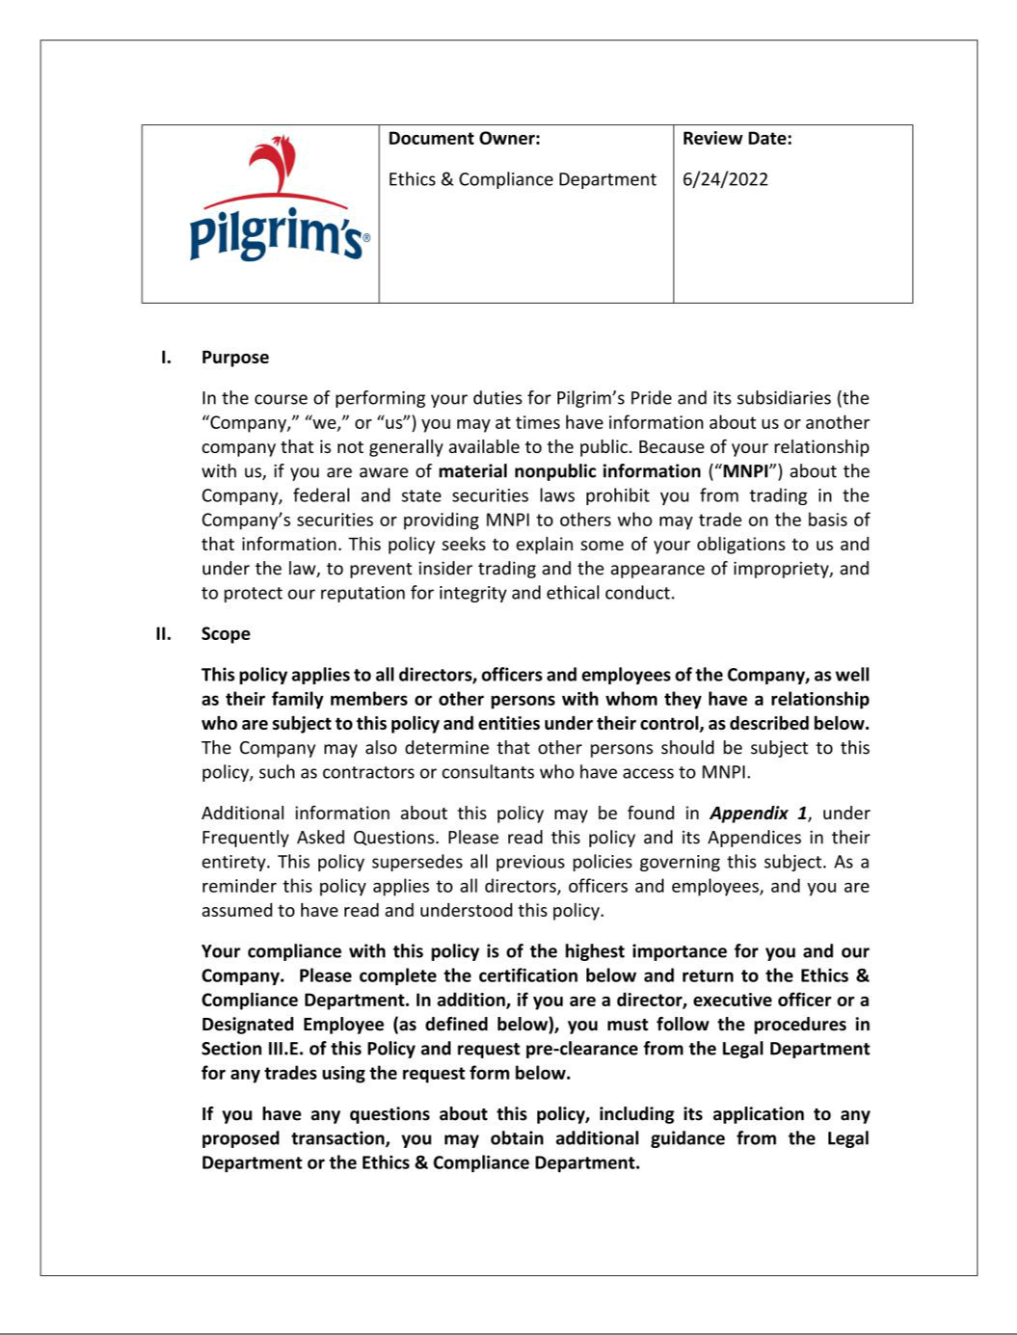

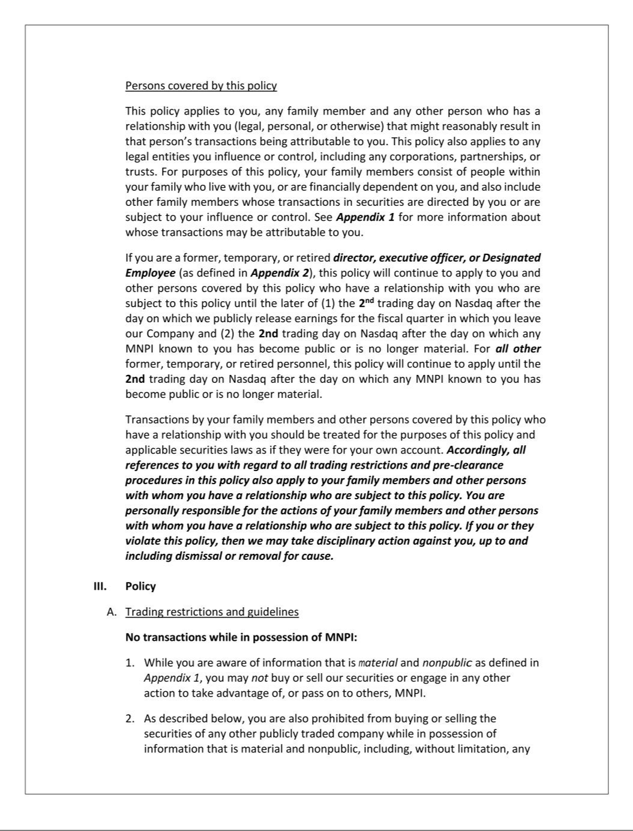

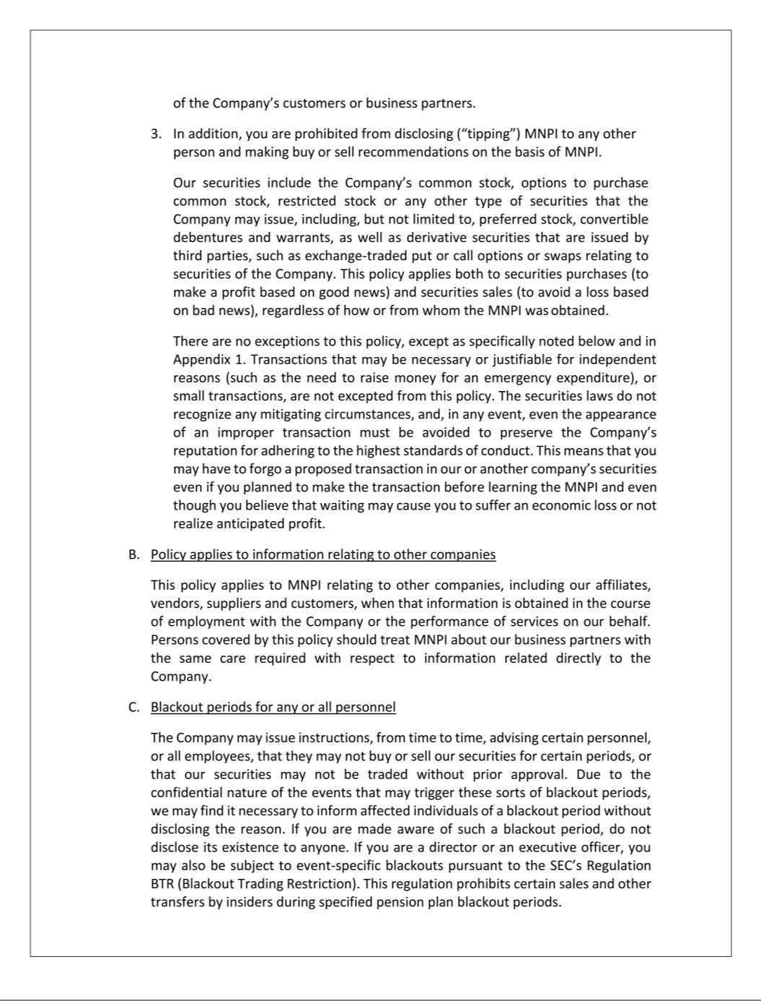

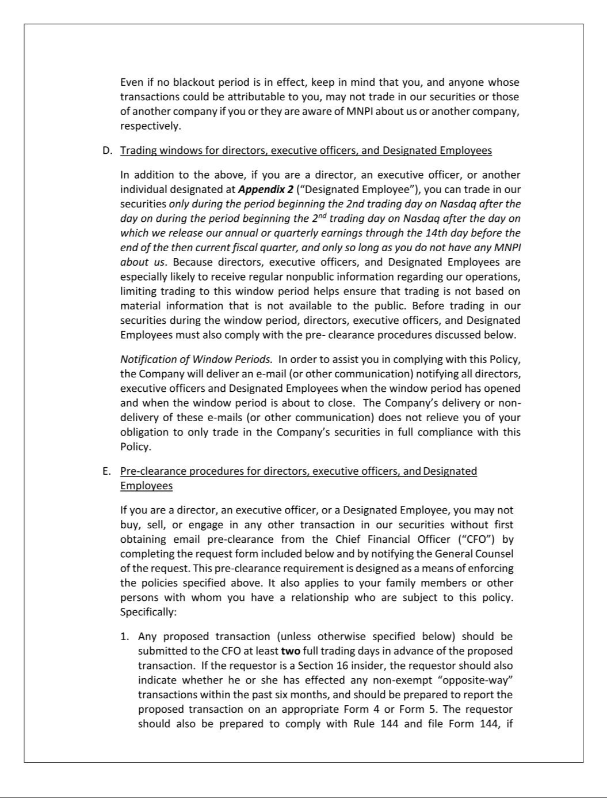

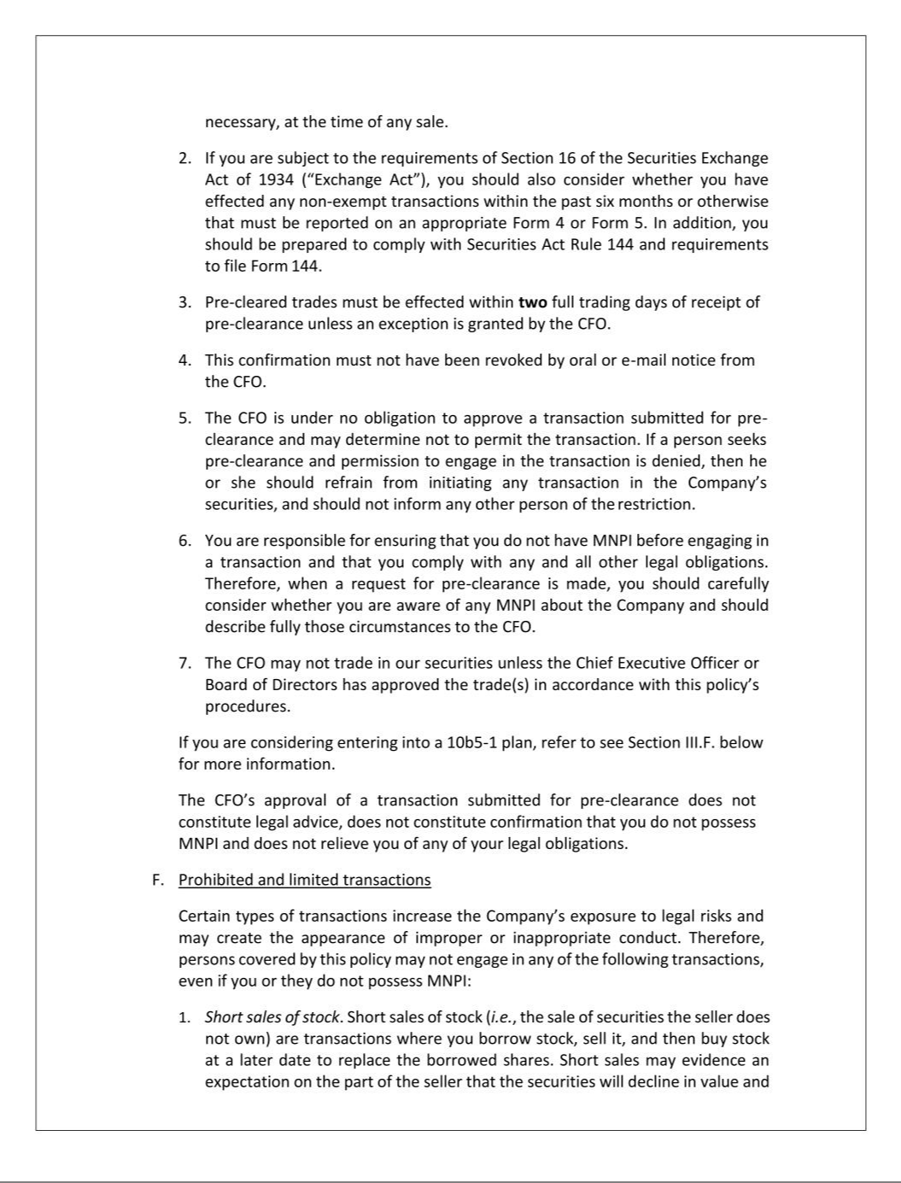

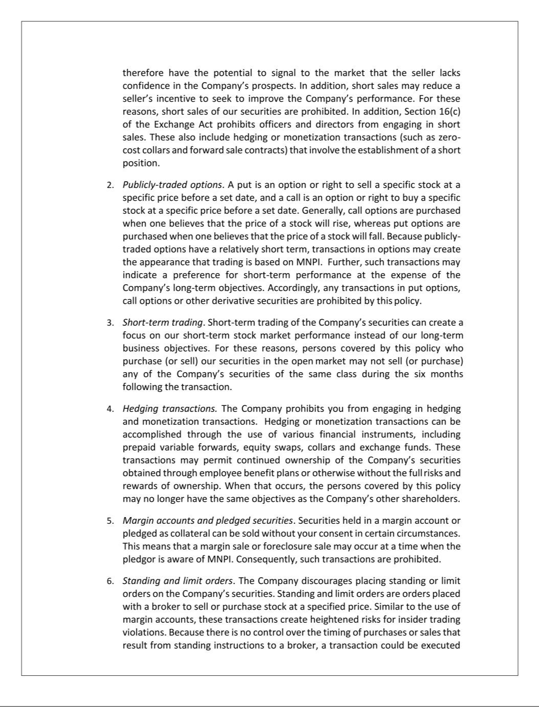

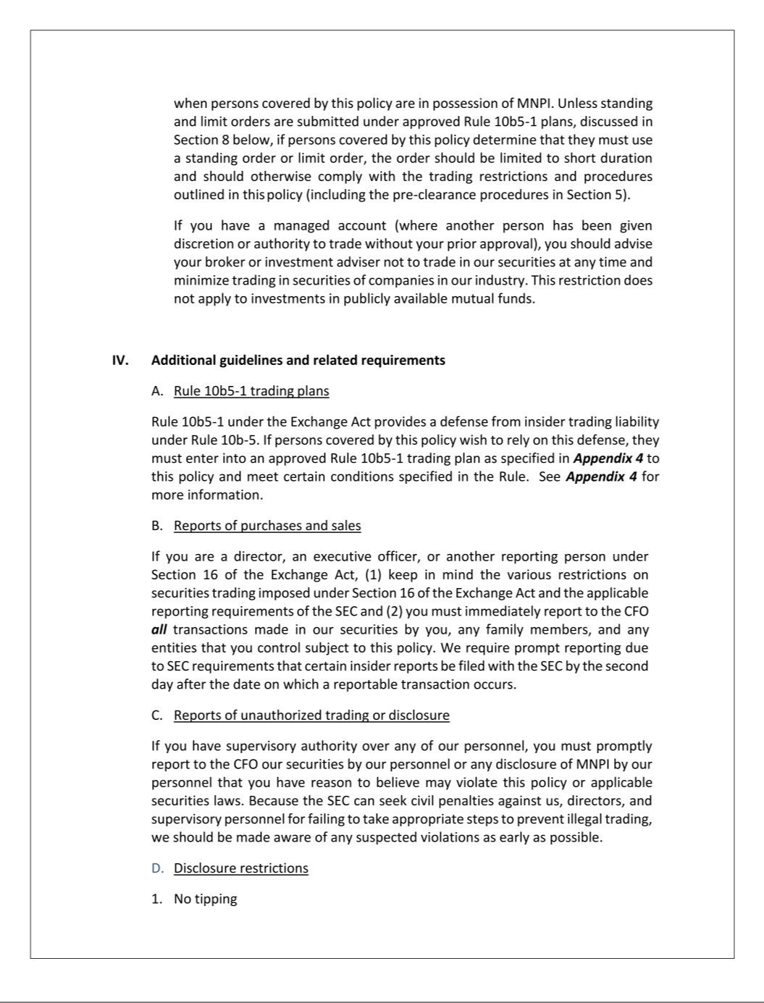

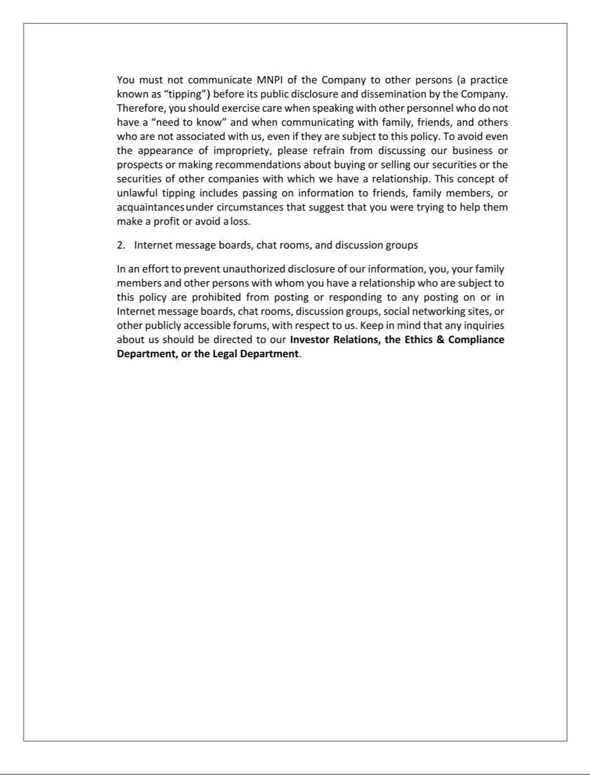

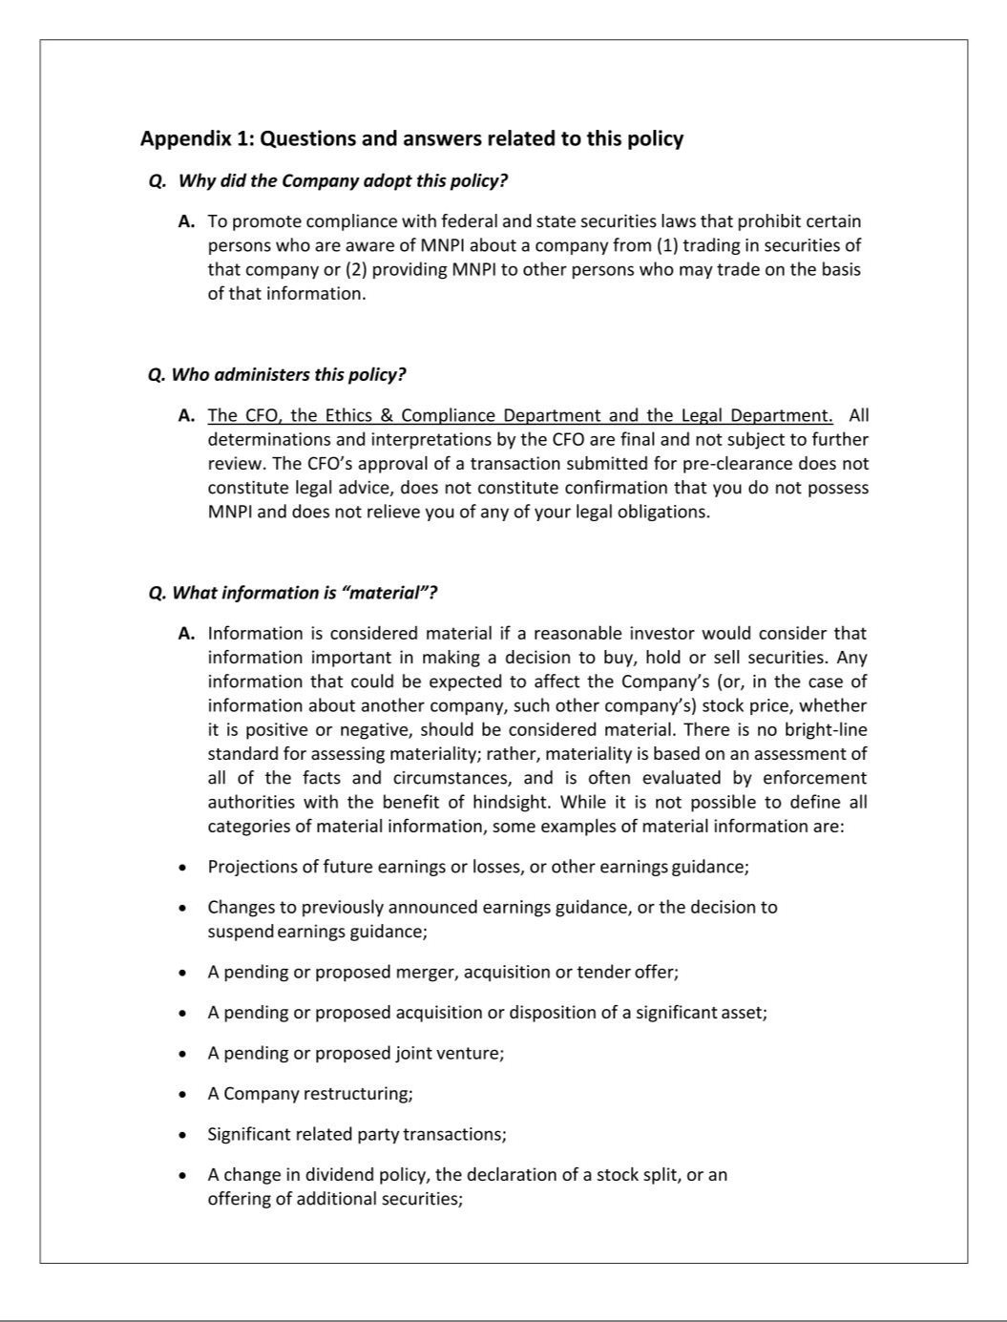

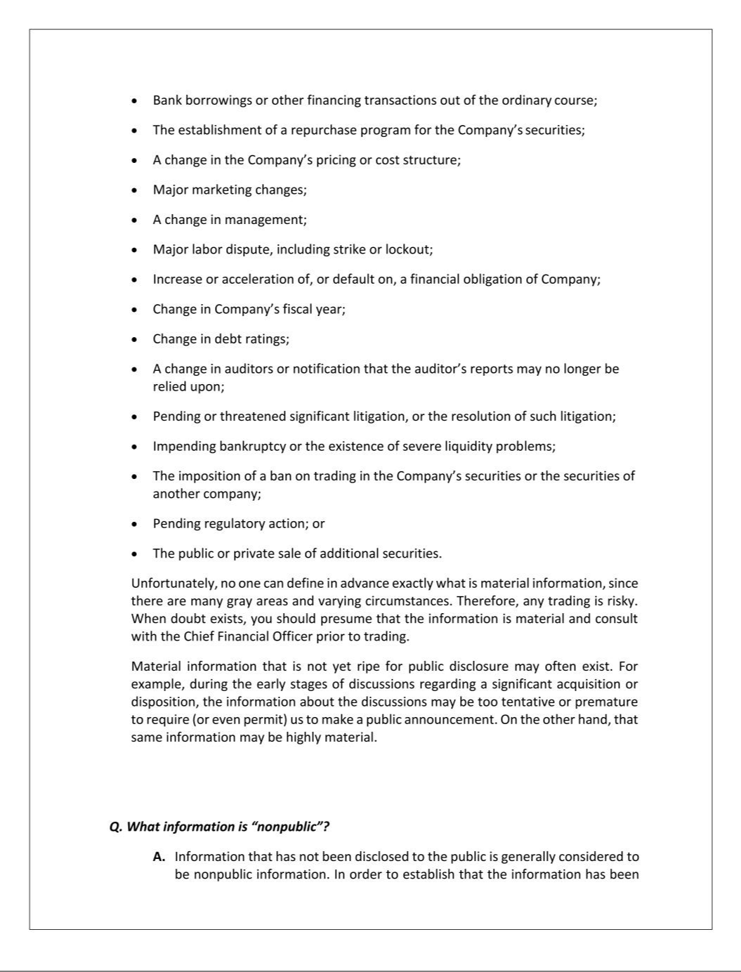

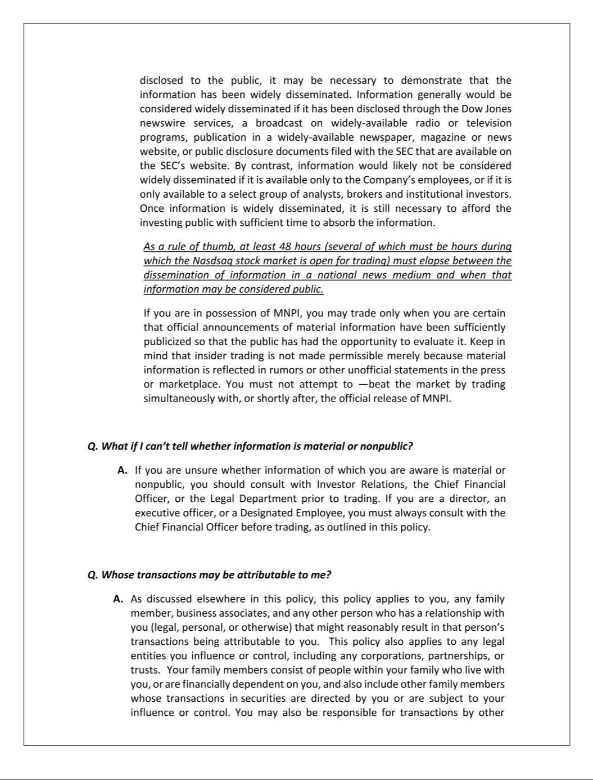

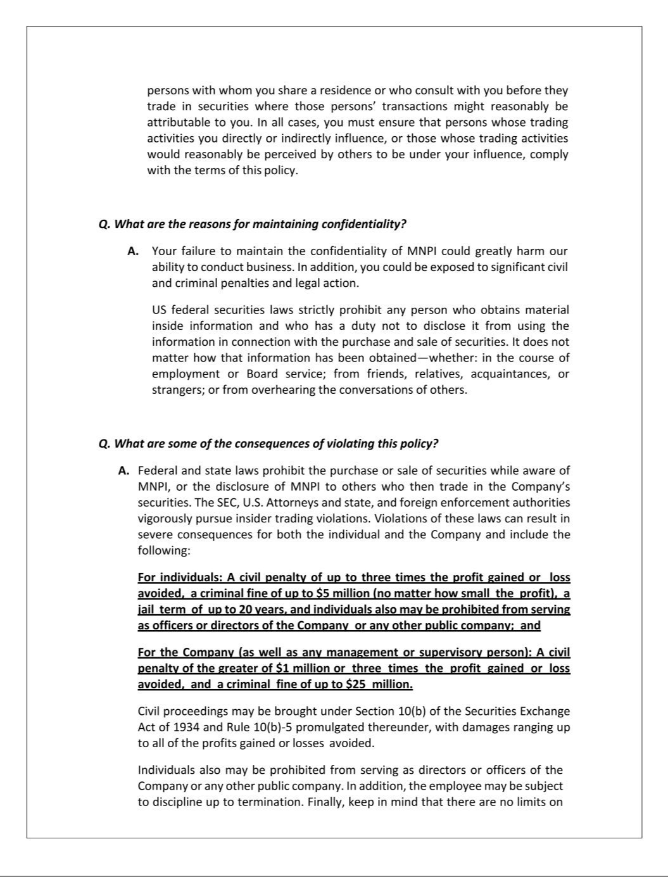

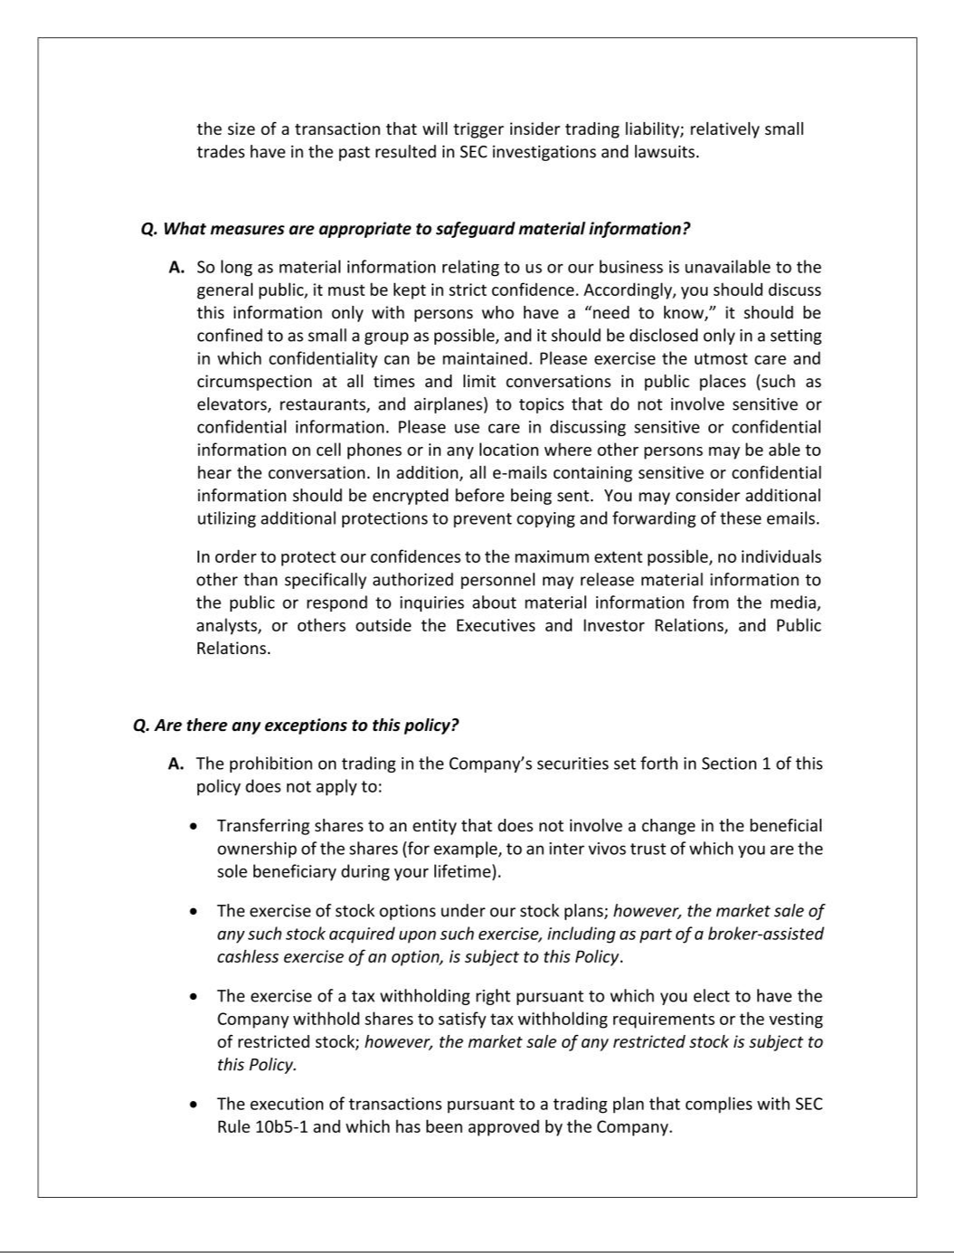

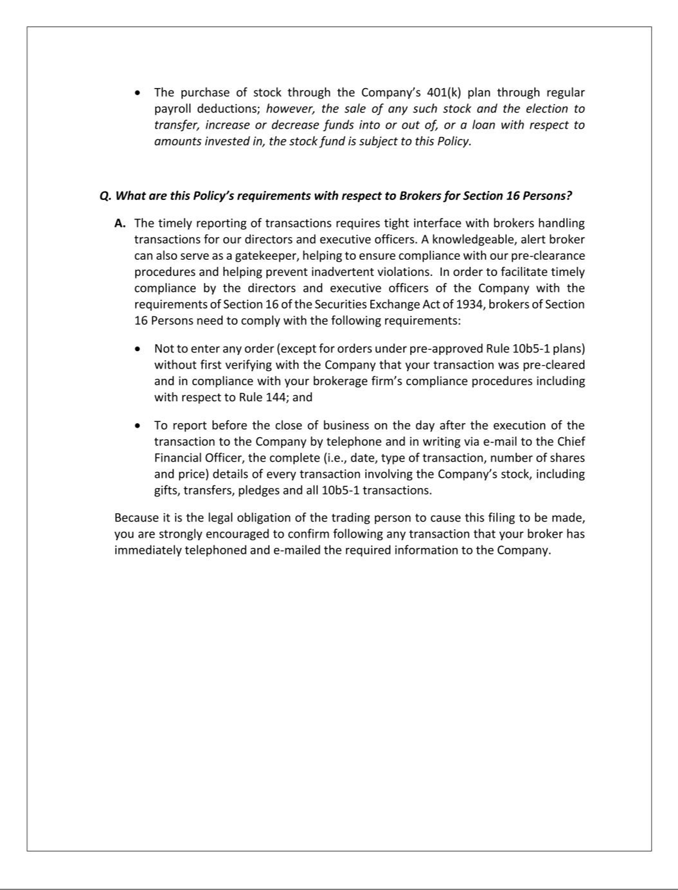

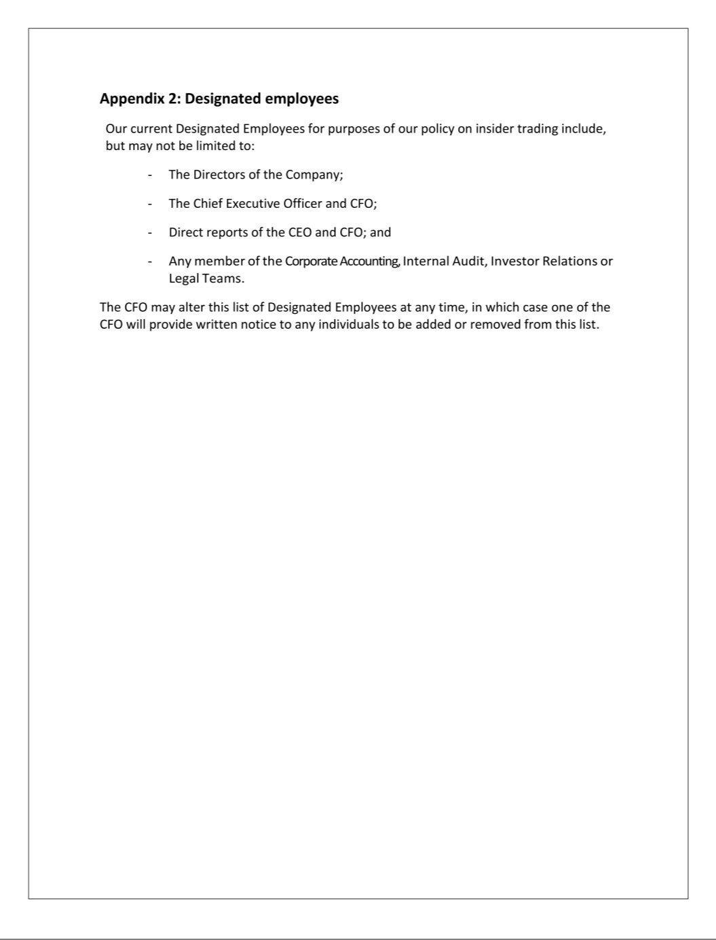



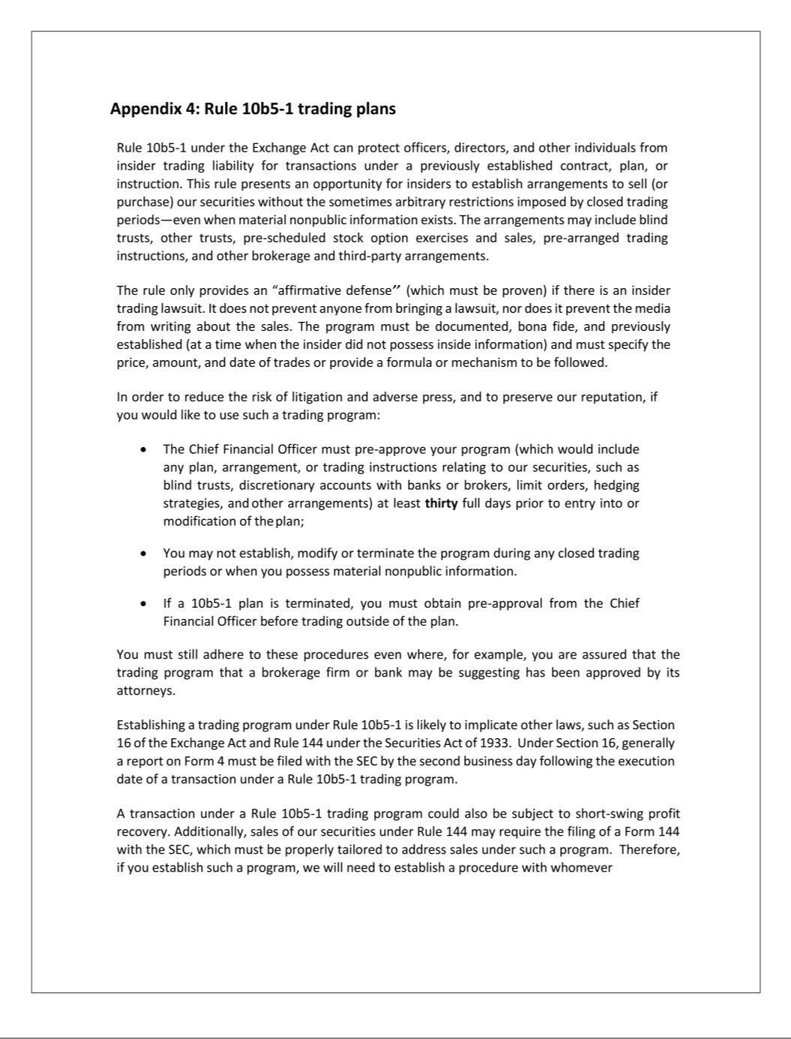

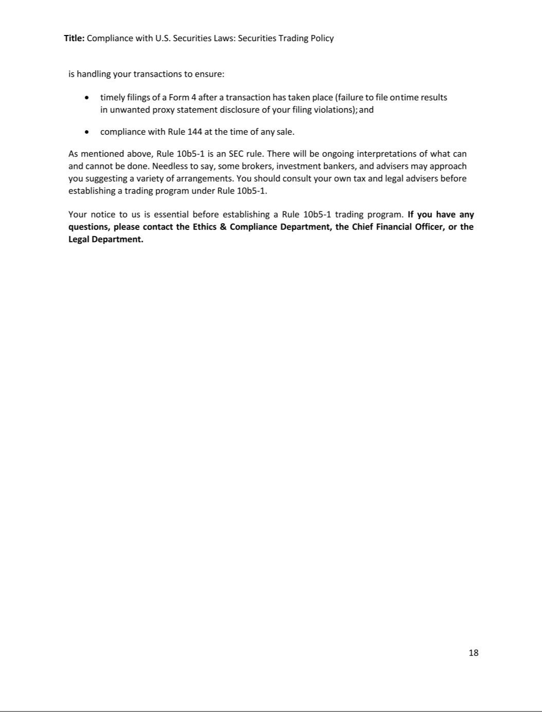

 | EXHIBIT 21
 | PILGRIM'S PRIDE CORPORATION
 | SUBSIDIARIES OF REGISTRANT
 | Jurisdiction of Incorporation or
 | Organization
U.S. Subsidiaries
Pilgrim's Pride Finance LLC | Delaware
POPPSA 3, LLC | Delaware
POPPSA 4, LLC | Delaware
PPC Transportation Company | Delaware
Merit Provisions, LLC | Delaware
Pilgrim's Pride Affordable Housing Corporation | Nevada
Pilgrim's Pride Corporation of West Virginia, Inc. | West Virginia
Hadgraft Industrial Properties, LLC | Georgia
Foreign Subsidiaries
To-Ricos Distribution, Ltd. | Bermuda
To-Ricos, Ltd. | Bermuda
Moy Park Beef Orléans Sàrl | France
Moy Park France Holdings SAS | France
Moy Park France SAS | France
Ivory Investments Luxembourg Holding S.C.S. | Luxembourg
Sandstone Holdings Sàrl | Luxembourg
Pilgrim's Pride Malta Finance Limited | Malta
Avícola Pilgrim's Pride de Mexico, S. A. de C.V. | Mexico
FAMPAT, S.A. de C.V. | Mexico
Gallina Pesada S.A.P.I. de C.V. | Mexico
Inmobiliaria Avicola Pilgrim's Pride, .S de .RL. de C.V. | Mexico
Pilgrim's Pride S. de R.L. de C.V. | Mexico
Plan Pro Restaurantes, S.A. de C.V. | Mexico
Servicios Administrativos Pilgrim's Pride S. de R.L. de C.V. | Mexico
Albert van Zoonen B.V. | Netherlands
Arkose Investments Unlimited Company | Republic of Ireland
Consumer Foods Van Sales (Ireland) Ltd. | Republic of Ireland
Pilgrim's Food Masters Ireland Ltd. | Republic of Ireland
Rye Valley Foods Ltd. | Republic of Ireland

 | EXHIBIT 21
 | PILGRIM'S PRIDE CORPORATION
 | SUBSIDIARIES OF REGISTRANT
 | Jurisdiction of Incorporation or
 | Organization
Foreign Subsidiaries (Continued)
Attleborough Foods Ltd. | United Kingdom
Bakewell Foods Ltd. | United Kingdom
Consumer Foods Van Sales (UK) Ltd. | United Kingdom
Dungannon Proteins Ltd. | United Kingdom
Hamer International Ltd. | United Kingdom
Kitchen Range Foods Ltd. | United Kingdom
Moy Park (Bondco) Plc | United Kingdom
Moy Park Holdings (Europe) Ltd. | United Kingdom
Moy Park Ltd. | United Kingdom
Moy Park Newco Ltd. | United Kingdom
Noon Products Ltd. | United Kingdom
Oakhouse Foods Ltd. | United Kingdom
O'Kane Blue Rose (Newco 1) Ltd. | United Kingdom
O'Kane Poultry Ltd. | United Kingdom
Onix Investments UK Ltd. | United Kingdom
Pilgrim's Food Masters Holdings Ltd. | United Kingdom
Pilgrim's Food Masters UK Ltd. | United Kingdom
Pilgrim's Pride, Ltd. | United Kingdom
Pilgrim's Shared Services Ltd. | United Kingdom
Pioneer Brands Ltd. | United Kingdom
Randall Parker Foods Ltd. | United Kingdom
Rollover Ltd. | United Kingdom
Spurway Foods Ltd. | United Kingdom
W. & J. Parker (Wholesale) Ltd. | United Kingdom

EXHIBIT 22.1

PILGRIM'S PRIDE CORPORATION

LIST OF GUARANTOR SUBSIDIARIES

The following entities, as of December 31, 2023, were guarantors of the 4.25% senior notes due 2031, 3.50% senior notes due 2032, 6.25% senior notes due 2033, and 6.875% senior notes due 2034 issued by Pilgrim's Pride Corporation.

Name of Entity | Jurisdiction of Incorporation or
Name of Entity | Organization
Gold'n Plump Farms, LLC | Minnesota
Gold'n Plump Poultry, LLC | Minnesota
JFC LLC | Minnesota
Pilgrim's Pride Corporation of West Virginia, Inc. | West Virginia

EXHIBIT 23.1

Consent of Independent Registered Public Accounting Firm

We consent to the incorporation by reference in the registration statements (Nos. 333-179563, 333-182586, and 333-237154) on Form S-8, registration statement (No. 333-268974) on Form S-4, and registration statement (No. 333-270754) on Form S-3 of our report dated February 13, 2025, with respect to the consolidated financial statements of Pilgrim's Pride Corporation and the effectiveness of internal control over financial reporting.

/s/ KPMG LLP

Kansas City, Missouri

February 13, 2025

EXHIBIT 31.1

CERTIFICATION BY PRINCIPAL EXECUTIVE OFFICER

PURSUANT TO 18 U.S.C. SECTION 1350,

AS ADOPTED PURSUANT TO SECTION 302

OF THE SARBANES-OXLEY ACT OF 2002

I, Fabio Sandri, certify that:

- I have reviewed this annual report on Form 10-K for the year ended December 29, 2024, of Pilgrim's Pride Corporation;

- Based on my knowledge, this report does not contain any untrue statement of a material fact or omit to state a material fact necessary to make the statements made, in light of the circumstances under which such statements were made, not misleading with respect to the period covered by this report;

- Based on my knowledge, the financial statements, and other financial information included in this report, fairly present in all material respects the financial condition, results of operations and cash flows of the registrant as of, and for, the periods presented in this report;

- The registrant's other certifying officer(s) and I are responsible for establishing and maintaining disclosure controls and procedures (as defined in Exchange Act Rules 13a-15(e) and 15d-15(e)) and internal control over financial reporting (as defined in Exchange Act Rules 13a-15(f) and 15d-15(f)) for the registrant and have:

  - Designed such disclosure controls and procedures, or caused such disclosure controls and procedures to be designed under our supervision, to ensure that material information relating to the registrant, including its consolidated subsidiaries, is made known to us by others within those entities, particularly during the period in which this report is being prepared;

  - Designed such internal control over financial reporting, or caused such internal control over financial reporting to be designed under our supervision, to provide reasonable assurance regarding the reliability of financial reporting and the preparation of financial statements for external purposes in accordance with generally accepted accounting principles;

  - Evaluated the effectiveness of the registrant's disclosure controls and procedures and presented in this report our conclusions about the effectiveness of the disclosure controls and procedures, as of the end of the period covered by this report based on such evaluation; and

  - Disclosed in this report any change in the registrant's internal control over financial reporting that occurred during the registrant's most recent fiscal quarter (the registrant's fourth fiscal quarter in the case of an annual report) that has materially affected, or is reasonably likely to materially affect, the registrant's internal control over financial reporting; and

- The registrant's other certifying officer(s) and I have disclosed, based on our most recent evaluation of internal control over financial reporting, to the registrant's auditors and the audit committee of the registrant's board of directors (or persons performing the equivalent functions):

  - All significant deficiencies and material weaknesses in the design or operation of internal control over financial reporting which are reasonably likely to adversely affect the registrant's ability to record, process, summarize and report financial information; and

  - Any fraud, whether or not material, that involves management or other employees who have a significant role in the registrant's internal control over financial reporting.

Date: February 13, 2025 | /s/ Fabio Sandri
 | Fabio Sandri
 | Principal Executive Officer

EXHIBIT 31.2

CERTIFICATION BY PRINCIPAL EXECUTIVE OFFICER

PURSUANT TO 18 U.S.C. SECTION 1350,

AS ADOPTED PURSUANT TO SECTION 302

OF THE SARBANES-OXLEY ACT OF 2002

I, Matthew Galvanoni, certify that:

- I have reviewed this annual report on Form 10-K for the year ended December 29, 2024, of Pilgrim's Pride Corporation;

- Based on my knowledge, this report does not contain any untrue statement of a material fact or omit to state a material fact necessary to make the statements made, in light of the circumstances under which such statements were made, not misleading with respect to the period covered by this report;

- Based on my knowledge, the financial statements, and other financial information included in this report, fairly present in all material respects the financial condition, results of operations and cash flows of the registrant as of, and for, the periods presented in this report;

- The registrant's other certifying officer(s) and I are responsible for establishing and maintaining disclosure controls and procedures (as defined in Exchange Act Rules 13a-15(e) and 15d-15(e)) and internal control over financial reporting (as defined in Exchange Act Rules 13a-15(f) and 15d-15(f)) for the registrant and have:

  - Designed such disclosure controls and procedures, or caused such disclosure controls and procedures to be designed under our supervision, to ensure that material information relating to the registrant, including its consolidated subsidiaries, is made known to us by others within those entities, particularly during the period in which this report is being prepared;

  - Designed such internal control over financial reporting, or caused such internal control over financial reporting to be designed under our supervision, to provide reasonable assurance regarding the reliability of financial reporting and the preparation of financial statements for external purposes in accordance with generally accepted accounting principles;

  - Evaluated the effectiveness of the registrant's disclosure controls and procedures and presented in this report our conclusions about the effectiveness of the disclosure controls and procedures, as of the end of the period covered by this report based on such evaluation; and

  - Disclosed in this report any change in the registrant's internal control over financial reporting that occurred during the registrant's most recent fiscal quarter (the registrant's fourth fiscal quarter in the case of an annual report) that has materially affected, or is reasonably likely to materially affect, the registrant's internal control over financial reporting; and

- The registrant's other certifying officer(s) and I have disclosed, based on our most recent evaluation of internal control over financial reporting, to the registrant's auditors and the audit committee of the registrant's board of directors (or persons performing the equivalent functions):

  - All significant deficiencies and material weaknesses in the design or operation of internal control over financial reporting which are reasonably likely to adversely affect the registrant's ability to record, process, summarize and report financial information; and

  - Any fraud, whether or not material, that involves management or other employees who have a significant role in the registrant's internal control over financial reporting.

Date: February 13, 2025 | /s/ Matthew Galvanoni
 | Matthew Galvanoni
 | Principal Financial Officer

EXHIBIT 32.1

CERTIFICATION OF PRINCIPAL EXECUTIVE OFFICER

PURSUANT TO 18 U.S.C. § 1350 ADOPTED PURSUANT TO

SECTION 906 OF THE SARBANES-OXLEY ACT OF 2002

Pursuant to section 906 of the Sarbanes-Oxley Act of 2002 (subsections (a) and (b) of section 1350, chapter 63 of title 18, United States Code), the undersigned officer of Pilgrim's Pride Corporation (the “Company”), does hereby certify, to such officer's knowledge, that:

The Annual Report on Form 10-K for the year ended December 29, 2024 (the “Form 10-K”) of the Company fully complies with the requirements of section 13(a) or 15(d) of the Securities Exchange Act of 1934, and information contained in the Form 10-K fairly presents, in all material respects, the financial condition and results of operations of the Company.

Date: February 13, 2025 | /s/ Fabio Sandri
 | Fabio Sandri
 | Principal Executive Officer

EXHIBIT 32.2

CERTIFICATION OF PRINCIPAL EXECUTIVE OFFICER

PURSUANT TO 18 U.S.C. § 1350 ADOPTED PURSUANT TO

SECTION 906 OF THE SARBANES-OXLEY ACT OF 2002

Pursuant to section 906 of the Sarbanes-Oxley Act of 2002 (subsections (a) and (b) of section 1350, chapter 63 of title 18, United States Code), the undersigned officer of Pilgrim's Pride Corporation (the “Company”), does hereby certify, to such officer's knowledge, that:

The Annual Report on Form 10-K for the year ended December 29, 2024 (the “Form 10-K”) of the Company fully complies with the requirements of section 13(a) or 15(d) of the Securities Exchange Act of 1934, and information contained in the Form 10-K fairly presents, in all material respects, the financial condition and results of operations of the Company.

Date: February 13, 2025 | /s/ Matthew Galvanoni
 | Matthew Galvanoni
 | Principal Financial Officer

