UNITED STATES
SECURITIES AND EXCHANGE COMMISSION
WASHINGTON, D.C. 20549
FORM |  |  | 8-K
CURRENT REPORT
Pursuant to Section 13 or 15(d) of the Securities Exchange Act of 1934
Date of report (Date of earliest event reported): September 9, 2026
PILGRIM'S PRIDE CORPORATION
(Exact Name of registrant as specified in its charter)
Delaware |  |  |  |  |  | 1-9273 |  |  |  |  |  | 75-1285071
(State or other jurisdiction of  incorporation or organization) |  |  |  |  |  | (Commission File Number) |  |  |  |  |  | (IRS Employer Identification No.)
1770 Promontory Circle |  |  |  |  |  |  |  |  | 80634-9038
Greeley |  |  | CO |  |  |  |  |  | (Zip Code)
(Address of principal executive offices)
Registrant's telephone number, including area code: (970) 506-8000
Not Applicable
(Former name or former address, if changed since last report.)
Check the appropriate box below if the Form 8-K filing is intended to simultaneously satisfy the filing obligation of the registrant under any of the following provisions:
☐ Written communications pursuant to Rule 425 under the Securities Act (17 CFR 230.425)
☐ Soliciting material pursuant to Rule 14a-12 under the Exchange Act (17 CFR 240.14a-12)
☐ Pre-commencement communications pursuant to Rule 14d-2(b) under the Exchange Act (17 CFR 240.14d-2(b))
☐ Pre-commencement communications pursuant to Rule 13e-4(c) under the Exchange Act (17 CFR 240.13e-4(c))
Securities registered pursuant to Section 12(b) of the Act:
Title of each class |  |  |  |  |  | Trading Symbol |  |  |  |  |  | Name of Exchange on Which Registered
Common Stock, Par Value $0.01 |  |  |  |  |  | PPC |  |  |  |  |  | The Nasdaq Stock Market LLC
Indicate by check mark whether the registrant is an emerging growth company as defined in Rule 405 of the Securities Act of 1933 (§230.405 of this chapter) or Rule 12b-2 of the Securities Exchange Act of 1934 (§240.12b-2 of this chapter).
Emerging growth company |  |  | ☐
If an emerging growth company, indicate by check mark if the registrant has elected not to use the extended transition period for complying with any new or revised financial accounting standards provided pursuant to Section 13(a) of the Exchange Act. ☐

Item 7.01 Regulation FD Disclosure.
On September 9, 2026, Pilgrim’s Pride Corporation (the “Company”) and Pilgrim’s Europe Finance PLC, a wholly owned subsidiary of the Company, issued a press release announcing the pricing of the previously announced private offering of €500 million aggregate principal amount of 4.750% senior notes due 2034.
A copy of the press release is furnished as Exhibit 99.1 hereto. The information furnished pursuant to Item 7.01 of this Current Report on Form 8-K, including Exhibit 99.1, shall not be deemed “filed” for purposes of Section 18 of the Securities Exchange Act of 1934, as amended (the “Exchange Act”), or otherwise subject to the liabilities of that section, nor shall it be deemed incorporated by reference in any of the Company’s filings under the Securities Act of 1933, as amended, or the Exchange Act, except as expressly set forth by specific reference in such filing.

Item 9.01 Financial Statements and Exhibits.
(d) Exhibits
Exhibit No. |  |  |  |  |  | Description
99.1 |  |  |  |  |  | Press Release issued by the Company dated September 9, 2026.
104 |  |  |  |  |  | Cover Page Interactive Data File (formatted as Inline XBRL and contained in Exhibit 101)

SIGNATURES
Pursuant to the requirements of the Securities Exchange Act of 1934, the registrant has duly caused this report to be signed on its behalf by the undersigned hereunto duly authorized.
 |  |  |  |  |  |  |  |  | PILGRIM’S PRIDE CORPORATION
Date: |  |  | September 9, 2026 |  |  |  |  |  | /s/ Matthew Galvanoni
 |  |  |  |  |  |  |  |  | Matthew Galvanoni
 |  |  |  |  |  |  |  |  | Chief Financial Officer and Chief Accounting Officer
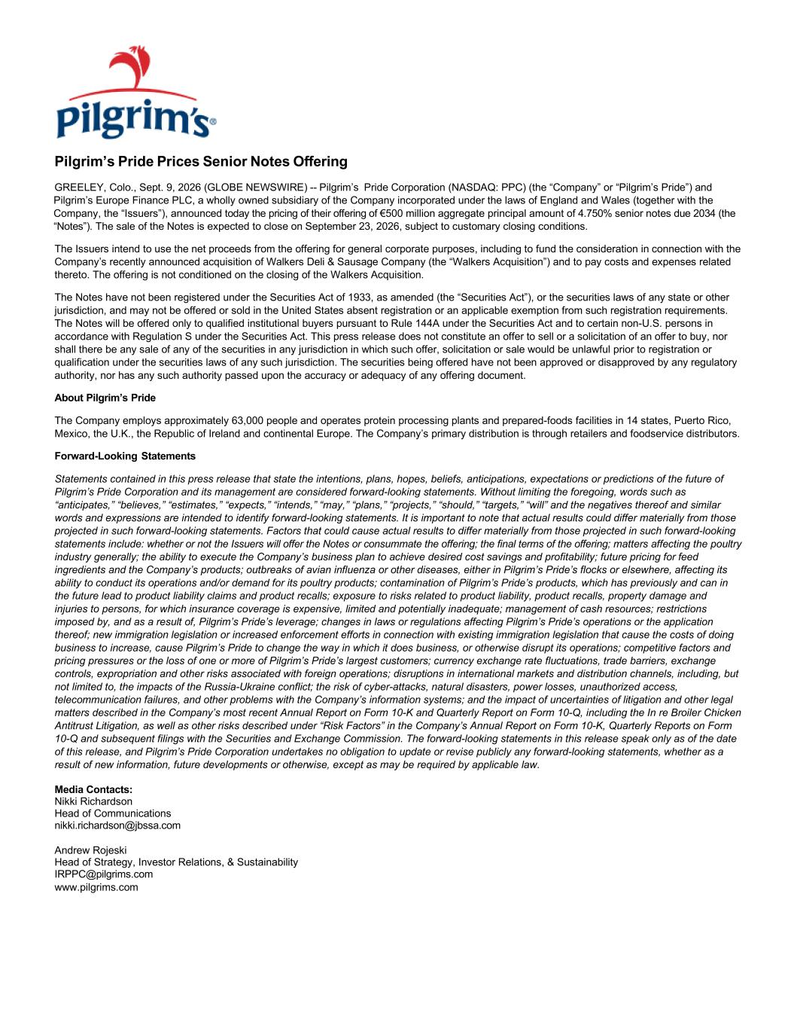

Pilgrim’s Pride Prices Senior Notes Offering GREELEY, Colo., Sept. 9, 2026 (GLOBE NEWSWIRE) -- Pilgrim’s Pride Corporation (NASDAQ: PPC) (the “Company” or “Pilgrim’s Pride”) and Pilgrim’s Europe Finance PLC, a wholly owned subsidiary of the Company incorporated under the laws of England and Wales (together with the Company, the “Issuers”), announced today the pricing of their offering of €500 million aggregate principal amount of 4.750% senior notes due 2034 (the “Notes”). The sale of the Notes is expected to close on September 23, 2026, subject to customary closing conditions. The Issuers intend to use the net proceeds from the offering for general corporate purposes, including to fund the consideration in connection with the Company’s recently announced acquisition of Walkers Deli & Sausage Company (the “Walkers Acquisition”) and to pay costs and expenses related thereto. The offering is not conditioned on the closing of the Walkers Acquisition. The Notes have not been registered under the Securities Act of 1933, as amended (the “Securities Act”), or the securities laws of any state or other jurisdiction, and may not be offered or sold in the United States absent registration or an applicable exemption from such registration requirements. The Notes will be offered only to qualified institutional buyers pursuant to Rule 144A under the Securities Act and to certain non-U.S. persons in accordance with Regulation S under the Securities Act. This press release does not constitute an offer to sell or a solicitation of an offer to buy, nor shall there be any sale of any of the securities in any jurisdiction in which such offer, solicitation or sale would be unlawful prior to registration or qualification under the securities laws of any such jurisdiction. The securities being offered have not been approved or disapproved by any regulatory authority, nor has any such authority passed upon the accuracy or adequacy of any offering document. About Pilgrim’s Pride The Company employs approximately 63,000 people and operates protein processing plants and prepared-foods facilities in 14 states, Puerto Rico, Mexico, the U.K., the Republic of Ireland and continental Europe. The Company’s primary distribution is through retailers and foodservice distributors. Forward-Looking Statements Statements contained in this press release that state the intentions, plans, hopes, beliefs, anticipations, expectations or predictions of the future of Pilgrim’s Pride Corporation and its management are considered forward-looking statements. Without limiting the foregoing, words such as “anticipates,” “believes,” “estimates,” “expects,” “intends,” “may,” “plans,” “projects,” “should,” “targets,” “will” and the negatives thereof and similar words and expressions are intended to identify forward-looking statements. It is important to note that actual results could differ materially from those projected in such forward-looking statements. Factors that could cause actual results to differ materially from those projected in such forward-looking statements include: whether or not the Issuers will offer the Notes or consummate the offering; the final terms of the offering; matters affecting the poultry industry generally; the ability to execute the Company’s business plan to achieve desired cost savings and profitability; future pricing for feed ingredients and the Company’s products; outbreaks of avian influenza or other diseases, either in Pilgrim’s Pride’s flocks or elsewhere, affecting its ability to conduct its operations and/or demand for its poultry products; contamination of Pilgrim’s Pride’s products, which has previously and can in the future lead to product liability claims and product recalls; exposure to risks related to product liability, product recalls, property damage and injuries to persons, for which insurance coverage is expensive, limited and potentially inadequate; management of cash resources; restrictions imposed by, and as a result of, Pilgrim’s Pride’s leverage; changes in laws or regulations affecting Pilgrim’s Pride’s operations or the application thereof; new immigration legislation or increased enforcement efforts in connection with existing immigration legislation that cause the costs of doing business to increase, cause Pilgrim’s Pride to change the way in which it does business, or otherwise disrupt its operations; competitive factors and pricing pressures or the loss of one or more of Pilgrim’s Pride’s largest customers; currency exchange rate fluctuations, trade barriers, exchange controls, expropriation and other risks associated with foreign operations; disruptions in international markets and distribution channels, including, but not limited to, the impacts of the Russia-Ukraine conflict; the risk of cyber-attacks, natural disasters, power losses, unauthorized access, telecommunication failures, and other problems with the Company’s information systems; and the impact of uncertainties of litigation and other legal matters described in the Company’s most recent Annual Report on Form 10-K and Quarterly Report on Form 10-Q, including the In re Broiler Chicken Antitrust Litigation, as well as other risks described under “Risk Factors” in the Company’s Annual Report on Form 10-K, Quarterly Reports on Form 10-Q and subsequent filings with the Securities and Exchange Commission. The forward-looking statements in this release speak only as of the date of this release, and Pilgrim’s Pride Corporation undertakes no obligation to update or revise publicly any forward-looking statements, whether as a result of new information, future developments or otherwise, except as may be required by applicable law. Media Contacts: Nikki Richardson Head of Communications nikki.richardson@jbssa.com Andrew Rojeski Head of Strategy, Investor Relations, & Sustainability IRPPC@pilgrims.com www.pilgrims.com



