UNITED STATES
SECURITIES AND EXCHANGE COMMISSION
WASHINGTON, D.C. 20549
FORM |  |  | 8-K
CURRENT REPORT
Pursuant to Section 13 or 15(d) of the Securities Exchange Act of 1934
Date of report (Date of earliest event reported): August 18, 2026
PILGRIM'S PRIDE CORPORATION
(Exact Name of registrant as specified in its charter)
Delaware |  |  |  |  |  | 1-9273 |  |  |  |  |  | 75-1285071
(State or other jurisdiction of  incorporation or organization) |  |  |  |  |  | (Commission File Number) |  |  |  |  |  | (IRS Employer Identification No.)
1770 Promontory Circle |  |  |  |  |  |  |  |  | 80634-9038
Greeley |  |  | CO |  |  |  |  |  | (Zip Code)
(Address of principal executive offices)
Registrant's telephone number, including area code: (970) 506-8000
Not Applicable
(Former name or former address, if changed since last report.)
Check the appropriate box below if the Form 8-K filing is intended to simultaneously satisfy the filing obligation of the registrant under any of the following provisions:
☐ Written communications pursuant to Rule 425 under the Securities Act (17 CFR 230.425)
☐ Soliciting material pursuant to Rule 14a-12 under the Exchange Act (17 CFR 240.14a-12)
☐ Pre-commencement communications pursuant to Rule 14d-2(b) under the Exchange Act (17 CFR 240.14d-2(b))
☐ Pre-commencement communications pursuant to Rule 13e-4(c) under the Exchange Act (17 CFR 240.13e-4(c))
Securities registered pursuant to Section 12(b) of the Act:
Title of each class |  |  |  |  |  | Trading Symbol |  |  |  |  |  | Name of Exchange on Which Registered
Common Stock, Par Value $0.01 |  |  |  |  |  | PPC |  |  |  |  |  | The Nasdaq Stock Market LLC
Indicate by check mark whether the registrant is an emerging growth company as defined in as defined in Rule 405 of the Securities Act of 1933 (§230.405 of this chapter) or Rule 12b-2 of the Securities Exchange Act of 1934 (§240.12b-2 of this chapter).
Emerging growth company |  |  | ☐
If an emerging growth company, indicate by check mark if the registrant has elected not to use the extended transition period for complying with any new or revised financial accounting standards provided pursuant to Section 13(a) of the Exchange Act. ☐

Item 8.01 Other Events.
On August 18, 2026, the board of directors (the “Board”) of Pilgrim’s Pride Corporation (the “Company”) received an unsolicited proposal (the “Proposal”) from its majority stockholder JBS N.V. (“JBS”) to acquire all of the outstanding shares of common stock of the Company not already owned by JBS or its subsidiaries for a fixed exchange ratio of 2.086 JBS Class A common shares for each share of Company common stock, based on the JBS and Company closing share prices on August 18, 2026 of $13.66 and $28.49, respectively. A copy of the Proposal is attached hereto as Exhibit 99.1 and incorporated herein by reference. The Board will be forming a special committee of the Board to review and evaluate the Proposal. There is no assurance that the Proposal will result in the consummation of the transaction contemplated by the Proposal or any other transaction.

Item 9.01 Financial Statements and Exhibits.
(d) Exhibits
Exhibit No. |  |  |  |  |  | Description
99.1 |  |  |  |  |  | Proposal Letter, dated as of August 18, 2026.
104 |  |  |  |  |  | Cover Page Interactive Data File (formatted as Inline XBRL and contained in Exhibit 101)

SIGNATURES
Pursuant to the requirements of the Securities Exchange Act of 1934, the registrant has duly caused this report to be signed on its behalf by the undersigned hereunto duly authorized.
 |  |  |  |  |  |  |  |  | PILGRIM’S PRIDE CORPORATION
Date: |  |  | August 19, 2026 |  |  |  |  |  | /s/ Matthew Galvanoni
 |  |  |  |  |  |  |  |  | Matthew Galvanoni
 |  |  |  |  |  |  |  |  | Chief Financial Officer and Chief Accounting Officer
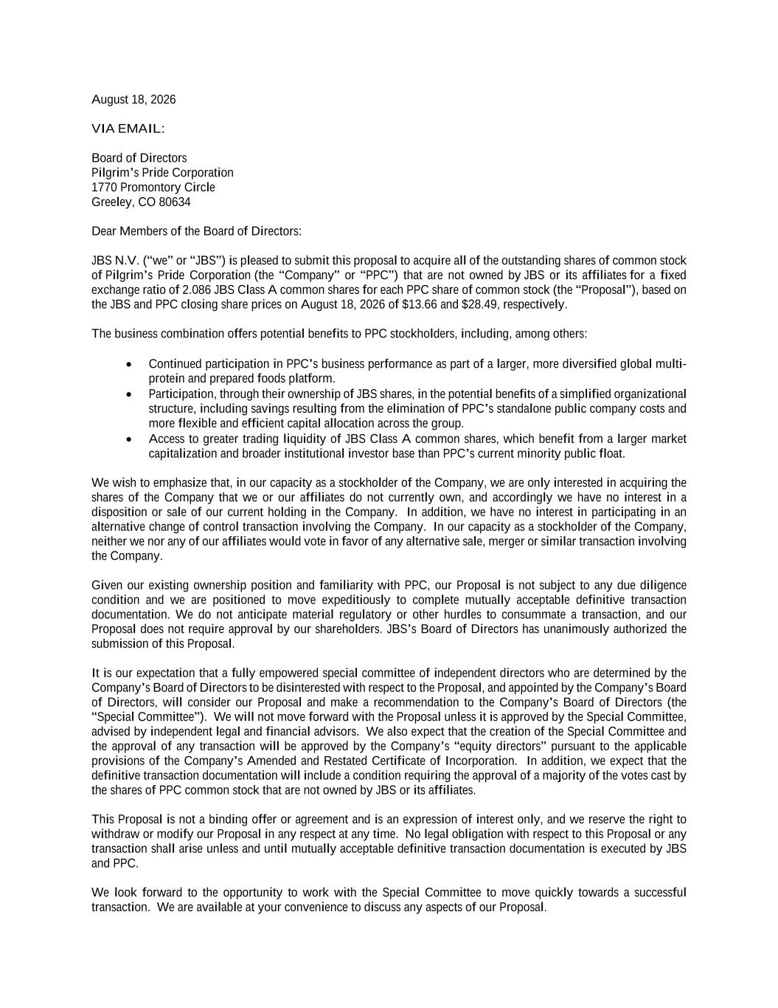

August 18, 2026 VIA EMAIL: Board of Directors Pilgrim’s Pride Corporation 1770 Promontory Circle Greeley, CO 80634 Dear Members of the Board of Directors: JBS N.V. (“we” or “JBS”) is pleased to submit this proposal to acquire all of the outstanding shares of common stock of Pilgrim’s Pride Corporation (the “Company” or “PPC”) that are not owned by JBS or its affiliates for a fixed exchange ratio of 2.086 JBS Class A common shares for each PPC share of common stock (the “Proposal”), based on the JBS and PPC closing share prices on August 18, 2026 of $13.66 and $28.49, respectively. The business combination offers potential benefits to PPC stockholders, including, among others: • Continued participation in PPC’s business performance as part of a larger, more diversified global multi- protein and prepared foods platform. • Participation, through their ownership of JBS shares, in the potential benefits of a simplified organizational structure, including savings resulting from the elimination of PPC’s standalone public company costs and more flexible and efficient capital allocation across the group. • Access to greater trading liquidity of JBS Class A common shares, which benefit from a larger market capitalization and broader institutional investor base than PPC’s current minority public float. We wish to emphasize that, in our capacity as a stockholder of the Company, we are only interested in acquiring the shares of the Company that we or our affiliates do not currently own, and accordingly we have no interest in a disposition or sale of our current holding in the Company. In addition, we have no interest in participating in an alternative change of control transaction involving the Company. In our capacity as a stockholder of the Company, neither we nor any of our affiliates would vote in favor of any alternative sale, merger or similar transaction involving the Company. Given our existing ownership position and familiarity with PPC, our Proposal is not subject to any due diligence condition and we are positioned to move expeditiously to complete mutually acceptable definitive transaction documentation. We do not anticipate material regulatory or other hurdles to consummate a transaction, and our Proposal does not require approval by our shareholders. JBS’s Board of Directors has unanimously authorized the submission of this Proposal. It is our expectation that a fully empowered special committee of independent directors who are determined by the Company’s Board of Directors to be disinterested with respect to the Proposal, and appointed by the Company’s Board of Directors, will consider our Proposal and make a recommendation to the Company’s Board of Directors (the “Special Committee”). We will not move forward with the Proposal unless it is approved by the Special Committee, advised by independent legal and financial advisors. We also expect that the creation of the Special Committee and the approval of any transaction will be approved by the Company’s “equity directors” pursuant to the applicable provisions of the Company’s Amended and Restated Certificate of Incorporation. In addition, we expect that the definitive transaction documentation will include a condition requiring the approval of a majority of the votes cast by the shares of PPC common stock that are not owned by JBS or its affiliates. This Proposal is not a binding offer or agreement and is an expression of interest only, and we reserve the right to withdraw or modify our Proposal in any respect at any time. No legal obligation with respect to this Proposal or any transaction shall arise unless and until mutually acceptable definitive transaction documentation is executed by JBS and PPC. We look forward to the opportunity to work with the Special Committee to move quickly towards a successful transaction. We are available at your convenience to discuss any aspects of our Proposal.


Sincerely, JBS N.V. By: _/s/ Guilherme Perboyre Cavalcanti_____________ Guilherme Perboyre Cavalcanti Global Chief Financial Officer and Investor Relations Officer By: ______________________ Eliseo Santiago Perez Fernandez Officer

